The Copy Is Never Exact
DNA, Inheritance, and the Coming Edit of Ourselves
Lothar J. Musiol

Copyright
The Copy Is Never Exact: DNA, Inheritance, and the Coming Edit of Ourselves
Copyright © 2026 Lothar J. Musiol. All rights reserved.
Photographs in this book are from Wikimedia Commons and are credited in the appendix. The diagrams are original.

Author's Note
I am not a geneticist. I am someone who wanted to know what was in the tube, and kept reading. The people who did the work are named in the text, with the year and the journal where it matters, so that anyone who wants the original can find it. Where the record is disputed, as it is for 1953, I have tried to give each side its best case and then say what I think.
Three people appear in this book: Ruth, born in 1948, her daughter Anna, born in 1978, and Anna's son Theo, born in 2011. They are invented. Their freckles, their milk tolerance, and their arguments at the table are there so that the mechanisms have somewhere to happen. Nothing bad is done to them for drama.
Where the status of a claim matters, I say which of three things it is. Settled: measured, repeated, and used every day. Working: the best current account, with real gaps. Speculative: allowed by what we know, not shown. Most of the book is settled. The last chapters are not, and say so.
Gene names are in italics (BRCA1). The proteins they encode are not (the BRCA1 protein). Prices are in United States dollars and carry a year. Where I give my own opinion, I mark it as mine.

Contents
Copyright
Author's Note
Prologue — The Tube in the Mailbox
PART I — The Shape of It
1. The Eagle, 28 February 1953
2. Photo 51
3. What the Shape Explains
4. The Race Before the Race
PART II — The Molecule
5. Four Letters
6. The Chemistry Under the Letters
7. The Copying Machine
8. From Letter to Protein
9. Most of the Text Is Not Genes
10. Where Mistakes Come From
PART III — Inheritance
11. Why Theo Has Ruth's Freckles
12. Who Gets What: X, Y, and the Mother's Line
13. Dominant, Recessive, and the Messy Middle
14. What Is Not in the Genes
PART IV — The Monk
15. Brno, 1856: Peas in a Garden
16. The Ratios
17. Lost for Thirty-Five Years
18. Flies in a Bottle
19. Galton's Shadow
PART V — Learning to Read
20. Cutting and Pasting
21. Sanger's Ladders
22. Copying Without a Cell
23. The Fingerprint
24. Fast, Cheap, and Everywhere
PART VI — What We Can Do Now
25. Scissors from Bacteria
26. The First Cures
27. Writing from Scratch
28. Reading the Dead
PART VII — Copies
29. Dolly, 5 July 1996
30. What a Clone Is and Isn't
31. The Human Question
PART VIII — Dinner
32. Ten Thousand Years of Editing
33. The Tomato That Didn't Rot
34. Animals on the Menu
35. What Is Actually Risky
PART IX — The Whole Book
36. Three Billion Letters, One Race
37. What the Genome Turned Out to Say
38. Biobanks and the Million
PART X — Reading Your Own
39. The Spit Kit
40. What a Genome Can Tell You
41. What It Cannot Tell You
42. Who Else Is Reading
PART XI — Correcting the Text
43. Fixing What Is Broken
44. The Line We Said We Would Not Cross
45. Enhancement
46. The Next Hundred Years
APPENDIX
Five Books
A Spit-Kit Glossary
A Short Timeline
Papers Named in the Text
Photo Credits

Prologue — The Tube in the Mailbox
It is a Tuesday in early spring, and a woman named Anna is standing at a mailbox with a padded envelope. Inside the envelope is a plastic tube. Inside the tube is about two millilitres of her saliva, mixed with a blue stabilising fluid that will keep what is in it from rotting on the way to a laboratory in another state.
Anna is invented. So is her mother, Ruth, who is seventy-eight and lives twenty minutes away, and so is Anna's son Theo, who is fifteen and thinks the whole thing is slightly disgusting. The tube is not invented. Several million people have mailed one. What matters at the mailbox is what Anna has just posted.
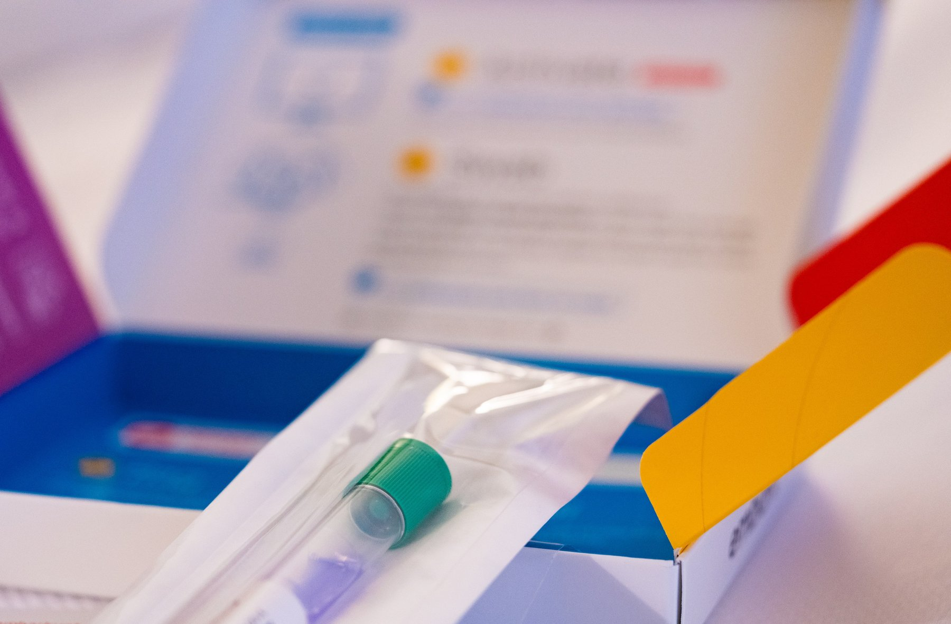
Figure 0. An opened spit-kit box, the collection tube still sealed in its bag.
Two millilitres of spit looks like nothing much. Mixed into it, with the bacteria and the crumbs of breakfast, are a few hundred thousand cells shed from the lining of her cheeks. A cell is one of the tiny living units a body is built from. Each of these is about fifteen microns across, roughly a fifth the width of a human hair.
Each cell has a nucleus, a small compartment that holds the instructions. The instructions are a molecule with a cumbersome name, deoxyribonucleic acid, DNA for short. They sit on forty-six threads. Those threads are two copies of one text. One parental set, the reference finished in 2022, is about 3.1 billion letters. Printed in ordinary type, that one set would fill about a thousand telephone directories. The nucleus holds both sets, about 6.2 billion letters. Laid end to end, the forty-six threads stretch about two metres. Two metres of thread, in a sphere too small to see.
Nearly every cell from her scalp to her heels carries the same pair of texts, with tiny differences. She has about thirty-seven trillion of those cells. Multiply the two metres by that number and she is carrying something like seventy billion kilometres of thread. That is more than four hundred times the distance from the Earth to the Sun.
None of this was known when Ruth was born. In 1948 the molecule had been named and its ingredients listed, and most people who thought about it believed it was too dull to carry information. Proteins, the working molecules that do almost every job in a cell, were the interesting ones. The physicist Max Delbrück dismissed the repeating chain as a stupid molecule, too monotonous to be a gene. The geneticist Evelyn Witkin later recalled the phrase, in a 2012 interview published in PLOS Genetics; it was the view of the laboratory, not a line from a paper of his. Five years later, in the spring of 1953, James Watson and Francis Crick built a model in Cambridge out of metal plates and wire that showed what the chain was for. The photograph that settled the shape as a helix came from Rosalind Franklin's laboratory at King's College London. Her student Raymond Gosling took it, under her direction, of the wet form of the molecule. The sentence Watson and Crick wrote is quietly loaded: it had not escaped their notice that the pairing they proposed suggested a copying mechanism.
The shape and the copying are the same fact. DNA is a twisted ladder split lengthwise into two strands. Pull the strands apart and each is a template the cell can rebuild the missing half from, so one ladder becomes two. A cell does this every time it divides. Anna's body has been doing it since a single cell in 1978 became two.
The copying is astonishingly good, and it is not perfect. A copying enzyme is a protein that speeds a chemical job. It checks its own work. A second set of enzymes checks again. After both checks, about one letter in a billion is wrong. One division of one nucleus, 6.2 billion letters, is expected to leave a handful of mistakes. That handful is the picture. Hold it. The sixty or seventy new letters Theo carried at conception are not one division. They are the leftovers of hundreds of divisions in the making of a sperm. The copy is never exact, and everything that has ever evolved, including us, is downstream of that.
The laboratory will not read Anna's text in full. It will look at a few hundred thousand positions in the 3.1 billion of one set, the spots known to vary between people. It will report ancestry, a handful of health risks, and relatives who have also mailed a tube.
She will learn three things, and miss the ones she might have wanted. She carries one copy of a variant, a spot where her letters differ from the average, that makes a certain disease a little more likely. She carries one copy of a variant that lets her drink milk as an adult, which she already knew. She has a second cousin in Ohio. She will not be told how long she will live, or whether Theo will inherit Ruth's temper. No laboratory can tell her that.
In 1990 a complete human text was priced at three billion dollars and scheduled to take fifteen years. Today a full genome, the 3.1 billion letters of one set, read so that both copies are visible, costs a few hundred dollars and takes a day. Reading turned out to be the easy part. Writing is only now beginning.
The letters can now be read, and in a few cases rewritten in a living person. What should be rewritten, and who decides, is the last argument of this book. It can wait until the shape is clear.
Anna walks home. Somewhere between the mailbox and her front door, in the lining of her gut, cells divide and copy both sets of the text, and a few of them get a letter wrong.

PART I — The Shape of It

1. The Eagle, 28 February 1953
The Eagle is a pub on Bene't Street in Cambridge, a few minutes' walk from the old Cavendish Laboratory. It has a courtyard, low ceilings, and a back room where airmen in the Second World War burned their squadron numbers into the ceiling with candles and lighters. On a Saturday at the end of February 1953, at lunchtime, a tall, loud, thirty-six-year-old physicist named Francis Crick walked in with a thin, twenty-four-year-old American named James Watson and told the room, or at least the people near him, that they had found the secret of life.
The phrase is in Watson's memoir, published in 1968, and Crick later said he did not remember saying it, which is what people say about their best lines. Whether or not he said it, it was nearly true. That morning the two of them had worked out, with cardboard cutouts and a good deal of pacing, how the four chemical units of DNA fit together in pairs. Within a week they had a metal model of the whole molecule standing on a bench, six feet tall, held together with clamps and retort stands. Within two months a paper about it, a little over nine hundred words long, was in print. The paper is dated 25 April 1953 and appears in the journal Nature under a title so modest it reads like an apology: "Molecular Structure of Nucleic Acids: A Structure for Deoxyribose Nucleic Acid."
That paper is the start of this book, and it is worth asking why a shape should matter so much. Chemists had known the ingredients of DNA for decades. What nobody had was the arrangement, and in this molecule the arrangement is everything, because the arrangement is how it copies.
The two men were an odd pair, and the oddness is part of why it worked. Crick had been trained as a physicist, had spent the war designing mines for the Admiralty, and had come to biology late and hungry. He was known at the Cavendish for a laugh that could be heard through walls and for a habit of explaining other people's problems to them before they had finished describing them. He had not yet finished his PhD. Watson had finished his, at Indiana, at twenty-two, on the genetics of viruses that infect bacteria. He had come to Europe on a fellowship to learn chemistry, had been bored by it, and had seen a photograph of a DNA fibre at a meeting in Naples in the spring of 1951 that changed what he wanted to do with his life. He arrived in Cambridge that autumn, met Crick, and the two of them decided, without being asked and without any formal permission, that they would work out the structure of DNA.
They had no laboratory of their own. They shared an office. The Cavendish was run by Sir Lawrence Bragg, who had shared a Nobel Prize with his father in 1915 for working out how to use X-rays to find the positions of atoms in crystals, and whose unit was officially devoted to proteins. DNA belonged, by a gentlemen's agreement among British laboratories, to King's College London. Maurice Wilkins had started the fibre work there. Rosalind Franklin joined in 1951 to run the X-ray work on those fibres, recording how a beam bounces off a molecule and lands on film. Photographs from her laboratory would show the wet form of DNA as a helix. Watson and Crick's job was to think about other things. They thought about DNA instead.
Their method was the one Linus Pauling had used at Caltech in 1951 to find the alpha helix, the coiled shape that runs through most proteins. Pauling did not grind through the diffraction data, the pattern of spots and smudges an X-ray beam leaves on film after it bounces off a molecule's repeating structure, which a trained eye can work backward from to the shape that made it. He asked what shapes were chemically possible, built models of them with the correct bond lengths and angles, and then checked the models against the X-ray pictures. Watson and Crick copied the method and, at first, copied the mistakes. In November 1951 they built a three-chain model with the phosphate backbones on the inside and invited the King's group up to see it. Franklin took it apart in minutes. It had far too little water in it, which her measurements showed the molecule to be full of, and it put charged phosphate groups where they could not sit. Bragg told them to stop.
They did not entirely stop. Through 1952 Crick worked on his thesis and Watson worked on tobacco mosaic virus, and both of them talked about DNA in the office and in the Eagle. What put them back on the problem, with permission this time, was Pauling. In the last weeks of 1952 word came across the Atlantic that Pauling had a structure. His son Peter was a graduate student in the same Cavendish office, and in January 1953 Peter produced a copy of the manuscript. It was a triple helix with the phosphates on the inside, essentially the model Franklin had demolished fourteen months earlier, and it was wrong in a way that a first-year chemistry student could see: the phosphate groups were drawn without their charges, so that in the form Pauling described the molecule would not have been an acid at all. Watson said afterwards that his first feeling was fear that Pauling had won and his second, once he had read the paper carefully, was that they had perhaps six weeks before Pauling noticed his own error. Bragg, who had lost the alpha helix to Pauling two years earlier and did not care to lose again, let them build.
* * *
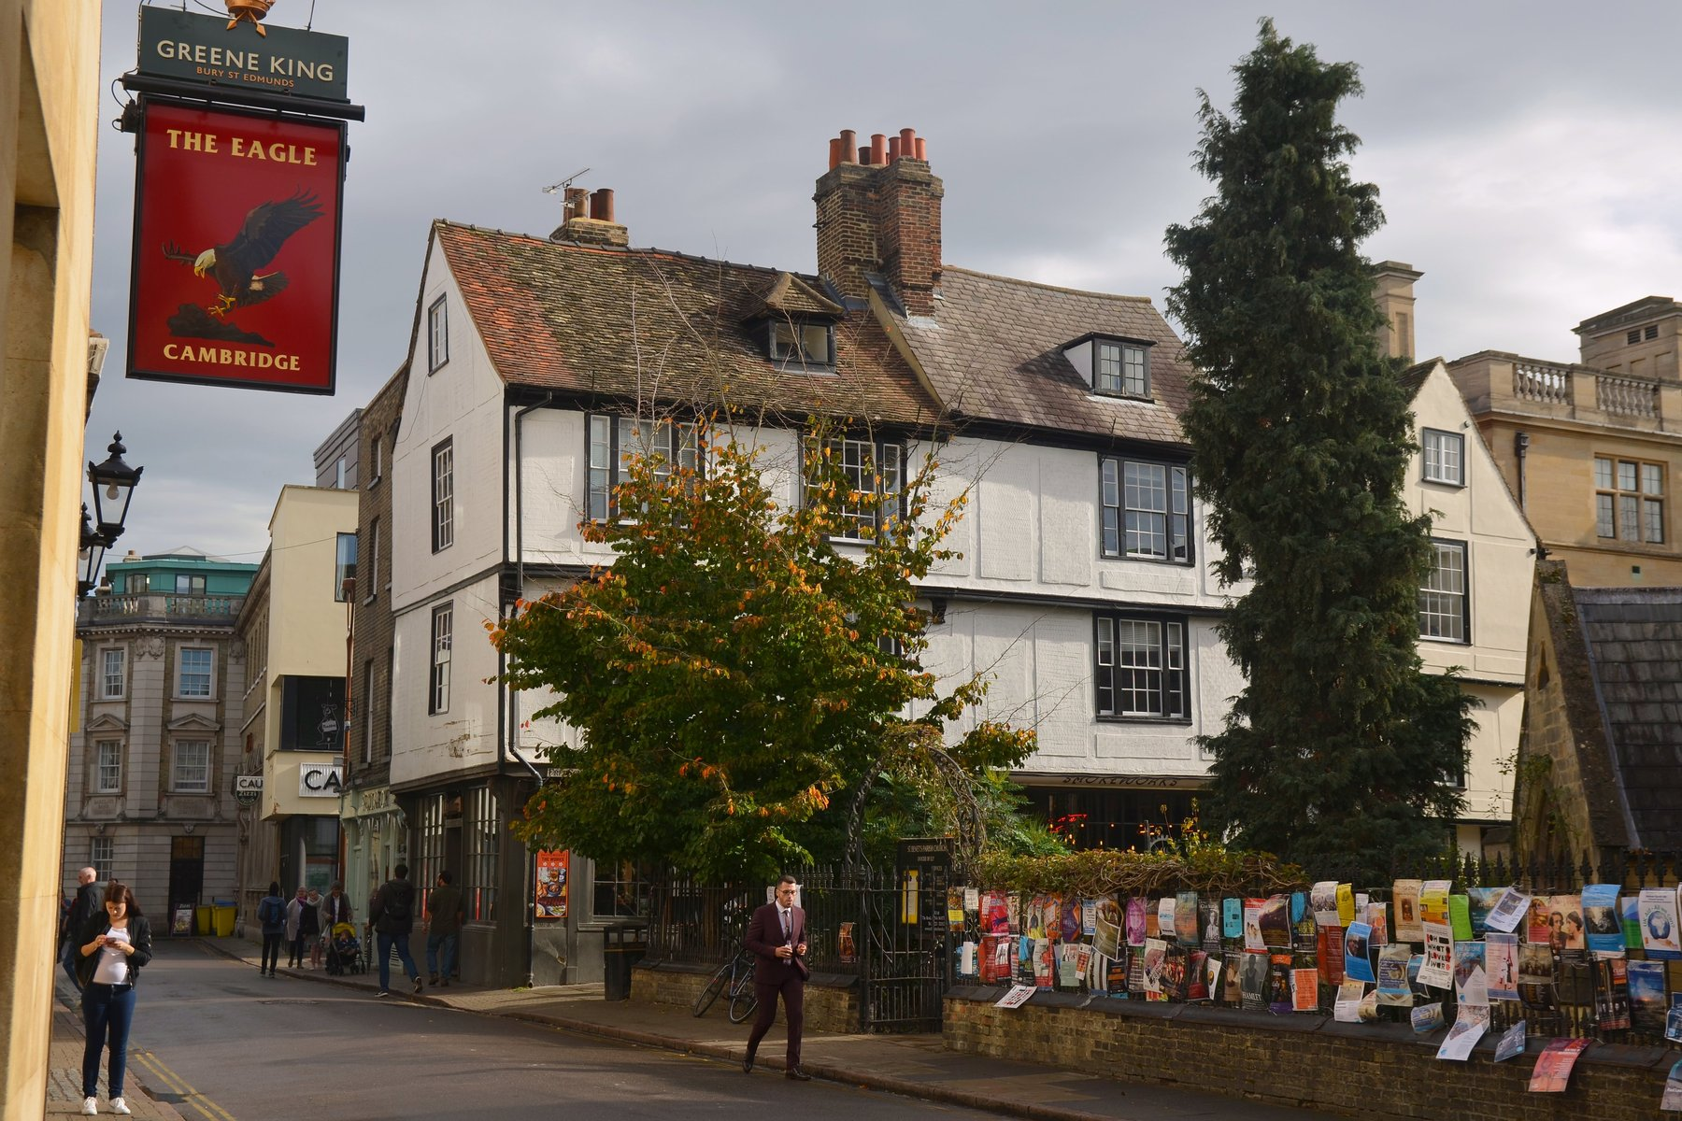
Figure 1. The Eagle, Bene't Street, Cambridge.
The pieces of the puzzle were, by then, mostly on the table. Everyone agreed that DNA was a long chain in which sugar and phosphate groups alternated to form a backbone, and that from each sugar hung one of four flat, ring-shaped bases: adenine, guanine, thymine, cytosine, known ever since by their initials. Franklin's X-ray photographs from King's said the molecule was a helix, meaning it was twisted into a spiral, like a spring or a spiral staircase, about twenty ångströms wide, with something repeating every thirty-four ångströms along its length. An ångström is a unit so small it is normally used only for single atoms; ten of them side by side would barely span the width of a strand of spider silk. An Austrian-born chemist at Columbia, Erwin Chargaff, had published in 1950 a peculiar regularity: in every kind of DNA he measured, the amount of adenine equalled the amount of thymine, and the amount of guanine equalled the amount of cytosine, even though the ratio of the two pairs to each other varied from species to species. Chargaff had visited Cambridge in the summer of 1952 and been unimpressed by Watson and Crick, who did not, at the time, seem to know the chemical formulas of the bases. He left them his rule anyway.
What Watson did in the last week of February 1953 was to take the rule seriously as a fact about shape. He cut the four bases out of stiff cardboard, to scale, and moved them around on his desk trying to find a way that two bases could sit side by side across the width of the helix, joined by the weak attractions called hydrogen bonds, with the backbones on the outside. His first idea was that like paired with like: adenine with adenine, and so on. Jerry Donohue, an American crystallographer (a scientist who works out a molecule's shape from the way it scatters X-rays) who shared the office and happened to know more about the chemistry of these particular rings than anyone in the building, told him that the textbook drawings he was using showed the bases in the wrong form. In the drawings, some of the atoms carried their hydrogens in a way known as the enol form, that Donohue said was rare in real molecules. In the more common keto form, the hydrogens sat elsewhere, and the like-with-like pairs no longer fitted.
Watson redrew the cardboard. On the morning of Saturday 28 February he found that adenine paired with thymine, held by two hydrogen bonds, made a shape almost exactly the same size as guanine paired with cytosine, held by three. Two different pairs, one width. They would stack down the middle of a helix like the rungs of a ladder, and the ladder would be the same width everywhere. Chargaff's rule fell out at once: if every A is bonded to a T, there must be as many of one as the other. So did something more important. If the two strands were pulled apart, each carried the full information needed to rebuild the other. Where one strand had A, the new partner must have T. Where it had G, the partner must have C.
That was the morning Crick walked into the Eagle.
The model took a week to build, because the machine shop had to cut new metal templates for the bases and because Crick insisted on checking every distance and angle against the known chemistry. The chains ran in opposite directions, one up and one down, which Crick had deduced from a piece of King's data that he had seen in a report and that Franklin, who had generated it, had not yet drawn the conclusion from. The two backbones wound around a common axis with ten bases per turn, one every 3.4 ångströms, so that one full turn came to Franklin's thirty-four. The bases were flat and perpendicular to the axis, stacked like coins. The whole thing was about twenty ångströms across.
They wrote the paper in March. It has two authors, no experiments, and one figure, a sketch of the helix drawn by Crick's wife Odile. It proposes the structure, notes that the bases pair in a specific way, and observes that this specific pairing "immediately suggests a possible copying mechanism for the genetic material." That sentence is the reason the paper is famous. It is the only sentence in it that is about biology rather than geometry, and it was put in, Crick said later, because leaving it out would have looked as if they had not noticed. In the same issue of Nature, immediately after, were two papers from King's College: one from Wilkins and colleagues, one from Franklin and Gosling, presenting the X-ray evidence. The arrangement was negotiated between the laboratory heads. It gave the impression, which was not quite the truth, of a joint effort.
A second paper by Watson and Crick, in Nature on 30 May 1953, spelled out the copying idea. If the strands separate, each acts as a template on which a new partner is assembled, letter by letter, by the pairing rules. The result is two helices where there was one, each combining one old strand with one new. They also noted, in a paragraph that will matter later in this book, that mistakes could occur if a base briefly took a rare chemical form and paired with the wrong partner. That paragraph is the first written suggestion that mutation might be a matter of where a hydrogen atom happens to be.
* * *
Why did a shape settle a question that decades of chemistry had not? Because the shape answered what people had actually been asking, which was not "what is DNA made of" but "how can anything made of only four ingredients carry the instructions for a living thing, and how can those instructions be passed on." The order of the bases along the chain was unconstrained by the structure: any sequence would fit, because every rung was the same width. So the order could be a message. And the pairing meant the message could be copied by a purely mechanical process that needed no intelligence and no reading, only chemistry. A cell could make a copy of its text the way you make a plaster cast, by pressing.
The metal model stood in the Cavendish for a while and then was dismantled; some of the plates survive in museums. Watson and Crick shared the Nobel Prize in Physiology or Medicine in 1962 with Wilkins. Franklin, whose photograph and whose measurements ran under the whole enterprise, had died in 1958 and could not be named, because the prize is not given to the dead. What the field owed her is the subject of the next chapter.
The Eagle has a plaque now, and a beer named after the molecule, and people come in to sit where Crick sat. But the discovery did not happen in a pub. It happened at a desk, on a Saturday morning, with cardboard, and it began with a photograph that neither man had taken.

2. Photo 51
The photograph is a black square with a white cross in it. The cross is smudged, as if someone had drawn an X with a wet thumb, and its arms are broken into short dashes. Around the edges there are darker arcs. It was taken in the basement of King's College London, in the Strand, in May 1952, on a camera built for the purpose, with an exposure that lasted more than sixty hours. The specimen was a single fibre of DNA drawn out of a wet gel, thinner than a hair, held in a humid chamber so that it stayed swollen with water. The film is labelled, in a laboratory notebook, as photograph number 51.
A fibre photograph is not a picture of one molecule. It is what you get when you pull a wet gel into a thread so that many chains point the same way, fire X-rays through the thread, and let the scattered beam blacken a film. Each helix in the bundle scatters alike. The film records the sum. Molecules lined up along one axis, and free to rotate around it, smear the sharp spots of a crystal into layer lines. Those lines are the broken dashes of the X. The X is what a corkscrew looks like in an X-ray beam.
It is the most famous X-ray picture ever taken, and almost no one who has seen it can read it. That is fair; it takes training. But the cross is the point. When X-rays pass through a helix, the regular twist of the molecule scatters them into a pattern that any crystallographer of the day would have recognised as the fingerprint of a helix. The spacing of the dashes along the arms gives the distance between successive turns. The angle of the X gives the pitch. The missing fourth dash on each arm says something about how the two chains are staggered. The dark arcs at the top and bottom give the distance between the stacked bases: 3.4 ångströms. Photo 51 is, to a trained eye, a message that says: helix, thirty-four ångströms per turn, twenty across, bases stacked one every 3.4, and probably two chains.
The person who took it was a graduate student named Raymond Gosling. The person who supervised him, who had built the apparatus, worked out the humidity conditions, and would spend the next year extracting the numbers from the pattern, was Rosalind Franklin.
* * *
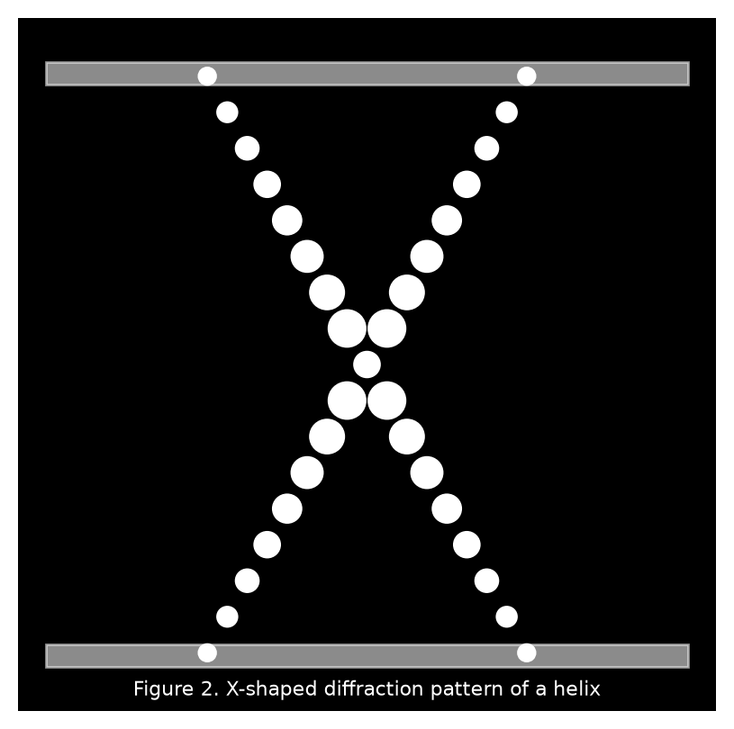
Figure 2. The X-shaped diffraction pattern of a helix.
Franklin was born in London in 1920 into a banking family, went to Cambridge, took a doctorate in physical chemistry on the structure of coal, and spent four years in Paris learning X-ray diffraction from Jacques Mering, who was among the best in the world at applying the technique to things that were not neat crystals. She was thirty when she came to King's in January 1951, on a three-year fellowship, to work on DNA. She was a careful experimentalist and a formidable arguer, and she did not suffer people who guessed.
She also walked into a misunderstanding that poisoned the next two years. Maurice Wilkins, the deputy head of the biophysics unit, had been working on DNA fibres for a year with Gosling and understood that Franklin was joining his project. Franklin, from what she had been told by the unit's director, John Randall, understood that DNA was now her project and that Wilkins would work on something else. Neither of them had been told the same thing. Wilkins returned from a holiday to discover a colleague who treated his DNA work as her own and his advice as interference. Franklin, for her part, had a colleague who kept turning up expecting to be consulted on results she considered hers. They never sorted it out. They barely spoke.
Within a year she had done something no one else had. DNA fibres, she found, took two forms depending on how wet they were. At lower humidity the molecule was shorter and thicker and gave a sharp, crystalline pattern; she called this the A form. At high humidity it lengthened, took up more water, and gave a simpler, blurrier pattern; this was the B form. The two could be turned into each other by changing the moisture in the chamber. Earlier photographs, including the ones that had drawn Watson to the problem, had been muddled superimpositions of the two. Franklin separated them, and by doing so rendered the B form's helical cross visible for the first time. Photo 51 is a B-form picture.
The humidity numbers are the whole distinction, and they are worth having in ordinary units. The A form was stable when the air in the chamber was about three-quarters saturated, and it gave more than a hundred measurable spots, a crystallographer's feast. The B form needed the air nearly saturated, about 92 percent, the damp of a wet room, and it gave the simpler cross. A single fibre could be driven from one form to the other and back by changing only the water, which meant they were two states of one molecule. Franklin measured the B form at about 20 ångströms across, two millionths of a millimetre, and 34 ångströms from one turn to the next. Those are the numbers that stand in the Cambridge model. She had them in 1952, from a fibre thinner than a hair and an exposure that ran past sixty hours because the specimen scattered so little light. Gosling loaded the camera. She had decided the conditions.
She then arrived at a decision that has been argued about ever since. The A form gave the richer data, with many more spots, and Franklin was a crystallographer: she wanted to solve the structure properly, from the spots, by the long mathematical road. She put the B form aside and spent most of 1952 on the A form, which, as it happens, does not show a clean helical pattern, because in the drier state the molecule packs in a way that hides the signature. For a time she doubted whether the A form was helical at all. In July 1952 she and Gosling circulated a mock funeral notice among colleagues announcing the death of the DNA helix. It was a joke, at Wilkins's expense, and it has been used against her judgment ever since. It should not be. Her notebooks show that by the end of the year she had concluded that both forms were helical, with two chains, with the phosphates on the outside, and she had measured the B form's dimensions to within a few percent of the values Watson and Crick would use.
What she had not done, by January 1953, was find the pairing of the bases. Nobody had. And she was not looking for it with cardboard, because she did not build models. She thought the model-builders were guessing, which, until the last week of February, they were.
On Friday 30 January 1953, Watson took the train to London to show Wilkins the Pauling manuscript. He stopped first at Franklin's laboratory, where the conversation went badly; the account in his memoir, in which she is made to seem on the point of striking him, is his and has been doubted by everyone else who was in the building. He then continued to Wilkins's office, where Wilkins, who had by this time been told by Franklin's own student that she was leaving King's in the spring and who regarded the work as reverting to him, opened a drawer and showed Watson Photo 51.
Watson later wrote that his mouth fell open and his pulse began to race. He had seen helical patterns before and knew what the cross meant. On the train back to Cambridge he sketched what he remembered on the margin of a newspaper. It was not much: the cross, the spacing. But it settled, for him and for Crick, that the molecule was a helix, that it was a B-form helix with the thirty-four ångström repeat, and that they should build a two-chain model rather than three.
A second transfer mattered as much and is less known. In December 1952 the Medical Research Council, which funded both laboratories, had sent a committee to King's to review the work. Franklin had written up her results for the visitors in a short report. One of the visitors was Max Perutz, the head of Watson and Crick's unit at the Cavendish. In February 1953 Crick asked Perutz to see the report, and Perutz, who did not regard it as confidential, handed it over. It contained Franklin's measurements, her statement that the phosphates were on the outside, and a detail about the symmetry of the A-form crystal that Crick, who had done his doctoral work on exactly that kind of symmetry, recognised at once as meaning the two chains ran in opposite directions. Franklin had written the symmetry down without seeing what it meant. Crick saw it in minutes. It fed straight into the model.
Franklin was not told about either transfer. She learned that Cambridge had a structure in March, when Wilkins telephoned. She went up to see the model, checked it against her data, and agreed that it was right. Her paper in the 25 April Nature was already drafted before she saw it; she added a sentence saying that her results were consistent with the Cambridge model. The paper describes the B-form pattern, gives the dimensions, and argues, from her own data, for a two-chain helix with the phosphates outside. In a draft dated 17 March, before she knew about the model, she had written most of that already.
* * *
So what was hers? The clean separation of the two forms, and therefore the first clear helical picture. The dimensions. The location of the backbone. The water content that had killed the first Cambridge model. The symmetry observation, though not its interpretation. What was not hers, and would not have been for some time on the road she had chosen, was the base pairing, which is the part that explains inheritance. Aaron Klug, who inherited her notebooks and became her most careful defender, concluded that she was perhaps a few months from the structure and that she would have got there by her own route. He also concluded that she would have got the backbone right before the pairing, and might not have seen the copying mechanism at once. I think that is fair, and I think it does not settle anything, because the question was never whether she would have won the race. It was whether her data should have been used without her being asked, and the answer to that is no.
In the spring of 1953 she left King's for Birkbeck College, a mile away, and was made to promise, as a condition of the move, that she would stop working on DNA. She turned to viruses, and in five years at Birkbeck, with Klug and others, she did work on the structure of tobacco mosaic virus and polio virus that was at least as good as anything she did on DNA. In the autumn of 1956 she learned she had ovarian cancer. She worked between operations. She died on 16 April 1958, aged thirty-seven.
The Nobel Prize for the structure went to Watson, Crick, and Wilkins in 1962. It is awarded only to the living, and to at most three people, so there was no place for her either way. Watson's memoir, published in 1968 over Crick's and Wilkins's objections, gave her a nickname, mocked her clothes and her lack of lipstick, and presented her as an obstacle. He added an epilogue conceding that he had misjudged her. The book sold a great deal, and for a generation it was the story. Since then her notebooks have been read, her letters published, her papers reassessed, and the King's report and its journey to Cambridge documented in detail. She is now more famous than Wilkins, and a building, a university, a Mars rover, and a good many schools carry her name.
The picture is still in a drawer at King's. It is a black square with a white cross in it, and it is the reason the model in Cambridge was a helix with two chains and not something else.

3. What the Shape Explains
Take the model apart in your head. Unwind the helix until it is flat, a ladder lying on a table. The two uprights are the backbones, each a chain of sugar and phosphate, sugar and phosphate, repeating every 3.4 ångströms. The rungs are the base pairs. Every rung is built from two bases, one bolted to each upright, meeting in the middle and held there by hydrogen bonds. There are only four kinds of base and therefore, by the rule Watson found on his desk, only two kinds of rung: A with T, and G with C. Look along the ladder and read the left-hand upright: A, G, G, T, C, A. Now cover it and read the right: T, C, C, A, G, T. You did not need to look. Each side dictates the other.
That is the whole of the copying mechanism, and it is worth being slow about how much it explains, because in 1953 nearly everything about heredity was a mystery and this one shape swept away a surprising number of those mysteries at once.
Start with Chargaff. Between 1949 and 1951 Erwin Chargaff and his students at Columbia had taken DNA from yeast, from calf thymus, from bacteria, from human sperm, and had measured, with a precision no one had bothered with before, how much of each base it contained. The older textbook view, going back to Phoebus Levene in the 1920s, was that the four bases occurred in equal amounts and repeated in a fixed order, which would make DNA a monotonous polymer, like nylon, incapable of spelling anything. Chargaff's numbers said this was wrong. The proportions varied from species to species: human DNA was about 30 percent adenine, a bacterium might be 25 or 35. So the molecule was not monotonous. But underneath the variation was a regularity he could not explain and did not try to. In every sample, adenine and thymine came out equal, and guanine and cytosine matched just as closely, to within the error of the measurement.
He published the rule in 1950 and told anyone who would listen. Few did, because a rule without a reason looks like a coincidence. The model gave the reason in a single glance. If every A on one strand is bonded to a T on the other, then counting the As counts the Ts. The same for G and C. Chargaff's regularity is not a property of the chemistry of the bases. It is a property of the ladder.
The pairs are not interchangeable, and the reason is geometry. Adenine and guanine are large bases with two rings; thymine and cytosine are small, with one. A large paired with a large would be too wide for the helix; two smalls would be too narrow and would not reach across. Only a large with a small fits the twenty-ångström width. That still leaves two large-small combinations, A with C and G with T, and those are ruled out by the hydrogen bonds. A hydrogen bond needs a hydrogen atom on one side, attached to a nitrogen or an oxygen, pointing at a nitrogen or oxygen on the other side with a spare pair of electrons. Adenine and thymine, in their common forms, present two such matched pairs across the gap. Guanine and cytosine present three. A facing C, or G facing T, lines up donors against donors and acceptors against acceptors, and the pair does not hold. So the rule is not a convention. It is the only arrangement that fits.
The three bonds of a G–C pair against the two of an A–T pair have a consequence you can feel with a thermometer. Heat a solution of DNA and, at some temperature between about 70 and 95 degrees Celsius, the strands come apart, a process biochemists call melting. DNA rich in G and C melts at a higher temperature than DNA rich in A and T, because it has more bonds per rung to break. Organisms that live in hot springs tend, for that reason among others, to run G–C-rich. This was measured in the years after 1953 and was one of the first quantitative tests the model passed.
Now the two backbones. Crick's insight from Franklin's symmetry data was that they ran in opposite directions. Each sugar in the chain has its carbon atoms numbered, and the phosphate links the carbon numbered 3 on one sugar to the carbon numbered 5 on the next, so that the chain has a direction, like a row of arrows. One strand runs 5-to-3 up the page; its partner runs 5-to-3 down the page. Biologists say the strands are antiparallel. It sounds like a detail and it turned out to be an enormous nuisance, because the enzyme that copies DNA can only work in one direction along a strand, and so the two strands have to be copied by two different tricks. That story belongs to chapter 7. For now the point is that the model predicted the nuisance before anyone had found the enzyme.
The twist has consequences too. Because the two backbones are not evenly spaced around the axis, the helix has two grooves running along it, one wide and deep, the major groove, and one narrow, the minor groove. In the major groove the edges of the base pairs are exposed, and the pattern of atoms along the edge differs for each of the four possible rungs. A protein that fits into the major groove can therefore read the sequence without opening the helix, by touch, the way a finger reads Braille. This is how the regulators of genes find their addresses, and it was implicit in the model long before anyone had identified a regulator.
The dimensions themselves were confirmed and then refined. Watson and Crick had ten base pairs per turn from Franklin's photograph; later work with DNA in solution gave about 10.5. Their 3.4 ångström rise per base pair has held. So has the diameter. The B form they modelled is the form that exists in a living cell, because a living cell is wet. The A form, which Franklin spent 1952 on, is what DNA becomes when it dries, and turns up in life mainly in stretches where DNA is paired with RNA.
* * *
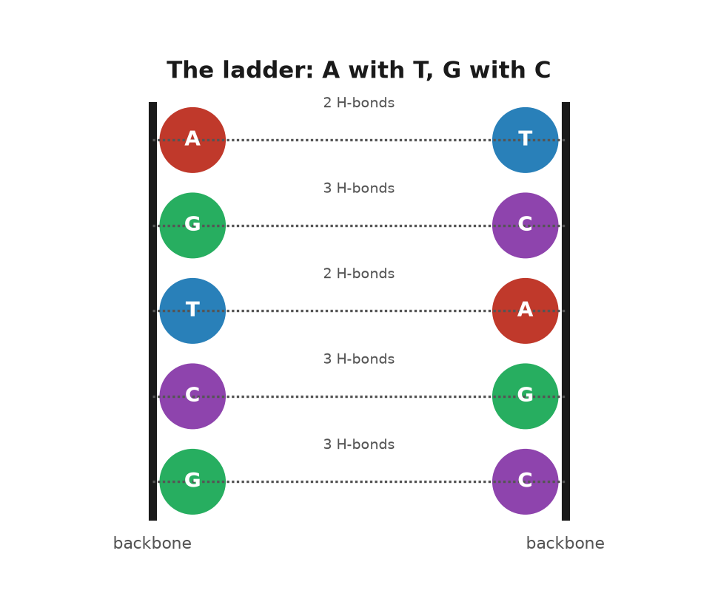
Figure 3. The ladder: A with T, G with C.
A shape that explains inheritance ought to make predictions, and the first big one was about how the copy is made. The paper of 30 May 1953 said it: unwind the helix, use each old strand as a template, assemble a new partner on each. The result is two helices, each with one old strand and one new. Chemists called this semiconservative, because each daughter keeps half of the parent. There were two rival ideas. In the conservative scheme, the parent helix stays intact and a completely new one is built beside it. In the dispersive scheme, the parent is chopped and the pieces scattered between the daughters. The three schemes give distinct answers to a simple question: after one round of copying, is there any helix left that is composed entirely of old material? Semiconservative says no, every helix is half and half. Conservative says yes, one of the two. Dispersive says every strand is a patchwork.
Matthew Meselson and Franklin Stahl settled it in 1958 at Caltech, in an experiment so clean it is still taught as the model of what an experiment should be. They grew bacteria for many generations in a broth in which all the nitrogen was the heavy isotope nitrogen-15, so that every base in every DNA molecule was heavy. Then they switched the bacteria to ordinary nitrogen-14 and let them divide once. DNA can be sorted by weight in a spinning tube of caesium chloride solution, where heavy molecules settle into a band lower than light ones. After one division, all the DNA sat at a single band exactly halfway between heavy and light. No fully heavy helix survived, so the conservative scheme was dead. After a second division there were two bands, one halfway and one light, in equal amounts, which is what you get if each half-and-half helix is pulled apart and each old strand gets a new light partner. The dispersive scheme, which would have given a single band drifting gradually lighter, was dead too. The paper appeared in the Proceedings of the National Academy of Sciences in July 1958, five years after the shape. It has been praised ever since as the most beautiful experiment in biology, and the shape had told it what to look for.
The second prediction was about information. If the order of the bases is the message, the message must somehow specify proteins, which are chains of twenty different amino acids and which do almost all the work in a cell. Four letters have to spell twenty words. Crick thought about this more clearly than anyone. In a talk in 1957, published in 1958, he laid out what he called the sequence hypothesis and what he labelled, with a straight face, the central dogma. The sequence hypothesis said that the order of bases in a stretch of DNA determines the order of amino acids in a protein, and nothing else does. The central dogma said that information flows from DNA to RNA to protein and not backwards: a protein cannot rewrite the DNA that made it. He chose the word dogma, he admitted later, because he thought it meant a bold idea with no evidence, and did not know it meant a belief that cannot be questioned. The name stuck anyway.
The dogma has been dented. In 1970 Howard Temin and David Baltimore identified viruses that copy RNA into DNA, running the arrow in reverse, which is how HIV inserts itself into the human text. But no one has ever caught a protein writing its own sequence back into a gene, and that was the claim Crick cared about. It is why acquired characteristics are not inherited. A blacksmith's arms do not alter his sperm. The arrow points one way.
The third prediction was almost an aside, and it is the one this book is named for. In the same May paper Watson and Crick pointed out that each base can, rarely, shift a hydrogen atom to a new position, taking on what chemists call a tautomeric form. In that form its pattern of donors and acceptors changes, and it can pair with the wrong partner. If the shift happens at the moment a strand is being copied, the wrong letter goes into the new strand and, on the next copy, is faithfully paired and fixed. They suggested that this might be one way spontaneous mutations arise. It was a guess, and a good one, and how good is still being argued in physics journals seventy years later. Chapter 10 returns to it.
* * *
Watson presented the model at the Cold Spring Harbor Symposium on Long Island in June 1953, a few weeks after the paper. The audience was the American geneticists and phage biologists who would spend the next decade turning the shape into a science. Some were sceptical. Max Delbrück, Watson's own mentor, had been sceptical since the spring and had worried in letters about how a helix with two chains wound around each other could ever be unwound for copying without tangling; twisted that tightly over such a distance, it would have to spin like a propeller. He was right that this was a problem and wrong that it was fatal. Cells solve it with enzymes known as topoisomerases, that cut a strand, let it swivel, and rejoin it, and those were identified in the 1970s.
By the end of 1953 the shape was accepted by almost everyone who mattered. It was the right width, it fitted Franklin's photographs, it obeyed Chargaff, it copied itself on paper, and it told a dozen people what experiment to do next. Bragg, who had been made to look slow by Pauling two years before, wrote the introduction to the Cambridge papers and took a good deal of pleasure in the fact that the answer had come from his laboratory. Franklin's paper with Gosling sat in the same issue of Nature. King's had the measurements. Cambridge had the pairing.
What none of that explained was why anyone had doubted, for thirty years, that DNA was the substance of heredity at all. That doubt has its own history, and it begins with a Swiss doctor and a pile of used bandages.

4. The Race Before the Race
In the winter of 1868 a twenty-four-year-old Swiss physician named Friedrich Miescher arrived in Tübingen to work in the laboratory of Felix Hoppe-Seyler, one of the founders of what would come to be known as biochemistry. Hoppe-Seyler's laboratory was in the kitchen of the old castle, which was a fair location, because the work was mostly boiling things. Miescher wanted to know what cells were composed of, and he needed cells. The surgical clinic down the hill supplied him with bandages from wounds that had gone septic. The pus on them was rich in white blood cells, and white blood cells have large nuclei.
He washed the cells off the bandages with salt solution, dissolved away their outer membranes with a weak alkali, and was left with nuclei. From those he extracted a substance that was not a protein: it resisted the enzymes that digest proteins, it was acidic, and it contained a great deal of phosphorus, which no protein did. He called it nuclein. He had, in 1869, isolated DNA, though he did not know what it was for, and his paper was held up by Hoppe-Seyler, who repeated the work himself before letting it appear in 1871.
Miescher later moved to Basel and discovered that salmon sperm was a much better source of nuclein than pus, which was an improvement in every respect. He speculated, cautiously, that the substance might be involved in fertilisation. He did not suggest it carried heredity, and neither did anyone else for a long time.
By the 1920s the ingredients were known. Albrecht Kossel in Germany had identified the four bases and won a Nobel Prize for it in 1910. Phoebus Levene at the Rockefeller Institute in New York had worked out that each base was attached to a sugar and a phosphate to make a unit he termed a nucleotide, and that nucleotides were strung together in a chain. Levene also identified the sugar, deoxyribose, in 1929, which gave the substance its modern name.
Levene then did something that held the field back for twenty years. He proposed that the four nucleotides occurred in equal amounts and repeated in the same order, a tetranucleotide, over and over. The evidence was thin: the bases seemed roughly equal in the impure samples of the day, and the methods for measuring the length of the chains were so crude that DNA looked like a small molecule. But the idea was tidy and Levene was eminent, and it became the textbook view. Under it, DNA could not carry information for the same reason a fence cannot carry a message: every picket is the same. The pickets were not, in fact, the same. The measurements that seemed to show equal amounts of the four bases were too crude to see the differences, and a chain that looks short because your ruler cannot reach the end will look like a small molecule. Chargaff's later measurements killed the equality. Until then the fence was the textbook, and a textbook is hard to argue with when the man who wrote the underlying chemistry is the authority in the room.
If DNA was a fence, then heredity had to live in the proteins, and there was a great deal going for proteins. They were made of twenty different amino acids, which gave them an alphabet. They came in thousands of distinct kinds. They folded into elaborate shapes. They did the visible work of the cell, as enzymes, as muscle, as the pigment in blood. Chromosomes, which everyone agreed carried the genes, were known to contain both protein and DNA, and the sensible bet was that the protein was the message and the DNA was the scaffolding. The physicist Max Delbrück, Watson's mentor in the phage group, had a phrase for the general view. Evelyn Witkin, who heard it as a student, later recalled him calling DNA a stupid molecule, too simple, on the tetranucleotide story, to be a gene. The recollection is hers, published in a 2012 interview in PLOS Genetics, not a sentence from a paper of his.
* * *
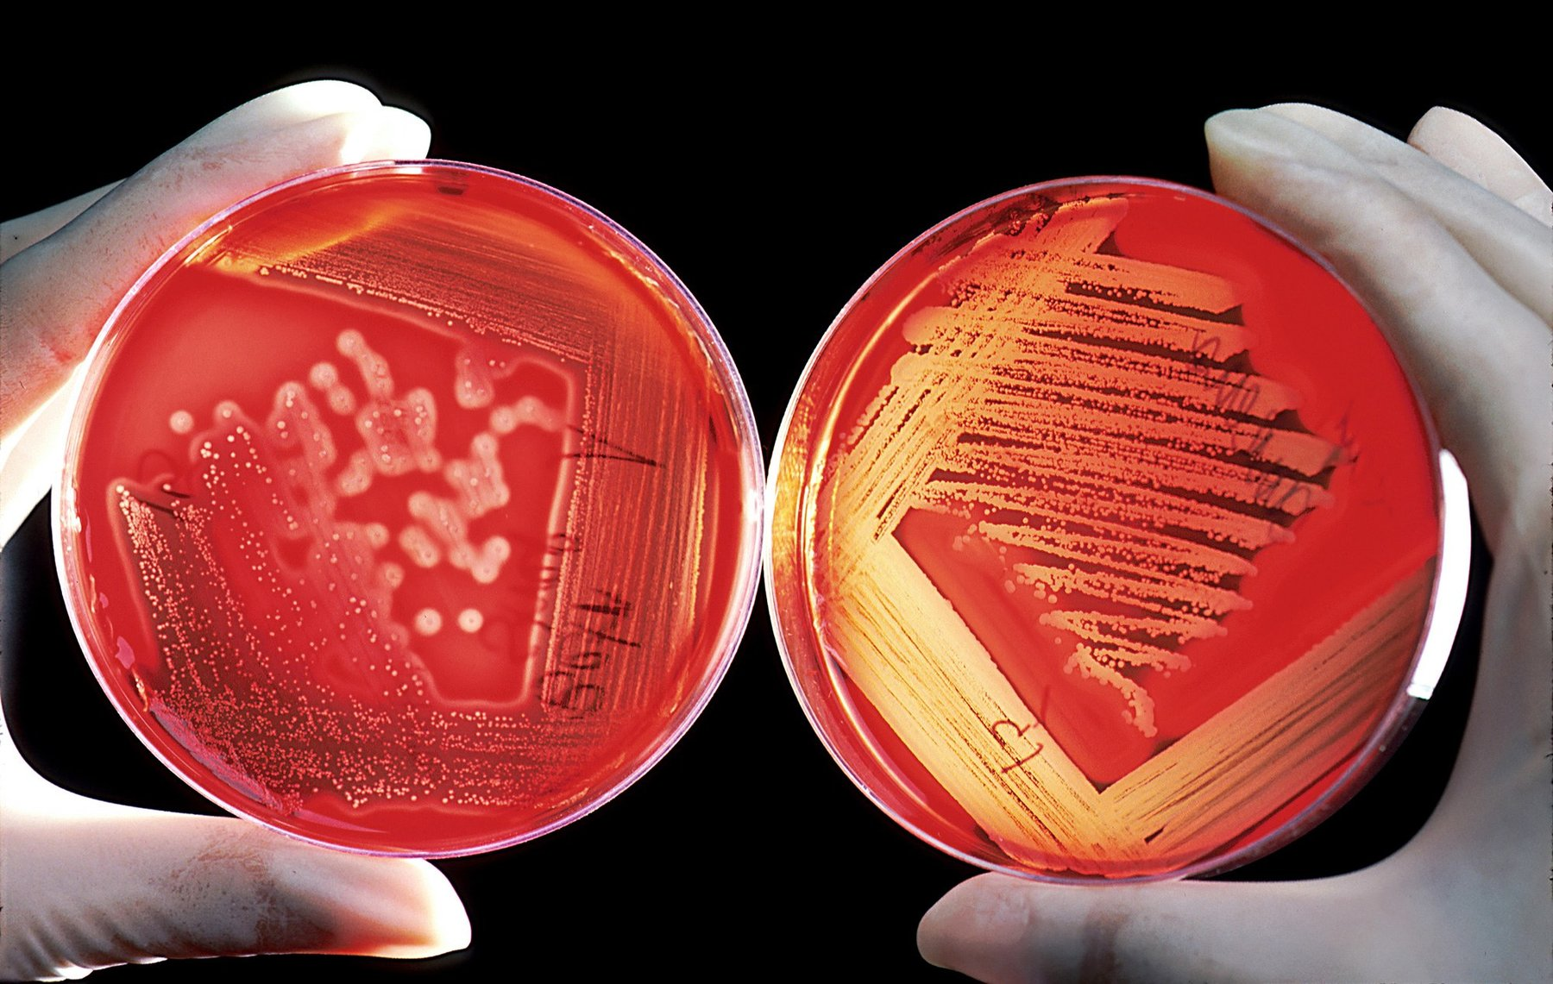
Figure 4. Colonies of bacteria on a plate, each mound grown from a single cell.
The evidence that overturned this arrived in three instalments, each of which was ignored more than it deserved.
The first was an accident of public health. In 1928 Frederick Griffith, a bacteriologist at the British Ministry of Health, was studying the bacterium that causes pneumonia, Streptococcus pneumoniae, which comes in two forms. One has a smooth coat of sugar and kills mice; the other, lacking the coat, is rough under the microscope and harmless. Griffith killed smooth bacteria with heat and injected them into mice, which lived. He injected live rough bacteria, and the mice lived. Then he injected both together, heat-killed smooth and live rough, and the mice died, and from their blood he recovered live smooth bacteria. Something in the dead cells had passed into the living ones and changed them, permanently and heritably. He called it the transforming principle and did not know what it was. He was killed in an air raid on London in 1941, still not knowing.
Griffith was not hunting for the molecule of heredity. He was sorting outbreaks, so that one wave of pneumonia could be told from the one before it. The sugar coat comes in types a serum can tell apart. What passed into the living cells was the ability to build one particular type, and the ability bred true. A daughter cell made the dead cell's kind of coat. In 1928 almost nobody was willing to use the word inheritance for a bacterium. It was inheritance all the same.
The second instalment took sixteen years. At the Rockefeller Institute, Oswald Avery, a quiet Canadian-born physician in his sixties who had spent his career on pneumococcus, set out with Colin MacLeod and Maclyn McCarty to purify the transforming principle. It took most of a decade. They grew the smooth bacteria by the vat, broke them open, and removed one class of substance after another, testing after each step whether what remained could still transform rough cells into smooth. They took out the sugar coat; the extract still worked. They digested the proteins with enzymes; it still worked. They removed the lipids and the RNA; still. What was left was a fibrous white material that formed threads when alcohol was added, contained phosphorus in the right proportion, and was destroyed by the one enzyme that specifically breaks down DNA. Their paper appeared in the Journal of Experimental Medicine in February 1944. It concluded, with the caution of people who knew what they were claiming, that the transforming substance was a nucleic acid of the deoxyribose type.
The reception was muted. Avery was a bacteriologist publishing in a medical journal, and the geneticists did not all read it. Those who did had objections. Perhaps a trace of protein, too small to detect, was the real agent. Perhaps transformation was a peculiarity of pneumococcus. Alfred Mirsky, a colleague at the same institute, argued for years that Avery's preparations were contaminated. Avery was nominated for a Nobel Prize repeatedly and never got one; the committee's own records, opened later, show that the doubts about purity were taken seriously in Stockholm. He retired in 1948 and died in 1955, two years after the shape.
In May 1943, with the paper still unpublished, Avery wrote to his brother Roy, also a bacteriologist. The transforming material matched a nucleic acid. Nobody had expected that. It behaved as if it might be a gene. The letter was private. The paper, when it came, was more guarded.
He had a reason to guard it. If DNA were only Levene's repeating four-letter block, the white fibres could spell nothing. A trace of protein stuck to them would still be the real agent. That objection was fair until someone showed the bases could stand in any order. Chargaff's measurements, still a few years off, would do it. Until then a sceptic had a door.
The third instalment was built to answer that objection. In 1952, at Cold Spring Harbor, Alfred Hershey and Martha Chase used a virus that infects bacteria. They named it T2. A bacteriophage, the word for this kind of virus, is little more than a protein coat around a core of DNA. It lands on a bacterium and injects something. Twenty minutes later the bacterium bursts and releases about a hundred new viruses. Whatever was injected had to be the instructions.
The two materials can be marked apart, because their chemistry differs. Protein contains sulfur, in the amino acids cysteine and methionine, and DNA contains none. DNA contains phosphorus in every link of its backbone, and protein contains almost none. Grow the virus in radioactive sulfur and only the coat glows. Grow it in radioactive phosphorus and only the core does.
They let each batch infect bacteria, then stripped the empty coats off with a Waring blender, the same countertop machine a kitchen used for drinks. A spin sank the heavy bacteria and left the light coats in the liquid. In the 1952 paper the blender knocked about three-quarters of the sulfur off the cells, and only about fifteen percent of the phosphorus. The new viruses carried thirty percent or more of the parental phosphorus, and less than one percent of the parental sulfur. The coat had stayed outside. The core had gone in and done the building.
The separation was not clean. A sceptic could still mutter about a trace of protein. It was done, though, on the virus the most influential group of geneticists in America already studied, by one of their own, in the journal they read. It convinced the people Avery had not. Watson arrived in Cambridge that autumn certain that DNA was the thing to solve.
* * *
There is a fourth thread, and it runs through the physics rather than the biology. In 1938 William Astbury in Leeds, who had spent the decade taking X-ray photographs of wool and hair, put a fibre of DNA in front of his beam and got a pattern. It was blurry, but it showed a strong repeat at 3.4 ångströms along the fibre, which he read, correctly, as flat bases stacked one on top of another like a pile of pennies. He built a model that was wrong in most other respects. In 1951 his student Elwyn Beighton took photographs that, seen now, plainly show the helical cross of the B form. Astbury did not publish them. He did not see what they meant.
Chargaff's rule, from 1950, was the last piece, and Chargaff himself is the strangest figure in the story, because he had the evidence and hated the conclusion. He had begun measuring the bases because he read Avery's paper and believed it, at a time when few did. His measurements killed the tetranucleotide idea and gave the model-builders their pairing rule. When he met Watson and Crick in Cambridge in the summer of 1952, he found two men who could not, in his telling, remember the chemical difference between the bases, and he was appalled that such people should be building models of his molecule. After 1953 he spent the rest of a full career saying that the double helix had been a lucky guess by amateurs and that molecular biology was the practice of biochemistry without a licence. He was not entirely wrong about the luck. He was entirely wrong about what it meant.
Why did it take from 1869 to 1952 for the obvious to become accepted? Partly because the obvious was not obvious: a molecule with four ingredients looked too simple to spell out a human being, and until Chargaff nobody knew the ingredients came in variable proportions. Partly because the evidence arrived from the wrong people in the wrong journals. Miescher was a physiologist, Avery a medical bacteriologist, Astbury a textile physicist, Chargaff a chemist who disliked biologists. The people who owned the question of heredity were geneticists, and they worked with flies and corn and did not, for the most part, care what a gene was made of as long as it behaved. And partly because the matter could not be settled by any amount of purification. Avery could show that DNA carried the message. He could not show how, and until someone showed how, a sceptic could always imagine a hidden protein.
The shape did what the purifications could not. It showed that a molecule built from four ingredients could carry any message at all, provided the ingredients could come in any order, and it showed how the message could be copied. After April 1953 there was nothing left for the protein to do. The Cambridge model was in Nature that month. So were the two King's papers, Wilkins and colleagues, Franklin and Gosling. Three papers, one issue, one shape.
Ruth was five that spring. Nobody told her, and it did not matter, because the molecule had been copying itself in her since 1948 without waiting for anyone to name the mechanism. What it was copying, and what the letters themselves consisted of, is the subject of the next part.

PART II — The Molecule

5. Four Letters
One parental set of the instruction book that built a person runs to about 3.1 billion letters, and if that one set were printed in ordinary type, ten letters to the centimetre and no spaces, it would fill about a thousand volumes the size of a telephone directory. Each cell stores two such sets, about 6.2 billion letters, in a sphere about six thousandths of a millimetre across, roughly a tenth the width of a human hair. The sphere is the nucleus. A body has tens of trillions of them, give or take, and the packing problem alone would defeat any engineer who tried to do it with wire.
The first job of this chapter is to say what the letters are. The second is to say how they are packed.
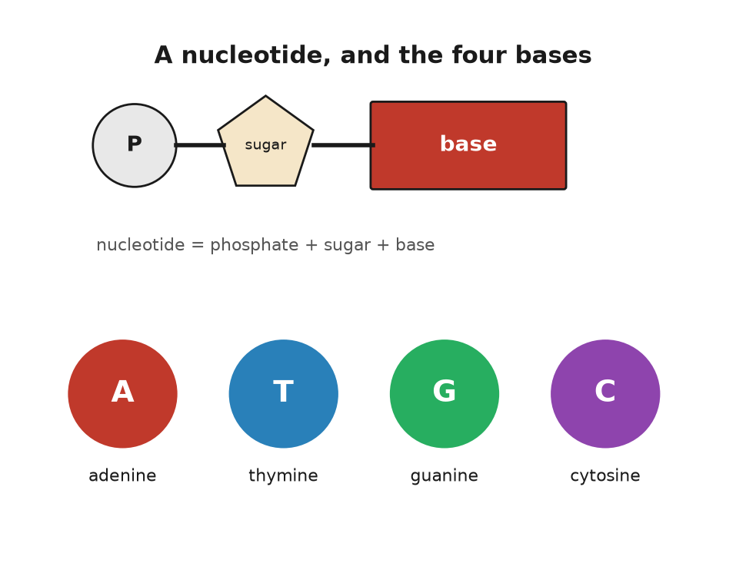
Figure 5. A nucleotide, and the four bases.
A letter of DNA is a nucleotide, and a nucleotide is three things bolted together. The first is a sugar, deoxyribose, a ring of four carbon atoms and one oxygen with a fifth carbon sticking off the side. The second is a phosphate group, a phosphorus atom holding four oxygens, which is attached to that fifth carbon. The third is the base, a flat ring or double ring of carbon and nitrogen atoms, attached to the first carbon of the sugar on the opposite side. The sugar and the phosphate are the same in every nucleotide. Only the base differs, and it differs in four ways.
Adenine and guanine are the large ones, built of two fused rings, and chemists call them purines. Thymine and cytosine are the small ones, a single ring, and are called pyrimidines. All four are flat, like coins, and all four are slightly greasy on their faces and wet at their edges, which is why they stack face to face down the middle of the helix and hold hands with their partners at the sides. The names have histories. Adenine was first isolated from pancreas, and the Greek for gland is aden. Guanine came from guano, the bird droppings mined off the coast of Peru for fertiliser. Thymine takes its name from the thymus, cytosine from cells generally. Nobody planned the alphabet.
Nucleotides join by their sugars and phosphates. The phosphate on the fifth carbon of one sugar bonds to the third carbon of the next, and so on, so that the backbone is an alternation of sugar, phosphate, sugar, phosphate, with a base hanging off every sugar like a flag off a pole. That alternation is a strand. Two strands, running in opposite directions with their flags meeting in the middle, are the helix.
The letters are read in only one direction along a strand, from the free phosphate at the five-prime end toward the free sugar at the three-prime end, which is a convention the way reading left to right is a convention, except that here the chemistry enforces it. When a sequence is written down, as in the HBB gene's opening letters, ATGGTGCACCTGACTCCTGAG, it is written five-prime to three-prime unless someone says otherwise.
There is a cousin molecule, ribonucleic acid, RNA for short, that will matter a great deal from chapter 8 onward, and its differences are minor enough to list. Its sugar is ribose, which has one more oxygen atom than deoxyribose; that oxygen makes RNA easier to break, which is why RNA is used for messages and DNA for the archive. And it uses uracil in place of thymine, a base that differs from thymine by one missing methyl group. RNA is usually a single strand, but it can fold back on itself and pair up internally, and a good deal of the machinery of the cell is built from RNA folded into shapes.
* * *
How many letters? In 2022 a group led by Sergey Nurk finished the job the earlier drafts had left, the repetitive stretches at the ends and the middles, and published the assembly in Science. They called it T2T-CHM13. The nuclear chromosomes in it come to 3,054,815,472 base pairs. There is no Y in that cell line, only an X and the twenty-two other chromosomes, the autosomes. Add the mitochondrial genome, a small circle of 16,569 letters outside the nucleus that comes from the mother, and one parental set is 3,054,832,041 base pairs. Everyone rounds that to 3.1 billion. That is the thousand directories from the opening of this chapter.
A nucleus holds two sets, about 6.2 billion base pairs. The Y chromosome, finished in 2023, is about 62 million letters. A boy and a girl differ by tens of millions of letters and still both sit near 6.2 billion. The rungs in a single nucleus outnumber the people on Earth.
The letters are not one continuous strand. They are divided among chromosomes, and a human cell has forty-six of them, in twenty-three pairs. In the same 2022 assembly, chromosome 1 is the longest, about 248 million base pairs. The smallest autosome, chromosome 21, has about 45 million. No chromosome is the whole 3.1 billion. The X carries about 154 million and the Y about 62 million, of which a large fraction is repetitive filler. Each chromosome is one enormous double helix, so the longest single DNA molecule in a cell of the right kind is about eight centimetres long.
Multiply out and the total DNA in one nucleus comes to a little over two metres. Two metres is a doorway. The compartment it has to fit is far smaller than the full stop at the end of this sentence.
Multiply by the cells in a body and the thread becomes a distance. Eva Bianconi and colleagues, in 2013, counted about thirty-seven trillion human cells. Later tallies have come in nearer thirty trillion. Either way, a body contains tens of billions of kilometres of double helix. Numbers like that are the reason biology books reach for the solar system. It is enough to go to Neptune and return several times, and every centimetre of it is two nanometres wide, a nanometre being ten ångströms, the impossibly tiny unit introduced in chapter 1.
Two metres into six microns is a compaction of about ten thousand to one in linear terms, and it is achieved in stages, with proteins.
The first stage is the nucleosome. The helix winds itself, about one and two-thirds turns, around a spool made of eight histone proteins, two each of four kinds, and the wound stretch runs 147 base pairs. Then there is a short linker, twenty to eighty base pairs, and another spool. Under the electron microscope the result looks like beads on a string, and that phrase is the standard description. The histones are positively charged, because they are rich in the amino acids lysine and arginine, and DNA is negatively charged, because every phosphate carries a charge, so the winding is partly electrostatic. It is also adjustable. Chemical tags added to the histone tails loosen or tighten the winding, and that is one of the ways a cell turns genes on and off without touching the letters, a subject that comes back in chapter 9.
The second stage is that the beaded string coils into a thicker fibre, about thirty nanometres across, whose exact geometry was argued about for forty years and is now thought to be less regular than the textbooks drew it. The third stage is loops. The fibre is gathered into loops of tens to hundreds of thousands of base pairs, pinned at their bases by ring-shaped proteins, and the loops are the working units: a gene and its switches usually sit in one loop, kept away from the neighbours. The fourth stage, which only happens when a cell is about to divide, is the full condensation into the fat X-shaped chromosomes of the school textbook. Those exist for perhaps an hour per division. For the rest of a cell's life the chromosomes are diffuse, each occupying its own territory in the nucleus, like countries on a map without borders.
The result is a nucleus with two metres of thread and no knot. Any stretch the cell needs can be reached in seconds. The whole text can be copied, unpacked, repacked, and split in two, in a few hours.
None of this packing is visible. What is visible is the skin of a hand, the freckles, a scrape that is already closing. The closing is cells dividing. Each division copies the text, checks it, and winds it onto the spools again. The scrape closes in a week. Nobody watches the packing. It happens anyway.
* * *
One last point about the letters, and it is the one people most often get wrong. The text is the same in every cell, but it is not used the same way. The cell in a cheek that ended up in a spit tube and the cell in a retina that is reading this page carry the same 6.2 billion base pairs. What differs is which stretches are unpacked and read. The cheek cell has its keratin genes open and its rhodopsin genes shut; the retinal cell has the opposite. This is not because the letters differ but because the packing differs. Same book, different pages dog-eared.
There are exceptions to the sameness. Red blood cells throw away their nucleus entirely and carry no DNA at all. Egg and sperm cells carry one set, not two. And every cell accumulates its own private errors, so that two cells from the same cheek, sequenced deeply enough, would differ at a few hundred positions. But the general picture holds. A human being is a colony of tens of trillions of cells that share a text and specialise by reading particular parts of it.
There is a human-scale way to feel the speed. The copying enzyme of the next chapter adds about fifty letters a second on one stretch. Reading one nucleus aloud, one letter a second, would take nearly two hundred years. The cell finishes in a few hours, because it starts the copy in thousands of places at once.
The letters are chemistry. What holds them together, what pulls them apart, and what they are for once read, is chemistry too, and that is the next chapter.

6. The Chemistry Under the Letters
A single human cell is running something like ten thousand distinct chemical reactions at the same time, in a volume smaller than a speck of flour, at a temperature of 37 degrees, in salt water. Most of those reactions, left to themselves at that temperature, would take years or centuries. They take milliseconds because the cell has catalysts, helpers that speed up a reaction without being used up by it, and the catalysts are the proteins that DNA specifies. The molecule of chapter 5 is an archive. This chapter is about what the archive is an archive of.
It is the one chapter in the book that is mostly chemistry. A reader who last saw a chemical formula at school can take it slowly. There is nothing here that a kitchen does not also do.
Begin with the bonds, because there are two kinds and the difference runs through everything.
A covalent bond is two atoms sharing a pair of electrons. It is strong, in the sense that breaking one at body temperature takes energy the cell must supply on purpose. The backbone of DNA is covalent: the sugars and phosphates are joined by phosphodiester bonds, and a strand does not fall apart in warm water. It takes an enzyme to cut it. The 3.1 billion letters of one parental set are not one chain but twenty-three. Chromosome 1, the longest, is about 248 million letters, and chromosome 21, the shortest, about 47 million. Each of those chains stays in order for a lifetime because covalent bonds hold it.
A hydrogen bond is weaker by about a factor of twenty. It forms when a hydrogen atom that is already attached to an oxygen or a nitrogen is attracted to a second oxygen or nitrogen nearby. The hydrogen is slightly positive, the second atom slightly negative, and they lean toward each other without sharing electrons. The rungs of the ladder are hydrogen bonds, two per A–T pair and three per G–C pair. Individually each is feeble, and a single pair would separate spontaneously in a fraction of a second. Collectively, over a stretch of a few dozen base pairs, they hold. The strands can nevertheless be unzipped, by heating to around 90 degrees, or, in the cell, by an enzyme that walks along the helix prising the rungs apart as it goes.
This is the design principle, and it is worth stating because it is not obvious: the information is held by weak bonds, so that it can be read, and the order of the letters is held by strong bonds, so that it cannot be scrambled. Water is the medium that makes both possible. Water molecules are themselves hydrogen-bonded to each other, which gives water its high boiling point and its reluctance to let greasy things dissolve in it. The bases are greasy on their faces. They hide from water by stacking on top of each other, and that stacking, as much as the hydrogen bonds, keeps the helix together.
Now proteins, because they are what the letters are for.
A protein is a chain of amino acids. An amino acid is a small molecule with an amino group at one end, a carboxylic acid group at the other, and a side chain in the middle, and there are twenty kinds in the standard set, distinguished only by the side chain. Glycine's side chain is a single hydrogen atom. Tryptophan's is a double ring. Some side chains are greasy and hide from water; some carry a charge and seek it; two, cysteine and methionine, contain sulfur; one, proline, kinks the chain. The amino group of one amino acid can bond covalently to the carboxyl group of the next, releasing a water molecule, and the link is called a peptide bond. A chain of a few amino acids is a peptide; a chain of fifty or more is a protein. Human proteins run from about fifty amino acids to over thirty thousand, the record being titin, the molecular spring that holds muscle fibres together and gives a stretched muscle its pull back.
Here is the fact that turns a chain into a machine. A protein does not stay a chain. Within seconds of being made, it folds, and the fold is determined by the sequence. Greasy side chains cluster inward, away from water; charged ones face out; hydrogen bonds form along the backbone into spirals and pleated sheets; here and there two cysteines bond across the fold and lock it. The result is a compact object with a definite shape, and the shape is the function. A protein that binds oxygen has a pocket the size of an oxygen molecule. A protein that cuts DNA has a groove the width of a double helix. Change one amino acid in the wrong place and the pocket closes, or the groove warps, and the machine stops.
That sequence alone determines the fold was shown by Christian Anfinsen at the National Institutes of Health around 1961. He took a compact enzyme, ribonuclease, a chain of 124 amino acids pinned into shape by four sulfur bridges, and unfolded it completely: a concentrated solution of urea pulled the chain loose, and a second chemical broke the bridges. The enzyme stopped working. Then he removed the chemicals slowly and let air back in. The chain refolded itself, without help, into the same working shape, remade the same four bridges out of the 105 possible ways of pairing its eight cysteines, and its activity came back almost entirely. Anfinsen concluded that the information for the shape was in the sequence, and nowhere else, and shared the Nobel Prize in Chemistry in 1972 for it. The idea has limits; many larger proteins need helpers, known as chaperones, to fold correctly in the crowded cell, and some, like the prion, a misfolded protein behind mad cow disease, can fold two ways. But as a principle it holds, and it is why a text of four letters can specify a machine: the text specifies the sequence, the sequence specifies the fold, and the fold does the work. Predicting the fold from the sequence by computation took sixty years and is part of the story of chapter 27.
Most proteins that do chemical work are enzymes, and an enzyme is a catalyst: a molecule that speeds up a reaction without being consumed by it. The speed-ups are not modest. A reaction that would take a year on its own can be compressed into a millisecond, which is a factor of thirty billion, and some enzymes do better than that. The trick is the shape. The reacting molecules are held in a pocket, the active site, in exactly the orientation that makes the reaction easy, with charged side chains positioned to pull electrons where they need to go. Emil Fischer, in 1894, called it a lock and key. Daniel Koshland, in 1958, pointed out that the lock changes shape as the key goes in, and termed that induced fit. Both pictures are used.
An enzyme is named for what it does, with the suffix -ase. Lactase breaks down lactose, the sugar in milk. Ruth has never been able to drink a glass of milk without regret, because the gene that keeps lactase switched on into adulthood is switched off in her; her ancestors, on her father's side, came from a region where nobody kept dairy cattle. Anna inherited persistence from her father and can drink it; Theo has Anna's copy. The variant is a single letter change, not in the lactase gene itself, LCT, but in a switch about fourteen thousand base pairs upstream, in a neighbouring stretch called MCM6, and it arose in Europe perhaps seven thousand years ago and spread because people who carried it could digest a food the others could not. It is the cleanest example in the human text of a mutation that was useful, and it is a chemistry story: one letter, one switch, one enzyme, one glass of milk.
* * *
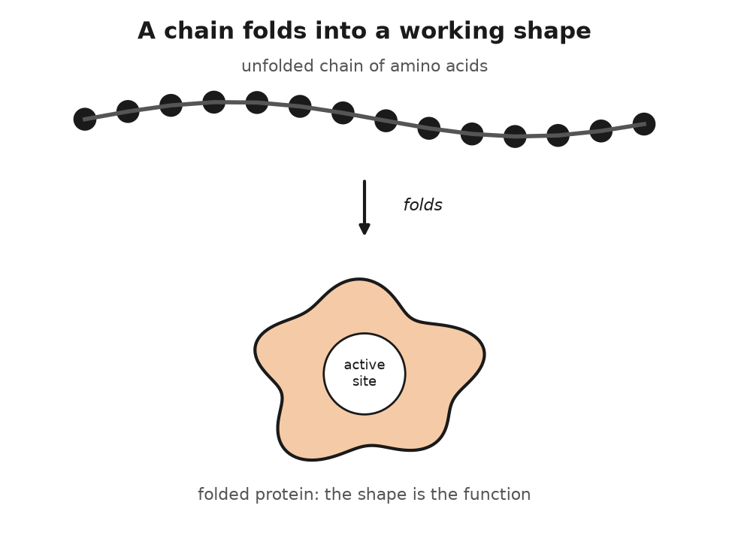
Figure 6. A chain of amino acids folds into a working shape.
Enzymes need energy to run uphill reactions, and the cell's energy is carried by one molecule, adenosine triphosphate, ATP. It is a nucleotide, in fact the very adenine nucleotide of chapter 5, with two extra phosphates bolted onto its tail. Those phosphates are held by bonds that release a good deal of energy when broken, and the cell breaks them, one at a time, to pay for almost everything it does: contracting muscle, pumping ions, building proteins, copying DNA. Every letter added to a new strand of DNA arrives as a triphosphate and pays for its own attachment by shedding two of its phosphates. The spent molecule, ADP, adenosine diphosphate, is recharged, mostly in the mitochondria, the bean-shaped compartments that fill most cells by the hundred. The turnover is hard to believe. A resting adult recycles roughly their own body weight in ATP every day, sixty or seventy kilograms of it, and the total amount present at any moment is about fifty grams. ATP is not a store. It is a current.
There are two ways to recharge it, and the difference between them is the difference between a sprint and a marathon. The first is glycolysis, a ten-step sequence in the cell's fluid that splits one molecule of glucose into two smaller fragments. It needs no oxygen, it is the oldest chemistry in the book, older than oxygen in the atmosphere, and it is poor: two ATP, net, per glucose. A sprinter's leg muscles run on it for the few seconds when blood cannot bring oxygen fast enough, and the fragments pile up as lactate. The second way is what breathing is for. In the mitochondria, the fragments are burned down to carbon dioxide and water, and the electrons stripped from them are passed along a chain of proteins embedded in the inner membrane, stepping down in energy until, at the far end, they are handed to oxygen. Each handover powers a pump that pushes protons, hydrogen nuclei, out across the membrane, building up a pressure of charge like water behind a dam. Taken all the way to carbon dioxide this way, the same glucose yields around thirty ATP, about fifteen times what glycolysis manages alone.
The protons flow back through a turbine. It is a protein known as ATP synthase, and it literally rotates: the inflowing protons turn a ring of subunits in the membrane, the ring turns a crooked axle, and the axle, poking into the head of the machine, squeezes three catalytic pockets in turn, each squeeze pressing a phosphate onto an ADP. One full turn makes three ATP, and the turbine can spin more than a hundred times a second. Peter Mitchell proposed the proton scheme in 1961 and then, from a private laboratory he set up in a restored house in Cornwall, spent a decade arguing with a field that disbelieved him, because everybody expected a chemical intermediate that nobody could find. He received the Nobel Prize in Chemistry in 1978. The structure of the turbine's head was solved in 1994 by John Walker in Cambridge, who shared the 1997 prize with Paul Boyer, whose idea of the three pockets taking turns the structure confirmed. In 1997, Hiroyuki Noji, Masasuke Yoshida and colleagues in Japan glued a fluorescent filament to the axle, added ATP, and watched it spin under a microscope, running the turbine backward. Every breath Anna takes is to keep the protons flowing.
Cyanide shows how literal that is. It binds the last protein in the chain, the one that hands electrons to oxygen, at the metal centre where the handover happens, and jams it. The electrons stop, the pumps stop, the proton pressure drains away, and the turbines stop turning. The blood is still full of oxygen; the cells simply cannot use it, which is why the veins of a cyanide victim can stay as red as arteries. The heart and brain, which keep almost no ATP in reserve, fail within minutes. An ion of two atoms, one carbon and one nitrogen, kills by stopping one enzyme, which is the clearest demonstration there is that the chemistry in this chapter is not background. It is the job.
A worked example ties the chapter together, and it is the one the rest of the book returns to more than once.
Hemoglobin is the protein that carries oxygen in red blood cells. It is made of four chains, two identical alpha chains and two identical beta chains, each folded around a flat iron-containing ring known as heme that grips one oxygen molecule. The beta chain is 146 amino acids long. It is specified by a gene called HBB on chromosome 11.
In 1949 Linus Pauling, with Harvey Itano and colleagues, showed that the hemoglobin from people with sickle cell disease moved differently in an electric field from normal hemoglobin, and coined the phrase molecular disease. In 1956 Vernon Ingram in Cambridge chopped the two proteins into fragments, spread the fragments on paper, and found that they differed in a single fragment, and that the difference was one amino acid: at position six of the beta chain, a glutamic acid had been replaced by a valine. Glutamic acid carries a negative charge and likes water. Valine is greasy and does not. That one greasy patch on the surface of the protein lets deoxygenated hemoglobin molecules stick to each other, and they polymerise into stiff rods that deform the red cell into a sickle, and the sickle cells jam in small blood vessels.
At the level of the text, the change is a single letter. A codon is a three-letter unit of the genetic code that specifies one amino acid, a system chapter 8 explains in full; here, the codon GAG, which specifies glutamic acid, has become GTG, which specifies valine. An A has become a T. One letter in 3.1 billion, one amino acid in 146, one greasy side chain where a charged one belonged, and the consequence is a disease that affects millions and that, as chapter 26 will describe, was in 2023 the first to be treated by rewriting the letters.
The change is also, in the malaria belt, an advantage. Carriers, with one copy of the sickle variant and one normal copy, are substantially protected against the most dangerous form of malaria, which is why the variant has persisted at high frequency in West Africa, the Mediterranean, and India. Chemistry does not judge. A greasy valine is a disease in one context and a shield in another, and the copying machinery, which is the subject of the next chapter, has no way of knowing which.

7. The Copying Machine
A cell in the lining of a gut lives about four days. Somewhere in that span it divides, and before it divides it copies its 6.2 billion base pairs in about eight hours, working on thousands of stretches at once, and hands one full set to each daughter. The copy is, after checking, wrong at about six positions. Six in six billion. That is the machine this chapter is about, and the first thing to say is that when Watson and Crick suggested it in May 1953, nobody knew whether it was mechanically possible.
The doubts were reasonable. A double helix has to be unwound to be copied, and a long twisted rope does not unwind without something spinning. The two strands run in opposite directions, so a single enzyme moving along the fork would be reading one of them backwards. And the whole thing had to happen inside a nucleus already stuffed with thread. Delbrück, Watson's mentor, thought the model might be right about the pairing and wrong about the copying. It took fifteen years to show that it was right about both, and the answer turned out to be a set of about a dozen proteins that work as one assembly.
The enzyme came first. In 1956 Arthur Kornberg at Washington University in St Louis, working with extracts of E. coli, found a protein that would string nucleotides into DNA if it was given a template strand to copy and a short starting stretch to build on. He called it DNA polymerase, and he shared the Nobel Prize in 1959 for it. The enzyme he identified turned out not to be the main copying enzyme at all; a mutant bacterium with almost none of it copied its DNA perfectly well, and the workhorse, polymerase III, was discovered in 1970. But the principle held. A polymerase takes a template strand, reads it one base at a time, and adds to the growing new strand whichever nucleotide pairs with the base it is reading. A opposite T, G opposite C. It does the reading by shape: a correctly paired base fits the enzyme's pocket and a mispaired one does not, and the pocket closes on a fit and stalls on a misfit. The polymerase is Watson's cardboard, running at speed.
What the enzyme could not, by itself, settle was which of three copying schemes a cell actually uses. The old helix might stay intact and an entirely new one be built beside it. The old helix might be broken up and its letters scattered into the new ones. Or each daughter helix might keep one old strand and build one new partner, which is what the 1953 paper predicted and what is called semiconservative. Matthew Meselson and Franklin Stahl, at Caltech, distinguished the three with density, and published the result in the Proceedings of the National Academy of Sciences in 1958. They grew E. coli for many generations on nitrogen-15, the heavy isotope, so every DNA strand was dense. Then they switched the bacteria to ordinary nitrogen-14 and took samples each generation. After one generation every helix was intermediate in density, one heavy strand and one light, and the fully heavy DNA was gone. After two generations a fully light helix appeared beside the intermediate. That is the pattern of one old strand kept and one new strand built. It is not the pattern of a conserved old helix, and it is not the pattern of a chopped-up one. The result is a row of bands in a tube, which is why the paper is still the one students are shown.
The speed is worth a number. The bacterial enzyme adds about a thousand nucleotides a second. The human one is slower, about fifty a second, because it is doing more checking, and if a human cell copied its genome with one polymerase at one end it would take four years. It does not. Human chromosomes are studded with tens of thousands of origins, points where copying can start, and in a dividing cell thousands of them fire at once, each sending a fork off in both directions, so that the whole text is copied in a working day.
* * *
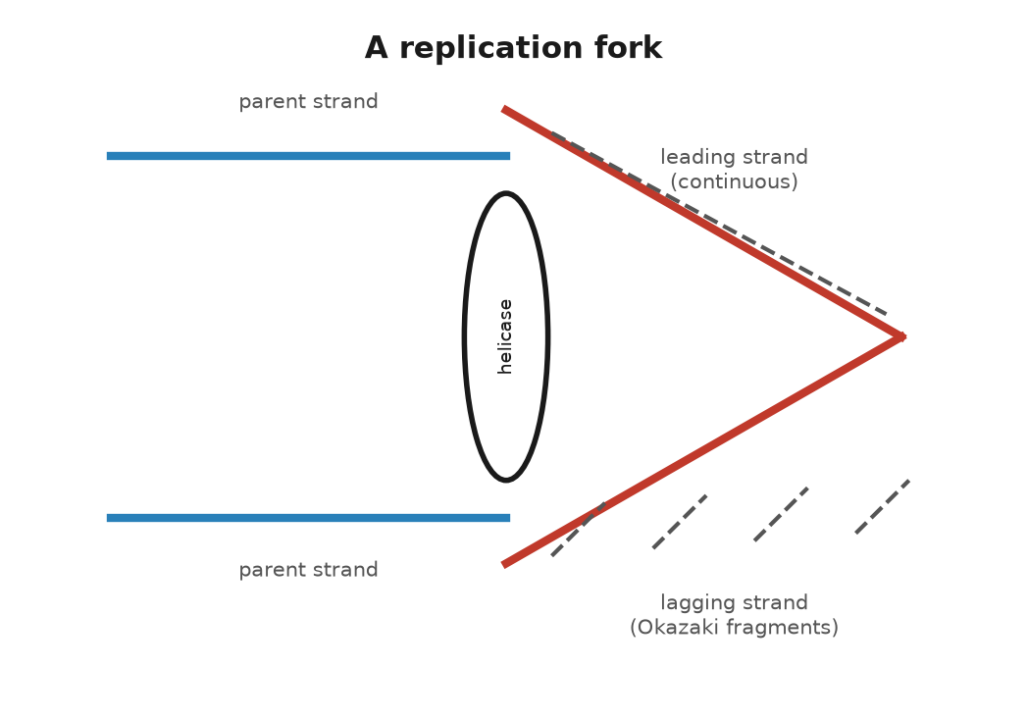
Figure 7. A replication fork.
Now the fork, which is where the mechanical objections were answered.
The helix is opened by an enzyme, helicase, which is shaped like a ring, threads itself onto one strand, and crawls along it, prising the hydrogen bonds apart as it goes at a rate that matches the polymerase. Behind it, the single strands are coated with small proteins that stop them from snapping back together. Ahead of it, the unopened helix is being twisted tighter by the unwinding, and that is the propeller problem. It is solved by topoisomerases, enzymes that cut one or both strands ahead of the fork, let the helix swivel to release the strain, and reseal the cut. The cut-and-reseal happens thousands of times per chromosome per copy, and it is one of the places where the machine is fragile. Several anticancer drugs work by jamming a topoisomerase in the cut state, so that a fast-dividing cell breaks its own chromosomes.
The polymerase cannot start a strand from nothing; it can only extend one. So each new strand begins with a short primer of RNA, about ten letters, laid down by an enzyme known as primase, and the polymerase builds on from there. The primer is later removed and replaced with DNA.
Then the direction problem. A polymerase only builds one way, from the five-prime end toward the three-prime end. It reads the template in the opposite direction. At a fork, one template is aimed so that this is easy. The polymerase follows the helicase and lays down one continuous new strand. That is the leading strand.
The other template runs the wrong way. The polymerase has to work in brief bursts, away from the fork, each burst starting from its own RNA primer. Something then has to stitch the bursts together. Reiji Okazaki, in Nagoya in 1968, caught the pieces. In humans they are about 100 to 200 letters long, and they are known as Okazaki fragments. The stitcher is DNA ligase. This stop-and-start strand is the lagging strand.
The two polymerases are held in one assembly, so they move at the same rate. The lagging strand loops out like the slide of a trombone while the leading strand runs straight. Bruce Alberts and others worked that picture out through the 1980s. It has held up in the electron microscope: a helicase ring in front, two polymerases behind, one strand looped.
Every element of it was forced by the model. Antiparallel strands forced the lagging strand. A twisted helix forced the topoisomerase. A polymerase that cannot start forced the primer. Watson and Crick's paper said the copying was simple in principle. It was. In practice it takes a machine of a dozen parts.
Now the errors, because they are the subject of the book.
The polymerase, choosing a nucleotide by fit, gets it wrong about once in a hundred thousand. That would be sixty thousand errors per copy, which is far too many. So the polymerase checks itself. Attached to it is a second active site, an exonuclease, that faces backwards, and if the base just added does not sit properly in its pair, the growing strand is pulled back into the exonuclease and the last letter is chewed off and tried again. This proofreading catches about ninety-nine of every hundred mistakes, and the error rate after it is about one in ten million.
Then a separate set of enzymes goes over the copy. The mismatch repair system scans new DNA for rungs that do not fit, a G against a T, an A bulging out with no partner, and when it finds one it has to decide which strand is the old, correct one and which is the new, wrong one. In bacteria the old strand is chemically tagged and the new one is not yet. In humans the mechanism is still being argued but it works, and mismatch repair catches most of what proofreading missed. After it, the rate is about one in a billion, and a genome of six billion letters comes through with a handful of errors. When mismatch repair is broken, as it is in people who inherit a faulty copy of one of its genes, the mutation rate rises a hundredfold and the result is a strong predisposition to colon cancer, Lynch syndrome. Paul Modrich worked out the mechanism and shared the Nobel Prize in Chemistry in 2015.
One in a billion is the figure that runs through this book, and here is what it means for a child. The child carries roughly sixty to seventy new mutations that neither parent has. Most of them arose not in the child but in the cell divisions that produced the father's sperm. A woman's eggs are all formed before she is born and sit waiting; a man's sperm are made continuously, from stem cells that keep dividing, so that a sperm from a forty-year-old man is the product of several hundred more copyings than an egg of the same age, and each copying adds its billionth. This is why new mutations come mostly from fathers, about four to one, and why the number rises by roughly two per year of the father's age. It was measured directly, by sequencing parents and children, in 2012 by Augustine Kong and colleagues in Iceland.
* * *
There is one more problem with copying that the fork cannot solve, and the solution is one of the strangest pieces of machinery in the cell.
The lagging strand starts every fragment with an RNA primer that is later removed. At the very end of a chromosome, when the last primer is removed, there is nothing upstream to build the replacement from, so the new strand is a little shorter than its template. Every copying loses a few dozen letters from each end. This is the end-replication problem, and it was pointed out by Alexey Olovnikov in 1971 and independently by Watson in 1972. Left unsolved it would eat the chromosomes from the ends inward, a few letters per division, until the genes were reached.
The ends are protected by telomeres, stretches of the same six letters, TTAGGG, repeated over and over, about two thousand times in a newborn. They carry no genes; they are the blank margins of the page, and the copying machine is allowed to trim them. When they get short, the cell stops dividing. In most adult tissues this is exactly what happens: a cell has a budget of divisions, fifty or so in the laboratory, and then it retires. The budget was found by Leonard Hayflick in 1961 and is known as the Hayflick limit.
Cells that must divide forever, the stem cells that make blood and gut lining and sperm, have a way round it. They make an enzyme, telomerase, which carries its own brief RNA template and uses it to add new TTAGGG repeats onto the ends, restoring the margin. Telomerase was discovered in 1985 by Carol Greider, a graduate student in Elizabeth Blackburn's laboratory at Berkeley, on Christmas Day, in a pond organism called Tetrahymena, and the two of them shared the Nobel Prize in Physiology or Medicine in 2009 with Jack Szostak. Nearly all cancers switch telomerase on, which is how they divide without limit, and switching it off is one of the strategies under trial against them.
So the machine copies six billion letters in a working day, checks its work twice, loses a little of the margin each time, and gets about six letters wrong. The letters it gets right are the ones the cell then reads, and reading is a machine of its own.

8. From Letter to Protein
In the spring of 1961, at the National Institutes of Health outside Washington, Marshall Nirenberg and a German postdoctoral fellow, Heinrich Matthaei, ran an experiment that looks, described plainly, like a magic trick.
They broke bacteria open and kept the soup: the ribosomes, the amino acids, and the small molecules that carry amino acids around. Into that soup they poured a synthetic strand of RNA made of nothing but the letter U, over and over. UUUUUU. Out came a protein made of nothing but one amino acid, phenylalanine, over and over. The tape had been read three letters at a time. UUU meant phenylalanine.
The tape was not copied from a gene. An enzyme isolated in 1955 by Marianne Grunberg-Manago and Severo Ochoa will string nucleotides into RNA with no template at all, if it is handed the raw letters. Give it only uracil and the product is poly-U. Nirenberg and Matthaei then asked which amino acid the soup would build in, trying the twenty candidates in separate tubes, one of them radioactive in each tube so a new chain would register on a counter. Only phenylalanine did. The decisive run was Matthaei's, in the small hours of 27 May 1961, while Nirenberg was away. Later accounts of that night, including Nirenberg's, put the count in the phenylalanine tube near 38,000, against a background near 70. A tape of one letter had produced a chain of one amino acid. That is as close to a decoded word as an experiment gets.
That single result did more to crack the genetic code than anything before it, and it is worth being clear about what "the code" means. Between the letters of DNA and the shape of a protein sits a translation problem: four kinds of letter, twenty kinds of amino acid, and a rule connecting them that nobody had proven existed until Nirenberg and Matthaei's tape yielded a single, predictable amino acid.
The path from letter to protein runs through an intermediate, and that intermediate is RNA, the cousin molecule from chapter 5. A gene is transcribed: an enzyme known as RNA polymerase attaches to a stretch of DNA at a specific address, the promoter, unwinds the two strands locally, and builds a single strand of RNA that matches one of them, letter for letter, with U standing in for T. The product is called messenger RNA, or mRNA, and it carries the gene's instructions away from the archive and out to where the work gets done.
In humans the raw transcript is edited before it is used. Most human genes are broken into pieces known as exons, separated by stretches known as introns, which can run from under a hundred letters to hundreds of thousands. The whole gene, introns and exons together, is transcribed, and then a machine, the spliceosome, cuts the introns out and glues the exons together, discarding what is between them. This was discovered in 1977, independently, by Richard Roberts and Phillip Sharp, working with an adenovirus, and it surprised nearly everyone; genes had been assumed to be continuous. They shared the Nobel Prize in Physiology or Medicine in 1993. Splicing is not a fixed job for a given gene. The same stretch of DNA can be spliced in distinct combinations in different tissues, so that one gene can specify several related proteins, a trick known as alternative splicing that is a large part of why twenty thousand human genes can produce a much larger number of distinct proteins.
The finished messenger RNA leaves the nucleus and arrives at a ribosome, a machine built of RNA and protein together, about twenty nanometres across, that sits in the cell's outer fluid by the thousand. The ribosome is the site of translation, and it is here that the code is actually read.
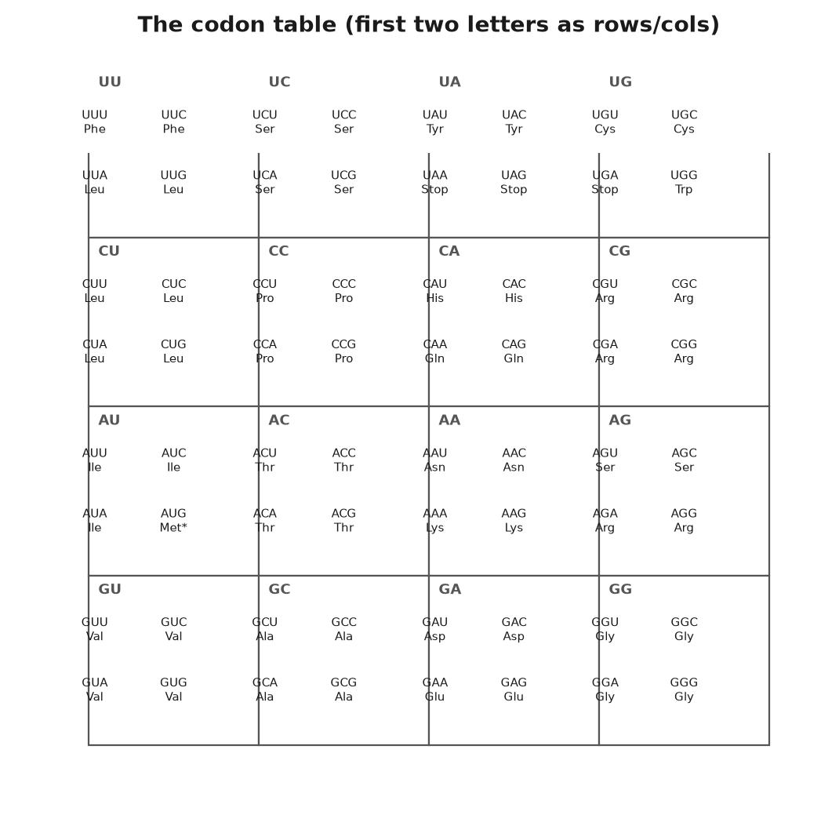
Figure 8. The codon table.
* * *
The reading unit is the codon: three letters of mRNA, read in one direction without gaps, specifying one amino acid. Three letters from an alphabet of four give sixty-four possible codons, which is more than enough for twenty amino acids, and the surplus is used for punctuation and redundancy. Three codons, UAA, UAG, and UGA, mean stop; the ribosome releases the finished chain when it reaches one. One codon, AUG, means both start and, wherever it appears mid-message, the amino acid methionine. The other sixty codons are shared among the remaining nineteen amino acids, so that most amino acids are specified by more than one codon; leucine has six. This redundancy is known as degeneracy, and it means that many single-letter changes in DNA have no effect on the protein at all, because the new codon still calls for the same amino acid. That fact matters later, when the book discusses how many mutations are silent.
Working out the sixty-four assignments took from 1961 to about 1966 and was mostly done by three groups: Nirenberg's, which kept refining the poly-nucleotide method; Har Gobind Khorana's at Wisconsin, which built defined short RNA sequences chemically and tested them one by one; and Robert Holley's, which worked out the structure of the adaptor molecule that does the actual matching. The three shared the Nobel Prize in Physiology or Medicine in 1968. The adaptor is called transfer RNA, tRNA, and its existence had been predicted by Crick in 1955, on paper, before anyone had isolated one, on the reasoning that something had to recognise a three-letter codon on one side and carry a specific amino acid on the other, since amino acids themselves have no way to read RNA. Each tRNA molecule folds into a cloverleaf shape with a three-letter anticodon at one end that pairs with a codon on the mRNA, and the matching amino acid chemically attached at the other end. When the anticodon fits the codon in the ribosome's reading slot, the amino acid is added to the growing chain, the ribosome shifts along by three letters, and the next codon comes into position.
Watch one arrival and the stutter stops being abstract. A transfer RNA comes in carrying its amino acid. If its three-letter tip matches the three letters on display, it stays. The growing chain is passed across and joined to that new amino acid. The bond is formed by a folded stretch of the ribosome's own RNA, not by a protein. The machine then steps forward by exactly three letters, and the empty carrier leaves.
The three places have names. The arrival place is the A slot, A for aminoacyl, where the amino acid comes in. The chain sits in the P slot, P for peptidyl, peptidyl being the string of amino acids already joined. The empty carrier leaves through the E slot, E for exit. A wrong carrier is admitted rarely, about once in several thousand amino acids.
The code, once cracked, turned out to be nearly the same in every living thing that has been checked, from bacteria to oak trees to people. AUG has meant methionine and start for as long as life has kept written records; UAA has meant stop the whole time. This near-universality is itself a strong argument for common descent: unrelated origins would have had no reason to agree on which sixty-four triplets mean what, and the arrangement is not the most efficient possible one, which argues against it being independently reinvented. There are exceptions, mostly small ones, and they are informative rather than embarrassing. Mitochondria, the compartments that recharge a cell's energy, run a slightly different dialect of the code; in human mitochondria, UGA, a stop everywhere else, means the amino acid tryptophan. Mitochondria were once free-living bacteria that were absorbed by an ancestral cell roughly one and a half to two billion years ago and have kept a scrap of their own genome, and their own slightly drifted code, ever since.
The ribosome itself deserves a moment, because it is arguably the oldest machine still running in every living cell, and because working out its structure took until the twenty-first century. It is built of two subunits, one large and one compact, each a scaffold of folded RNA studded with proteins. The RNA does the chemistry: the bond that joins one amino acid to the next is formed by a piece of the large subunit's RNA acting as the catalyst, not by any of the proteins, which is one of the pieces of evidence for the idea that RNA came before protein in the early history of life on Earth. The atomic structure of the ribosome, worked out by X-ray crystallography, was published between 2000 and 2001 by three groups working somewhat competitively, led by Ada Yonath, Venkatraman Ramakrishnan, and Thomas Steitz, who shared the Nobel Prize in Chemistry in 2009. A working ribosome adds about twenty amino acids per second in humans, so an average protein of a few hundred amino acids takes perhaps twenty seconds to build, once transcription and splicing have already produced the message.
Many antibiotics work by jamming a bacterial ribosome and sparing ours, because the two machines are alike and not the same. Streptomycin makes the bacterial ribosome misread, so its proteins come out garbled. Tetracycline blocks the arrival slot, so the next adaptor cannot enter. Chloramphenicol interferes with the bond-forming RNA of the large subunit. A human ribosome is built on a plan of its own, and an ordinary dose does not stop it. The same drugs can disturb the mitochondria, whose ribosomes still resemble the bacterial machines they descended from. The code is shared. The reader of the code has drifted, and medicine uses the drift.
* * *
Crick drew an arrow, DNA to RNA to protein, and the arrow does not run backward under its own power. A letter is copied into RNA, the RNA is read three letters at a time, and the chain folds, as chapter 6 described, into a working shape.
A short message makes the lookup less abstract. Take the sickle change from chapter 6, three letters in the messenger, GAG, which means glutamic acid. The ribosome does not recognise glutamic acid as a substance. It waits until a transfer RNA whose anticodon matches GAG arrives carrying glutamic acid, and then it joins that amino acid to the chain. Change the middle letter and the codon is GUG, which means valine, and a different transfer RNA, loaded with valine, is the one that fits. The ribosome has not made a decision. It has admitted whichever adaptor paired. Sixty-four codons and twenty amino acids means several codons often share an amino acid, so a change at the third letter is frequently silent: GGA and GGG both mean glycine, and the protein is unchanged. A change that creates UAA, UAG, or UGA stops the chain early. An insertion of one letter shifts every codon downstream, so the rest of the protein is gibberish. The table is small enough to write on a card. The consequences are not, because the card is consulted millions of times a minute in every tissue of a body.
Crick noticed, writing in 1966, that the third letter of a codon is often loose. He named the looseness wobble. One transfer RNA can pair with two or three codons that share their first two letters, which is why leucine can have six codons and still be served by fewer adaptors than six. The flexibility is chemical, a slack pairing at one position, and it is another reason a changed letter so often leaves the protein alone. The copy can be inexact and the protein exact. That is the code's built-in tolerance, and it is why most of a child's sixty or seventy new letters, when they fall inside a gene at all, change nothing a doctor could measure.
Nirenberg and Matthaei did not stop at a tape of U. A tape of C produced proline. A tape of A produced lysine. Mixtures, and then Khorana's defined sequences, filled the rest of the card. By 1966 the table was complete enough to print, and it has been reprinted, with the mitochondrial footnotes, in every textbook since.
A body's cells are, at any moment, running tens of thousands of ribosomes on tens of thousands of messages, translating the small fraction of the text that codes for protein at all. What the rest of one parental set, the 3.1 billion letters, is doing is the next question.

9. Most of the Text Is Not Genes
If one parental set were a book of 3.1 billion characters, the recipe for making proteins, the part biologists call coding sequence, would fill about forty-six million of them: roughly one and a half percent. Fold in the introns that get spliced out of those same genes and the genes as regions, coding and non-coding parts together, take up something like a quarter of the text. The other three-quarters was, for a long time, filed under the least satisfying word in the science: junk.
This chapter is about what is actually there, and it turns out to be less a junkyard than an archive with a great deal of packing material, some genuinely broken equipment, and, mixed in, most of the switches that decide when the machinery runs at all.
Start with the switches, because they are the least controversial part. A gene's coding sequence is, in effect, mute without instructions on when to speak. Near the start of most genes sits a promoter, the address RNA polymerase docks at to begin transcription, and scattered elsewhere, sometimes tens of thousands of letters away, sit enhancers, stretches of DNA that proteins known as transcription factors grip onto, bending the DNA around into a loop so that the enhancer touches the promoter and boosts transcription. A single gene can have several enhancers, active in different tissues or at separate times, which is part of how one genome builds a retina and a liver from the same instructions: the coding sequence for a given protein might be identical between the two tissues, while the switches that decide whether that sequence gets read at all differ completely. None of this is coding sequence. All of it is essential, and none of it would exist if the noncoding majority of the genome really were pure debris.
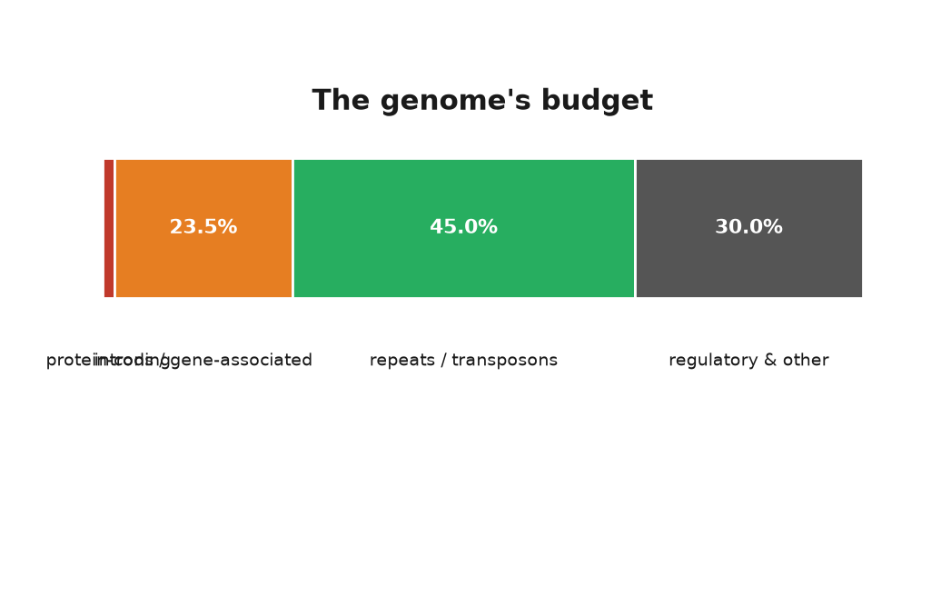
Figure 9. The genome's budget: coding, introns, repeats, regulatory, other.
* * *
Now the debris, or what looks like it. Repeated elements make up roughly forty-five percent of the human genome, and the great bulk of them are transposons: stretches of DNA that, over evolutionary time, have made copies of themselves and inserted the copies elsewhere in the genome, the way a chain letter photocopies itself into new mailboxes. The single most common element in the human genome is a family called Alu, a sequence about three hundred letters in length that appears more than a million times and by some counts accounts for around ten percent of the entire genome on its own. Most transposons in the modern human genome are dead: they have picked up mutations that stop them from copying themselves again, and they sit as fossils, evidence of an old infection that never fully cleared. A minority, mostly a family named LINE-1, can still occasionally jump, and when a jump lands inside a working gene it can cause disease; several cases of hemophilia, a disorder in which the blood does not clot properly, have been traced to exactly that.
The existence of jumping genetic elements at all was worked out decades before anyone understood the molecular mechanism, by Barbara McClintock, working with maize at Cold Spring Harbor from the 1940s onward. She found that certain patches of colour on corn kernels appeared and vanished in ways that ordinary mutation could not explain, and concluded that pieces of the genome were physically moving from one location to another and switching genes on and off as they landed. The idea was met, for a long time, with polite disbelief; it did not fit the picture of a fixed, orderly set of genes in fixed positions. McClintock was proven right once molecular tools existed to see the elements directly, and she received the Nobel Prize in Physiology or Medicine, alone, in 1983.
The argument over how much of the noncoding genome does something useful, rather than simply riding along, has run for decades and has not fully settled, which is a case where this book has to say plainly that the two camps of scientists who study it do not agree.
In 2012 the ENCODE consortium, short for Encyclopedia of DNA Elements and a large international research project, mapped where in the genome proteins bind, where RNA is synthesised, and where the chemical marks of active chromatin, DNA packaged with its spool proteins from chapter 5, sit. The project reported that some kind of biochemical activity, transcription, protein binding, or a chromatin mark, could be detected over roughly eighty percent of the genome. Announced as a headline figure, it was widely reported as meaning that eighty percent of the genome is functional.
Evolutionary biologists pushed back hard, and the disagreement is about what "functional" should mean. Biochemical activity is not the same as consequence. Transcription happens accidentally at low levels almost everywhere in a genome; a protein binding a stretch of DNA does not mean that binding matters to the organism's survival. The evolutionary approach asks a different question: how much of the genome is under selection, meaning that a harmful mutation there would be weeded out because it hurts survival or reproduction. By comparing the human genome to those of many other mammals and looking for stretches that have stayed suspiciously unchanged over tens of millions of years, evolutionary biologists including Chris Rands and colleagues, writing in 2014, estimated that something between about eight and fifteen percent of the human genome is under this kind of constraint. That is a far smaller figure than eighty percent, though still five to ten times larger than the coding sequence alone, which tells you that most of the functional non-coding genome is regulatory: promoters, enhancers, and RNA molecules that never become protein.
I think the honest summary is this, and I mark it as my own reading of a real dispute. ENCODE measured something real and useful, a map of where the cell's machinery touches down. It overstated what that map says about function in the evolutionary sense. The evolutionary estimate is closer to what most geneticists mean by how much of the genome matters. It probably still misses a switch that evolved only in humans, and recently, and so left no fossil in a comparison between species. Both figures can be true. They are answers to two questions, not one.
Those RNA molecules are not the messenger of chapter 8. Messenger RNA is a temporary copy of a gene on its way to a ribosome. The RNAs that manage switches are another workforce, and two examples show the range.
In 1993 Victor Ambros and Gary Ruvkun, working on a worm about a millimetre long, identified an RNA of about twenty-two letters that pairs with a messenger and stops a protein from being finished. A second example turned up in 2000, and then hundreds, in animals and in plants. These microRNAs are how a cell turns a protein down without editing the gene. A human cell produces several hundred of them. Ambros and Ruvkun shared the Nobel Prize in Physiology or Medicine in 2024.
Distance is the other surprise. The gene that lays out a limb, SHH, is controlled in the developing limb by an enhancer about a million letters away, sitting inside a neighbouring gene. A change in that far enhancer can add an extra finger or thumb while the coding letters of SHH itself are untouched. Proteins grip the enhancer and the start of the gene, and the DNA bends until the two touch. A million letters, inside a nucleus, is a brief walk. The recipe and the switch are not neighbours on the page. They are neighbours in the packing.
* * *
Whatever the final percentage, one function of the noncoding genome is now settled beyond argument: epigenetics, the study of chemical marks that change which genes get read without changing the letters themselves, an idea briefly touched on in chapter 5 through the packing of the nucleosome, deserves its due here as chemistry.
DNA itself can carry a chemical mark without changing its letters. The most common is methylation: a small chemical tag, a methyl group, attached to a cytosine, usually one that is followed by a guanine. Heavily methylated promoters tend to be shut; the tag physically discourages the transcription machinery from docking, and it also attracts proteins that compact the chromatin around it. Histones, the spool proteins from chapter 5, carry their own set of marks, acetyl groups and methyl groups added and removed at specific positions on their protruding tails, and different combinations of marks correlate with genes being open, primed, or silenced. None of these marks change a single letter of the underlying sequence. All of them are copied, imperfectly, when a cell divides, which is how a liver cell's daughter is also a liver cell rather than reverting to a blank slate: the pattern of switches, not just the text, is inherited from one cell generation to the next.
The clearest demonstration in humans is X-inactivation. Female mammals carry two X chromosomes. Males carry one X and one Y. Two active X chromosomes would double the dose of every gene on the X, and that dose is generally harmful. Early in a female embryo, each cell shuts one X at random and wraps it up. Every descendant of that cell keeps the same one shut for life.
A calico cat is the picture. The coat-colour gene sits on the X. One X says orange and the other says black. Each patch of fur is the descendants of a cell that shut one or the other. The coating is done by an RNA. A gene named XIST, reported by Carolyn Brown and colleagues in 1991, is copied into a long RNA that stays in the nucleus, spreads over the X it came from, and does not make a protein. The proteins that pack the chromosome follow that RNA. Mary Lyon proposed the underlying pattern in 1961, from breeding experiments in mice, well before anyone could see the RNA itself.
The same basic toolkit, methylation and histone marks, is how roughly two hundred distinct cell types in a body run varied programs from an identical genome, and how, as chapter 14 will describe, an experience early in life can leave a chemical trace that outlasts the experience itself, though not, in most cases, one that gets passed to the next generation.
One switch is concrete enough to taste. Anna's switch, from her father, sits outside the gene, in the kind of enhancer this chapter has been describing. A gut cell and a skin cell can both carry it. Only the gut cell has the enhancer's protein partners in place, so only the gut cell makes the enzyme.
Put one parental set on a shelf the way chapter 5 did, about a thousand telephone directories. The protein recipes fill roughly fifteen of them. That is the whole of him, as a parts list. The introns and the switches fill a few hundred. The dead transposons fill nearly half the shelf, four or five hundred volumes of chain letters that mostly no longer copy themselves. The rest is structural sequence, RNA genes, and pages nobody has assigned. ENCODE's eighty percent and the evolutionary eight to fifteen percent are two ways of counting those volumes. They do not become the same number by being printed side by side.
None of this changes what happens when the machine copies the text and gets it wrong, which is the same whether the wrong letter falls in a gene, a switch, a dead transposon, or a stretch nobody has a name for yet. Where those wrong letters come from, and what a cell does about them, is the last chapter of this part.

10. Where Mistakes Come From
When a child is conceived, the genome is not a clean copy of either parent's. Comparing the child's DNA against both parents, a geneticist would find somewhere between sixty and seventy positions where the child carries a letter neither parent has. This number, and the fact that most of those new mutations trace to the father's side, comes from direct family sequencing studies, the first solid one published in 2012 by Augustine Kong's group in Iceland, and it has been repeated many times since with similar results. Every child of every generation carries a similar new burden. It is the price of copying, and this chapter is about where the price comes from, how the cell tries to avoid paying it, and a live scientific question about whether some of the toll is, at bottom, a quantum event.
The most obvious source of new mutations is the copying error described in chapter 7: a polymerase places the wrong letter, proofreading misses it, mismatch repair misses it too, and the wrong letter becomes permanent on the next round of copying, since by then it has a perfectly matched, if wrong, partner. This route alone, at roughly one error per billion letters copied, adds up over trillions of divisions in a lifetime.
But DNA does not sit passively waiting to be copied; it is chemically attacked every day, even doing nothing at all. The bond joining a purine base, adenine or guanine, to its sugar is not perfectly stable in water, and it spontaneously breaks at a low but steady rate, a process known as depurination. Estimates for a human cell run to around ten thousand such losses per day. Left alone, a lost base leaves a gap that, if copied over, produces a random letter in its place; in practice, a dedicated repair pathway usually patches the gap correctly first. Cytosine undergoes a different spontaneous change, deamination, in which it loses an amino group and turns chemically into uracil, a letter that does not belong in DNA at all and is efficiently recognised and excised; but a chemically modified form of cytosine, the one carrying the methylation tag from chapter 9, deaminates instead into thymine, a letter that does belong in DNA, and this disguised error slips past repair far more often. That single chemical quirk is why methylated cytosines are among the most mutation-prone positions in the whole genome, and it is part of why a particular cancer-causing mutation in a gene, TP53, recurs at the same few positions in tumour after tumour: those are methylated cytosines.
Radiation adds to the chemical toll from outside. Ultraviolet light, mainly from the sun, is absorbed by two neighbouring thymine or cytosine bases on the same strand and fuses them into a distorted unit called a pyrimidine dimer, which the copying machine either repairs correctly or, if repair fails, reads badly, producing a characteristic and well-studied class of skin-cancer mutation. Ionising radiation, from cosmic rays, from radioactive decay in rock, or from a medical scan, carries enough energy to break a DNA strand outright, sometimes both strands at the same position, which is a far more dangerous injury than a single wrong letter. And a long list of chemicals, some natural and some manufactured, react directly with DNA and distort it: aflatoxin, a mould toxin found on improperly stored grain and nuts, forms a bulky attachment to guanine that is strongly linked to liver cancer in parts of the world where contaminated food is common; benzo[a]pyrene, one of dozens of carcinogens, cancer-causing chemicals, in tobacco smoke, does something similar and is a major contributor to lung cancer's mutation burden. And the transposons of chapter 9, when one of the rare active ones jumps, tear the text at both its old and new locations, occasionally landing inside a working gene and breaking it.
Against all of this, the cell runs several dedicated repair systems, distinct from the proofreading and mismatch repair of chapter 7, each specialised for a different kind of damage. Base excision repair recognises a single damaged or wrong base, such as a deaminated cytosine, cuts it out, and rebuilds the gap using the opposite strand as a guide. Nucleotide excision repair handles bulkier distortions, such as UV-induced pyrimidine dimers, by cutting out a stretch of a couple of dozen letters around the damage and resynthesising it; people who inherit a broken copy of one of the genes in this pathway have a condition known as xeroderma pigmentosum, in which ordinary sunlight causes severe, early skin cancer, because the dimers that everyone's skin cells accumulate every sunny day are never removed. Mismatch repair, already introduced as a proofreading backstop, also has a starring role in disease when it fails on its own: inherited faults in its genes cause Lynch syndrome, a strong predisposition to colorectal and several other cancers, and the mechanism was worked out largely by Paul Modrich. Tomas Lindahl, who discovered base excision repair, and Aziz Sancar, who worked out nucleotide excision repair in detail, shared the 2015 Nobel Prize in Chemistry with Modrich for mapping this whole defensive system.
The result of copying errors, chemical attrition, and imperfect repair is a small catalogue of mutation types, which recur throughout the rest of this book and are worth naming once, clearly. A point mutation swaps one letter for another. An insertion or deletion adds or removes letters, and if the number added or removed is not a multiple of three, it shifts every downstream codon, as chapter 8 explained. A copy-number change duplicates or deletes a whole stretch, sometimes a whole gene or several. And a chromosomal mutation rearranges or miscounts entire chromosomes, as when an extra copy of chromosome 21 causes Down syndrome. All four kinds trace back, ultimately, to the sources catalogued above.
Charles Darwin, in 1859, needed exactly one ingredient he could not supply: a source of heritable variation for natural selection to act on. He could see, from pigeon breeders and cattle farmers, that offspring vary and that some variations are inherited, but he had no mechanism for where the variation originally comes from, and his own guess, a vague notion of blending inheritance under the influence of use and environment, was largely wrong and sat uneasily beside his own theory. Gregor Mendel, working at almost the same time and unread by Darwin, supplied half the missing piece: heredity is particulate, carried in discrete units that do not blend, a story told in Part IV of this book. What Mendel's peas could not supply was novelty: his seven traits were already present, in two forms each, in the varieties he started with. Neither man had, or could have had, an account of where a genuinely new trait comes from in the first place.
Mutation is that account, and this chapter's chemistry is the mechanism Darwin lacked. Bring the two together, add Mendel's particulate inheritance and the population genetics developed by Ronald Fisher, J. B. S. Haldane, and Sewall Wright in the 1920s and 1930s, and the result, consolidated by Theodosius Dobzhansky, Ernst Mayr, and George Gaylord Simpson through the later 1930s and 1940s, is what biologists call the Modern Synthesis: mutation supplies raw variation, recombination, the shuffling of chromosome segments between parents that Part III explains, mixes it further, and selection, acting on the resulting differences in survival and reproduction, changes which variants become common. Mutation without selection is just noise. Selection without mutation has nothing to select. Neither, alone, is the theory of evolution; together, they are.
* * *
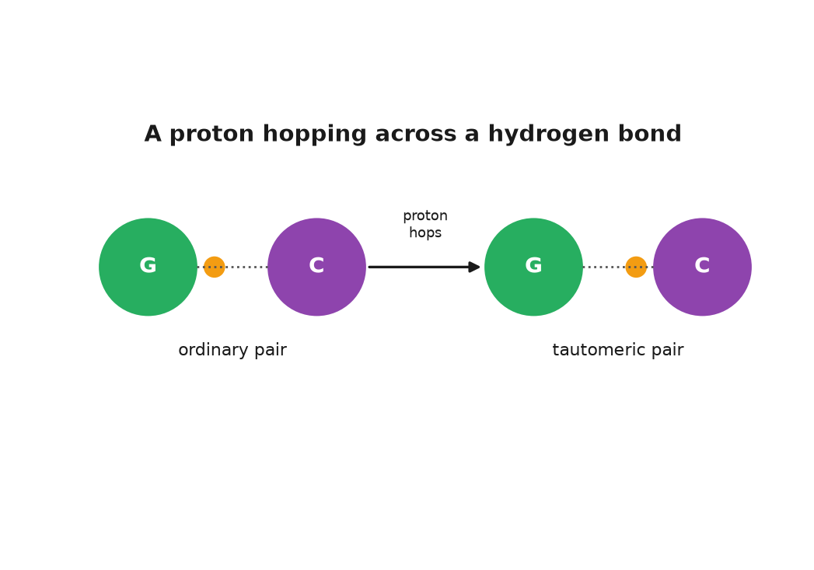
Figure 10. A proton hopping across a hydrogen bond: ordinary pair, tautomeric pair.
There is one more source of variation to consider, and it is the one Lothar asked about directly: whether mutation is purely a matter of classical chemistry, molecules bumping and reacting the way billiard balls do, or whether quantum mechanics plays a genuine role.
The honest answer has a settled part and a working part, and the two should not be blurred together.
The settled part is straightforward and, once stated, almost too obvious to seem interesting: light is fundamentally a quantum phenomenon, and so is the interaction of radiation with matter that causes DNA damage. A photon of ultraviolet light is absorbed by a thymine base as a single indivisible quantum of energy, kicking an electron into an excited state that then allows the two neighbouring bases to fuse into the dimer described earlier in this chapter; the physics of that absorption is textbook quantum chemistry, no more controversial than the physics of a photograph. In that narrow, well-established sense, quantum mechanics is already part of the settled story of mutation, and always has been, since chemistry itself is built on quantum rules about how electrons and bonds behave.
The working part is narrower, and it is not settled. Watson and Crick's second paper of 1953 already noted that a base can briefly flip into a rare shape, a tautomer, and then pair with the wrong partner. The question is whether that flip is sometimes a quantum event.
Picture one hydrogen atom sitting in the middle of a base pair, held by a bond. In ordinary physics it stays on its own side of a low wall. Tunnelling is the quantum fact that a particle can be found on the far side of a wall it does not have the energy to climb. It is established in some enzyme reactions. In 1963 the physicist Per-Olov Löwdin proposed that the hydrogens in a base pair might tunnel, so that for an instant the pair is the rare tautomer. If the copying enzyme reads the strand in that instant, it writes the wrong letter.
For decades this stayed a theoretical curiosity, difficult to test directly inside a hydrogen bond a few tenths of a nanometre long. In 2022 a paper by Louie Slocombe, Marco Sacchi, and Jim Al-Khalili, published in the journal Communications Physics, used detailed quantum mechanical calculations to estimate how readily this tunnelling actually occurs in a G–C base pair at body temperature. Their calculation found that the tunnelling happens fast, on a timescale of quadrillionths of a second, too brief for any laboratory clock to follow directly and faster than earlier, simpler estimates had suggested, and that even though the resulting tautomeric form is short-lived and reverts almost immediately, a small but non-negligible fraction of base pairs are sitting in the tautomeric form at any given instant, purely as a matter of ordinary quantum equilibrium. A later paper the same year, by Slocombe, Max Winokan and colleagues in the Journal of Physical Chemistry Letters, put a polymerase around a mismatched G–T pair and calculated that tunnelling could speed a wrong letter into place in that squeezed geometry. It is still a calculation. Nobody has yet watched a living polymerase copy a tunnelled tautomer.
What that calculation does not show, and what nobody has yet shown, is that this fast quantum flicker actually gets past a working polymerase often enough, in a living cell, to be copied into a permanent mutation before the tautomer reverts or before proofreading catches it. The proofreading and mismatch-repair systems described earlier in this chapter evolved, in effect, to catch exactly this kind of transient mispairing, whatever its ultimate physical cause, and no experiment has yet isolated tunnelling as a distinct, measurable contributor to the final mutation rate observed in a real organism, as opposed to a laboratory calculation of what happens to an isolated base pair. So I place this where the book's own vocabulary says it belongs: working, not settled. It is a serious hypothesis, backed by real calculation, about one possible route to one class of spontaneous mutation, sitting alongside the classical chemical routes, depurination, deamination, radiation damage, that are already firmly established and almost certainly responsible for the great majority of the mutations this chapter has catalogued. Quantum tunnelling may turn out to be a minor but real contributor to the tautomer route specifically. It has not been shown to be the dominant source of mutation generally.
* * *
Whatever the balance between chemistry and quantum flicker inside one base pair, the outcome for the species is the same. Mutation is the raw material of change; it is copying's shadow, inseparable from the very mechanism that makes life possible at all, because a molecule that copied itself with true, permanent perfection would also be a molecule that could never have produced anything new since the first cell. Selection is the editor that decides, generation after generation, which of those shadows survive. Neither, alone, explains a finch's beak or a sickle-shaped red blood cell or Anna's switch, from her father. The next part of this book turns from the chemistry of the mistake to the question of who inherits it, and why Theo's freckles came from Ruth.

PART III — Inheritance

11. Why Theo Has Ruth's Freckles
There is a photograph on Ruth's refrigerator, held up by a magnet shaped like a lemon. It was taken last summer at a picnic table. Ruth is on the left, seventy-seven then, in a sun hat. Anna is in the middle. Theo, fourteen at the time and already taller than both of them, is on the right, scowling at the sun. All three have freckles across the nose and cheekbones, the same scatter, as if someone had flicked the same brush at three faces. Ruth's husband, Anna's father, had none. Theo's father has none either. The freckles have come down one line of the family like a surname.
Ruth, Anna and Theo are invented, and what they carry has been arranged for convenience. But the question the photograph raises is a real one, and it was the central puzzle of biology for most of the nineteenth century. How does a feature get from a grandmother to a grandson? Why is it not diluted on the way, given that at each step a parent with the feature had a child with a parent without it? And why does Theo have Ruth's freckles but not her curly hair, her blood group, or her habit of finishing other people's sentences?
The answer begins with a count. Every ordinary cell in Ruth's body holds 46 chromosomes, and they come in 23 pairs. The number was settled surprisingly late. From 1923, on the authority of Theophilus Painter, the textbooks said 48, and it took until 1956, when Joe Hin Tjio and Albert Levan in Lund looked at cultured human cells with a better technique, for the count to be corrected. Twenty-two of the pairs are matched: the two chromosomes in each pair are the same length and carry the same genes in the same order. The twenty-third pair is the sex chromosomes, and it gets its own chapter.
The two members of each pair have different histories. One came from Ruth's mother, in the egg. The other arrived from Ruth's father, in the sperm. So Ruth has, for instance, two copies of chromosome 16, and somewhere on each of them sits a gene called MC1R, which makes a receptor protein on the surface of pigment cells. Certain variants of MC1R are strongly associated with red hair, skin that burns, and freckles; the association is settled, though freckling is not a one-gene affair and several other regions of the text contribute. Suppose that Ruth's chromosome 16 from her father carries one such variant and the one from her mother does not. She freckles. What matters is what she gave to Anna.
* * *
Cells divide in two ways, and the difference between them is the whole of inheritance. The ordinary way is mitosis. A cell copies all 46 chromosomes, lines up the 92 resulting threads, pulls one full set to each end, and pinches in two. Both daughter cells have 46, and both are, apart from the copying errors of Chapter 10, the same as the parent. This is how skin replaces itself, how a cut heals, how a fertilised egg becomes a person of tens of trillions of cells. Nothing is shuffled. Nothing is halved.
The other way is meiosis, and it happens only in the ovaries and the testes. Here a cell copies its 46 chromosomes once and then divides twice, so that the four products each hold 23, one from every pair. This halving is not optional. If eggs and sperm each carried 46, a child would have 92 and a grandchild 184. Fertilisation restores the count: 23 from the egg plus 23 from the sperm makes 46, and the pairs are re-formed, one partner from each parent.
Which member of each pair goes into a particular egg is a matter of chance, decided pair by pair. When Ruth's ovaries made the egg that became Anna, chromosome 1 could go in as the version from Ruth's mother or the version from Ruth's father; the same for chromosome 2, independently; and so on through all 23. Two choices, 23 times over, is 2 to the power 23, which is 8,388,608 distinct sets of chromosomes that Ruth could pass on, more than the population of London. Anna's father had the same number available. Multiply them, and the count of possible children from one couple, before anything else happens, is about 70 trillion, roughly nine thousand times the number of people alive on Earth today. This is independent assortment, each pair dealt on its own. A garden of peas will show the same rule later, in Part IV, and the friar who counted them could not have known the reason was physical. The pairs line up across the middle of the cell before the first division, each pair orients itself without reference to the others, and the spindle pulls whichever partner faces which way.
That is the first shuffle. The second is stranger and matters more. Before the pairs separate, they pair. Each chromosome finds its partner, lies along it, and the two exchange pieces. A stretch of the chromosome 16 that came from Ruth's father is cut out and swapped for the matching stretch from her mother's copy, so that the chromosome 16 that goes into the egg is neither of Ruth's two but a splice of both. This is crossing over. The Belgian cytologist, a scientist who studies cells under the microscope, Frans Alfons Janssens saw the crossed threads, the chiasmata, in 1909 and guessed what they meant. Thomas Hunt Morgan's fly room in New York inferred the exchange in the 1910s from the way traits travelled together, or failed to. In 1931 Harriet Creighton and Barbara McClintock, working with maize, and Curt Stern, working with fruit flies, showed in the same year that a visible chunk of chromosome had physically changed places when the traits did.
The numbers are known well enough to state. In each human meiosis there is at least one crossover on almost every pair, and usually one to three; the total across all 23 pairs is reported as roughly 50 in men and about 70 to 80 in women, with the exchanges clustered at hotspots that a protein called PRDM9, identified in 2010, helps to choose. Because crossovers are few and the chromosomes are long, a piece of text that sits near a freckle variant tends to travel with it into the same egg. Pieces far away on the same chromosome, or on other chromosomes, do not. This is why Theo got Ruth's freckles and not her curls: the two are written in different places and were dealt separately.
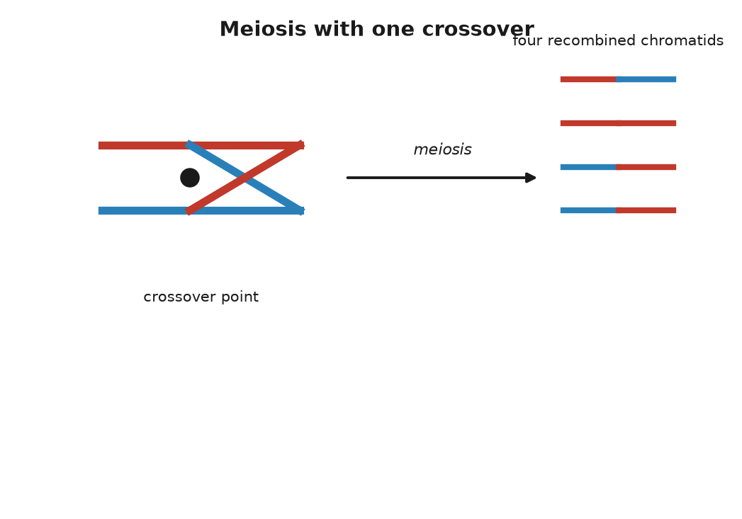
Figure 11. Meiosis, with one crossover between a maternal and a paternal chromosome.
* * *
Put the two shuffles together and the arithmetic of the family photograph falls out. Anna received exactly one full set of 23 from Ruth, so Anna and Ruth share half of their text, exactly, not on average. Which half was decided by the coin tosses and crossovers in one egg in 1977. At the MC1R position, the chance that the egg carried the freckling variant was one in two. It did.
Theo is a second toss. The chromosome 16 that Anna passed to him was itself a splice of her two copies, one from Ruth and one from Anna's father. Again, one chance in two at the freckle position. Again, it came through. On average a grandchild carries a quarter of a grandparent's text, but "on average" is doing real work in that sentence. Because the pieces are dealt in chunks, the actual fraction varies from grandchild to grandchild. Theo might carry 20 percent of Ruth, or 30 percent; a whole chromosome from Ruth may have gone through untouched, and another may be absent entirely.
The same spread shows up between brothers and sisters, and it has been measured. Two children of the same parents share half their text on average, since each got a random half of each parent. But each child's random half is its own, not a copy of the other's. Peter Visscher and colleagues, in a 2006 paper in PLoS Genetics, used genetic markers to measure the actual sharing in several thousand pairs of siblings and found that it ran from roughly 37 percent to 62 percent. Some brothers are, genetically, nearer to cousins than the average implies. Some are much closer than that. Anyone who has watched two siblings and wondered how they emerged from the same house has, in a sense, been measuring this.
It is worth pausing on what the shuffle rules out. The nineteenth century's default picture of inheritance was blending: the child as a mix, half of one parent's fluid and half of the other's, the way paint mixes. Darwin held a version of it, and it gave him trouble. In 1867 the engineer Fleeming Jenkin pointed out in a review that under blending any new advantageous variant would be diluted by half in the first generation and by half again in the next, and would vanish before selection could act on it. Darwin had no answer. The answer was in a paper in Brünn that he never read. Traits are not fluids. They are carried on particles, on stretches of text, and a stretch of text is either copied into the egg or it is not. Ruth's freckles were not halved in Anna and quartered in Theo. They are present in Theo at full strength and can go into his children the same way, whatever his father contributed, which in this case was nothing.
One last thing about eggs, because the timing is a small surprise that makes the mechanism real. A woman's eggs are not made through her life. They form before she is born. By about the fifth month of a female fetus's development, all of the cells that will ever become eggs have formed and have begun meiosis, and then they stop, part way through the first division, with their chromosomes already paired and the crossovers already completed. They wait in that state until ovulation, one or a few at a time, from puberty on.
So the egg that became Anna began its meiosis inside Ruth in 1947 or early 1948, while Ruth was herself inside her mother, and finished it in 1977, about 29 years later. And the egg that became Theo began meiosis inside Anna in 1978, when Anna was a fetus in Ruth's womb. For a few months that year, a cell that would become part of Theo was physically present inside Ruth. Three generations, one body. Sperm are produced the other way, continuously from puberty, at a rate reported as about a thousand per second, and every one of them is the product of a fresh chain of cell divisions, which is why the new mutations in Chapter 10 come mostly from the father.
The long wait has a cost. Paired chromosomes held for decades sometimes fail to separate cleanly when the division finally resumes, and an egg ends up with two copies of a chromosome instead of one. Fertilised, it gives a child with three. For most chromosomes this is not survivable. For chromosome 21, the smallest, it is, and the result is Down syndrome, which occurs in about 1 birth in 700 overall and rises with the mother's age, from roughly 1 in 1,200 at 25 to about 1 in 100 at 40. It is the same mechanism that gave Theo his freckles, run with one step out of place.
Twenty-two of the 23 pairs play this game evenly, with both partners the same size and carrying the same genes. The twenty-third pair does not, and its unevenness decides who can inherit what.

12. Who Gets What: X, Y, and the Mother's Line
On 7 April 1853, at Buckingham Palace, Queen Victoria gave birth to her eighth child, a boy named Leopold, with chloroform administered by the physician John Snow. She thought the anaesthetic delightful and said so. The boy was less fortunate. He bruised at the slightest knock, bled for hours from small cuts, and spent much of his childhood in bed with swollen joints. The doctors called it haemophilia, a word that had been in use for a few decades. In March 1884, on the stairs of a club in Cannes, Leopold slipped, fell, and died the next morning of a bleed into the brain. He was thirty.
Neither of Victoria's parents had the disease, and neither, as far as the records show, did anyone in the generations before them. She carried a change that was new in her, or in one of her parents' cells. Two of her daughters, Alice and Beatrice, carried it too, and through them it travelled into the ruling houses of Germany, Spain and Russia. Alice's daughter Alix married Nicholas II and became Empress Alexandra; their only son, Alexei, born in 1904, had the disease, and the family's desperation over his bleeding gave the monk Rasputin his place at court. Two of Beatrice's grandsons, Spanish princes, died in the 1930s after car accidents, from injuries that a clotting body would have survived. In 2009 a team led by Evgeny Rogaev, working on the Romanov remains recovered near Yekaterinburg, reported in Science that the family's mutation was a single-letter change affecting the splicing of the gene F9: haemophilia B, rather than the commoner haemophilia A.
The pattern in that family is the textbook pattern, and it was recognisable well before anyone knew what a gene was. The disease appeared in sons. It was passed by mothers who were themselves well. Affected fathers, when they survived to have children, had healthy sons and carrier daughters. It skipped, and it reappeared. The explanation is the uneven twenty-third pair.
* * *
Twenty-two of the pairs in every human cell are matched partners. The twenty-third is either two X chromosomes, in which case the person is, with rare exceptions, female, or one X and one Y, in which case male. The X is a substantial chromosome, about 156 million letters long, roughly a twentieth of the whole 3.1-billion-letter text, and carrying about 800 protein-coding genes. The Y is a runt. In the reference genome it was listed at about 57 million letters, under a fiftieth of the text and more than half of that repetitive sequence so tangled that it was not fully read until 2023, and it carries only a few dozen protein-coding genes. The two share a short region at each tip, where they can pair during meiosis; along the rest of their length they have almost nothing in common.
What the Y does have is one compact gene, SRY, near its tip. It was found in 1990 by Andrew Sinclair, Peter Goodfellow, Robin Lovell-Badge and colleagues in London, and the next year Lovell-Badge's group showed that a mouse embryo with two X chromosomes and an inserted copy of the mouse version of the gene develops as a male. The gene is a switch. Around the sixth week of development, in an embryo that has it, the protein it encodes starts a cascade that makes the primitive gonads become testes, and the rest follows from the hormones the testes produce. Without it, the default is ovaries. People exist with an X and a Y and a broken SRY who develop as women, and people with two Xs and a stray copy of SRY who develop as men. One gene of a few hundred coding letters, on a chromosome that is otherwise mostly rubble, decides.
The egg always contributes an X. The sperm contributes an X or a Y, so it is the father's contribution that decides the sex of a child, a fact that would have been of some use to Henry VIII. The chance is close to even, with a small excess of boys at birth, about 105 to every 100 girls, for reasons that are not fully understood.
Now the pattern. A gene on the X chromosome has two copies in a woman and one in a man. If a variant on the X is recessive, meaning that a working copy on the partner chromosome masks it, then a woman with one bad copy is well, and a man with one bad copy has no partner chromosome to mask it, because his other sex chromosome is the Y and the Y does not carry the gene. So a carrier mother passes the variant to half her children on average: her sons who receive it are affected, her daughters who receive it are carriers. An affected father passes his X to all of his daughters, who become carriers, and his Y to all of his sons, who are untouched. This is Victoria's family drawn as a rule.
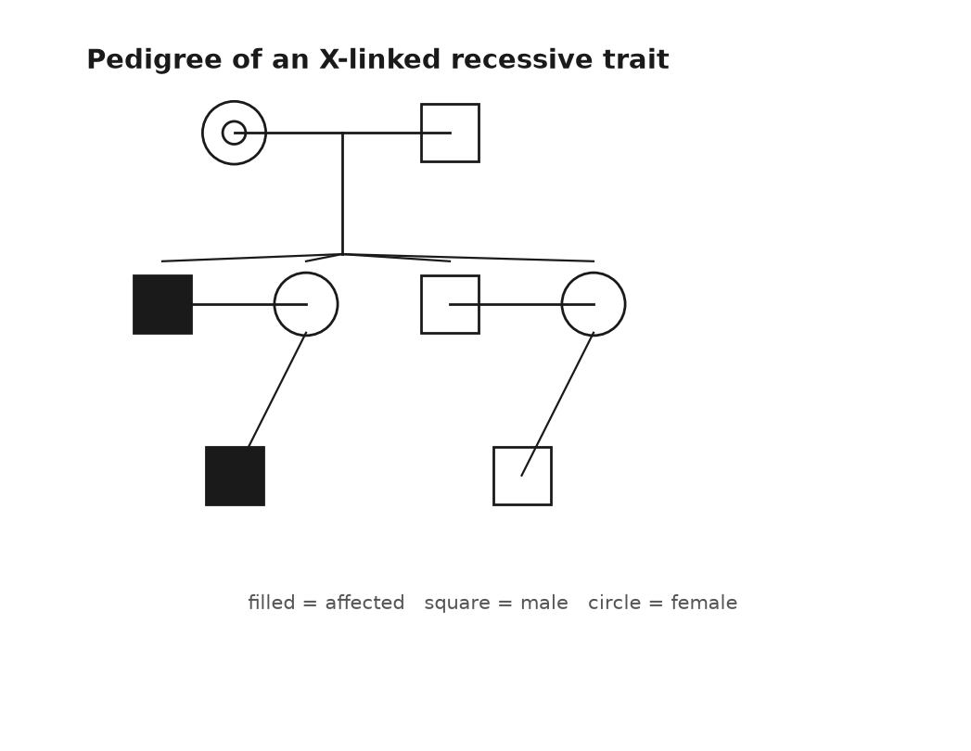
Figure 12. A pedigree of an X-linked recessive trait across four generations.
The commonest X-linked trait is not a disease but a limitation. About 8 percent of men of northern European ancestry cannot distinguish reds and greens as most people do, against about 0.5 percent of women. The genes for the red-sensitive and green-sensitive pigments of the retina, OPN1LW and OPN1MW, lie side by side near the tip of the X, so similar in sequence that during meiosis the paired chromosomes sometimes misalign by one gene and exchange unequally, deleting or blending copies. Jeremy Nathans worked this out in 1986. Haemophilia A comes from variants in F8, also on the X; haemophilia B from F9. Duchenne muscular dystrophy comes from DMD, which at about 2.2 million letters is the longest gene in the human text and, being long, is a large target for damage. A daughter of a colour-blind father is a carrier for certain, and a son of that daughter has one chance in two.
* * *
There is a complication in the rule, and it is a beautiful one. A woman has two Xs and a man has one, so a woman's cells ought to make twice the dose of every X-linked protein, which for most genes would be a problem. They do not. In 1961 Mary Lyon, working on coat colour in mice at Harwell in England, proposed in a short letter to Nature that early in the development of a female embryo each cell switches off one of its two X chromosomes at random and leaves the other running, and that every descendant of that cell keeps the same choice. The silenced chromosome curls into a dense knot at the edge of the nucleus that Murray Barr had seen in 1949 and that is still called the Barr body. The switch itself is an extended molecule of RNA, ribonucleic acid, DNA's single-stranded cousin, made by a gene named XIST, found in 1991, which coats the chromosome it came from and shuts it down.
The consequence is that every woman is a mosaic. In some patches of her body the X from her mother is working; in others, the X from her father. The clearest demonstration walks about on four legs. In cats, the gene that makes fur orange rather than black sits on the X. A male cat has one X and is either orange or not. A female with an orange allele, the working term for one version of a gene, on one X and a non-orange allele on the other is a tortoiseshell: patches of orange where the non-orange X was silenced, patches of black where the orange one was. Add the unrelated white-spotting gene and she is a calico. Almost every calico is female. The rare male has two Xs and a Y. The identity of the orange gene stayed unknown until 2025, when two groups reported that it is a deletion that alters the activity of a gene named ARHGAP36. The mosaic matters for people too. A woman carrying a variant for an X-linked disease is usually well, but if by chance the healthy X was silenced in most of the relevant tissue she can have symptoms, and some do.
Two other parts of the text follow rules of their own, and they are worth knowing about because they have become the working tools of ancestry.
The first is not in the nucleus at all. Every cell contains hundreds to thousands of mitochondria, the compartments in which sugar and oxygen are turned into ATP, adenosine triphosphate, the tiny molecule a cell spends the way a household spends electricity, and each mitochondrion carries its own small circle of DNA. The human version is 16,569 letters long, holds 37 genes, and was read in full by Fred Sanger's laboratory in Cambridge in 1981, one of the first complete pieces of human text. It is a leftover. Mitochondria are descended from free-living bacteria that took up residence inside another cell something like two billion years ago, and their little genome is what remains of the bacterium's own. It is inherited from the mother only. An egg holds around a hundred thousand copies; a sperm brings a hundred or so in its midpiece, and those are tagged and destroyed after fertilisation. A child's mitochondrial text is the mother's, which is her mother's, unchanged apart from the occasional copying error, back along a single unbroken line of women. The father contributed none, and a son, if he has children, will pass none.
The second is the Y, which goes the other way, father to son, and unlike the other chromosomes never recombines along most of its length, because it has no matching partner. A surname in a patrilineal culture travels the same route. In 2000 Bryan Sykes tested this on his own name and reported that roughly half of the men named Sykes he sampled in Britain shared one Y type, consistent with a single founder some seven centuries ago and a modest rate, in each generation, of what geneticists politely call non-paternity.
Because these two pieces of text do not shuffle, every difference between two people's copies is a mutation that happened since their lines diverged, and the differences can be sorted into a tree. Rebecca Cann, Mark Stoneking and Allan Wilson did this in a Nature paper in 1987 with mitochondrial DNA from 147 people, found that the deepest branches were African, and estimated that all of the copies traced to a single woman who lived about 200,000 years ago. The press named her Mitochondrial Eve, and the name has caused confusion ever since.
She was not the first woman, or the only woman alive, or anyone's Eve. She is a statistical necessity. Take any set of people and follow their mothers' mothers' lines into the past; the lines merge, since every woman had one mother, and they must all meet somewhere. Lines also end, whenever a woman has only sons or no children, and as they end, the meeting point moves forward in time. Thousands of women were alive alongside her, and most of them are your ancestors too, by other routes; they simply did not pass you a mitochondrion. The same logic applied to the Y gives a most recent common male ancestor. The two are not a couple and need not have lived at the same time. Current estimates, with wide error bars, put the mitochondrial ancestor at roughly 150,000 to 200,000 years ago and the Y ancestor at roughly 200,000 to 300,000 years ago, the latter pushed earlier in 2013 when a rare lineage from Cameroon turned up that branched off deeper than any known before. The letters that ancestry companies attach to your mitochondrial and Y types, H, U, L3, R1b and the rest, are branches on those two trees, called haplogroups, and they tell you about two lines of ancestry out of the thousands you have.
Which brings the question back from lines to letters. A version of a gene arrived from one parent or the other, on one chromosome or another. Whether the version you received shows itself, or waits behind its partner, is the next thing to settle, and it is the one puzzle in this part that Mendel would have recognised at once.

13. Dominant, Recessive, and the Messy Middle
A school worksheet still says that brown eyes are dominant over blue. A brown-eyed parent carries B or b; a blue-eyed parent is bb; fill in the square, a grid geneticists call a Punnett square, after Reginald Punnett, for working out the odds of each combination. One line at the bottom asks whether two blue-eyed parents can have a brown-eyed child, and the expected answer is no. The worksheet is wrong.
It is wrong in an honourable way, because it repeats a model published in 1907 by Charles and Gertrude Davenport, which was the best available at the time and is still the version most people carry around. Eye colour is not one gene. The biggest single lever, pinned down by two groups in 2008, is one letter inside an intron, a stretch of the gene cut out before its message is read, of a gene named HERC2 on chromosome 15, which controls how strongly its neighbour OCA2 is switched on in the iris; OCA2 makes a protein needed to load pigment into the cells there. That one letter accounts for most of the difference between blue and brown in Europeans. But a 2021 study of nearly 200,000 people identified some fifty further regions of the text that nudge the shade, and green, hazel and grey are made by combinations of them. Two blue-eyed parents can have a brown-eyed child. It is uncommon. It happens.
So this chapter has two halves, and they are the two halves of inheritance. Some traits really do behave the way the worksheet says: one gene, two versions, a clean rule. Most do not. And the interesting part is what "dominant" turns out to mean when you look at the protein.
* * *
Take cystic fibrosis. The gene is CFTR, on chromosome 7, found in 1989 by a collaboration between Lap-Chee Tsui's group in Toronto and Francis Collins's in Michigan, at the end of a search through about 250,000 letters of text. The protein sits in the membranes of lung, gut and sweat-gland cells and pumps chloride; when it fails, the mucus thickens, and the lungs clog and become infected. More than 2,000 different variants of CFTR have been documented in patients, but one of them, called ΔF508, accounts for about 70 percent of the disease-causing copies in people of European ancestry. It is a deletion of three letters, which removes a single amino acid, a phenylalanine, at position 508 of a chain 1,480 long. The protein folds wrong, and the cell's quality control destroys it before it reaches the membrane.
Cystic fibrosis is recessive. One working copy of CFTR makes enough protein; a person with one ΔF508 and one normal copy is a carrier and is well. About 1 in 25 people of European ancestry is such a carrier. The chance that two carriers have children together is therefore about 1 in 625, and the chance that any given child of two carriers receives the variant from both is 1 in 4, which is Mendel's ratio. Multiply, and the disease appears in about 1 in 2,500 births in those populations, which is close to what the registries record. The carriers, being well, never see the variant in themselves; it surfaces two generations after entering a family, or ten, whenever two lines carrying it happen to meet. Since October 2019 a combination of three drugs, sold in the United States as Trikafta, has been able to coax the ΔF508 protein into a shape the cell will accept, and the median predicted survival for a child born with the disease, which was a few years in the 1950s, now runs past fifty.
Sickle cell disease follows the same rule with one addition that explains why it is so common. The variant is Glu6Val in HBB, from Chapter 6. Two copies give the disease; one copy gives sickle cell trait, and a person with the trait is mostly well. But in 1954 Anthony Allison, working in Kenya and Uganda, showed that children with one copy were far less likely to suffer severe malaria than children with none, and the map of the variant across Africa, the Mediterranean and India follows the historical map of the parasite. In parts of sub-Saharan Africa 10 to 20 percent of people carry it, and about 1 in 13 African Americans does. This is a balanced polymorphism: the carriers do better than either kind of non-carrier, so the population keeps a variant that kills a fraction of its children. About 300,000 babies a year are born with the disease worldwide. Evolution has no master plan and does not apologise.
Huntington's disease is the other way round. It is dominant: one copy is enough, and each child of an affected parent has one chance in two, regardless of the other parent. The gene, HTT on chromosome 4, was located in 1983 by James Gusella's group using markers in the enormous families around Lake Maracaibo in Venezuela that Nancy Wexler had spent years documenting, and the gene itself was found in 1993 by a collaboration of several groups. The variant is not a single wrong letter but a stutter: a run of the triplet CAG that is repeated about 10 to 35 times in most people and 40 or more times in those who will develop the disease. The extra repeats put a long tail of glutamines on the huntingtin protein, and the tail does damage on its own. That is why it is dominant. It is not that one healthy copy is too weak; it is that the mutant copy does something harmful that the healthy copy cannot undo. Symptoms typically begin in the thirties or forties, after the age at which most people have had children, which is why the variant persists.
That is the lesson hidden in the worksheet. Dominance is not a property of a gene; it is a property of what one copy of a particular variant does at the level of the protein. A variant that destroys a protein is usually recessive, because one working copy usually suffices. A variant that makes a protein do something new, or a variant in a gene where half the dose is not enough, is dominant. Familial hypercholesterolaemia is the second kind: one damaged copy of LDLR, the receptor that clears cholesterol from the blood, roughly doubles a person's LDL and brings heart attacks forward into the forties and fifties, while two damaged copies give LDL several times normal and heart attacks in childhood. One copy is bad and two are worse, which is called incomplete dominance, and about 1 person in 250 has the one-copy form.
Blood groups show the last variation. The ABO system, discovered by Karl Landsteiner in 1901, which brought him the 1930 Nobel Prize in Physiology or Medicine, comes from one gene on chromosome 9 that makes an enzyme adding a sugar to the surface of red cells. The A version adds one sugar, and the B version, differing by a handful of amino acids, adds another. The O version has a single letter missing near the start, which shifts the reading frame, the three-letter groupings a cell reads its text in, and produces no working enzyme at all. Someone with an A and a B copy makes both sugars and is blood group AB: neither allele hides the other, and this is codominance. O is recessive to both, being nothing. Six combinations give four blood groups, and two group-A parents, each carrying an O, can have a group-O child and be surprised.
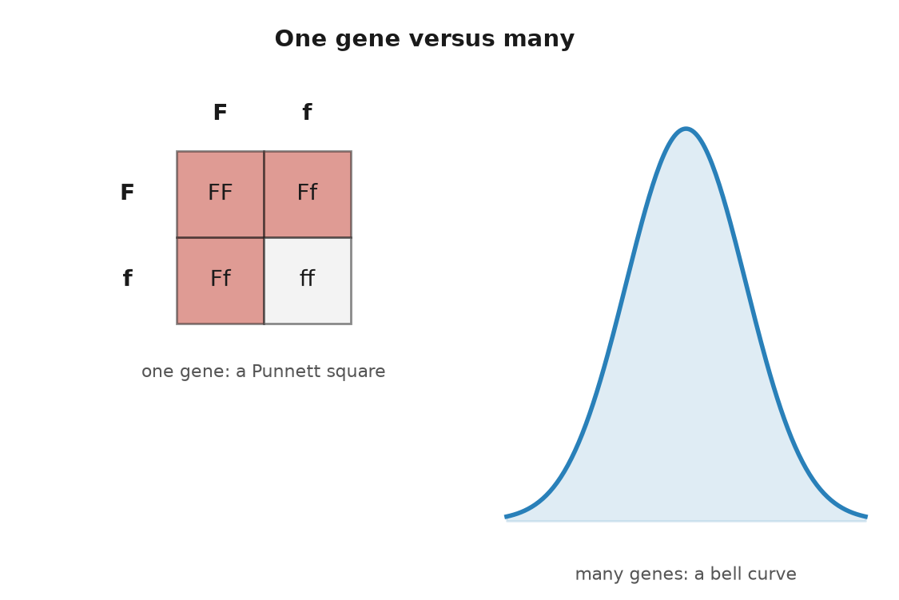
Figure 13. A Punnett square for one gene beside the bell curve that thousands of genes produce.
* * *
Then there is the middle, where most of what we can see about each other lives.
Height is the classic. Francis Galton measured 928 adult children and their parents in the 1880s and noticed that the children of very tall parents were tall but not as tall, and the children of very short parents short but not as short; he termed it regression toward mediocrity, and the statistical idea of regression is his. Height sits on a bell curve, with no clean categories, and the early Mendelians and the biometricians who studied such curves spent the 1900s arguing about whether Mendel's rules could possibly apply to it. In 1918 Ronald Fisher settled the matter on paper: if a trait depends on many genes, each with a small effect, each following Mendel's rules, the sum comes out as a bell curve. Both sides were right.
The count was filled in a century later. In October 2022 a consortium led by Loïc Yengo published in Nature an analysis of 5.4 million people and identified 12,111 positions in the text where a single-letter variant is associated with height. Together they account for about 40 percent of the variation in height among people of European ancestry, and considerably less in people of other ancestries, because most of the 5.4 million were European and the markers travel badly. The variants are not spread evenly; they cluster in about a fifth of the genome, near genes that build cartilage and bone. Twelve thousand levers, each moving the needle by a fraction of a millimetre.
Skin colour is another. A single variant in a gene called SLC24A5, found in 2005 by Keith Cheng's laboratory after they noticed a pale mutant of the zebrafish, is nearly universal in Europeans and nearly absent in West Africans, and accounts for a large share of the difference in pigmentation between those two groups. It is one of a dozen or more genes with detectable effects, including SLC45A2, OCA2, MC1R and KITLG, and a 2017 study of African populations by Sarah Tishkoff's group showed that much of the variation at these genes is far older than our species, so that light and dark alleles were both in circulation before there were humans to carry them.
Theo's freckles belong here, with a footnote. MC1R is a major gene for freckling, and a person with a strong variant will usually freckle; how many and how dark depend on other genes and on the sun. Anna's switch, from her father, is Mendelian and dominant. Two traits at the same table, one governed by a square and one by a curve.
Which brings in the word that causes more confusion than any other in this field. Height is said to be about 80 percent heritable. That does not mean that 80 percent of a person's height came from the genes and 20 percent from breakfast. Heritability is a statistic about a population, not a fraction of a person. It is the share of the variation in a trait, among the people in a particular population living in a particular range of environments, that can be attributed to the genetic differences between them. Change the population or the environment and the number changes.
Two examples pin this down. The number of fingers a person has is obviously genetic, and its heritability is close to zero, because almost all the variation in finger count comes from accidents. And Dutch men grew about 20 centimetres taller between the 1850s and the 1990s while the heritability of height stayed high throughout; the genes explained who was taller than whom in each decade, and the food explained why every decade was taller than the last. High heritability says nothing about whether a trait can be changed. It says how much of the spread, here and now, tracks the text.
The numbers come mostly from twins. Identical twins share essentially all their text; fraternal twins share half on average, like any siblings. If a trait runs more alike in identical pairs than in fraternal pairs, the excess is attributed to genes, and the geneticist Douglas Falconer gave the formula: twice the difference between the two correlations. A 2015 review in Nature Genetics by Tinca Polderman and colleagues gathered 2,748 twin studies covering 17,804 traits in 14.5 million pairs, and found that the average heritability across everything ever measured in twins was about 49 percent. The method has known weaknesses. It assumes that identical and fraternal twins are treated equally alike, which is not quite true. It cannot say which genes. It counts a child who inherits both a musician's genes and the family piano as a genetic effect. And it describes one population at one time. Within those limits, it is settled that almost every human trait anyone has bothered to measure is heritable to some degree, and that almost none is heritable entirely.
Even 80 percent leaves a fifth of the story to something else, and for height, as for the rest, the something else begins before birth.

14. What Is Not in the Genes
In September 1944 the Dutch government in exile called a railway strike to help the Allied advance, and the German administration in the occupied Netherlands answered by cutting food shipments to the west of the country. Then the canals froze. By the turn of the year the cities of the west, Amsterdam, Rotterdam, The Hague, Leiden, were on an official ration that fell through the winter to somewhere between 400 and 800 calories a day, less than a third of what an adult needs. People walked out to the farms to trade linen for potatoes. They ate sugar beets and tulip bulbs. Estimates of the deaths run from about 18,000 to 22,000. Relief came at the end of April 1945, with bombers dropping food instead of bombs, and liberation on 5 May.
The winter was brief and sharply bounded, and the Dutch, who kept careful records even in the worst of it, had unknowingly built the cleanest natural experiment in human nutrition that exists. Every child conceived or carried in those months has a known date and a known exposure. In 1976 Gian-Paolo Ravelli, Zena Stein and Mervyn Susser published in the New England Journal of Medicine a study of about 300,000 nineteen-year-old men examined for military service, and reported that those who had been in the first half of gestation during the famine were markedly more likely to be obese, reported as close to double the rate of the unexposed. Later work by Susser, Hans Hoek and others found that people conceived at the height of the hunger were about twice as likely to develop schizophrenia. Tessa Roseboom and colleagues in Amsterdam followed the cohort into their fifties and sixties and added heart disease, glucose intolerance and several other conditions. These associations are settled: measured, and repeated for half a century.
In 2008 Bas Heijmans and colleagues at Leiden published in PNAS a first look at a mechanism. They took blood from 60 people who had been conceived during the famine and compared them, six decades on, with their own same-sex brothers and sisters who had not been. At a regulatory region of the gene IGF2, which governs growth in the fetus, the famine group had less methylation, a chemical tag on the DNA that turns a gene up or down without changing its letters, by about 5 percent, than their siblings. The effect was small. It was consistent. And it had been laid down in the first ten weeks of a pregnancy in the winter of 1944 and was still there in 2008.
Hold onto what that means. The text of those people was fixed at conception and did not change. What their mothers ate in the first ten weeks altered how the text was read, and the alteration lasted. The tube in the mailbox reads letters. It does not read winters.

Figure 14. A bare field in winter, furrows and nothing in leaf.
* * *
Three things are not in the genes, and the first, environment, is the one everybody grants. The second is development, and the third is chance, and the two are hard to separate, so take them together with the tightest possible test: two people with the same text.
Identical twins come from one fertilised egg that split, and for most of the twentieth century they were treated as genetically identical by definition. In 2021 a group at deCODE in Iceland led by Hákon Jónsson sequenced 381 pairs, with their parents and children, and reported in Nature Genetics that a typical pair differ at about five positions, mutations that arose in the first few cell divisions after the split, and that some pairs differ at more than a hundred. So "identical" is an average. What is more striking is how different the outcomes can be when the text is the same. If one identical twin develops schizophrenia, the chance that the other does is reported at roughly half. For type 1 diabetes the concordance is reported in the range of 30 to 50 percent; for multiple sclerosis, roughly 25 to 30 percent. Half the time or more, the co-twin escapes, with the same letters.
Fingerprints are the miniature, exact version of this. The ridges on the fingertips form between roughly the tenth and sixteenth week of gestation, where the skin buckles under pressure from the growing pads beneath it and the fluid around it, and the pattern depends on the geometry of that moment: the fetus's position, the blood pressure in the finger, the exact rate of growth that week. Identical twins have similar types of pattern, loops or whorls, and distinct prints, which is why Francis Galton, who published the first systematic book on fingerprints in 1892, could recommend them for identification, and why Scotland Yard began using them in 1901. Nothing in the text specifies a print. The text specifies a process, and the process has noise in it.
The noise goes deeper than skin. The tiny roundworm Caenorhabditis elegans has exactly 959 cells as an adult, every one of them arising by a lineage that is the same in every worm, and worms can be bred so that all have the same text and can be kept in the same dish at the same temperature on the same food. They still die at varying ages, spread over days in a life of two or three weeks. Nobody arranged that. Molecules jostle, a gene fires a little early in one cell and a little late in another, and the differences ripple outward. Some of the variation in any population, and nobody knows exactly how much, is nothing more than this.
* * *
The third thing not in the genes is the one that the word "genetic" most misleads people about, and the clearest case is a disease that is entirely genetic and entirely preventable.
In 1934 a Norwegian physician, Asbjørn Følling, examined two young siblings with severe intellectual disability whose mother had noticed a strange musty smell in their urine, and found that the urine contained phenylpyruvic acid. The condition was named phenylketonuria, PKU. It is recessive and caused by variants in PAH on chromosome 12, whose enzyme breaks down the amino acid phenylalanine. Without it, phenylalanine from ordinary food piles up and poisons the developing brain. In 1953 Horst Bickel in Birmingham showed that a diet nearly free of phenylalanine, started early, prevents the damage, and in 1963 Robert Guthrie's heel-prick test made it possible to find the affected babies in the first days of life, which is where universal newborn screening began. About 1 baby in 10,000 of European ancestry has PKU, with the rate varying widely between countries. On the diet, they grow up with normal intelligence.
Consider the heritability. In a world where everyone eats ordinary food, PKU is close to 100 percent heritable; who has it is decided by the text and nothing else. In a world with the diet, the disability disappears and the genes are unchanged. The heritability of the disease, as a disease, drops toward zero, not because the genes have changed but because the environment has. A high heritability, as the last chapter said, is a statement about the spread in one setting. It is not a sentence.
The same logic runs the other way. Short sight is highly heritable in every population that has been measured, and in the cities of East Asia its prevalence in young adults has risen to reported levels of 80 to 90 percent within two generations, a change far too fast for the text to have moved. What moved was childhood: more hours indoors, less bright light. A gene that raises the risk of myopia raises it in a child who reads indoors; in a child who herds goats, the same gene may do very little. There is no such thing as the effect of a gene. There is the effect of a gene in an environment.
What about the other direction: could a grandmother's environment have left a mark on the text that a grandchild received? Not on the letters; that is Chapter 10's business, and the letters mutate by their own chemistry, not by need. The candidate is the layer of marks on top of the letters, the methyl groups and histone tags of Chapter 9, which decide which parts of the text are read in which cell. Within one body these marks are settled science; they are how a liver cell's daughters stay liver cells. The question is whether an acquired mark can cross into the next generation.
The problem for mammals is that the marks are wiped, twice. When the cells that will become eggs or sperm are first set aside in the embryo, their methylation is stripped almost entirely and rewritten, and after fertilisation most of what remains on both the egg's and the sperm's contribution is stripped again. A mark acquired in 1950 would have to survive the first wipe in the grandmother's ovaries, be laid down in the egg that became the daughter, survive the second wipe in the embryo, survive the first wipe again in the daughter's fetal ovaries, and survive the second wipe again in the grandchild. Some things do survive, by design: the imprinted genes, of which IGF2 is one, keep a parent-specific mark on purpose. A few stretches of repetitive DNA escape by accident.
In plants and worms the story is different, and it is settled. Plants set aside no early germ line, no cells reserved from the start to become eggs or sperm; their flowers grow late from ordinary tissue, and a methylation state can pass down unchanged for many generations. Linnaeus described a toadflax in 1744 whose flowers were radially symmetrical instead of the usual snapdragon shape, and in 1999 Enrico Coen's group at Norwich showed that the difference was not a change in the letters of the gene concerned but a heavy methylation of it, inherited as if it were a mutation. In maize, one allele can permanently reprogram its partner, a phenomenon called paramutation that Alexander Brink described in 1956. In the roundworm, tiny RNA molecules made in response to a virus or to starvation are passed through eggs and sperm and keep working in descendants for three or more generations, as Oded Rechavi's group showed in 2011 and 2014.
In mice there is one famous case and a handful of contested ones. The agouti viable yellow mouse carries a jumping element parked next to the coat-colour gene Agouti; whether the element is methylated is set partly at random in each embryo, and unmethylated mice come out yellow and fat, methylated ones brown and lean. In 2003 Robert Waterland and Randy Jirtle showed that feeding pregnant mothers extra methyl donors, folate, vitamin B12, choline and betaine, shifted the litters toward brown. That is a diet in the womb changing a mark in the offspring, and it is settled. Whether the shift persists into the grandchildren, past the wipes, is weaker, and the studies reporting it have been hard to repeat. Sperm from male mice on a high-fat diet carry altered tiny RNAs that affect their pups' metabolism, which is a working result, not yet a settled one.
In humans the evidence for transmission across generations, as opposed to exposure in the womb, is thin. There is a distinction that matters here. When a pregnant woman starves, three generations are in the room: the woman, the fetus, and the fetus's germ cells, which will become the grandchildren. Effects in the grandchildren are not evidence that anything crossed a generation; they may be direct exposure, once removed. Only the great-grandchildren would tell. Studies from the Swedish parish of Överkalix, published by Marcus Pembrey and Lars Olov Bygren in 2006, reported that a grandfather's food supply as a boy was linked to his grandsons' lifespans, in a small population with many possible confounders; the result has been much cited and not convincingly repeated. I think the honest summary is this: in humans, intergenerational effects through the womb are settled, transgenerational epigenetic inheritance through the germ line is speculative, and the burden of proof sits with the claim.
That leaves Lamarck, who in 1809 proposed that features acquired by use or disuse were passed on, the giraffe's stretched neck to its calf, and whose name has been attached to every version of the idea since. Darwin himself accepted a version of it. It was August Weismann, in the 1880s, who argued that the germ line is sealed off from the body, and who reported cutting the tails off several hundred mice across five generations without producing a single short-tailed pup, a demonstration that was mocked at the time and is decisive anyway. The seal is real, and it leaks a little at the edges, through imprinted genes and tiny RNAs, and nothing that leaks through carries information about what an animal did or wanted. The ghost is mostly still a ghost, and where it is not, it is a few marks, for a few generations, by a mechanism Lamarck never imagined.
Ruth's freckles reached Theo because a stretch of letters was copied twice and came through both times intact; the winter of 1944 reached its children, perhaps their children, and then stopped, because it was never written in the letters to be copied. What the letters do carry, and in what proportions, was first counted, with a paintbrush and a very large amount of patience, by a friar in a garden in Moravia.

PART IV — The Monk

15. Brno, 1856: Peas in a Garden
The garden is a strip of ground about thirty-five metres long and seven wide, along the south wall of an Augustinian abbey in the Moravian town of Brünn, which is now Brno in the Czech Republic. It is the spring of 1856. A stout man in a friar's habit is kneeling among the pea plants with a pair of fine forceps and a small brush of the kind painters use for detail. He opens a flower bud that has not yet unfolded, picks out the ten immature stamens one by one, and drops them into a dish. Then he touches the brush to the open flower of a different plant, carries back a dusting of yellow pollen, and paints it onto the stigma of the flower he has just stripped. He slips a little bag over the flower, ties it, writes a label. Then he moves to the next bud.
He will do this, by his own account, for eight growing seasons, and he will raise and score something like 28,000 plants before he is done. Nobody has asked him to. Nobody is paying him. The result will be the first quantitative law of inheritance, and almost nobody will read it for thirty-five years.
The man's name was Gregor Mendel, and it had not always been. He was born Johann Mendel on 20 July 1822 in Heinzendorf, a village of German-speaking farmers in Austrian Silesia, now Hynčice in the Czech Republic. His father, Anton, worked a modest farm and owed the local landowner three days of labour a week. Johann was clever, and the village priest noticed. He was sent to the Gymnasium in Troppau and then to the philosophical institute in Olmütz, and the family's money ran out along the way. His younger sister Theresia gave up part of her dowry to keep him in school. He fell ill more than once with what the records call nervous exhaustion and spent months at home in bed. A farm boy with a gift for mathematics and no money had, in the Austrian Empire of the 1840s, one reliable route to a life of study, and in 1843 he took it. He entered the Augustinian abbey of St Thomas in Brünn as a novice and was given the name Gregor.
The abbey was an unusual house. Its abbot, Cyrill Napp, ran it less like a place of prayer than like an unassuming college. The friars taught in the town's schools, kept a library of several thousand volumes, maintained a mineral collection and a botanical garden, and counted a composer, a philosopher, and a plant breeder among their number. Moravia was sheep country and orchard country, and its landowners were seriously interested in better wool and better fruit. Napp himself had chaired a society for the improvement of sheep, and he had written, in the course of that work, that the real question was not whether traits were inherited but what was inherited and how. It is hard to imagine a better landlord for what Mendel was about to do.
Mendel was ordained in 1847. He was a poor parish priest; visiting the sick made him ill himself, and Napp moved him into teaching instead. He was good at it. In 1850 he sat the state examination for a teacher's licence, in Vienna, and failed. The examiners found his natural history patchy and his physics self-taught, which it was. What they did not find was any lack of ability, and one of them suggested that the abbey send him to university. Napp did. From the autumn of 1851 to the summer of 1853 Mendel was a student at the University of Vienna.
The physics there was taught by Christian Doppler, the man whose name is on the change in pitch of a passing siren. Doppler had set up the Physical Institute in Vienna the year before Mendel arrived, and he taught physics as a thing done with instruments and repetition, not a thing read about. Mendel also took mathematics from Andreas von Ettingshausen, including combinatorics, the arithmetic of how many ways things can be arranged. He took plant physiology from Franz Unger, who was already arguing, several years before Darwin's book, that plant species were not fixed and that new forms arose from old. It was an odd education for a friar and exactly the right one for the problem he would choose. Unger gave him the puzzle, Doppler the habit of measurement, and Ettingshausen the arithmetic to read the answer.
He sat the teaching examination a second time in 1856 and did not complete it. The accounts differ; the usual one is that he fell ill during the oral, and one biographer suggests a quarrel with an examiner. He went back to Brünn, taught physics and natural history at the town's technical school as a substitute for the next fourteen years, and that same spring began the crosses in the garden.
* * *
Why peas? The choice was not casual, and Mendel says so on the first pages of his paper. He wanted a plant that came in clearly different forms, that bred true when left alone, that could be crossed by hand when he wished, and whose hybrids were as fertile as their parents. The garden pea, Pisum sativum, passed on every count.
The crucial property is the flower. A pea flower is built like a small boat. Two lower petals are fused into a keel, and the keel wraps the stamens and the pistil so closely that pollen from outside almost never gets in. The plant fertilises itself, usually before the flower has opened. A pea variety will therefore breed true for generation after generation, wrinkled giving wrinkled and tall giving tall, because nothing from outside is mixing in. This gave Mendel pure lines to start from. It also meant that when he wanted a cross he had to make it himself, and that when he had made it he could be nearly certain the pollen he painted on was the only pollen involved. The bags were insurance against the pea weevil and the occasional determined bee.
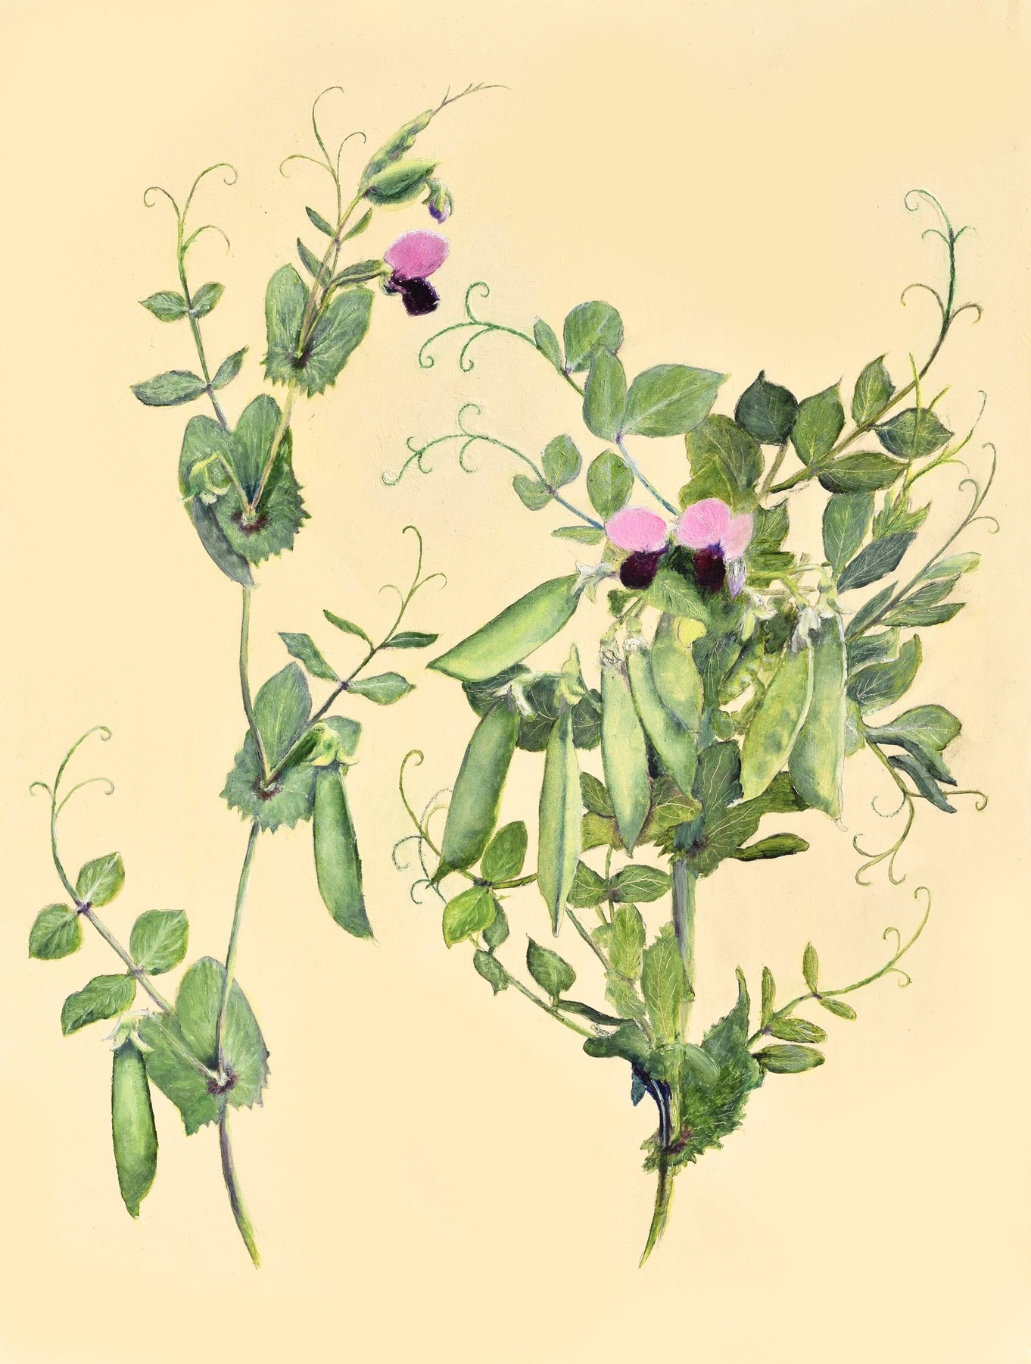
Figure 15. A drawing of Mendel's pea flowers and pods.
Others had crossed plants before him, and some had done far more of it. Joseph Kölreuter in the 1760s and Carl Friedrich von Gärtner in the 1840s had between them performed thousands of crosses across hundreds of species. Gärtner's book of 1849 runs to some 800 pages, and Mendel read it closely. What none of them had done was count. They had asked whether hybrids were possible, whether they were fertile, whether they resembled one parent or the other or something in between. They had not sown the hybrids' seed, grown every plant, sorted the offspring by a single trait, and written down how many fell on each side. Mendel put his finger on this in the second paragraph of his paper. Nobody, he wrote, had determined the numbers of the various forms in each generation or their statistical relations. That sentence is the whole difference.
Before starting, he did something that separates him from nearly every hybridiser before him. He bought thirty-four varieties from seed merchants and grew them for two years, 1854 and 1855, simply to see whether each bred true. Twelve failed the test or were too close to others and were dropped. Twenty-two remained. This is the first step of a controlled experiment, establishing what your starting material does when you do nothing to it, and it is why his later numbers meant something.
Then he chose the traits. Pea varieties differ in dozens of ways, and most of the differences shade into one another. Mendel wanted characters that were either one thing or the other, with nothing between, so that a seed or a plant could be scored with a glance and no judgement. He settled on seven. The seed was round or wrinkled. The cotyledons, the seed's own first pair of leaves, packed inside it, were yellow or green. The seed coat was grey-brown or white, and this went with the flower colour, violet or white, so tightly that he treated the two as one character. The ripe pod was inflated or pinched in between the seeds. The unripe pod was green or yellow. The flowers grew along the stem, in the leaf axils, the narrow angles where each leaf meets the stem, or bunched at the top. The stem was long, around two metres, or short, well under half a metre.
Seven is a number people have wondered about since, because the pea has seven pairs of chromosomes, and it has been suggested that Mendel picked one trait per chromosome by luck or by cunning. Neither is right. He knew nothing of chromosomes, and later mapping showed that several of his seven characters sit on the same chromosome, far enough apart that the effect he would have needed to notice was small. He chose seven because seven gave him clean yes-or-no scoring, and he said so.
The work of the eight seasons was mostly labour. Each cross meant opening buds, removing stamens, painting on pollen, bagging, labelling, and later harvesting each pod separately and counting what was in it. The reciprocal crosses had to be done too, round pollen onto wrinkled flowers and wrinkled pollen onto round, so that he could show it made no difference which parent supplied which. Then the hybrid seeds had to be sown, grown, and left to fertilise themselves, and their seeds harvested and counted, and those sown in turn. For seed shape and seed colour the answer was visible in the pod, and one plant could yield dozens of data points. For stem length or flower position each plant was a single data point and had to be grown to maturity. He raised tall and short varieties on the same plot so that soil would not confound the result, and he watched for that sort of confounding throughout. In the greenhouse he ran checks on whether flowers under bags gave the same results as flowers in the open.
Scoring was a physical job, not a judgment. Round seeds and wrinkled seeds were sorted into dishes and counted, pod by pod, and the dishes were the data. A seed that was neither clearly round nor clearly wrinkled would have wrecked the ratio, which is why he had spent two years throwing out varieties that shaded. The paper does not describe a statistical test, because the tests had not been invented. It describes piles.
It was weather-dependent work, and Mendel was one of Moravia's most diligent recorders of weather. He kept daily readings for decades, published on the climate of Brünn, sent monthly reports to the meteorological service in Vienna, and once wrote a careful account of a tornado that crossed the abbey grounds. He kept bees and tried to cross them and failed, because he could not control whom a queen met in the air. The peas were the one system where he controlled everything.
The question Mendel had posed is the physicist's version of a family puzzle. Not "what is inherited," which was everyone's puzzle, but "in what proportions, and does the proportion hold." Doppler's student asked it of a pea.
By the autumn of 1863 the crosses were finished. Mendel had, in his notebooks, counts from roughly 28,000 plants and a great many more seeds, and he had two winters in which to work out what the numbers meant.

16. The Ratios
Five thousand four hundred and seventy-four round. One thousand eight hundred and fifty wrinkled. The numbers are on a page of a paper published in Brünn in 1866, and they are the moment the subject of this book stops being a matter of opinion. Divide one by the other and you get 2.96. Mendel wrote it as 2.96 to 1 and then, in the next breath, as what it plainly was: 3 to 1.
Here is how the numbers arose. Take a pea variety that has bred true for round seeds and one that has bred true for wrinkled. Cross them, either way round. Every seed in the resulting pods is round. Not mostly round, not a bit less wrinkled than the wrinkled parent; round, indistinguishable from the round parent's own seed. The wrinkled character has vanished. Sow those round hybrid seeds, let the plants fertilise themselves, and open the pods. The wrinkled character is back, unchanged, in about a quarter of the seeds. In Mendel's 253 hybrid plants that was 5,474 round and 1,850 wrinkled.
He called the character that showed in the hybrid dominant, and the one that hid, recessive. Both words are still in use. He then did the same for the other six characters and got the same shape of answer each time. Yellow cotyledons beat green, 6,022 to 2,001. Grey-brown seed coats beat white, 705 to 224. Inflated pods beat constricted, 882 to 299. Green unripe pods beat yellow, 428 to 152. Flowers along the stem beat flowers at the top, 651 to 207. Tall beat short, 787 to 277. Added up across all seven, 14,949 to 5,010, which is 2.98 to 1.
Character | Dominant form | Recessive form | Ratio
Seed shape | 5,474 round | 1,850 wrinkled | 2.96
Seed colour | 6,022 yellow | 2,001 green | 3.01
Seed coat and flower | 705 grey-brown, violet | 224 white | 3.15
Pod shape | 882 inflated | 299 constricted | 2.95
Unripe pod colour | 428 green | 152 yellow | 2.82
Flower position | 651 axial | 207 terminal | 3.14
Stem length | 787 long | 277 short | 2.84

A ratio that turns up seven times in seven different characters is not a fact about seed shape. It is a fact about how inheritance works. Mendel saw that, and then he did the thing that makes him Mendel rather than a lucky gardener. He asked what was underneath the 3.
* * *
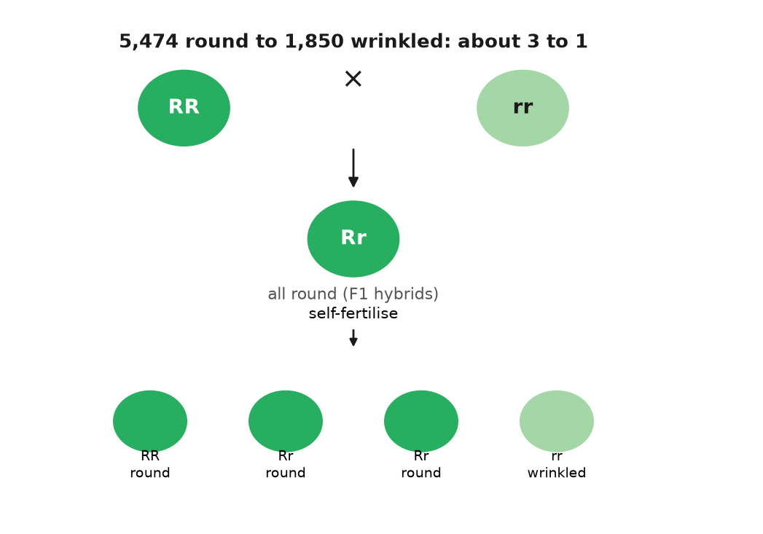
Figure 16. 5,474 round seeds to 1,850 wrinkled: about 3 to 1.
The answer came from the next generation. He took the round seeds from the hybrids' pods, the three quarters, and sowed them. Some of those plants bred true: every seed round, generation after generation, exactly like the original round parent. Others did not: they gave round and wrinkled again, in the same 3 to 1. He counted. Of 565 plants grown from round hybrid seed, 193 bred true and 372 threw wrinkled seed. That is 1 to 1.93, and Mendel took it as 1 to 2. So the three quarters were not one thing. One quarter of the whole were true round, two quarters were round-looking hybrids, and one quarter were wrinkled. The 3 to 1 on the surface was a 1 to 2 to 1 underneath.
He wrote the underlying series as A + 2Aa + a, and that notation contains the whole theory. Each plant carries two factors for a character, one from each parent. A pure round plant is AA; a pure wrinkled plant is aa. The hybrid is Aa, and looks round because A is dominant. Dominant, here, does not mean common, and it does not mean healthy. It means that one copy is enough to show. A recessive character can be the ordinary one in a population, and a dominant one can be rare. The words describe the hybrid, not the world.
When the hybrid makes pollen or eggs, each grain or egg gets one factor, not both and not a blend, and it gets A or a with equal odds. Combine a random pollen grain with a random egg and you get AA one time in four, Aa two times in four, aa one time in four. That is the 1 to 2 to 1. Since AA and Aa look alike, it appears as 3 to 1. The recessive character had not been destroyed or diluted in the hybrid. It had been carried, whole and silent, and handed on.
This is what later textbooks call segregation, and it is worth pausing on how strange it was. Every theory of inheritance before Mendel, and Darwin's own theory after him, assumed that the contributions of two parents mixed in the child like two inks in water. Mendel's numbers said they did not. They said inheritance was made of particles that kept their identity, that a plant carried two of each and passed on one, and that which one was a matter of chance with fixed odds. The A and the a of 1866 are, at a distance of a century and a half, the two copies of a gene that every reader of this book carries at every position on every pair of chromosomes.
A neighbour's garden makes the same mechanism concrete without pretending a person is a pea. Suppose a tall pea, Aa, is planted next to a short one, aa. The tall plant looks tall. It tells you nothing about the silent a it is carrying. Cross them and about half the offspring are short. The short ones reveal the a that the tall parent had hidden, exactly as the wrinkled factor was hidden in the round hybrid, and the two-thirds-to-one-third arithmetic of Mendel's 565 plants would have given the odds of it. That is the entire content of a genetic counsellor's first sentence, and a friar counted it out in 1864. Human freckles are not this clean. They depend on several genes, the best known being MC1R, and on sunlight. The pea is the rule. The neighbour's tall plant is the picture. A face is not.
Then Mendel did the experiment that turned one law into two. He crossed a plant with round yellow seeds to one with wrinkled green seeds. The hybrids were all round and yellow, as expected. He let them self-fertilise and opened 556 seeds. There were 315 round yellow, 101 wrinkled yellow, 108 round green, and 32 wrinkled green. Look at shape alone and it is 423 round to 133 wrinkled, about 3 to 1. Look at colour alone and it is 416 yellow to 140 green, about 3 to 1. Each character had done its own thing without any regard to the other, and two independent 3 to 1s multiply out to 9 to 3 to 3 to 1. He tried three characters at once and got the 27-way series that theory predicted. The factors, whatever they were, were not only particles. They were separately dealt particles, shuffled without regard to one another.
That second rule, independent assortment, has a catch that Mendel could not have found with his seven characters, and it is an honest one to state now. Factors are dealt independently only when they sit on different chromosomes, or far apart on the same one. Factors that sit close together on the same chromosome tend to travel together, and the ratios bend. William Bateson and Reginald Punnett saw this in sweet peas in 1905, with flower colour and pollen shape refusing to give 9 to 3 to 3 to 1, and it took a room full of flies in New York, two chapters from here, to explain it. Mendel's rule is right as far as it goes. The catch is a fact about where the factors live, which he had no way to know.
What the factors were, at the level of molecules, took another 125 years. In 1990 a group in Norwich showed that the wrinkled seed is a pea whose gene for a starch-branching enzyme has been broken by a jumping piece of DNA about 800 letters long; the seed makes less starch, holds less water, and wrinkles as it dries. The short stem, identified in 1997, is a broken gene for an enzyme that makes the growth hormone gibberellin. The green cotyledon is a gene that fails to break down chlorophyll. By 2011 four of Mendel's seven had been pinned to a specific gene and a specific change, and more have been narrowed down since. Every one of them is a case of the copy being inexact somewhere in a pea's ancestry, and of the inexact copy being carried, whole and recessive, until Mendel counted it.
* * *
On the evening of 8 February 1865, in the hall of the Realschule in Brünn, Mendel read the first half of his results to the Natural History Society of the town. About forty people came. He read the second half on 8 March. The minutes record no questions worth noting. The paper, "Versuche über Pflanzen-Hybriden," Experiments on Plant Hybrids, was printed in the Society's Proceedings for 1865, which appeared in 1866, and ran to about forty pages. The Proceedings went out by exchange to something like 120 libraries and societies across Europe and beyond, including the Royal Society and the Linnean Society in London. Mendel ordered forty offprints and sent them to botanists he thought would care.
Almost nobody did. Between 1866 and 1900 the paper was cited perhaps a dozen times, mostly in passing and mostly wrongly, as one more study of whether hybrids were stable. The largest of the botanical handbooks of the period, Wilhelm Olbers Focke's Die Pflanzen-Mischlinge of 1881, mentioned Mendel briefly and missed the point. Darwin's own copy of that book is in the Darwin collection at Cambridge University Library. Andrew Sclater, writing in the Journal of Biosciences in 2006 after the copy had been examined, reported that pages 108 to 110, the pages that mention Mendel's peas, were never cut. An opened page would not have handed Darwin the ratios either, because Focke did not say what Mendel had found. The story that Darwin owned an uncut offprint of Mendel's own paper is a different claim, and there is no credible evidence for it.
Why the silence? Part of it was framing. Mendel had presented his work as a contribution to the hybrid question, an old debate about whether crossing could make new species, and his readers filed it there. Part of it was the audience. Botanists of 1866 did not think in ratios; a paper whose central claims were 3 to 1 and 9 to 3 to 3 to 1 read to them like a paper about arithmetic, not about plants. Part of it was the one expert Mendel did reach. He wrote to Carl Nägeli in Munich, a leading botanist, and Nägeli answered politely, doubted the generality of the result, and steered Mendel toward hawkweed, a plant that, as it turned out, sets seed without fertilisation and could not have shown the ratios if it tried. Mendel spent years on it and got nothing.
And part of it, I think, was that the discovery had arrived before anyone knew what to ask. Nobody in 1866 was asking what the particles of inheritance were, because nobody was sure there were particles. Darwin's book was seven years old and its weakest point, as its critics said at once, was that blending inheritance should swamp any new variation in a few generations. Mendel's peas were the answer to that objection. They were sitting in 120 libraries, and the man who most needed them never saw them.

17. Lost for Thirty-Five Years
In the spring of 1900 Carl Correns, a botanist at Tübingen, had a result he was proud of and a footnote he had not followed up. He had spent several years crossing peas and maize and had observed, in the second generation of his hybrids, a 3 to 1 split that he could explain with a neat model of paired factors segregating. The footnote was in Focke's handbook and pointed to a paper by a Brünn friar. Correns went to the library, read it, and discovered that the friar had done all of it, more carefully and with more plants, thirty-four years earlier. Correns titled his own paper, submitted to the German Botanical Society in April 1900, "G. Mendel's Rule Concerning the Behaviour of the Progeny of Racial Hybrids." He gave the credit in the first line.
He was not alone. In March 1900 Hugo de Vries in Amsterdam had published a short note in French reporting the same 3 to 1 in a range of plant species, without mentioning Mendel; a longer German version, printed shortly afterwards, did mention him. In June 1900 Erich von Tschermak in Vienna published pea crosses of his own and cited the 1866 paper. Three botanists in three countries, within three months, and all of them tracing to a dead abbot in Moravia. Historians have since argued that Tschermak did not fully grasp what he was citing, and that de Vries may have encountered Mendel before he found the ratio rather than after. The ordinary account of a triple independent rediscovery is probably too tidy. What is not in doubt is that in 1900 the paper came back from the dead and stayed alive.
The scramble over who was first is worth a paragraph, because it shows what "lost" had meant. De Vries had the ratio in several species and, in the French note of March 1900, did not mention Mendel. Correns had read Focke's footnote, gone to the 1866 paper, and saw his own result already in print. He then saw de Vries's note, and the German version of his own paper, which does cite Mendel, followed within weeks. Whether de Vries had known the paper before he counted, and only remembered it when a rival appeared, is still argued. Tschermak's June paper cites Mendel and reports pea numbers, and later readers have doubted that he understood the 1 to 2 to 1 underneath the 3 to 1. The tidy story of three independent discoveries is too clean. The untidy one is enough. A paper that had sat in about 120 libraries for thirty-four years became, in one spring, the thing every hybridiser had to answer.
Mendel had not lived to see it. He was elected abbot of St Thomas on 30 March 1868, after Napp died, and the election ended his research. He wrote to Nägeli that the new duties left him no time; the surviving letters, which run from 1866 to 1873, show a man doing hawkweed crosses at the edges of an administrator's day and getting results that seemed to contradict his peas, because hawkweed, unknown to anyone then, produces seed without fertilisation. He published a brief paper on it in 1869 and then nothing more on heredity.
The last decade of his life was eaten by a tax dispute. In 1874 the Austrian parliament passed a law requiring religious houses to pay an assessment on their property into a fund for the clergy. Mendel took the position that the law was unconstitutional and refused to pay the abbey's share. The state answered by placing parts of the abbey's estate under administration. Other abbots settled; Mendel did not, for ten years, and it made him, in the words of more than one contemporary, difficult. He died in Brno on 6 January 1884 of kidney disease with heart failure, aged 61. Leoš Janáček, then a young choirmaster in the town who had been a pupil at the abbey's school, is reported to have played at the funeral. His successor as abbot, Anselm Rambousek, is said to have burned Mendel's papers, and the usual explanation is that he wanted the tax business closed. The notebooks with the counts from 28,000 plants are gone. What survives are the printed paper, the letters to Nägeli, and a few pages of notes.
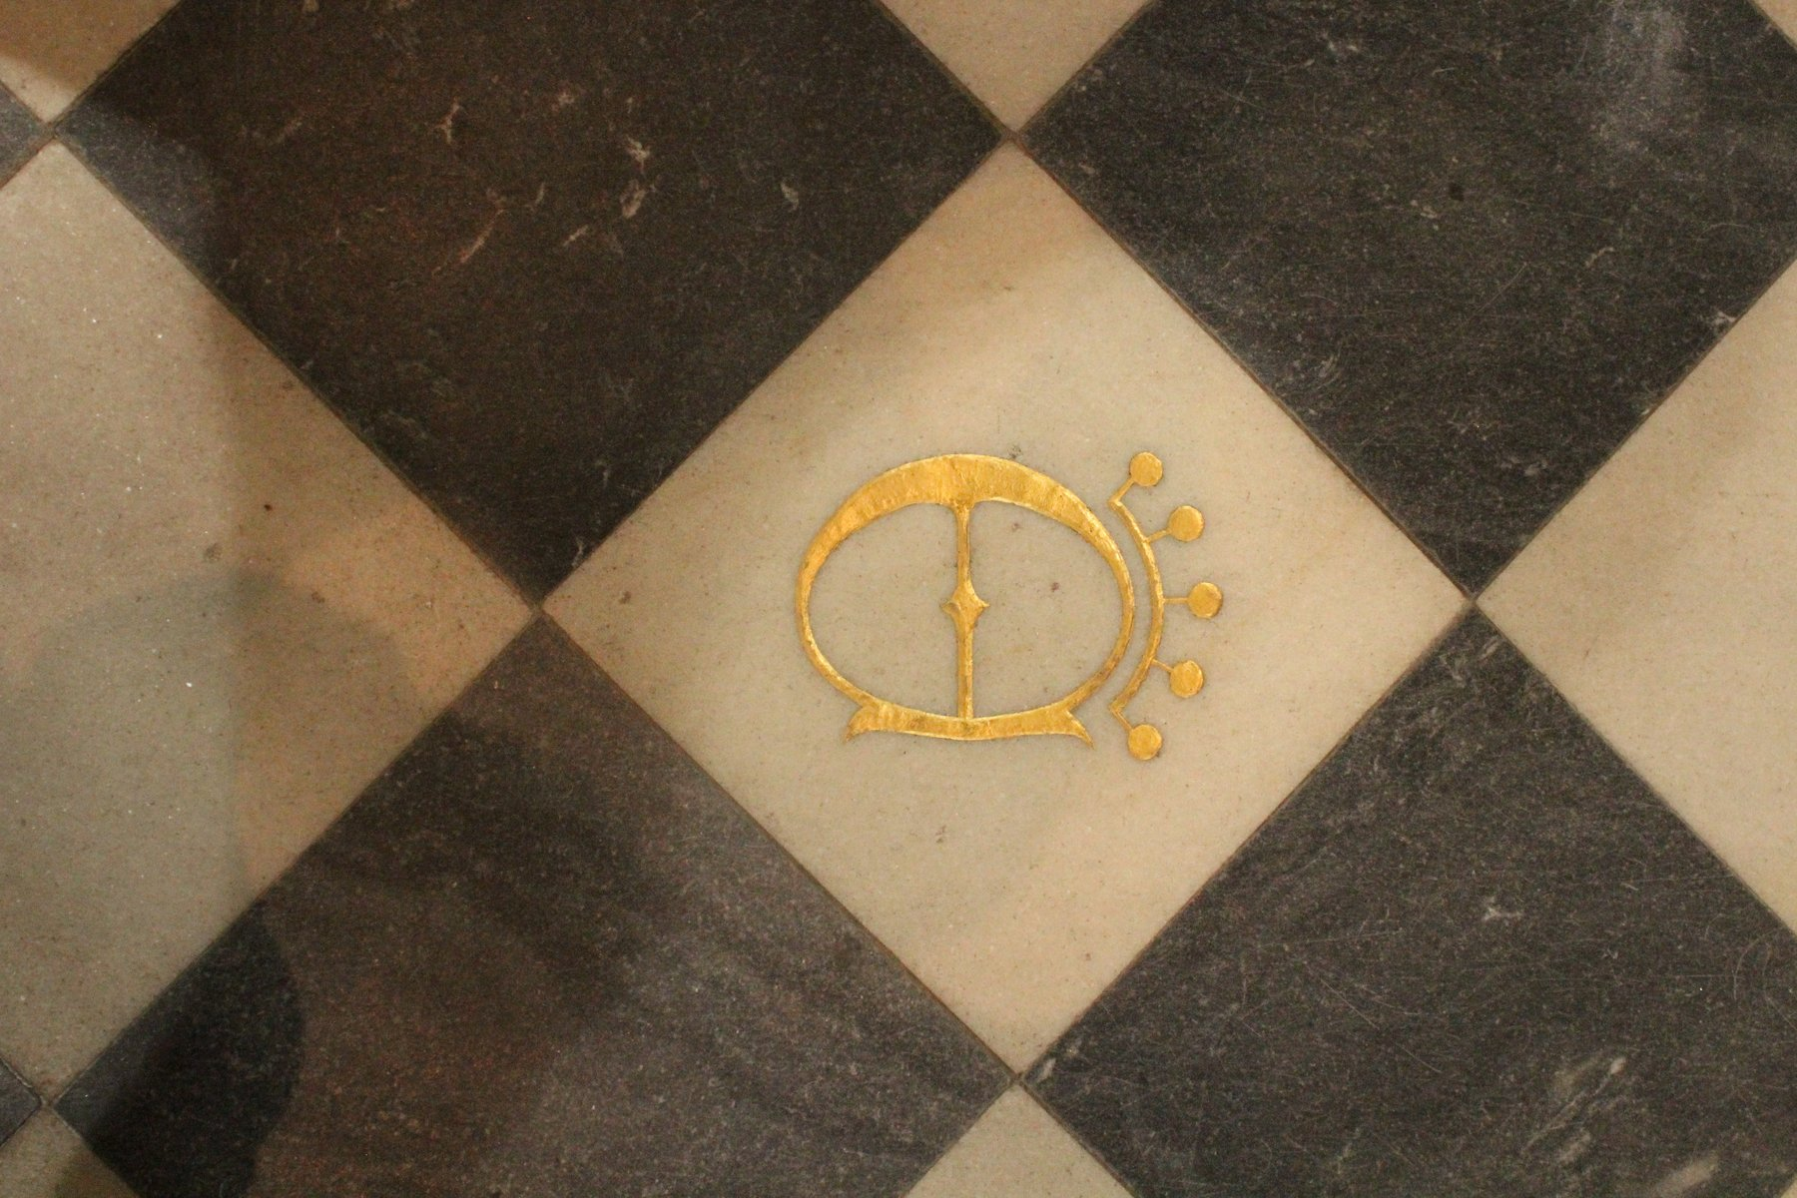
Figure 17. The abbatial church of the Augustinian abbey of St Thomas in Old Brno, the house where Mendel lived.
* * *
The man who did most to make the rediscovery stick was English and had never crossed a pea. William Bateson, a Cambridge zoologist, had spent the 1890s arguing that evolution proceeded by discontinuous jumps and collecting cases of variation to prove it. When he read Mendel in the spring of 1900, he saw at once that the ratios were the mechanism his argument had lacked. He arranged an English translation for the Journal of the Royal Horticultural Society in 1901, and in 1902 he published a short book called Mendel's Principles of Heredity: A Defence. The word "defence" in the title was not decoration. The biometricians, led by Karl Pearson and W. F. R. Weldon at University College London, held that inheritance was a matter of continuous measurement and correlation, in the tradition of Francis Galton, and that a friar's particles were a curiosity. The argument between them was bitter and personal and lasted the better part of a decade.
In the course of it, Bateson named the field. In a letter to Adam Sedgwick dated 18 April 1905 he proposed the word "genetics" for the study of heredity and variation, and in 1906 he used it in public at the Third International Conference on Hybridisation and Plant Breeding in London, whose proceedings appeared under the new name. The word "gene" came three years later, from the Danish botanist Wilhelm Johannsen, in his 1909 textbook on the exact theory of heredity. He cut it down from de Vries's "pangene," which in turn derived from Darwin's "pangenesis," and he meant it as a deliberately neutral term: a unit of account for the thing that segregated, with no claim about what it was made of. Johannsen also gave us "genotype" for the factors a plant carried and "phenotype" for what it looked like, which is the distinction between a visible trait and a silent factor handed on.
He earned the word with beans, not with a definition. In the years before 1909 he grew pure lines of the common bean, self-fertilised for generations, and selected the heaviest seeds and the lightest. Within a pure line, selection did nothing. The heavy seeds did not produce heavier offspring than the light ones, because the differences were the season, the position in the pod, the accidents of growth, and not a factor that could be bred. Between lines, the differences held. A gene, on that evidence, was whatever stayed constant when the visible plant did not. Johannsen could not see it. He could show that blending and training would not move it. That is still a useful way to hold the word. It is a unit of account, not a bead someone had looked at.
Where the factors lived was settled almost as fast. In 1902 and 1903 Walter Sutton, a graduate student at Columbia, was looking at grasshopper sperm. Chromosomes travelled in pairs. Each parent contributed one of each pair. The pairs separated when the sex cells formed. That is exactly what Mendel's factors did.
Theodor Boveri in Würzburg reached the same conclusion from another kind of wreckage. Sea-urchin eggs fertilised by two sperm ended up with the wrong chromosome sets, and the embryos failed in ways that tracked which chromosomes were extra. The visible threads and Mendel's factors moved by the same rules. The threads were a reasonable place for the factors to live. That was the chromosome theory of heredity. It was not yet a proof that one particular factor rode on one particular thread. A room full of flies would be needed for that.
In the years just after 1905, Bateson and R. C. Punnett crossed sweet peas and got a result Mendel's second rule forbade. Flower colour and the shape of the pollen grain did not travel independently. Purple flowers kept company with long pollen. Red flowers kept company with round pollen. Or the reverse, depending on how the parents had been built.
They used two words for it, coupling and repulsion. Their explanation was that certain classes of pollen and egg were produced in extra numbers, a scheme known as reduplication. It saved the counts on paper. It said nothing about where the factors sat.
The association was strong and not perfect. Some offspring carried a combination neither parent had preferred, which is what an occasional exchange of chromosome pieces would produce, though nobody in 1906 drew that picture. Bateson disliked the chromosome explanation for years after the flies had made it obvious. The sweet peas had been the first sight of linkage, described with the wrong cause. The proof still needed a trait you could see and a chromosome you could count in the same animal, which is what the next chapter is for.
* * *
There is one more thing to say about Mendel's numbers, and it is uncomfortable. They are too good.
In 1936 Ronald Fisher, the statistician whose own work had by then joined Mendel to Darwin, went through the 1866 paper with the tool he had done more than anyone to build, the chi-squared test, which measures how far a set of counts strays from what theory predicts. Real counts stray. If you toss a fair coin 400 times you expect about 200 heads, but you would be surprised to get exactly 200, and you would be suspicious of a person who reported exactly 200 on every one of many tries. Fisher found that Mendel's counts, taken together, sat closer to the predicted ratios than chance would put them. Across the whole paper, he calculated, results as good as Mendel's or better would arise by chance about seven times in a hundred thousand.
He spotted a second oddity. To decide whether a round second-generation plant was pure AA or hybrid Aa, Mendel grew ten of its seeds and looked for any wrinkled ones. But a hybrid plant has a one-in-four chance of giving a round seed each time, and a run of ten round seeds from a hybrid happens about once in eighteen tries. So some hybrids should have been misclassified as pure, and the expected ratio was not 1 to 2 but roughly 1 to 1.9. Mendel reported ratios closer to the 1 to 2 he expected than to the 1 to 1.9 he should have got.
Fisher did not accuse Mendel of fraud. He suggested, carefully, that an assistant who knew what the abbot expected might have tidied the counts. The suggestion has been argued over ever since. The most thorough modern review, a 2008 book by five statisticians and historians titled Ending the Mendel-Fisher Controversy, agreed that Fisher's arithmetic was right and that the fit is unusually close, and turned up no evidence of deliberate falsification. The candidate explanations are mundane. Ambiguous seeds, and there are always some, may have been scored unconsciously toward the expected class. Mendel says outright that he left some experiments out of the paper, and a researcher who drops the crosses that failed will report data that fit better than they should. He may have tested more than ten seeds for some plants. None of this is proof of anything, and the seven-in-a-hundred-thousand figure depends on assumptions about how the experiments were pooled that not everyone accepts.
My own view, marked as mine: the numbers are honest and somewhat tidied, in the way that most numbers from a single researcher with a hypothesis and no blind scoring are tidied, and the ratios are real, because they have been reproduced in every genetics classroom for a century. The 3 to 1 does not depend on Mendel's 5,474. It depends on the rules of a molecule that copies itself, and by 1910 the place where the rules were written was about to be uncovered, in a bottle of fruit flies in New York.

18. Flies in a Bottle
The bottle is an ordinary half-pint milk bottle with a plug of cotton wool in the neck, and there is a layer of mashed banana in the bottom. It is May 1910, on the sixth floor of Schermerhorn Hall at Columbia University in New York, and a professor of zoology named Thomas Hunt Morgan is looking through a hand lens at a fly that should not be there. The flies in the bottle, several hundred of them, have red eyes. This one, a male, has white eyes. Morgan has been breeding fruit flies for about two years, looking for exactly this, a spontaneous change of the sort de Vries had described in evening primroses, and he has had little to show for it. Now he has one fly.
He kept it alive, which was not trivial, and mated it to ordinary red-eyed females. The offspring, more than a thousand of them, all had red eyes. White had vanished, exactly as wrinkled had vanished in Mendel's hybrids. Morgan then mated those red-eyed offspring to each other and counted the next generation. He got 2,459 red-eyed females, 1,011 red-eyed males, and 782 white-eyed males. The 3 to 1 was there, roughly. But there were no white-eyed females at all. The white eye had come back only in sons.
Morgan published this in Science in July 1910, and the explanation he gave is the one still taught. A fruit fly, like a person, has a pair of sex chromosomes, XX in females and XY in males. If the white-eye factor sits on the X, a male has only one copy and shows whatever it carries; a female has two, and needs the recessive on both to show it. The daughters of the white-eyed founder all carried one white X hidden behind a red one, and their sons inherited that X half the time. This was the first trait ever tied to a particular chromosome, and it was the proof that Sutton and Boveri had lacked. Morgan, who two years earlier had been publicly sceptical of both Mendel and the chromosome theory, changed his mind because his flies made him.
Drosophila melanogaster is a small brownish fly that lives on rotting fruit, and it is close to the ideal animal for counting. A female lays hundreds of eggs. A generation takes about ten days at room temperature. A bottle costs nothing, a banana costs a cent, and a thousand flies fit in a space smaller than a shoebox. The animals can be knocked out with a whiff of ether and sorted on a white card under a lens, and they have only four pairs of chromosomes. Morgan's laboratory, which became known as the Fly Room, was about five metres by seven, with eight desks, and it smelt of banana and ether and the flies that had escaped.
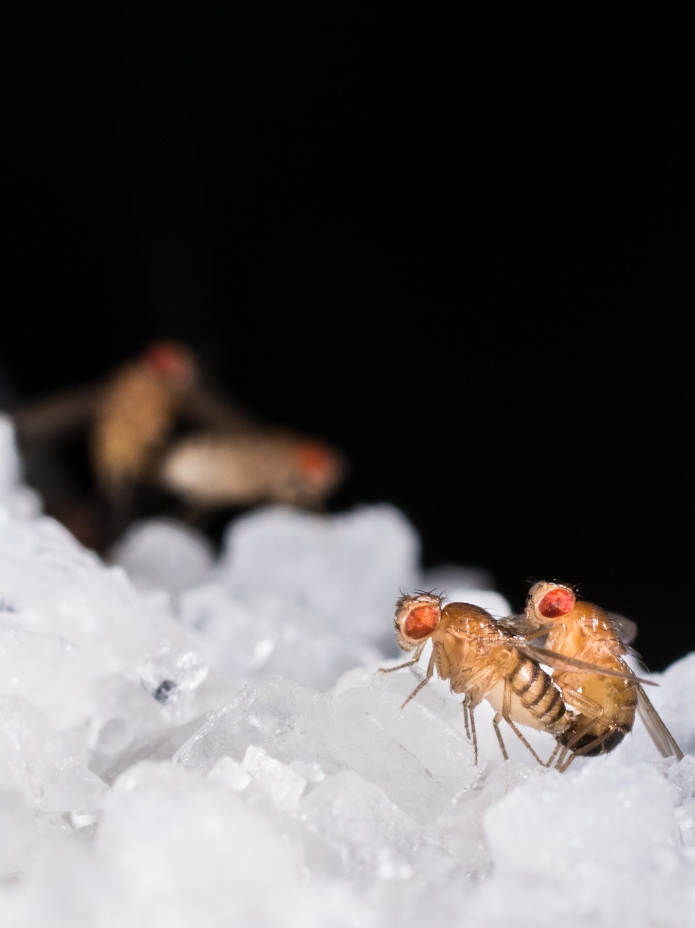
Figure 18. A fruit fly, Drosophila melanogaster: the red eye and the bristles the mappers counted.
* * *
The room mattered because of who was in it. Morgan took on two undergraduates in 1910, Alfred Sturtevant and Calvin Bridges, and a graduate student, Hermann Muller, and treated them as colleagues from the first day. New mutants came in steadily once people knew what to look for: yellow bodies, vermilion eyes, miniature wings, rudimentary wings, and dozens more. Many of them, like white, turned out to be on the X. And when two X-linked mutants were crossed together, the two traits did not assort independently, as Mendel's second rule required. They tended to stay together, because they were on the same chromosome. But they did not stay together always. Some fraction of the offspring had the traits recombined, and the fraction was different for each pair of traits, and it was the same fraction every time that pair was tested.
Morgan's guess at why originated with a Belgian cytologist, a cell scientist, Frans Alfons Janssens, who in 1909 had seen paired chromosomes under the microscope crossing over one another during the formation of sex cells and had suggested that they exchanged pieces at the crossing. If so, two factors close together on a chromosome would rarely be separated by an exchange, and two far apart would often be. The recombination fraction was a measure of distance.
Sturtevant, then nineteen, saw the consequence one evening in the autumn of 1911. He took the recombination figures for six X-linked factors home from the laboratory, put aside his homework, and by morning had arranged them along a line so that the distances added up. Yellow body and white eye were close, about one unit apart. Vermilion was thirty-odd units further along. Miniature and rudimentary lay beyond it. The spacing satisfied every pair of figures at once, which it could only do if the factors really were arranged in a line, one after another, along a physical thread. He published it in 1913 in the Journal of Experimental Zoology. It was the first genetic map, drawn by an undergraduate in one night.
The unit he used was one percent recombination, later named the centimorgan after his professor. Human geneticists still measure in it. One centimorgan is, roughly, a one-in-a-hundred chance that two positions will be separated when eggs or sperm are made. In people that chance is, on average, about a million letters of DNA. The match is lumpy. Some stretches recombine often and some almost never.
Sturtevant did not have letters. He had percentages. If yellow and white recombined in about one fly in a hundred, they were one unit apart. If yellow and miniature recombined in about a third of the flies, they were about thirty-three units apart. The test of the map was that the long distances equalled the sum of the short ones. They did, well enough for a night's work. That additivity is what a line gives you. A bag of unlinked factors does not.
Bridges supplied the last proof. In 1916 he studied rare exceptional flies, white-eyed daughters and red-eyed sons that ought not to exist, and showed under the microscope that each carried an abnormal count of X chromosomes, an extra one or a missing one, exactly as the theory predicted if the eye factor rode on the X and the X had occasionally failed to separate. A gene's inheritance and a chromosome's inheritance had been shown to be the same event, in the same fly. The four of them wrote a book together, The Mechanism of Mendelian Heredity, in 1915. It is short, and nearly everything in it is still true.
The map was still a row of percentages. In 1933 it became something a person could see.
The salivary glands of a fruit-fly larva hold giant chromosomes. Each is a bundle of about a thousand copies of the same DNA, laid side by side. Under a microscope they show a barcode of dark and pale bands. T. S. Painter, at the University of Texas, reported that December that the bands were stable enough to follow a rearranged piece to its new address.
Calvin Bridges then drew the bands for all four chromosomes. His 1935 maps marked more than three thousand of them. A factor the crosses had placed between two others sat, on the giant chromosome, between the bands those factors matched. The line an undergraduate had drawn from percentages was a thread in a cell. For decades a fly geneticist gave an address as a band.
Muller went further and, in a sense, further than anyone wanted. In 1926 and 1927, at the University of Texas, he exposed male flies to X-rays and bred them. Mutations, which in the Fly Room turned up perhaps once in tens of thousands of flies, now appeared in a large fraction of the offspring. Muller reported a rate around 150 times the spontaneous one, and the new mutants were of every kind, lethal and visible, dominant and recessive. His paper in Science in July 1927 was titled "Artificial Transmutation of the Gene," and it drove home two things at once. The gene was a physical thing that radiation could damage, and the copy could be rendered inexact on demand. He was awarded the Nobel Prize in Physiology or Medicine in 1946, a year after two cities had been irradiated by design, and he spent much of the rest of his life warning about radiation and the human germline.
Morgan's own Nobel came in 1933, in Physiology or Medicine, for the chromosome theory. He had moved to the California Institute of Technology in 1928, taking Sturtevant and Bridges with him, and it is on the record that he divided part of the prize money among the children of Bridges and Sturtevant. Bridges died in 1938 at 49. Sturtevant lived until 1970 and wrote the field's first history. The Fly Room itself was eventually turned into other uses, but Drosophila never fell out of use. It gave the world the genes that lay out a body plan in the 1980s, and at the time of writing it is still in tens of thousands of bottles, on banana or a modern substitute.
* * *
What the flies had shown was Mendel with an address. Factors were real, they sat in a line on chromosomes, they could be mapped, and they could be broken. What the flies had not yet shown was how any of this squared with Darwin. Mendel's characters were discrete, round or wrinkled, red or white. Darwin's variation, the raw material of selection, was continuous, a little taller, a little faster. Galton's followers, the biometricians, had measured that continuous variation for forty years and showed it was inherited in the smooth statistical way that particles seemed not to allow. And Morgan's own school, with its focus on large visible mutations, had left it easy to suppose that evolution happened by mutation and not by selection at all.
Chapter 10 already joined the pieces. Mutation supplies the new letters. Mendel's particles carry them. Selection changes which ones spread. The flies did not invent that joining. They gave it an address, a line on a chromosome you could break with an X-ray.
The naturalists then had to be brought in, and that was done by a former member of the Fly Room. Theodosius Dobzhansky, who had come from Russia to Columbia in 1927, took the flies out of the bottle and into the wild. The wild cousin he used, Drosophila pseudoobscura, carries stretches of chromosome flipped end to end. A flip travels as a block, because it suppresses the usual exchange of pieces, and on the giant chromosomes of the larva one arrangement can be told from another.
On Mount San Jacinto in southern California he sampled the same places through the year, from 1939 into the early 1940s. One arrangement, which he labelled Standard, was scarcest in early summer and commoner by autumn. Another, Chiricahua, swung the opposite way. The swing returned the next year. A hidden chromosomal type was being favoured in one season and disfavoured in another, in a free-living population, on a schedule you could count. His 1937 book Genetics and the Origin of Species is the one the movement dates from. The mountain counts came just after, and they were evidence a naturalist could not dismiss as a bottle artefact.
Ernst Mayr in 1942 put species and geography into the account, George Gaylord Simpson in 1944 put in the fossil record, and Julian Huxley in 1942 gave the whole thing its name, the Modern Synthesis. Its content can be said in two sentences. Variation arises by mutation, which is inexact copying, and is inherited in Mendel's particles. Selection changes the frequencies of those particles, and given enough time that is evolution.
The bottles were the method. A generation every ten days means about thirty-six generations a year, which is what let an undergraduate draw a map before he finished his degree. A human geneticist waiting on families would have needed centuries for the same crosses. The fly did not have a simpler heredity. It had a faster one.
It was a clean piece of science, and it was finished in the same decade that its cousin, the application of heredity to human beings, was finishing something far darker in the courtrooms of Virginia and the ministries of Berlin.

19. Galton's Shadow
In the summer of 1884, at the International Health Exhibition in South Kensington, a visitor could pay threepence to pass through a narrow booth and be measured. Height standing and sitting, arm span, weight, breathing capacity, the strength of the hand's grip, the speed of a blow, keenness of sight and hearing, the highest audible note. A clerk wrote the results on a card, kept a copy, and gave the visitor the other. More than nine thousand people went through. The booth was the Anthropometric Laboratory, and the man who designed it, paid for it, and pored over the cards afterwards was Francis Galton.
Galton was born in Birmingham on 16 February 1822, five months before Mendel, into money made in guns and banking. He was Charles Darwin's half-cousin; they shared a grandfather, Erasmus Darwin. He was a child prodigy, an indifferent medical student, an explorer of south-west Africa, and then, after 1859 and his cousin's book, a man with a single idea. If ability was inherited like height, the human race could be improved the way a breeder improves cattle. His 1869 book Hereditary Genius traced judges, statesmen and scientists through their families and concluded that talent ran in blood. In 1883, in a book called Inquiries into Human Faculty and Its Development, he gave the project a name, from the Greek for well-born: eugenics.
It is worth saying plainly that Galton was a serious scientist, because that is part of the problem. He invented the weather map and named the anticyclone. He worked out regression to the mean, from measuring sweet-pea seeds and then the heights of parents and children. He invented the correlation coefficient, which his follower Karl Pearson turned into a rigorous tool. He established that fingerprints were unique and permanent and devised the classification system Scotland Yard adopted in 1901. He was the founder of the biometric school that fought Bateson over Mendel, and its methods, not Bateson's, are the ones a modern genome-wide study uses. The statistics of inheritance and the programme of breeding people came out of the same head at the same time, and for fifty years most people who used the one accepted the other.
* * *
In the United States the programme found money. On 1 October 1910 the Eugenics Record Office, the ERO, opened at Cold Spring Harbor on Long Island, funded at first by Mary Harriman, widow of the railroad magnate, and from 1918 by the Carnegie Institution. Its director was Charles Davenport, a Harvard-trained biologist who had embraced Mendel early and applied him with enthusiasm. Its superintendent was Harry Laughlin, a former schoolteacher from Missouri. The Office trained field workers, mostly young women, who went out to prisons, poorhouses and asylums and returned with pedigrees on index cards. By the time it closed in 1939 it held hundreds of thousands of them. The cards purported to trace feeblemindedness, pauperism, criminality, alcoholism and "shiftlessness" as Mendelian recessives, with the same confidence Mendel had brought to wrinkled seeds.
The first thing the Office wanted was law. Indiana had passed the first compulsory sterilisation statute in 1907, and Laughlin drafted a Model Eugenical Sterilization Law in 1922 for other states to copy. Many did; by the early 1930s about thirty states had some such law on the books. The question was whether the Supreme Court would allow it, and Virginia arranged a test case to find out.
Her name was Carrie Buck. She was seventeen, from Charlottesville, and had been raised in a foster home after her mother was committed to the Virginia Colony for Epileptics and Feebleminded. In 1923 she became pregnant. Later evidence indicates that she had been raped by a relative of the foster family; the family had her committed to the same Colony as her mother, and her daughter Vivian was born in 1924. The Colony's superintendent selected her for sterilisation under the new Virginia law, and a lawyer was appointed to appeal on her behalf, the appeal being part of the plan. The case reached the Supreme Court as Buck v. Bell. On 2 May 1927 the Court upheld the law, eight to one, in an opinion by Oliver Wendell Holmes Jr. It is short, and its most famous sentence is documented: "Three generations of imbeciles are enough." Carrie Buck was sterilised on 19 October 1927. The one dissenting justice, Pierce Butler, wrote nothing.
The three generations were a fiction. Carrie's school records show her promoted normally. Vivian, the third generation, was placed on her school's honour roll; she died of an intestinal illness in 1932, aged eight. The decision has never been formally overturned. Virginia repealed its law in 1974 and apologised in 2002. In total, somewhere around 60,000 people were sterilised under state laws in the United States, a third of them in California, and the practice continued in some states into the 1970s. The same movement, with Laughlin as an expert witness before Congress, helped carry the Immigration Act of 1924, which cut immigration from southern and eastern Europe on the argument that those populations carried inferior stock.
Germany was watching. The Law for the Prevention of Hereditarily Diseased Offspring was passed on 14 July 1933, five and a half months after Hitler became chancellor, and came into force on 1 January 1934. It set up hereditary health courts and made sterilisation compulsory for a list of conditions that included schizophrenia, manic depression, hereditary blindness and deafness, severe alcoholism, and, above all, "congenital feeblemindedness." Its drafters knew and cited the American statutes, and Laughlin's model law in particular; Laughlin received an honorary doctorate from Heidelberg in 1936 for his services to the science of racial hygiene, and accepted it. About 400,000 people were sterilised under the German law by 1945.
The road from there is brief and documented. From the autumn of 1939, under a programme later called T4 after the Berlin address from which it was run, doctors selected patients in psychiatric hospitals and institutions for the disabled for what the paperwork termed a mercy death. About 70,000 people were killed in six centres by August 1941, most of them in gas chambers using carbon monoxide, and the count continued in other forms until the end of the war. The staff who had built and run those chambers were then transferred east, and the method went with them, to Belzec, Sobibor and Treblinka. The Nuremberg trial of the doctors, in 1946 and 1947, traced the line in evidence. Eugenics did not cause the Holocaust. It supplied the vocabulary, the personnel, and the first machinery.
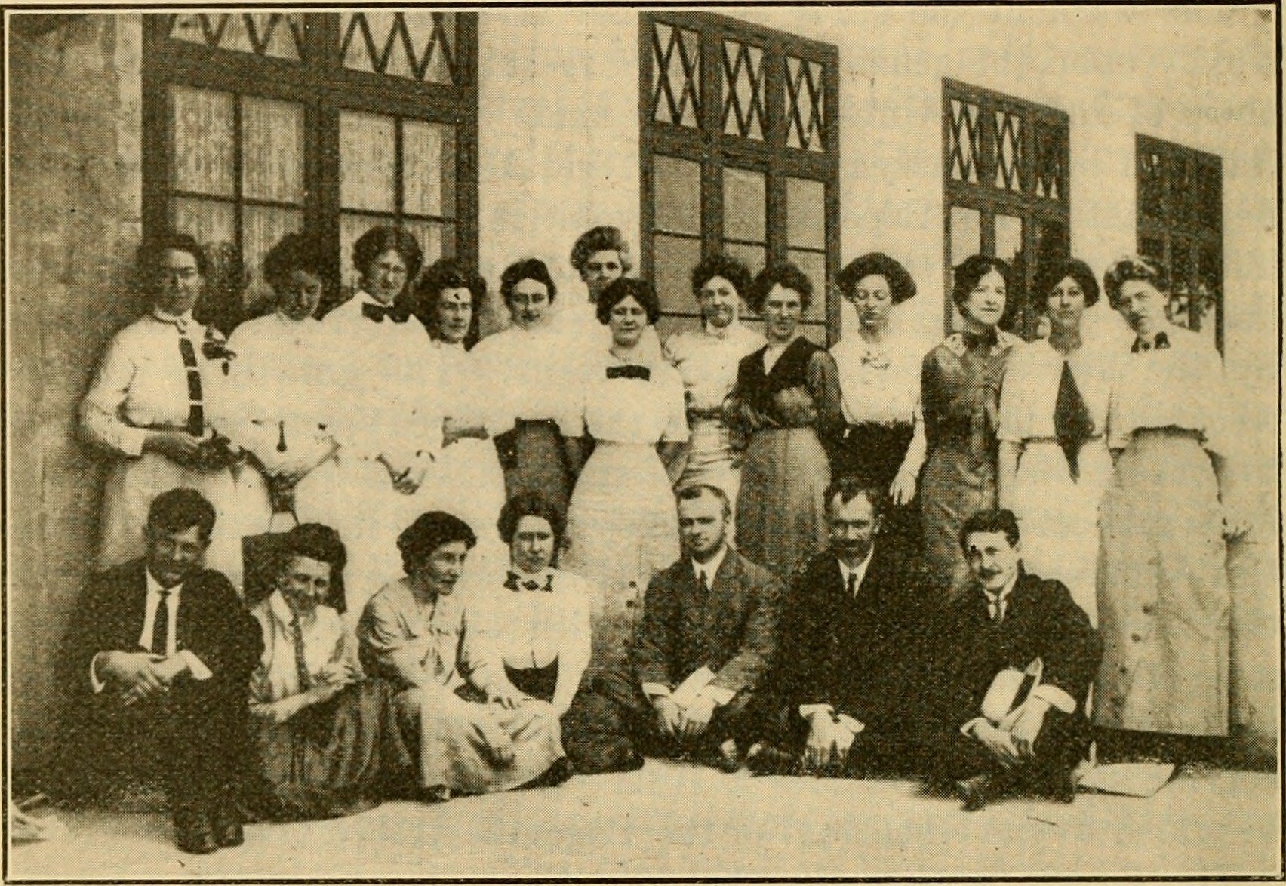
Figure 19. Field workers of the Eugenics Record Office at Cold Spring Harbor, June 1912. The rows are the people who filled the family files.
* * *
In the Soviet Union the same decades produced the mirror image, and it is worth the detour because the error was of the opposite kind. Trofim Lysenko, born in 1898 to a peasant family in Ukraine, rose to notice in 1929 with vernalisation, a real if old technique of chilling wheat seed so that winter varieties could be sown in spring. He claimed it would transform Soviet yields. It did not, but the claim was welcome, and Lysenko learned what was welcome. Through the 1930s he built a doctrine, known as Michurinist biology after a Russian plant breeder, whose core was that there were no genes, that heredity was a property of the whole organism responding to its conditions, and that characteristics a plant acquired during its life could be handed to its offspring. Lamarck, dead a century, was restored as state science, and Mendel, Morgan and Weismann were denounced as bourgeois idealists.
The man in his way was Nikolai Vavilov. Born in 1887, Vavilov was the most travelled botanist alive. He had led more than a hundred expeditions through some sixty-four countries, had identified the regions of the world where crop plants were first domesticated, and had built in Leningrad a seed bank of about a quarter of a million samples, the largest collection of crop diversity on earth. He was a Mendelian and a Darwinian, and for a decade he defended genetics in public against Lysenko while trying to keep his institute alive. He was arrested on 6 August 1940, while collecting plants in western Ukraine, sentenced to death the following year on charges of sabotage and espionage, had the sentence commuted, and died in Saratov prison on 26 January 1943 of starvation. During the siege of Leningrad, several of his staff starved to death in the building that held the seeds, surrounded by sacks of edible rice, wheat and peas that they would not touch.
In August 1948, at a session of the Lenin All-Union Academy of Agricultural Sciences, Lysenko announced that his report had been approved by the Central Committee, which meant by Stalin. Genetics as a science was ended in the Soviet Union. Laboratories were closed, textbooks pulped, and researchers dismissed, in the thousands by most estimates. The ban lasted, with loosening after Stalin's death, until Khrushchev's fall in October 1964; Lysenko was removed the next year and a commission published the details of his fraudulent farm results. Soviet biology took a generation to recover, and Soviet agriculture never did benefit from a single one of his methods.
It is easy to say that eugenics was bad ethics, and it was. It is more useful, in a book about how inheritance works, to say why it was bad science, because the scientific error is the one that could recur.
The first error was the pedigree. Davenport's field workers scored "feeblemindedness" from a conversation and a family rumour, and the tests that later replaced the conversation, the early IQ tests, short for intelligence quotient, a single score meant to sum up how a person reasons, measured schooling and English as much as anything else. A pedigree in which poverty runs in families is not evidence of a gene for poverty. The ERO's cards recorded a social fact and labelled it a Mendelian one, and none of it was ever checked the way Mendel checked his twenty-two varieties for two years before he crossed them.
The second error was arithmetic, and it is the one Mendel's own ratios expose. Suppose a condition really were a simple recessive, like wrinkled seed, and suppose it affected one person in ten thousand. Then the responsible allele, the faulty version of the gene, is carried by about one person in fifty, and nearly all copies of it, more than ninety-nine in a hundred, sit in carriers who show nothing and whom no court could identify. Sterilise every affected person in every generation and the allele's frequency falls, but slowly: from one in a hundred to one in two hundred takes a hundred generations, about two and a half thousand years. Reginald Punnett laid this out in 1917 and Fisher confirmed it in 1924, and the movement carried on regardless. The recessive character is not removed by removing the plants that show it. That is the one thing Mendel's peas had made most plain, and the people who claimed Mendel's authority did not do the sum.
The third error was Lysenko's, and it is the older one. Acquired characteristics are not, in any general way, inherited. Chapter 14 gave the honest modern version: there are real cases of environmental marks passing a generation or two, mostly in plants and worms, weakly and contestedly in mammals, and none of them makes a chilled seed into a new variety of wheat. A doctrine that says otherwise fails in the field, and when the state forbids the field from reporting the failure, people go hungry.
The echoes are not finished, and Part XI will pick them up: polygenic scores sold to parents choosing embryos, the language of improvement returning through a clinic door rather than a courtroom. I think the right defence against them is not to forget the science but to know it better than Galton's heirs did. The text is copied, the copy is inexact, the differences are mostly small, mostly recessive, and mostly hidden in people who look like everyone else, and no programme that ignores that has ever done anything but harm.

PART V — Learning to Read

20. Cutting and Pasting
A bacterium has no immune system in the sense that a child has one, but it has something older and simpler. Picture a single cell of Escherichia coli, a rod two microns long, small enough that three dozen of them laid end to end would barely span the width of a human hair, in a human gut. The bacterium is real, and it is under attack. A virus called a bacteriophage has landed on its surface, punched through the wall, and injected a few tens of thousands of letters of foreign DNA. The bacterium's reply is an enzyme that patrols the interior of the cell looking for one short word, four or six letters in length, and cuts the double helix wherever it finds that word. The cell's own DNA carries the same word at hundreds of places, but a second enzyme has already tagged every copy with a methyl group, the tiny chemical marker behind the gene-switching in chapter 9's look at epigenetics, and the tag blocks the blade. The invader's text is untagged. It is cut to pieces within minutes.
This was worked out slowly. In 1952 Salvador Luria and Mary Human noticed that phages grown on one strain of bacteria often failed to grow on another, as if the second strain restricted them. Werner Arber, in Geneva in the early 1960s, showed with Daisy Dussoix that the restriction was done by an enzyme that cut the phage DNA, and that the host protected itself by chemically modifying its own. Arber predicted that such enzymes would recognise specific sequences. In 1970 Hamilton Smith at Johns Hopkins purified one from Haemophilus influenzae, named it HindII, and showed that it cut at a defined six-letter site and nowhere else. Smith's colleague Daniel Nathans then used HindII on the DNA of a monkey virus, SV40, cut the circle into eleven fragments, and in 1971 arranged the fragments in order: the first physical map of a genome made with an enzyme. Arber, Smith and Nathans shared the 1978 Nobel Prize in Physiology or Medicine.
The word "restriction" stuck, though it is a poor name for what the enzymes became. By the end of the 1970s dozens had been purified, each recognising its own distinctive word, and the catalogue now runs to thousands, with a few hundred sold by the vial. The names are the bacterium's, abbreviated: EcoRI from Escherichia coli, BamHI from Bacillus amyloliquefaciens, HindIII from the same Haemophilus that gave Smith his first. Most recognise a palindrome, a sequence that reads the same on both strands when each is read in its own direction. EcoRI's word is GAATTC. On the other strand, read the other way, it is GAATTC again.
EcoRI, isolated in Herbert Boyer's laboratory at the University of California, San Francisco, in 1972, had a property that turned a curiosity into a tool. It did not cut straight across. It cut between the G and the A on each strand, which left every fragment with a four-letter single-stranded tail, AATT, hanging off the end. Any two fragments cut by EcoRI, from any organism whatever, carry matching tails, and in a test tube they find each other and pair up by the same hydrogen bonds that hold the helix together. Janet Mertz and Ronald Davis at Stanford showed this in 1972 and called the tails cohesive. Everyone else calls them sticky ends. With DNA ligase, an enzyme isolated in 1967 by several groups at once, the paired fragments could be sealed into a continuous strand. The scissors had found their paste.
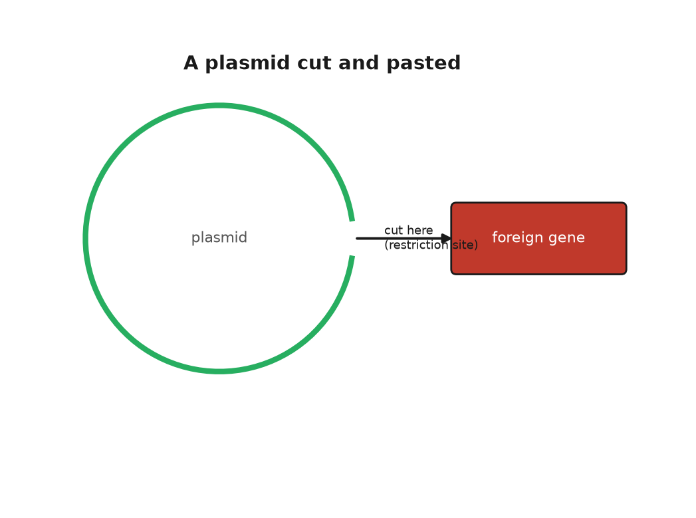
Figure 20. A plasmid cut open by a restriction enzyme, with a foreign gene pasted into the gap.
* * *
The first recombinant DNA molecule, DNA spliced together from two different sources, took shape in Paul Berg's laboratory at Stanford in 1972 without sticky ends, and without ever entering a living cell. Berg, with David Jackson and Robert Symons, took the circular DNA of SV40, opened it with EcoRI, and joined it to a piece of DNA from the bacteriophage lambda that carried three E. coli genes for digesting the sugar galactose. The joining was done by adding tails of A to one piece and tails of T to the other with an enzyme known as terminal transferase, then letting the tails anneal. The paper appeared in the Proceedings of the National Academy of Sciences, PNAS for short, in October 1972. Berg's plan had been to put the hybrid into E. coli and see whether the monkey virus genes worked there. He did not do it. A colleague, Robert Pollack, had telephoned him in 1971 to ask whether it was wise to put the DNA of a tumour virus into a bacterium that lives in the human gut, and Berg, having thought about it, agreed that it was not, or not yet. This was the first pause in the history of genetic engineering, and it was self-imposed.
The step into the cell was taken in 1973 by Stanley Cohen at Stanford and Boyer at UCSF. The story of how they met is well documented and has the flavour of legend anyway. At a conference on plasmids in Honolulu in November 1972, the two men went out for a late sandwich at a delicatessen near Waikiki and, over the corned beef, put their two projects together. Cohen worked on plasmids, the small circles of DNA that bacteria carry alongside their main chromosome and pass between themselves, which is how resistance to antibiotics spreads through a hospital. He had one such plasmid, which he had named pSC101, that carried a gene for resistance to tetracycline and, as luck had it, a single EcoRI site. He had also worked out, with Annie Chang and Leslie Hsu, that a cold bath of calcium chloride made E. coli take up naked plasmid DNA from the surrounding fluid. Boyer had the enzyme. If pSC101 was cut open with EcoRI, a fragment of anything else cut with the same enzyme could be pasted into the gap, the circle closed with ligase, and the whole thing fed to bacteria. Any bacterium that then grew on tetracycline had taken up the plasmid and, with it, the passenger.
It worked. The paper, by Cohen, Chang, Boyer and Robert Helling, was published in PNAS in November 1973. The first passenger was a gene from another bacterial plasmid, which was a modest thing to move. In May 1974 John Morrow, with Cohen and Boyer, put ribosomal genes from the African clawed frog Xenopus laevis into pSC101 and showed that E. coli copied the frog DNA every time it divided and, more surprisingly, transcribed it. A gene from a vertebrate had been carried across something like half a billion years of separate evolution and was being read by a bacterium. Stanford and the University of California filed a patent on the method in November 1974. It was granted in December 1980, licensed to several hundred companies on easy terms, and by the time it expired in 1997 it had earned the two universities about $255 million, a figure I repeat as reported.
Nobody in 1974 had an insulin gene to hand, or any human gene in a form that could be pasted. The point of the Cohen and Boyer experiment was not what it moved but that anything could be moved. The wall between species, which breeders had spent ten thousand years respecting, had a door in it.
* * *
The people best placed to see what might go wrong were the people who had built the door. In July 1974 Berg and ten colleagues, Cohen and Boyer among them, published a letter in Science that asked their fellow scientists to stop, voluntarily, two classes of experiment: putting antibiotic-resistance or toxin genes into bacteria that did not already carry them, and putting tumour-virus DNA into bacteria at all. The letter asked the National Institutes of Health to draw up guidelines, and it called for a meeting. The meeting took place from 24 to 27 February 1975 at the Asilomar conference grounds on the Monterey peninsula in California, among pines and sand dunes, with about 140 participants, most of them molecular biologists, plus a handful of lawyers and a few journalists who had been let in on condition that they stayed to the end.
The arguments at Asilomar were not tidy. Some participants thought the risks imaginary and the moratorium, the voluntary pause on research, a gift to future regulators. James Watson, who had signed the 1974 letter, spent the meeting saying he wished he had not. Others, including Berg, thought that if the field did not draw its own lines, Congress would draw them for it, badly. By the last night, working past midnight, the organisers had a draft that most of the room could accept. Experiments were sorted into risk classes. Each class was matched to a level of physical containment, from an open bench to a sealed laboratory under negative air pressure, meaning air pulled steadily inward so nothing drifts out, and to a level of biological containment, meaning bacteria crippled so that they could not survive outside a flask. The riskiest experiments were to be deferred. The NIH turned the draft into formal guidelines, published on 23 June 1976, that bound anyone who took federal money.
Asilomar has been cited ever since, sometimes as a model and sometimes as a warning, and the international summits on human genome editing in 2015, 2018 and 2023 were consciously staged in its image. I think both readings are fair. The scientists did pause themselves, which is rare, and none of the feared catastrophes occurred. They also confined the discussion to laboratory safety and kept the wider questions, about ownership and purpose and who decides, off the agenda, which is one reason those questions arrived later and less politely. The city council of Cambridge, Massachusetts, whose mayor Alfred Vellucci did not see why Harvard should decide what went into his city's drains, held its own hearings that summer and imposed a local moratorium of several months before allowing the work to continue under rules of its own.
Robert Swanson was twenty-nine, a venture capitalist, someone whose job is investing other people's money in new companies, recently let go by his firm, when he telephoned Boyer in January 1976 and asked for ten minutes. He got three hours in a bar near the UCSF campus. Boyer thought a company built on recombinant DNA was premature; Swanson thought otherwise, and on 7 April 1976 they founded Genentech, each reported to have put in $500. The company had no laboratory. Its first work was done under contract at the City of Hope medical centre near Los Angeles, where Keiichi Itakura and Arthur Riggs could synthesise a gene chemically, letter by letter, rather than fishing it out of a cell. The first target was somatostatin, a human hormone built from just fourteen amino acids, the basic building blocks of proteins from chapter 6, chosen because its gene could be built from scratch in weeks. In 1977 E. coli made it. It was the first human protein produced by a bacterium.
Insulin was the real prize, and there was a race for it. Insulin then came from the pancreases of pigs and cattle, collected at slaughterhouses by the tonne, and the supply was thought to be running short. The molecule has two chains, A and B, of 21 and 30 amino acids, which is longer than somatostatin but still compact enough to build. Walter Gilbert's group at Harvard was working from the natural gene. The Genentech and City of Hope team built the two chain genes chemically, put each into E. coli fused to a bacterial protein, cut the chains free, and joined them with the correct sulphur bridges in a flask. They announced success on 6 September 1978. Eli Lilly, which had sold insulin since 1923, took the licence. Humulin, insulin identical in sequence to the human kind and brewed by bacteria in steel tanks, was approved by the Food and Drug Administration in October 1982, the first drug produced by recombinant DNA to reach patients.
So by 1982 a bacterial defence against viruses had become a pair of scissors, a bacterial plasmid a paste-pot, and a gut bacterium a factory for a human hormone. Asilomar had already shown that the people who built the door would try to police it. The factory showed that the door opened onto a market. What none of this gave anyone was a way to read what they had pasted, and that method was the work of a quiet man in Cambridge who had already won one Nobel Prize and was about to earn a second.

21. Sanger's Ladders
The first genome anyone ever read belongs to a virus so small that ten thousand of them would fit across the width of a human hair. It is called phi X174, it infects E. coli, and its entire text is a single circle of DNA 5,386 letters long. In February 1977 a paper in Nature from the Medical Research Council's Laboratory of Molecular Biology in Cambridge printed the whole of it, or nearly: the count given then was 5,375, and the last eleven letters were tidied up over the following year. The authors were Fred Sanger and eight colleagues. Between them they had read every letter of a living thing's instructions for the first time, and the text held a surprise. Two of the virus's genes lay inside other genes, sharing the same letters but read in a different frame, like a sentence hidden in another sentence by starting one letter later. Nobody had thought that possible.
Sanger was fifty-eight and had already spent a career on the problem of reading. He was born on 13 August 1918 in Rendcomb, a village in Gloucestershire, the son of a doctor, and was raised a Quaker; he registered as a conscientious objector in 1939 and spent the war in a Cambridge laboratory. Between 1945 and 1955 he worked out the complete sequence of insulin, all 51 amino acids in its two chains, using a reagent he invented to label the end of a chain and sheets of paper chromatography, a technique that separates chemicals by how far each one travels across a wet sheet, to sort the fragments. Before that work nobody knew for certain that a protein had a fixed sequence at all. The 1958 Nobel Prize in Chemistry went to him alone. Then he turned to RNA, reading the 120 letters of a compact ribosomal RNA, a piece of the ribosome, the cell's protein-building machinery from chapter 8, in 1967, and then, in the early 1970s, to DNA, which was harder because it was longer and its four letters were chemically so alike.
His first DNA method, in 1975, was awkward, and it was the one used for most of phi X174. The method that replaced it, published in PNAS in December 1977 with Steve Nicklen and Alan Coulson, is the one the world used for the next thirty years, and it is worth understanding, because every genome in this book before 2005 was read with it.
* * *
Start with a single strand of the DNA you want to read and a brief primer that pairs with one end of it. Add DNA polymerase, the copying enzyme from Chapter 7, and the four ordinary building blocks, one of them carrying a radioactive atom. The enzyme extends the primer, letter by letter, making a copy of the strand. Now the trick. Into the tube goes a small dose of one building block, say A, in a crippled form: a dideoxy nucleotide, which is missing the hydroxyl group, a single oxygen-and-hydrogen pair, at its 3-prime carbon, the numbered backbone position from chapter 3's ladder, that the next letter needs in order to attach. The enzyme cannot tell the difference and slots it in. But once a crippled A is in, the chain can grow no further. It stops. Because the crippled A is a minority, the enzyme usually gets the ordinary one, and each copy runs on until, at some A along the way, it draws the short straw. Millions of copies, and the tube ends up holding a chain stopped at every A in the sequence: one that stopped at the first A, one at the second, one at the tenth. Four tubes, one for each crippled letter, give four such families.
The four tubes are then run side by side down a slab of polyacrylamide gel under an electric field, a method that separates DNA strands by length so finely that a chain of 101 letters travels visibly further than a chain of 102. Lay a sheet of X-ray film on the gel, wait, develop, and each lane shows a ladder of dark bands. The shortest fragments are at the bottom. Read upward across the four lanes, noting at each rung which lane the band is in, and the sequence writes itself: A, A, G, C, T, T, and so on, until the bands blur together somewhere past the two-hundredth rung. Later gels, taller and thinner, ran to five or six hundred letters. The X-ray film was the same one Alec Jeffreys would pull out of a developing tank seven years later, in the next chapter but two.
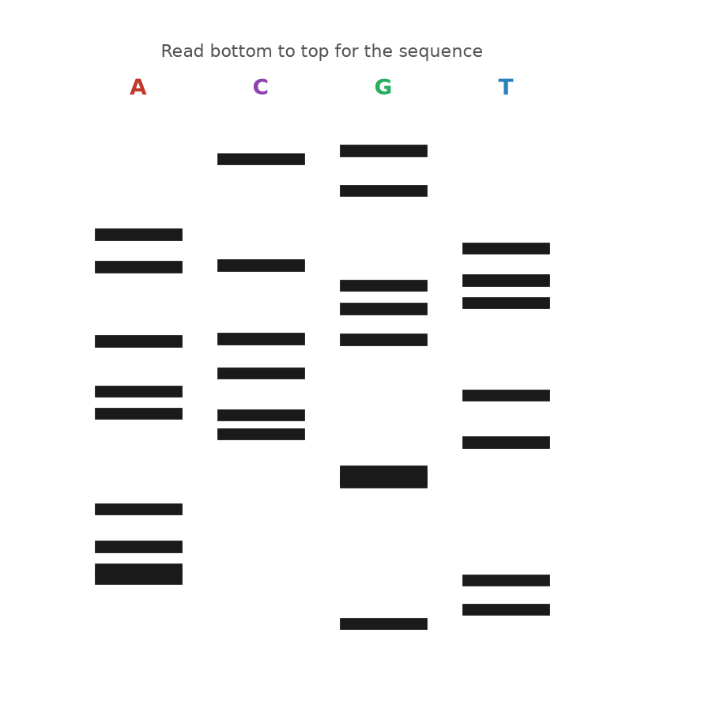
Figure 21. A Sanger sequencing gel: four lanes, read from the bottom upward.
Allan Maxam and Walter Gilbert at Harvard published a rival method in PNAS in the same February of 1977. Theirs used chemistry rather than an enzyme: label one end of the DNA, split the sample four ways, and in each tube use a reagent that breaks the chain at one kind of letter, dimethyl sulphate for G, hydrazine for C, and so on, under conditions gentle enough that each strand breaks only once. The result is also a ladder, read the same way. For a few years the two methods were used side by side. Gilbert's needed no cloning of the fragment into a single-stranded form and was popular at first; Sanger's used an enzyme instead of hydrazine and could be scaled up and, eventually, automated. Sanger's won. The 1980 Nobel Prize in Chemistry went to Sanger and Gilbert for reading DNA, and to Paul Berg for the recombinant molecule of Chapter 20. It was Sanger's second, which makes him one of only two people ever to win the chemistry prize twice; Barry Sharpless became the other in 2022.
Notice what the method actually reads. It does not read the strand you put in the tube. It reads copies of that strand, made on the spot by a polymerase, and it depends on the copying being faithful enough that a million copies stopped at the fortieth letter all carry the same thirty-nine letters before it. They very nearly do. When they do not, because the enzyme slipped on a run of identical letters or the template was damaged, the ladder shows a faint extra rung or a smeared one, and the reader has to decide. This is why the phi X174 count of 1977 was out by eleven letters, and why every sequence in this book was read more than once. A text is not read directly; it is copied and the copies are compared, which is, when you think about it, exactly what a cell does.
Sanger himself worked at the bench until the day he retired, in a group that rarely numbered more than a dozen, and he was known for doing the experiments with his own hands rather than through students. The Laboratory of Molecular Biology, which had opened its new building in 1962 with Perutz, Kendrew, Crick and Sanger under one roof, had by 1980 collected more Nobel prizes per square metre than any building in the world, and it kept the coffee room at the centre of the plan on purpose.
Sanger's laboratory used the new method as fast as it could be written up. In 1981 it published the entire human mitochondrial genome, the 16,569 letters a mother passes to a child, along with the finding that the mitochondrion reads a few codons differently from the rest of the cell. In 1982 it published bacteriophage lambda, 48,502 letters, then the largest genome read. For lambda the group could not proceed from one end to the other, because no gel reads more than a few hundred letters. So they broke the DNA into random pieces, cloned each into a small virus that delivered it as a single strand, read the pieces, and had a computer find the overlaps and stitch them together. Rodger Staden wrote the programs. The method is called shotgun sequencing, and it is, at heart, how every genome since has been assembled: read short stretches many times over and let the overlaps tell you the order.
* * *
The bottleneck was not the chemistry but the hands. Pouring gels, loading four lanes per sample, exposing film overnight and reading ladders by eye with a ruler was slow work, and a good technician read perhaps a few thousand letters in a day. A human genome, 3.1 billion letters read several times over for safety, was out of the question. At the California Institute of Technology, Leroy Hood and Lloyd Smith replaced the radioactive label with four fluorescent dyes, one colour for each of the four terminators, so that all four reactions could be run in a single lane and a laser at the bottom of the gel could read the colours as the bands passed. The paper appeared in Nature in June 1986. Applied Biosystems built the machine, the ABI 370A, and sold it from 1987; it read about 350 letters per lane, with no film and no ruler. Sanger's method had become a printer.
The machine that read the human genome was the next step but one. In 1998 Applied Biosystems released the PRISM 3700, which replaced the slab of gel with 96 hair-thin glass capillaries, each filled with a polymer that did the same job, and ran them unattended around the clock. A single 3700 could produce hundreds of thousands of letters a day, in reads of about 500 to 600 letters each. Celera, the company described in Chapter 36, bought three hundred of them; the public project bought hundreds more. The 3.1 billion letters of the first human sequence, in every draft, came out of capillaries by the dideoxy method, and the method was still, chemically, what Sanger had described in 1977 with a crippled A.
He was not there to run the machines. Sanger retired in 1983, at sixty-five, on the day he became eligible, and spent the next thirty years gardening at his house outside Cambridge and, by his own account, doing very little else. He turned down a knighthood, saying that he did not want to be called Sir, and accepted the Order of Merit in 1986. He described himself, more than once, as an ordinary sort of person who had simply enjoyed messing about in a laboratory, and people who worked with him tended to agree that he meant it. The genome campus that opened in the village of Hinxton in 1993 was named the Sanger Centre, and it went on to read about a third of the human sequence. He died on 19 November 2013, aged ninety-five.
Two habits from those years survive in every sequencing laboratory. One is coverage. A single dideoxy ladder is a copy of a copy, and that copy is not exact, so each stretch is read several times, from different fragments, and the reads are compared before a letter is believed. The public human genome aimed at reading every position eight to ten times over. The other is the reference. Once a sequence exists, a second individual is not read from scratch; its reads are lined up against the first and only the differences are recorded. Both habits began with lambda and a shortage of hands.
There is one number worth holding onto from the Sanger years. A human genome, if it had been read with dideoxy ladders on a capillary machine, would have needed something like six million reads of 500 letters, and then several times that for the overlaps. The method was also greedy. Every read needed a large and pure sample of the stretch in question, which in practice meant cloning it into bacteria first, growing a flask, and purifying the plasmid: days of work to obtain enough copies to read a few hundred letters. What sequencing needed, if it was ever to leave the laboratory, was a way to make a billion copies of any chosen stretch in an afternoon, in a tube, with no cell involved at all.

22. Copying Without a Cell
Highway 128 runs north-west out of Cloverdale, California, through the vineyards of Anderson Valley towards the redwoods and the coast, and on a Friday night in April 1983 Kary Mullis was driving it with a chemist from his company asleep in the passenger seat. Mullis was thirty-eight. He had a doctorate in biochemistry from Berkeley, a history of leaving jobs, and a position at Cetus Corporation in Emeryville, where his work was to synthesise short stretches of DNA called oligonucleotides, twenty or so letters long, that other people ordered for their experiments. He was thinking, as he drove, about a way of reading a single letter at a chosen place in a genome. Put a primer next to the place, add polymerase and a single dideoxy terminator of the kind Sanger used, and the enzyme would add one crippled letter and stop; the colour of that letter would settle the matter.
The trouble was that any real sample of human DNA contained the chosen place only once or twice among the 6.2 billion letters of a cell's nucleus, and one or two copies are too little to see. Somewhere on the mountain road, as he told it later, he saw what would happen if he used two primers instead of one, on opposite strands, facing each other across the region he cared about. Polymerase would extend both, and the two new strands would together contain a copy of the region. Heat the tube to separate the strands, cool it, and the primers would land again, now on four strands instead of two. Extend, heat, cool, and there would be eight. He pulled over, he said, to do the arithmetic on this exponential growth, doubling each round so the numbers explode rather than simply add up. Two to the tenth is a thousand. Two to the twentieth is a million. Two to the thirtieth is a little over a billion. The region between the primers, and only that region, would be copied out of the surrounding text a billion times over. Every cycle was a copying, and it needed no cell to do it.
* * *
The idea is known as the polymerase chain reaction, or PCR, and its three steps are three temperatures. At about 95 degrees Celsius, just shy of boiling, the hydrogen bonds between the strands let go and the double helix comes apart. At somewhere between 50 and 65 degrees, depending on the primers, the two primers find their targets on the separated strands and stick; they are brief, and they are present in vast excess, so they win the race against the original partner strand. At 72 degrees the polymerase extends each primer along its template. Then back to 95. The first cycle makes strands of no fixed length, running on past the far primer until the enzyme falls off, but by the third cycle products appear that are bounded by a primer at each end, and from then on those products dominate. After 30 cycles, each a few minutes long, a single starting molecule has become about a billion copies of a fragment a few hundred letters across, which is plenty to see on a gel, to read with Sanger's method, or to cut with an enzyme.
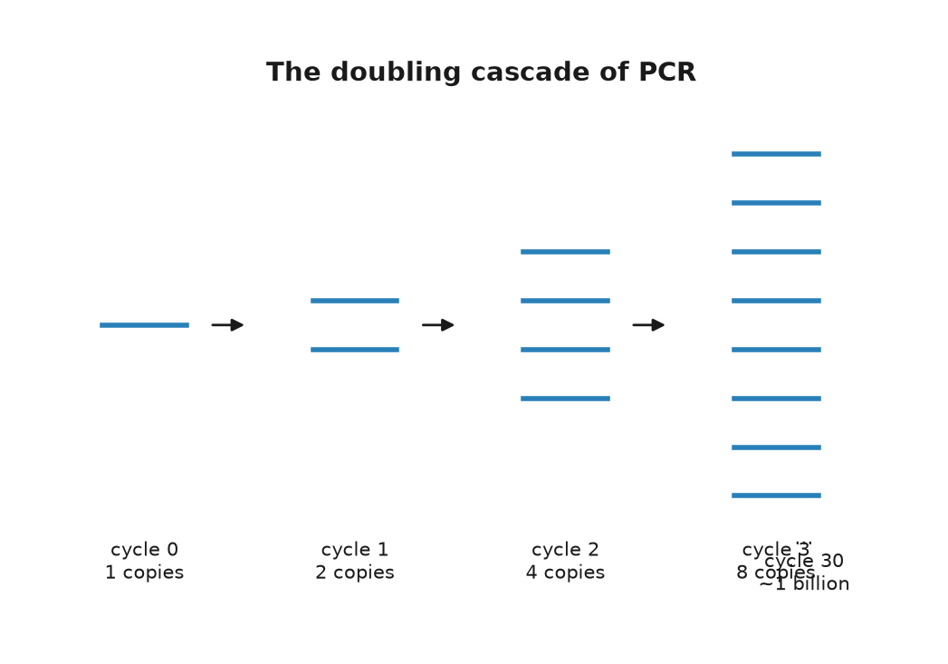
Figure 22. The doubling cascade of the polymerase chain reaction.
Mullis's colleagues at Cetus were not impressed, at first, and it is worth being fair about why. Nothing in the scheme was new. Primers, polymerase and heat were all standard; a paper from Gobind Khorana's laboratory in 1971, by Kjell Kleppe and others, had described in a paragraph the idea of copying a stretch repeatedly with two primers, and then dropped it. What Mullis saw was that the repetition was exponential and that exponential was the whole point. The first experiment that clearly worked at Cetus is dated 16 December 1983 in the company's records, as reported in later accounts. The first cycles were done by hand. Each round of 95 degrees killed the polymerase, which was then the Klenow fragment, a trimmed-down version of the E. coli copying enzyme, so a technician moved the tubes between water baths and pipetted in fresh enzyme every cycle, thirty times. Cetus built a robot to do the pipetting.
A team at Cetus led by Henry Erlich, with Randall Saiki, Stephen Scharf and Norman Arnheim, turned the trick into a method and published it in Science in December 1985, using it to amplify part of the HBB gene and diagnose sickle cell disease from a small blood sample. Mullis's own description appeared in Methods in Enzymology in 1987. Cetus paid him a bonus of $10,000. He left the company in 1986. In 1991 Cetus sold the rights to PCR to Hoffmann-La Roche for $300 million, and in 1993 Mullis received the Nobel Prize in Chemistry, shared with Michael Smith, who had devised a way to change a single chosen letter in a cloned gene. A challenge to the patents by DuPont, resting partly on the 1971 Khorana paper, had failed before a jury in 1991.
* * *
The enzyme that made the reaction practical came out of a hot spring. In 1966 Thomas Brock, a microbiologist from Indiana University, collected samples from Mushroom Spring in the Lower Geyser Basin of Yellowstone National Park, where the water runs at about 70 degrees Celsius, hot enough to scald skin instantly, and discovered a bacterium growing in it that most textbooks then said could not exist. He named it Thermus aquaticus and published it in 1969. Its proteins worked at temperatures that cook other proteins. In 1976 a group at the University of Cincinnati purified its DNA polymerase and showed that the enzyme copied DNA happily at 70 degrees. Nobody had a use for that until the Cetus team, with David Gelfand, put the Yellowstone enzyme into the chain reaction and published the result in Science in January 1988.
Taq polymerase, as it is called, survives the 95-degree step. That meant one dose of enzyme lasted the whole run, the water baths could be replaced by a programmable metal block that cycled its own temperature, and a person could load the tubes, press a button, and go to lunch. Because Taq works best at 72 degrees, the primers could be annealed at higher temperatures too, which left them fussier about where they landed and the products cleaner. Taq has one defect: it does not proofread. It makes a wrong letter about once in every ten thousand or so, which after thirty cycles means that a fraction of the copies carry an error somewhere. For most purposes that does not matter, and for the purposes where it does, polymerases from other hot-spring organisms that do proofread, such as Pfu from Pyrococcus furiosus, were found later. Brock's bacterium had been deposited in a public culture collection, so anyone could order it, and Yellowstone itself received nothing from the enzyme until a separate agreement with a biotechnology company in 1997 caused a small public row.
What the chain reaction did to biology is hard to overstate, so I will understate it: it removed the need for a cell. Before PCR, to study a gene you cloned it, which meant a plasmid, a bacterium, a flask and a week. After PCR, you designed two primers, ordered them, and had a billion copies before the end of the day, from a drop of blood, a hair root, a mouth swab, a cheek cell in a tube, or a fragment of a bone. Real-time versions, developed in the early 1990s by Russell Higuchi and others at Cetus and then Roche, watched the copies accumulate cycle by cycle with a fluorescent dye and read off, from the cycle at which the signal crossed a threshold, how many molecules had been there at the start. That number is what a laboratory means when it reports a viral load in a patient with HIV, the human immunodeficiency virus that causes AIDS.
A brief example shows the reach. To check Anna's switch, from her father, a laboratory does not need a genome. It designs two primers that flank the position, amplifies a fragment of a few hundred letters from a cheek swab, and either reads the fragment by Sanger's method or cuts it with a restriction enzyme that recognises one version of the site and not the other, and looks at the gel. The whole thing takes an afternoon and costs a few dollars in reagents. Before 1985 the same question would have taken a month.
The reaction also made a scientific career possible in places with no cold room and no flask. Field stations, veterinary laboratories, customs posts checking the species of a fish fillet, and school classrooms now run it in a box the size of a toaster, and the box costs less than a good bicycle. Mullis, as it happens, first presented the method to a wide audience at the Cold Spring Harbor symposium in the summer of 1986, on the same campus where Watson had first described the double helix in 1953, and by most accounts it was only then that the field grasped what Cetus had.
It is also what was measured, several billion times over, between 2020 and 2022. The genome of the new coronavirus was posted online from Shanghai on 10 and 11 January 2020, and within about a fortnight laboratories in Berlin, Hong Kong and elsewhere had designed primers against it and published protocols. The virus stores its text in RNA, so a swab from a child's nose first met an enzyme known as reverse transcriptase that copied the RNA into DNA, and then the chain reaction ran for up to 40 cycles looking for a few hundred letters of a viral gene. If the signal crossed the threshold by cycle 30, there had been a fair amount of virus; by cycle 38, very little; not at all, none that the test could find. The numbers on the report, which puzzled several million parents, were cycle counts.
The same power is the method's hazard. The reaction copies whatever the primers find, and it cannot tell a molecule from the sample from a molecule that drifted in from the technician's breath, a previous run, or the plastic of the tube. A single stray copy, amplified a billion times, looks exactly like a signal. The people who learned this most painfully were those trying to read DNA from the dead, in Chapter 28, where a Neanderthal bone handled by a dozen living humans will yield, by default, the dozen. Clean rooms, negative controls, meaning blank samples run alongside the real ones to catch stray contamination, and a certain paranoia are as much a part of PCR as the enzyme.
Mullis was, by the public record, an unusual laureate. He surfed, he wrote a memoir in 1998 that included his experiments with hallucinogens, and in later years he publicly doubted that HIV causes AIDS and that human activity warms the climate, positions that the evidence does not support and that most of the field found difficult to hear from him. He died on 7 August 2019, in Newport Beach, aged seventy-four. The reaction he saw on the mountain road is now run, by one estimate I have seen and cannot verify, more than a billion times a year.
There is one thing PCR did not do, and the gap matters for the next chapter. It made copies of a chosen stretch; it did not, by itself, tell one person's DNA from another's. For that, someone had to find the stretches where the text of two people reliably differs, and in the autumn of 1984 a geneticist in Leicester stumbled on them by accident on a Monday morning.

23. The Fingerprint
At five past nine on the morning of Monday 10 September 1984, in a darkroom in the genetics department of the University of Leicester, Alec Jeffreys lifted a sheet of X-ray film out of the developing tank and held it up to the light. It was, by his own later description, a mess: a set of smudgy grey lanes, each a column of dark bars varying in thickness and at different heights, like a supermarket barcode printed badly. He had been hoping for something much tidier. He looked at it for a few minutes and understood that the mess was the point. The lanes came from his technician, Jennifer Foxon, and from her mother and father, alongside DNA from a grey seal, a cow, a baboon, a mouse and a tobacco plant, and every human lane was distinct from every other. More than that: about half of the bars in Jennifer's lane appeared in her mother's and the other half in her father's. Within the hour, he has said, he and his colleagues were listing what the film could be used for, and the list included paternity, immigration disputes and crime.
Jeffreys was thirty-four. He had come to Leicester in 1977 and had been studying, among other things, the gene for the muscle protein myoglobin, in the course of which he noticed a short repeated sequence inside one of its introns, the non-coding stretches within a gene from chapter 9. The repeat was a member of a family. Scattered through the human genome are stretches, later called minisatellites, where a unit of ten to sixty letters is copied over and over in tandem, and the number of copies at any one stretch varies wildly from person to person, because such repeats are prone to slip during the copying of Chapter 7 and gain or lose a unit. Jeffreys noticed that many of these stretches shared a core sequence about a dozen letters long. A radioactive probe made from that core would stick to dozens of minisatellites at once, and since each of them varied in length from person to person, the probe would light up a pattern of bars that was, in effect, a summary of that person's repeat lengths at thirty or forty places. He named it a DNA fingerprint. It was published in Nature in March 1985, with a second paper in July.
The method was Southern blotting, invented by Edwin Southern in Edinburgh in 1975, and it was slow. Extract DNA from a sample, which had to be at least a few micrograms, meaning a bloodstain the size of a coin or a good quantity of semen. Cut it with a restriction enzyme, the DNA-cutting tool from chapter 20, run the fragments down an agarose gel, transfer them to a nylon membrane, soak the membrane in the radioactive probe, wash, and expose a film for days. Then compare barcodes by eye. No PCR was involved; the reaction existed in a laboratory in Emeryville but had not yet been published, and Jeffreys was working with the whole genome at once.
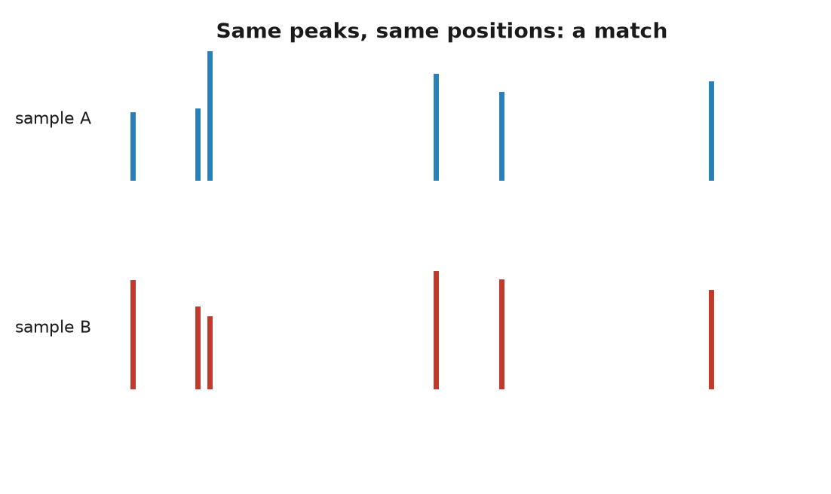
Figure 23. Short tandem repeat profiles from two samples.
* * *
The first case was not a crime. In 1985 a boy born in Britain to a Ghanaian mother had gone to Ghana and come back, and the immigration authorities suspected that the boy who returned was not the boy who had left, or was a nephew rather than a son. The mother's solicitor read about Jeffreys in a newspaper. The father was not available, so Jeffreys compared the boy's fingerprint with the mother's and with those of her three other children, reconstructed from them the bars the father must carry, and showed that the boy was her son and their full brother, with odds against the alternative that ran into the hundreds of thousands. The Home Office dropped the case. Paternity disputes followed by the hundred, and in 1987 the chemical company ICI opened a commercial laboratory, Cellmark, to run them.
The crime came from a few miles down the road. On 21 November 1983, a fifteen-year-old girl called Lynda Mann was raped and strangled on a footpath in the village of Narborough, south of Leicester. On 31 July 1986 a second fifteen-year-old, Dawn Ashworth, was killed in the same way on a lane in the next village, Enderby. A seventeen-year-old kitchen porter, Richard Buckland, who had learning difficulties, confessed to the second murder under questioning but denied the first. The police, wanting to tie him to both, sent Jeffreys the semen samples from the two victims and a blood sample from Buckland. Jeffreys used the newer single-locus probes, which light up one minisatellite at a time and give cleaner results from degraded material. The two crime-scene samples matched each other. Neither matched Buckland. In November 1986 he was released, the first person anywhere to be cleared of a crime by DNA, and the police, who had been told by a scientist that their confession was worthless, had to start again.
They started with what was then known as the blooding. From January 1987 every man aged between about seventeen and thirty-four who lived, worked or had been treated in the three villages of Narborough, Enderby and Littlethorpe was asked to give a sample of blood or saliva. Some five thousand men did; the figure usually reported is 5,511. Nobody matched. Then on 1 August 1987 a bakery worker named Ian Kelly, drinking with colleagues in a pub in Leicester, mentioned that he had given blood in the name of a fellow baker, Colin Pitchfork, who had told him a story about being in trouble over an earlier offence and had supplied a doctored passport for the purpose. A woman at the table reported the conversation six weeks later. Pitchfork was arrested on 19 September 1987. His blood matched the two samples, he admitted both murders, and on 22 January 1988 he was sentenced to life imprisonment, the first person convicted of murder on DNA evidence. He was released on licence in 2021 and recalled to prison within months, a matter still on the public record when this was written.
The United States followed within the year. In November 1987 a jury in Orlando, Florida, convicted Tommie Lee Andrews of rape on the strength of a match made by a commercial laboratory, and by 1989 a New York court, in the case of Joseph Castro, had thrown out DNA evidence from the same kind of laboratory because the work had been sloppy, which did more for the standards of the field than any conviction. Jeffreys was knighted in 1994.
* * *
The barcode of 1984 is no longer what a laboratory produces. It needed too much sample and took too long, and it was hard to turn into a number. By the early 1990s the method had moved to a different kind of repeat and to the chain reaction of the previous chapter. Short tandem repeats, or STRs, are stretches where a unit of usually four letters is repeated somewhere between five and fifty times. Each person carries two copies of each STR, one from each parent, and the two copies often differ in length. At one much-used marker on chromosome 5, one person might have a copy with eleven repeats and a copy with thirteen. A child, at the same marker, has one of the mother's two and one of the father's, as at every other. A pair of primers on either side of the repeat, thirty cycles of PCR, and the fragments come out of a capillary machine as peaks on a trace, one peak per copy, at positions that give the repeat number directly. Nanograms of DNA suffice, which is a few dozen cells. A licked stamp will do. The result is a list of numbers, two per marker, and lists of numbers can be stored and searched.
The United Kingdom set up the first national database in April 1995 and now profiles seventeen markers plus a sex test. The FBI's system, known as CODIS, the Combined DNA Index System, was authorised by an act of Congress in 1994 and became operational at the national level in October 1998 with thirteen core markers, expanded to twenty in January 2017. It held, by the mid-2020s, something over seventeen million profiles from convicted offenders and several million more from people merely arrested, figures I take from the FBI's own published statistics. Britain's holds profiles of about six million people. China's is reported to be far larger, and the reports are hard to check. Because a child shares one repeat number with a parent at every marker, a database that holds the parent can also point, weakly, at the child; this is called familial searching, it was first used to make an arrest in Britain in 2004, and it is the modest ancestor of the genealogy searches of Chapter 42.
The arithmetic that makes such profiles powerful is simple and the ways it goes wrong are subtle. At each marker, the frequency of a given pair of repeat numbers in the population can be measured; multiply the frequencies across thirteen or twenty markers, and the chance that a random unrelated person shares the whole profile falls below one in a quadrillion, several thousand times more than the number of people who have ever lived on Earth. That is the random match probability, and it is a real number. It is not the probability that the defendant is innocent, and confusing the two has a name, the prosecutor's fallacy, which the English Court of Appeal identified in a 1994 case and warned juries against. Suppose a partial profile from a degraded sample matches one person in a million. In a country of sixty-seven million there are about sixty-seven people who match. If nothing else connects the defendant to the crime, the profile makes him one of sixty-seven, not one in a million. Databases sharpen the problem: search seventeen million profiles for a one-in-a-million match and you expect to find seventeen innocent people, before you find anyone else.
The other failures are physical. DNA travels. In November 2012 a homeless man named Lukis Anderson was charged with a murder in a mansion near San Jose after his DNA was found under the victim's fingernails. He had been unconscious in a hospital at the time, drunk, and had been carried there by the same two paramedics who, hours later, attended the victim; the DNA had come with them on their equipment. He spent about five months in jail before the timeline was checked. Between 1993 and 2009, police in Germany, Austria and France pursued a woman whose DNA turned up at about forty crime scenes, including the murder of a police officer in Heilbronn in 2007, and who seemed to move between burglary, murder and shoplifting with no pattern at all. In March 2009 the investigators tracked her down: she worked in a factory in Bavaria that packed the cotton swabs the police used, and had contaminated them. In Manchester in 2011 a man named Adam Scott was charged with rape after his profile came up from a swab; the laboratory had reused a plastic tray that carried a trace from an unrelated sample of his, and the charge was dropped the following year. Mixtures of two or three people's DNA, and samples of a handful of cells, are now the daily material of forensic laboratories, and reading them is a matter of statistics and judgement, not a barcode held up to the light.
None of which is an argument against the method. In the United States, the Innocence Project counts more than 375 people freed from prison by DNA evidence since 1989, many after decades, and a fair number from death row. The technique that freed Richard Buckland before it caught Colin Pitchfork has done both, in that order, ever since. It reads, at most, a few dozen positions out of 3.1 billion, chosen precisely because they say nothing about the person except who they are. Reading the rest was, at the time of the Narborough case, an idea with a price tag of three billion dollars.

24. Fast, Cheap, and Everywhere
There is a chart on the website of the National Human Genome Research Institute in Bethesda, Maryland, that has been reproduced more often than any figure in genetics since the double helix, and it consists of one falling line. The vertical axis is the cost of sequencing a human genome, on a logarithmic scale, so that each gridline is ten times cheaper than the one above. The horizontal axis is time, from September 2001 to the most recent update. The line starts at about $95 million. For six years it slopes down gently, roughly halving every two years, in step with a grey reference line labelled Moore's law, the rate at which computer chips have improved since the 1960s. In late 2007 it leaves the grey line and falls off a cliff. By 2009 it is near $100,000. By 2011 it is near $10,000. By 2015 it is at about $1,000, and by 2022 the institute's own estimate is somewhere around $500 to $600. From the year the first draft was announced to 2022, the price of reading a person fell by a factor of something like a hundred thousand.
The starting figure needs care. The Human Genome Project, described in Part IX, cost about $2.7 billion over thirteen years, but that paid for maps, for the genomes of yeast, worm, fly and mouse, for technology and for the first human sequence together, and the institute's own estimate is that the human sequence itself accounted for a few hundred million to a billion dollars of it. The first genome of a single named person was James Watson's, read in 2007 by a company called 454 Life Sciences in about two months at a reported cost of about $1 million and handed to him on a pair of DVDs in Houston on 31 May of that year. Craig Venter's genome, read the same year with the older capillary machines, is not usually put on the chart because nobody agrees on what it cost. By 2014 Illumina was advertising a $1,000 genome, on condition that you bought ten of its HiSeq X machines for $10 million and ran them flat out. In September 2022 the same company announced a machine, the NovaSeq X, on which it said a genome could be read for $200 in consumables, and a rival, Ultima Genomics, had claimed $100 that May. By 2025 figures below $100 were being quoted. All of these are the cost of the chemicals and the machine time to a laboratory that runs thousands of genomes, not what a hospital bills a patient, which in the mid-2020s was still typically a few thousand dollars with interpretation, and not what a consumer paid a company for a full genome, which was a few hundred. The night in a hotel from the front of this book is the consumer price.
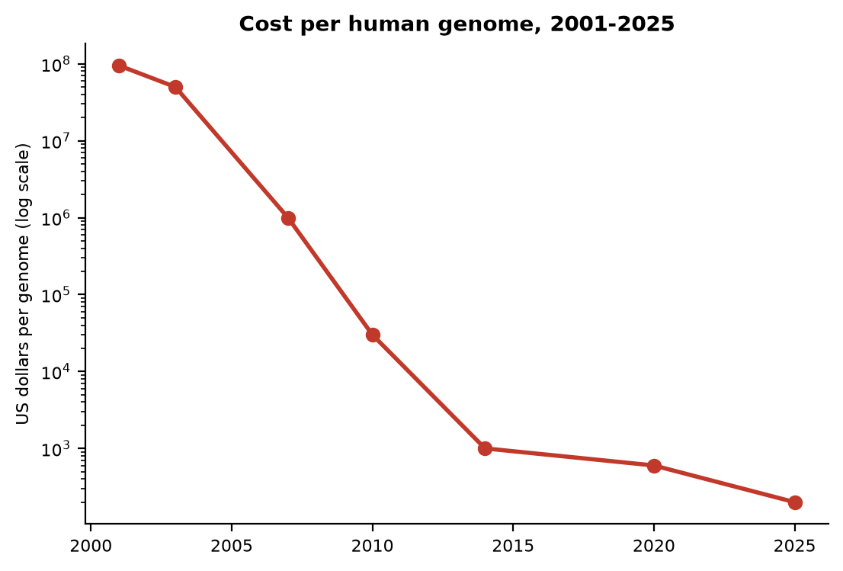
Figure 24. Cost per human genome, 2001 to 2025, on a logarithmic axis.
* * *
The cliff in 2007 has a cause, and the cause is that the ladders of Chapter 21 were replaced by something that does not read one strand at a time. The generic name is next-generation sequencing, which was a poor name the day it was coined and is now nearly twenty years old. The first commercial machine was built by 454 Life Sciences, a company founded in Connecticut by Jonathan Rothberg, who has said that the idea came to him while his newborn son was in intensive care in 1999 and nobody could tell him whether the boy was well. The 454 machine, launched in 2005 and described in Nature that year, attached single DNA fragments to beads, copied each bead's fragment into thousands of identical copies by a form of PCR run inside droplets of oil, dropped the beads into a plate with more than a million wells the size of a picolitre, so small that some fifty million of them would fit inside a single drop of water, and then washed the four building blocks over the plate one at a time. Where a block was added, a flash of light was produced; a camera recorded which wells flashed at which letter. Hundreds of thousands of fragments were read in parallel, in about four hours, at about 100 letters each. It was the 454 machine that read Watson, and the Neanderthal draft of Chapter 28.
The machine that won was born in a pub. In 1997 two chemists at Cambridge, Shankar Balasubramanian and David Klenerman, worked out over drinks at the Panton Arms how to watch a polymerase add letters to a single molecule, and in 1998 they founded Solexa to do it. Their method, sequencing by synthesis, is what most genomes on Earth are now read with, and it goes like this. Break the DNA into fragments a few hundred letters long. Attach adapters, brief manufactured DNA tags, to the ends and spread the fragments over a glass slide, a flow cell, coated with matching adapters, so that each fragment sticks at a random spot. Copy each fragment in place, over and over, into a tight cluster of about a thousand identical molecules, so that the signal from each spot is bright enough to see. Then add all four building blocks at once, each carrying a different fluorescent colour and each with its 3-prime end blocked, so that every cluster takes up exactly one letter and stops, in the same spirit as Sanger's crippled A. Photograph the slide. Every cluster glows one of four colours. Chemically remove the block and the dye, add the four blocks again, photograph again. Repeat 150 or 300 times. The photographs, hundreds of millions of coloured dots per frame, are turned into 150 or 300 letters for each of hundreds of millions of clusters. The first Solexa machine, the Genome Analyzer of 2006, read 36 letters at a time and produced about a billion letters per run. Illumina, of San Diego, bought Solexa for about $600 million in a deal closed in January 2007. Its NovaSeq X, sixteen years later, produces on the order of ten trillion letters in a run of a couple of days.
Ten trillion letters is about three thousand human genomes' worth. In practice each genome is read about thirty times over, so a single run yields something like a hundred genomes, and the price falls accordingly. Reading everything thirty times is not extravagance. Each read is a copy of a copy, made by a polymerase on a slide, and the machines make mistakes, about one letter in a thousand on a good day. Thirty overlapping reads of the same stretch let the software vote. Thirty reads that all say G, where the reference says A, is a real variant. One read that says G is noise. This is the same logic as shotgun sequencing on Sanger's lambda, applied at a scale Sanger's laboratory could not have imagined: the human text is read as a heap of hundreds of millions of brief fragments and reassembled by computer, not from scratch, but by lining each fragment up against the reference genome of Chapter 37 and noting where it differs.
* * *
Short reads have a blind spot, and the blind spot is repeats. If a fragment of 150 letters comes from a stretch where the same 171-letter unit is repeated ten thousand times, as it is at the centre of every chromosome, the fragment fits equally well at ten thousand places and the computer cannot say which. The sequence declared finished in April 2003 was in truth about 92 percent of the genome. The remaining 8 percent, the centromeres, the pinched-in middle regions that hold a chromosome's two arms together during division, the arrays of ribosomal RNA genes on five chromosomes, the ends, and lengthy stretches of near-identical duplicated segments, was a set of gaps labelled with an estimated length and the letter N.
Two technologies filled them, and both read one molecule at a time without copying it first. Pacific Biosciences, in California, fixes a single polymerase at the bottom of a well so small that light can only illuminate the enzyme itself, and films it in real time as it adds fluorescent letters to a single strand. Its first machine shipped in 2011, with reads of ten thousand letters or more and an error rate of about 15 percent, which was fixed in 2019 by running the same circular molecule round and round and taking a consensus: reads of fifteen to twenty thousand letters at better than 99.9 percent accuracy. Oxford Nanopore Technologies, founded in 2005, threads a single strand of DNA through a protein pore set in a membrane and measures the tiny electrical current through the pore as each letter passes and disturbs it. Its MinION, shown to early users in 2014 and sold from 2015, is the size of a large USB stick, weighs less than a hundred grams, plugs into a laptop, and cost about $1,000 with starter kits. Its early reads were only about 70 to 85 percent accurate; by the mid-2020s the best modes were reported above 99 percent, and the reads have no fixed length. Reads of a million letters and more have been published. The MinION went to West Africa in a suitcase in 2015 to read Ebola genomes at the bedside, and in August 2016 the astronaut Kate Rubins used one on the International Space Station.
A consortium calling itself Telomere-to-Telomere, led by Karen Miga and Adam Phillippy, used both of the long-read technologies on a cell line called CHM13 and published the first genuinely complete human genome in Science on 31 March 2022: 3,054,815,472 letters, no gaps, about 200 million letters that had never been seen and some ninety-nine newly predicted protein-coding genes among them. The Y chromosome, the hardest, was added in a paper in Nature in August 2023. CHM13 came from a hydatidiform mole, a failed pregnancy in which the egg had lost its own nucleus and duplicated the sperm's, so that its two copies of every chromosome were identical and there was only one text to assemble. That is why it was chosen. A genome with two different copies of everything, which is to say any of ours, is now assembled in the same way, and the pangenome of Chapter 37 is the result.
The last number in this chapter is a time, not a price. In 2012 a group at Children's Mercy Hospital in Kansas City, led by Stephen Kingsmore, read and interpreted the genome of a sick newborn in 50 hours, and argued in print that for a baby in intensive care with an undiagnosed genetic disease, days were the difference between a treatment and a funeral. By 2015 the time was 26 hours. In 2018, at the Rady Children's Institute in San Diego, it was 19 and a half hours. In 2021 a team at Stanford under Euan Ashley split a patient's DNA across 48 nanopore flow cells at once, sequenced it in about five hours, and reached a diagnosis in seven hours and eighteen minutes; the report appeared in the New England Journal of Medicine in January 2022 and Guinness recorded it. In routine use the answer takes two or three days, which is still faster than most of the tests it replaces. A California programme known as Project Baby Bear, which paid for rapid genomes for 178 infants on the state's Medicaid between 2018 and 2020, reported a diagnosis in about four in ten and a change of treatment in about a third, along with savings that the report put at $2.5 million. Roughly a third of babies in intensive care with a suspected genetic condition get a diagnosis this way; the rest get a genome that says nothing definite, which is a subject for Part X.
Everywhere is not an exaggeration. Sewage in London was found in 2022 to contain poliovirus by sequencing what flowed down the drains. The coronavirus of Chapter 22 became, within two years, the most sequenced organism in history, with more than sixteen million genomes shared on one public database. A MinION can read the DNA in a spoonful of pond water, or in air filtered through a zoo, and name the species passing. A spit tube of the kind in the prologue will be read on a chip that checks a few hundred thousand positions, but for a few hundred dollars more it could be read in full, and a newborn's could be read before leaving the maternity ward, as several countries were beginning to arrange when this was written. A person born in 1948, when nobody was sure the molecule carried anything at all, lived through the price of reading a human being going from infinite to a night in a hotel.
So the text can be read, by anyone, cheaply, in a day, and read so many times over that the machines' own miscopies are voted out; the next question, which a bacterium answered for the second time in 2012, was whether it could be rewritten.

PART VI — What We Can Do Now

25. Scissors from Bacteria
The most consequential laboratory tool of the century began as a complaint from the dairy industry. Yogurt and cheese are made by feeding milk to bacteria, mostly Streptococcus thermophilus and Lactobacillus, and bacteria have their own predators. A virus that infects bacteria is called a phage, and a phage outbreak in a starter culture can ruin a production run the way a frost ruins a vineyard. Food-culture companies lose money to phages every year. In the early 2000s, scientists working for Danisco, the Danish culture and ingredients company, were trying to understand why some of their strains survived an attack and others did not. The answer, reached in 2007, was that the surviving bacteria had filed the fingerprints of the phage in their own genome.
The repeats themselves had been sitting in the literature for twenty years, unexplained. In 1987 Yoshizumi Ishino and colleagues at Osaka University were sequencing a gene in Escherichia coli and reported, in the Journal of Bacteriology, an odd formation downstream of it: a brief sequence of about 29 letters repeated several times, with stretches of roughly 32 different letters between the repeats. It looked like a stutter. Nobody knew what it was for.
Through the 1990s Francisco Mojica, at the University of Alicante, kept going back to the salt marshes at Santa Pola, on the coast south of the city. The microbes that live in that brine carry the same stutter. He sequenced the odd region, found the repeats again, and then found them in species after species as public databases filled. In 2002, working with Ruud Jansen, he and his colleagues gave the pattern a name that has since become a verb: clustered regularly interspaced short palindromic repeats, CRISPR. In 2005 his group published the guess that explained the marshes. The spacers between the repeats matched the DNA of viruses. The stutter was a filing cabinet of enemies.
Two years later, in Science, Rodolphe Barrangou, Philippe Horvath and their Danisco co-authors showed it experimentally. Infect a culture, take the survivors, and the survivors have a new spacer in their CRISPR array, copied from the attacker. Delete the spacer and resistance is lost. Change the associated cas genes, the genes that build the cutting machinery, and resistance is lost. Bacteria, it turned out, have an adaptive immune system with a memory, and the memory is written in DNA. This is one of the clean satisfactions of biology: a question about spoiled yogurt, answered properly, turns out to be a puzzle about how one of life's oldest arms races is fought.
The step from immune system to tool took five more years, and it depended on working out exactly how the memory is used. The array is transcribed into RNA and chopped into pieces, each carrying one spacer. In the system that became famous, the one from Streptococcus pyogenes, that piece pairs with a second small RNA, called tracrRNA, described by Emmanuelle Charpentier's group in Nature in 2011, and the pair loads into a large protein known as Cas9. The RNA is the address. The protein is the machinery. Cas9 slides along DNA, and wherever the 20 or so letters of the guide match, and wherever the match is immediately followed by a brief motif the protein insists on, it cuts both strands.
That insisted-upon motif matters more than its ugly name suggests. It goes by the name protospacer adjacent motif, or PAM, and for the standard Cas9 it is any letter followed by two Gs. It is the reason the enzyme does not shred the bacterium's own filing cabinet, and it is also the first constraint any user meets: you cannot cut wherever you like, only within reach of a PAM. Since a PAM turns up every dozen letters or so in a random stretch of DNA, this is usually a mild annoyance rather than a wall.
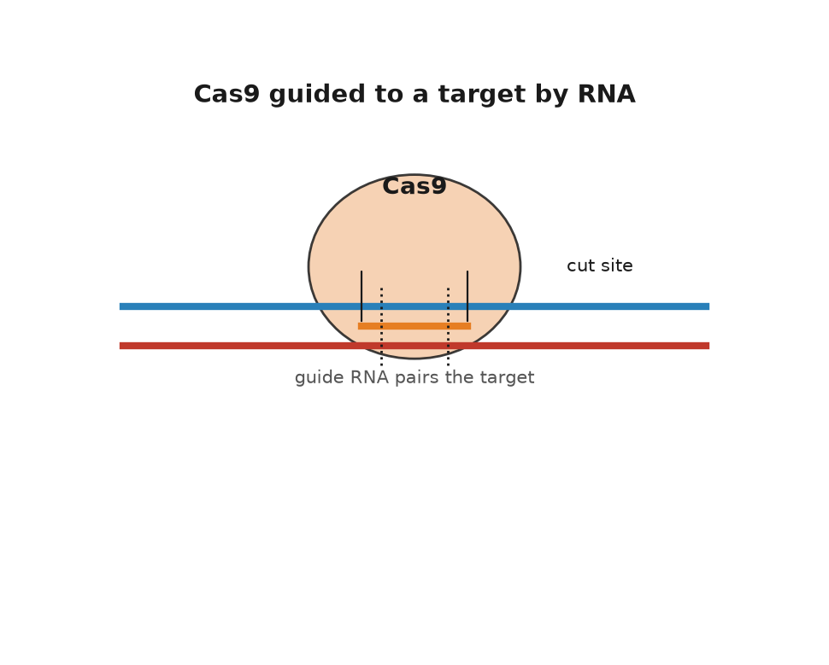
Figure 25. Cas9 guided to a target by RNA.
In June 2012, Science published a paper from Jennifer Doudna's laboratory at Berkeley and Charpentier's, then in Umeå, with Martin Jinek as first author. It showed that the two RNAs could be fused into one synthetic guide, and that by changing the letters of that guide you could send Cas9 to any address you chose in a test tube. The paper is calm in tone and enormous in consequence. It means a cutting enzyme is now programmable by typing, and the typing is cheap. A guide RNA can be ordered like a pizza.
By January 2013 the tool was working inside human cells, in near-simultaneous papers from Feng Zhang at the Broad Institute and George Church at Harvard, with others close behind. The Nobel Prize in Chemistry for 2020 went to Charpentier and Doudna. The credit for the jump into human cells, and the patents that followed, have been argued over in tribunals and law journals ever since, which is what happens when a tool worth billions is invented in several places within months.
* * *
Cutting is not editing. Cas9 makes a break; the cell repairs it, and what you get depends on which repair crew arrives. The fast, sloppy crew performs non-homologous end joining, which glues the ends back together and often loses or gains a few letters in the process. That is enough to wreck a gene, which is exactly what you want if the gene is doing harm. The careful crew performs homology-directed repair, which copies a template to rebuild the missing stretch. Supply your own template and you can write in a chosen sequence. The trouble is that the careful crew mostly works in cells that are preparing to divide, and it is far less efficient than the sloppy one. For most of the last decade, breaking has been easy and writing has been hard.
Two refinements from David Liu's laboratory at Harvard changed that. In 2016, Alexis Komor and colleagues published base editing in Nature: a disabled Cas9 that binds without cutting both strands, welded to an enzyme that chemically converts one base into another in place. The first version turned C into T. An adenine version, converting A into G, followed in 2017. No break, no repair lottery, just a single letter rewritten. In 2019, Andrew Anzalone and colleagues published prime editing, which uses a longer guide that carries both the address and the new text, plus a reverse transcriptase, an enzyme that writes DNA from an RNA template, to write that text into the nicked strand. In principle prime editing can make any small change: swap letters, insert a few, delete a few. In practice its efficiency varies by target in ways still being worked out.
As of late 2026 those two refinements have left the dish. Base editors are in living patients, which is the next chapter. Prime editing has been tried in people too. A 7 December 2025 paper in the New England Journal of Medicine reported two patients with chronic granulomatous disease, a rare immune failure in which white blood cells cannot kill certain microbes, whose blood-forming stem cells had been taken out, prime-edited to restore two missing letters in NCF1, and put back. The neutrophils, one class of those white cells, regained the chemical burst they use against infection, at least across the months of follow-up in the paper. Two patients are not a medicine. They are the first evidence that a nick-and-write editor, not only a cutter or a letter-swapper, can work in a person.
Cas9 is not the only enzyme in the cabinet, either. Cas12a, first described in 2015 under the name Cpf1, recognises a different motif, uses a shorter guide and leaves staggered rather than blunt ends. Cas13 targets RNA instead of DNA, which means a temporary edit with nothing permanent left behind, and it has been pressed into service for diagnostics. Smaller Cas proteins matter for a dull but decisive reason: the standard Streptococcus pyogenes Cas9 is a large protein, and packaging it into the adeno-associated viral vectors, harmless viruses hollowed out and used as delivery trucks for genes, is a tight fit. Much of the engineering of the last decade has been about size, motif requirements and fidelity rather than about the cutting itself.
The tool also changed how ordinary biology is done, which is easy to overlook next to the medical headlines. Pooled CRISPR screens knock out every gene in the genome, one per cell, across millions of cells at once, then ask which knockouts survive a drug or a virus or a starvation. That kind of experiment used to be a career. It is now a few weeks of work, and it has produced much of what we know about which genes a cancer cell depends on. The same approach, run with guides that switch genes on or off rather than break them, maps regulation as well as function.
The mechanism is settled science. Guides find their addresses, Cas9 cuts, base editors convert, cells repair. What is not settled is precision in a living animal, and this is where honest accounts and press releases part company. A guide 20 letters long will sometimes tolerate a mismatch or two. One parental set runs to 3.1 billion letters, and a cell carries two copies of it, so the genome contains a great many near-matches. Cutting at the wrong address is called an off-target effect, and it is measurable, reducible, and never quite zero. High-fidelity Cas9 variants, shorter guides, careful design software and whole-genome checks have pushed off-target rates down substantially since 2013. There are also on-target surprises: large deletions, rearrangements, and the occasional loss of a whole chromosome arm have all been reported after cutting exactly where intended.
There are also cellular consequences that nobody predicted from the biochemistry. In 2018 two groups reported that cells with an intact p53 damage-response pathway, the cell's built-in alarm system for broken DNA, resist being edited, so that the cells which survive an editing procedure are enriched for those with a weakened response, which is exactly the population one would rather not expand. The finding was argued over and its practical importance is still debated, but it illustrates the general lesson: a double-strand break is not a neutral act of typing. It is a kind of injury, and the cell treats it as one.
Then there is mosaicism. Edit a dish of cells and you get a mixture: some edited as you wanted, some edited differently, some not at all. In a treatment made from a patient's blood stem cells, a mixture can be good enough, because a large minority of corrected cells may be all the patient needs. In an embryo, a mixture is a different matter, since every cell of the resulting person descends from that mosaic. It is one of the several reasons the embryo work described later in this book was reckless as well as unlawful.
The address of the sickle-cell change in HBB is known to the letter, a single A where a T should be, and a base editor can in principle make that conversion without cutting the strand at all. The distance between "in principle" and "in a child" is measured in delivery, dose, safety data and about a billion dollars, and it is the subject of the next chapter.
What CRISPR actually did to biology was not to make editing possible. Gene targeting existed before it, through homologous recombination, the same template-copying repair described above, in mouse embryonic stem cells, work that earned Capecchi, Evans and Smithies the Nobel Prize in Physiology or Medicine in 2007, and through the zinc-finger and TALEN proteins of the 2000s. Those methods worked. They were also slow, expensive, and specialised: each new target meant engineering a new protein, which took a skilled laboratory months. CRISPR replaced protein engineering with a search string. That is why the technique spread through biology in about eighteen months, faster than almost any method before it, and why a graduate student in 2014 could knock out a gene in a week for the price of a set of reagents.
One further use deserves naming, because it is the only application of this technology that can spread on its own. A gene drive is an edit that copies itself onto the matching chromosome in every generation, so that instead of being inherited by half a carrier's offspring it is inherited by nearly all of them. Built with CRISPR, drives have been demonstrated in caged mosquitoes, crashing the population by making females infertile, and they are the most plausible route yet proposed to eliminating malaria transmission by Anopheles gambiae. They are also, by design, irreversible in the wild. No drive has been released in the field, the governance discussions run through the Convention on Biological Diversity and the affected African states, and the technical question of whether resistance evolves first remains open. Everything about gene drives is a working proposition rather than a settled one.
The first patient to be treated with it was a mother of four from Mississippi, and she was dosed in the summer of 2019.

26. The First Cures
Victoria Gray had lived with sickle-cell disease for thirty-four years: the crises that feel like being crushed, the hospital stays, the transfusions, the exhaustion. In the summer of 2019, at a research hospital in Nashville, she was given back her own blood stem cells after they had been removed, edited in a laboratory, and multiplied. The date usually reported is 2 July 2019. She was the first person in the United States to receive a CRISPR-based therapy for a genetic disease. When journalists spoke to her in the years that followed she described a life with the crises gone.
The edit is a clever piece of indirection. Sickle-cell disease is caused by a single change in HBB, the gene for adult beta-globin, and the obvious move is to correct that letter. The therapy does something else. Before birth, we run on a different version of the protein, fetal hemoglobin, encoded by HBG1 and HBG2, and after birth a repressor protein called BCL11A switches it off. Cut the enhancer, a stretch of DNA that acts as an on-switch for a nearby gene, that turns on BCL11A in blood-forming cells and the switch never flips: the patient makes fetal hemoglobin as an adult, and fetal hemoglobin does not sickle. The faulty gene is left exactly where it is. The cure works around it. Biology is full of these workarounds, and the people who find them deserve more credit than they get.
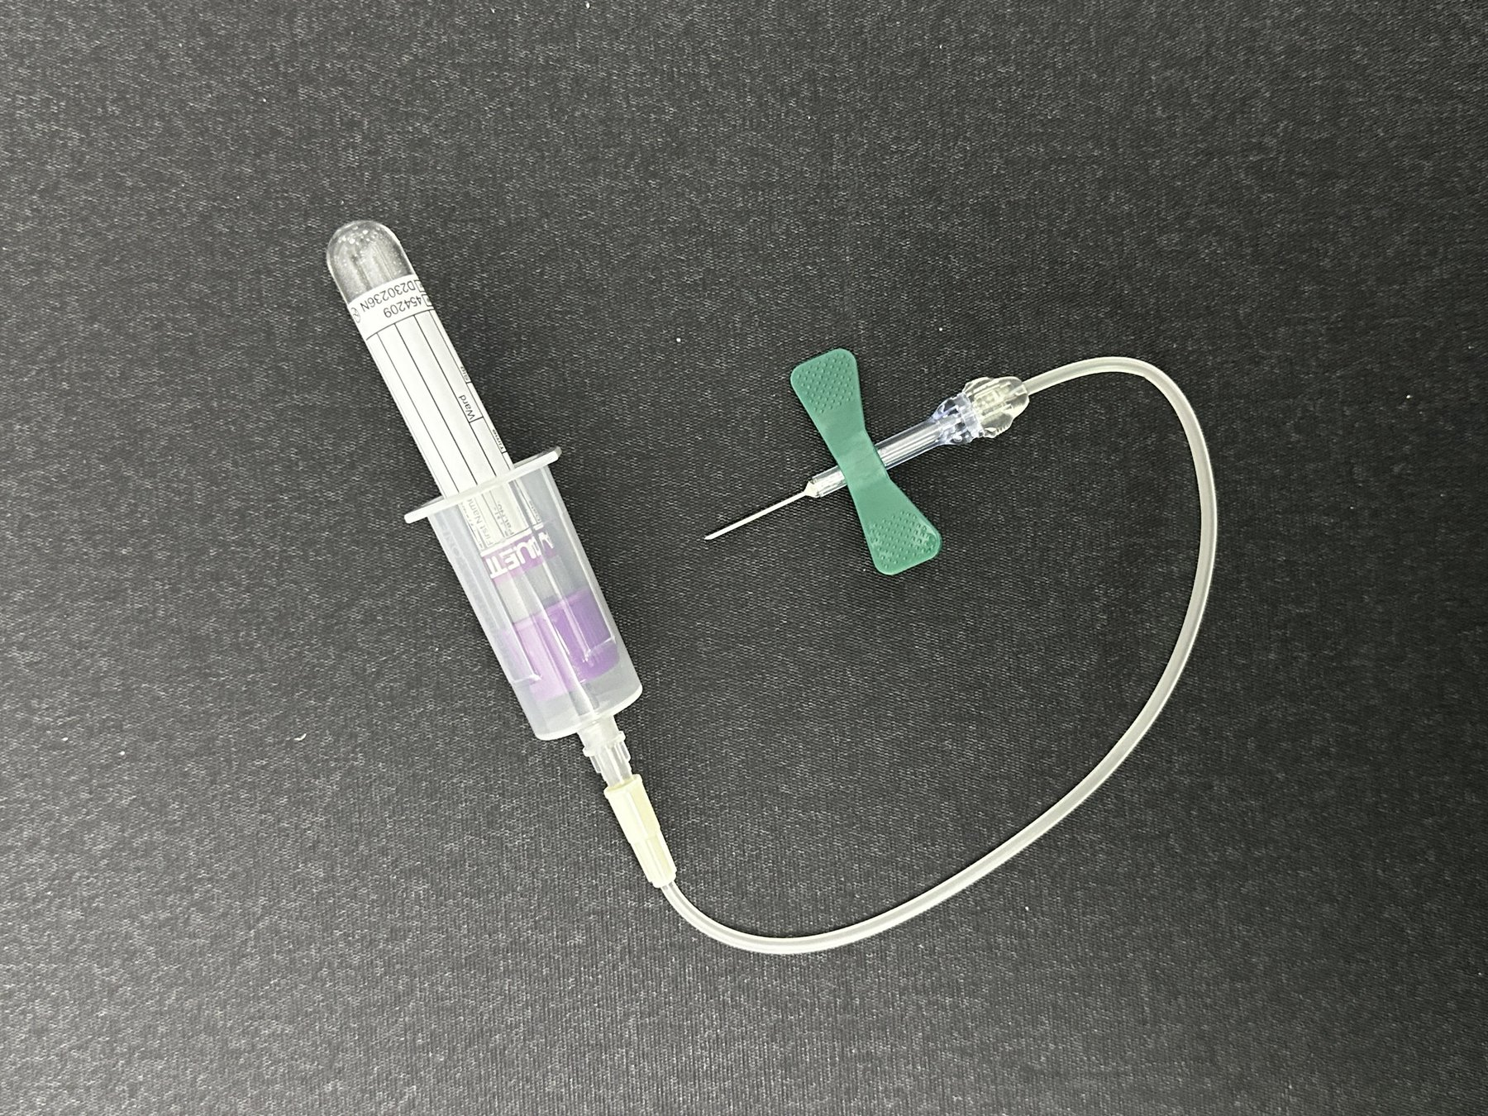
Figure 26. A blood collection tube and needle.
To understand why the field took thirty years to reach Nashville, it is worth remembering how badly the first attempt fared. On 14 September 1990, at the National Institutes of Health, a four-year-old named Ashanti DeSilva received her own white blood cells carrying a working copy of the gene for adenosine deaminase, an enzyme her immune cells needed to work properly, which she lacked. The team was led by W. French Anderson, Michael Blaese and Kenneth Culver. It was the first authorised gene-therapy trial in a human being. The results were ambiguous, since the children in that trial also stayed on the enzyme-replacement drug, and arguments about how much the gene therapy contributed lasted years. The optimism, however, was enormous, and by the late 1990s hundreds of trials were running.
On 17 September 1999, Jesse Gelsinger died in Philadelphia, four days after being injected with an adenoviral vector, a hollowed-out virus used to ferry the gene inside, carrying a gene for an enzyme of the urea cycle, the body's chemical pathway for clearing toxic ammonia from the blood. He was eighteen, he had a mild form of his disease, and he was a volunteer in a safety trial rather than a patient seeking treatment. His immune system reacted massively to the huge dose of virus; his organs began failing one after another. The subsequent investigations found problems in consent documents, in the reporting of animal data and of earlier patients' liver enzymes, and in the financial interests of the investigators and the university. Trials were suspended. The field's reputation went into a hole it did not climb out of for a decade.
Worse followed. Between 2000 and 2002 a French team led by Alain Fischer and Marina Cavazzana-Calvo reported that children with X-linked severe combined immunodeficiency, known as bubble-boy disease, had been given working immune systems by a retroviral vector. It was a real and durable success. Then several of those children developed leukaemia. The vector had inserted itself near a growth-promoting gene and switched it on. The mechanism is now well understood, and it is a sobering lesson about what "delivery" means: a virus that parks your gene in the genome parks it somewhere, and somewhere matters. Later vectors were redesigned to insert less dangerously, and self-inactivating designs largely solved the problem, but a child had to get cancer first for the lesson to be learned.
Sickle-cell disease is a good measure of how long that hole lasted. Its cause has been known at the molecular level since the 1950s, when Linus Pauling called it a molecular disease and Vernon Ingram pinned it to a single amino acid. It affects, by most estimates, around 100,000 people in the United States and many millions worldwide. It is the best-understood genetic disease there is, and until the 2020s the treatments on offer were a drug from the 1990s, transfusions, pain control and, for a lucky few with a matched sibling donor, a bone-marrow transplant. Understanding a disease completely and being able to do nothing much about it is the ordinary condition of medical genetics, and it is worth keeping in mind whenever a new gene is announced with fanfare.
The comeback was gene addition, the original idea of 1990, finally made to work through twenty years of unglamorous engineering of vectors, doses and manufacturing. Luxturna, Zolgensma, Hemgenix: each delivers a working gene by virus. None of them edits anything. The launch prices sit in the table in Chapter 43, one list, so this chapter does not restock them.
Editing arrived on the market in the last weeks of 2023. The therapy Victoria Gray received was licensed by Vertex and CRISPR Therapeutics under the name Casgevy, generically exagamglogene autotemcel, for sickle-cell disease and beta-thalassaemia. Britain's regulator approved it on 15 November 2023, the first approval of a CRISPR medicine anywhere. The American approval followed on 8 December 2023. The United States wholesale acquisition cost is in that same table. In the trials, the great majority of treated patients stopped having the pain crises that define the disease. That is the settled part.
* * *
The unsettled part is everything around the edit. The procedure is not an injection. The patient's stem cells must be mobilised and harvested, which is itself hard in sickle-cell disease. The cells are edited in a facility, checked, and frozen. Meanwhile the patient receives high-dose busulfan chemotherapy to empty the bone marrow so the edited cells have somewhere to live. That conditioning causes infertility in most patients, weeks of hospitalisation, and a small but real risk of death. It is the same brutal preparation used for a bone-marrow transplant, and it is the main reason a therapy that a healthy country's specialist centre can deliver is nearly impossible to deliver in the countries where most people with sickle-cell disease actually live: roughly three quarters of the world's cases are in sub-Saharan Africa. A $2.2 million treatment requiring a transplant unit is not, in any ordinary sense of the word, a cure for sickle-cell disease. It is a cure for a few hundred people who can reach it.
The prices raise a problem that medicine has not had to face before. A one-time treatment with a decades-long benefit is, in economic terms, an asset bought outright rather than a service rented monthly, and no insurance system in the world is designed for that. Manufacturers have offered outcome-based contracts, refunding part of the price if the effect fades, and public payers have experimented with subscription arrangements. In the United States, a federal model for state Medicaid programmes to negotiate sickle-cell gene therapies together began operating in 2025. Whether any of this survives contact with a hundred approved therapies rather than a handful is unknown. I think the pricing question will decide how much of this chapter matters to ordinary people, more than any remaining scientific problem will.
The way out of the transplant unit is to edit cells where they sit. In 2021, Intellia and Regeneron reported the first results for NTLA-2001, an infusion of lipid nanoparticles, tiny fat-based capsules that ferry their cargo into cells, carrying Cas9 instructions and a guide, aimed at the liver, in patients with transthyretin amyloidosis. The nanoparticles drain to the liver almost by accident of physiology, the liver cells take them up, the gene that makes the rogue protein is knocked out, and blood levels of that protein fell sharply and stayed down. No cells leave the body. No chemotherapy. The liver is the easy organ, because everything in the blood goes through it, and getting the same trick to work in muscle, brain or lung is an unsolved delivery problem rather than an editing one.
Editing has also quietly improved a therapy that was already working. CAR-T treatment, in which a patient's own T cells, a type of immune cell, are given a receptor that makes them hunt a cancer, was first approved in 2017 for a childhood leukaemia. It is effective and it is laborious, because the cells must be made individually for each patient, and some patients are too ill to wait or too depleted to supply cells at all. Editing allows donor cells to be used instead: knock out the receptor that would make them attack the recipient, knock out the marker that would make them attack each other, and you have an off-the-shelf product. In 2022 a thirteen-year-old girl in London with a T-cell leukaemia that had exhausted every other option received base-edited donor T cells at Great Ormond Street Hospital and went into remission, meaning the leukaemia retreated and its signs disappeared. Several such trials are now running. The cells are not a cure in the sense of a corrected genome; they are a weapon manufactured by editing.
Then came the case that changed how the field talks about its own future. KJ Muldoon was born in Philadelphia in the summer of 2024 with a severe deficiency of carbamoyl phosphate synthetase 1, an enzyme of the urea cycle, caused by mutations in CPS1. Without that enzyme, ammonia accumulates. The condition is usually lethal in infancy, and the standard hope is a liver transplant that a newborn may not survive to receive. A team at Children's Hospital of Philadelphia and the University of Pennsylvania, with Kiran Musunuru and Rebecca Ahrens-Nicklas among the leaders, designed a base editor for his particular mutation, tested it in cells and in animals, obtained regulatory clearance, manufactured it, and infused it in February 2025. The interval from diagnosis to dose was about six months. The New England Journal of Medicine paper of 15 May 2025 reports two infusions, at about seven and eight months of age. Later hospital and university accounts of the same case have spoken of a third dose. I will follow the paper. KJ tolerated higher doses of protein, needed less of his ammonia-scavenging medicine, and was sent home.
I think that six-month interval is the most important number in this chapter. A single edit for a single child cannot be priced the way a mass-market drug is priced, and the regulatory machinery was built for batches of a thousand patients, not one. If bespoke edits are to help the roughly 300 million people living with rare diseases, almost all of whom have no treatment of any kind, the platform has to be approved rather than each product. Regulators in the United States and Europe spent 2025 discussing exactly that, and the phrase being used is a plausible-mechanism pathway. Whether it can be made safe is a working puzzle, not a settled one.
It is also worth being careful with the word cure. In sickle cell, the results so far look like a durable remission of the disease's defining symptom, measured over a handful of years in a few dozen people. In the amyloidosis trials, a harmful protein is suppressed rather than a tissue repaired. For KJ, one child is doing better than expected. None of this is a promise about forty years from now, because nobody has forty years of data on an edited human being. The honest claim is that we have gone from a technique to a medicine in eleven years, which almost nothing in the history of therapeutics has done, and that we do not yet know what the twentieth-year follow-up looks like.
The next puzzle is whether we can write DNA as fluently as we now correct it, which turns out to be a different kind of problem altogether.

27. Writing from Scratch
On 20 May 2010, a team at the J. Craig Venter Institute reported in Science that they had booted up a bacterium whose entire genome had been built in a chemistry laboratory. They took the genome sequence of Mycoplasma mycoides, about 1.08 million letters, had it synthesised as more than a thousand overlapping cassettes, ready-built DNA segments of about a thousand letters each, designed to overlap at their ends, assembled them in yeast into a single circular chromosome, and transplanted it into a related bacterium, Mycoplasma capricolum. The recipient's own chromosome was lost as the cells divided and were selected. What remained began following the new instructions, divided, and produced colonies that were, by any test applied, the other species. They called it JCVI-syn1.0. Into the sequence they had written watermarks, coded stretches of DNA carrying the names of contributors, an email address, and three quotations, so that the artificial genome could be told from the natural one. One of the three was a line attributed to Richard Feynman, and the team wrote it in the wrong words; Feynman's own blackboard read "What I cannot create, I do not understand," and the synthetic genome carried a garbled version, which was later corrected. Even the first synthetic genome had a copying error, made by people rather than by the polymerase.
The road there had been walked in stages, and each stage caused an argument. In 2002 a team at Stony Brook led by Eckard Wimmer assembled a poliovirus from ordered DNA fragments and showed it was infectious in mice, which drove home the point that a virus is a sequence and the sequence is public. In 2003, Venter, Hamilton Smith and Clyde Hutchison reported synthesising the 5,386-letter genome of phage phi X174, the same little virus Sanger had read in 1977, in about two weeks. Reading and writing had met in the same organism, twenty-six years apart. The step from 5,386 letters to 1.08 million was mostly a matter of assembly: errors accumulate with length, so the work is to build short accurate pieces and stitch them, which the Venter team did by handing the final stitching to yeast, an organism that is unreasonably good at joining overlapping DNA.
The claim advanced at the time, and it is the right claim, is narrow: the software was synthetic, the hardware was borrowed. Nobody built a cell. They copied an existing text with high fidelity, added a signature, and installed it in a working machine. This is closer to transplanting an operating system than to writing one. Even so, it settled a real question. A genome is nothing more than its sequence. Get the letters right and the chemistry does not care whether they originated in an ancestor or in a synthesiser.
The more interesting result arrived six years later. In 2016 the same institute published JCVI-syn3.0, a genome cut down by trial and error to 531,000 letters and 473 genes, the smallest set that will still run a free-living cell in rich medium. That project revealed something humbling. Of those 473 genes, a substantial minority, reported at the time as around 149, had no known function. They could not be removed without killing the cell, and nobody could say what they did. A minimal cell, built deliberately by the people who understood cells best, still contained a hundred and fifty mysteries. I find that the single most useful fact in synthetic biology, because it sets the honest ceiling on how well anyone can claim to understand a genome. Later work has pinned functions on some of them, and the list of unknowns has shrunk, but it has not reached zero.
Yeast came next, and yeast is a proper organism with a nucleus and chromosomes. The Sc2.0 consortium, coordinated by Jef Boeke, set out to rebuild all sixteen chromosomes of Saccharomyces cerevisiae from synthetic DNA, not as a copy but as a redesign: repetitive elements removed, transfer-RNA genes relocated, stop codons, the three-letter stop signals from chapter 8, standardised, and recombination sites inserted so that the finished yeast can be prompted to scramble its own genome on command. The first synthetic chromosome, synIII, was published in 2014, much of it built by undergraduates in a teaching course. In 2023 the consortium reported the great majority of the genome complete, including a strain carrying multiple synthetic chromosomes at once and a purpose-built extra chromosome to hold the relocated transfer-RNA genes. Bacteria have also been recoded: in 2019 Jason Chin's group in Cambridge reported Escherichia coli rebuilt with about four million synthetic letters and a compressed genetic code that uses 61 codons instead of 64, which frees the three spare codons to be reassigned to amino acids nature does not use.
It is worth knowing how DNA is actually written, because the chemistry sets the limits. Almost all synthetic DNA is still made by the phosphoramidite method, developed by Marvin Caruthers and colleagues around 1980, which adds one letter at a time to a growing chain anchored to a solid support, in four steps per letter, with organic solvents. Each cycle works well over 99 percent of the time, which sounds excellent until you compound it: at 99.5 percent per step, a 200-letter product is correct in only about a third of molecules, and a 500-letter product in fewer than one molecule in ten. Set that beside the cell. The copying machine of chapter 7, with its proofreading and the repair crews behind it, gets roughly one letter wrong in a billion. The best chemistry in the world, writing from nothing, gets something like one in two hundred wrong. That is why synthesis companies sell short pieces and why everything lengthier is assembled from them and then sequenced to check. Printing the reactions onto chips has cut the cost per letter enormously, and enzymatic synthesis, which uses a polymerase in water instead of solvents, has been promising longer and cleaner products for several years now. It is working technology, not yet a settled replacement.
If DNA is a text, it can hold texts. In 2012, George Church's group encoded a book of about 53,000 words, plus images, into DNA and read it back. In 2013, Nick Goldman and Ewan Birney at the European Bioinformatics Institute encoded a mixed archive, including all of Shakespeare's sonnets and a clip of Martin Luther King's "I have a dream" speech, with an error-correcting scheme that let them recover the files intact. In 2017 Yaniv Erlich and Dina Zielinski borrowed a coding trick from video streaming and stored a complete computer operating system, a short film and a gift card, recovering every bit; they estimated a density of about 215 petabytes per gram. The attraction is density and durability. A gram of DNA can in principle hold hundreds of petabytes, each petabyte enough to store hundreds of thousands of feature films, and DNA in cool dry conditions survives for thousands of years, as the next chapter shows in some detail. The obstacles are cost and speed: writing is still far slower and dearer than any magnetic medium, and reading requires a sequencer. In 2019 a Microsoft and University of Washington team showed the whole loop running without hands, writing the word "hello" into DNA and reading it back automatically, and it took about twenty-one hours for five bytes. DNA storage is a working technology for archives nobody needs to open often, and speculative for anything else.
* * *
The most consequential piece of DNA writing so far was not a genome at all. It was a message. Katalin Karikó and Drew Weissman, working at the University of Pennsylvania through years of rejected grants, published in 2005 that swapping in a modified building block called pseudouridine, in place of one of RNA's ordinary letters, stopped synthetic messenger RNA, the molecule that normally carries a gene's instructions out to the cell's protein-building machinery, from triggering the innate immune alarm that had made it useless as a drug. That, with lipid nanoparticle delivery developed elsewhere, is the whole basis of the mRNA vaccine. When the sequence of the new coronavirus was published in January 2020, the design of a vaccine took days, because designing an mRNA vaccine is a typing exercise: take the sequence of the target protein, adjust the codons, add the caps and tails, order the DNA template. Two small changes made the difference between a good vaccine and a poor one, both written in at the keyboard: two letters' worth of amino acids swapped for prolines, an idea from Barney Graham and Jason McLellan's earlier coronavirus work, which hold the spike protein in the shape it has before it fuses with a cell. The first human dose went into an arm on 16 March 2020, roughly two months after the sequence appeared. By November the large trials were reporting about 95 percent protection against symptomatic disease, and on 2 December 2020 the United Kingdom became the first country to authorise one. Karikó and Weissman received the Nobel Prize in Physiology or Medicine in 2023.
That is what fluent writing looks like when the product is a short instruction rather than an organism. Manufacturing billions of doses was an industrial feat, and the clinical trials were conventional and large, but the act of writing was trivial in a way that would have been unimaginable in 1990. The message does not touch the genome. It is read for a few days and then broken down, which is part of why it could be written so freely.
Proteins are the other half of writing, and until recently they were the harder half. A gene's sequence determines the shape its protein folds into, the point Christian Anfinsen established with his ribonuclease in chapter 6, but for sixty years nobody could compute the shape from the sequence. Then in November 2020, at the CASP14 blind competition, a contest where teams predict protein shapes without being shown the answers first, DeepMind's AlphaFold2 predicted structures at accuracy comparable to experiment for most targets, a median score of about 92 on the contest's hundred-point scale, where the best entries two years earlier had scored around 60. In 2021 the method was published and the code released; by 2022 a public database held predicted structures for over 200 million proteins, which is essentially every protein sequence known. Separately, David Baker's laboratory in Seattle had spent two decades on the inverse problem, designing sequences that fold into shapes not found in nature, beginning with a small designed protein called Top7, reported in 2003, whose fold no natural protein had, and moving on to designed binders, molecules built to grab onto a specific target, enzymes and nanoparticle vaccines. One of those, a COVID-19 vaccine built on a designed protein cage, was approved in South Korea in 2022, the first medicine made of a protein designed from scratch on a computer. The 2024 Nobel Prize in Chemistry was awarded half to Baker for protein design and half jointly to Demis Hassabis and John Jumper for structure prediction.
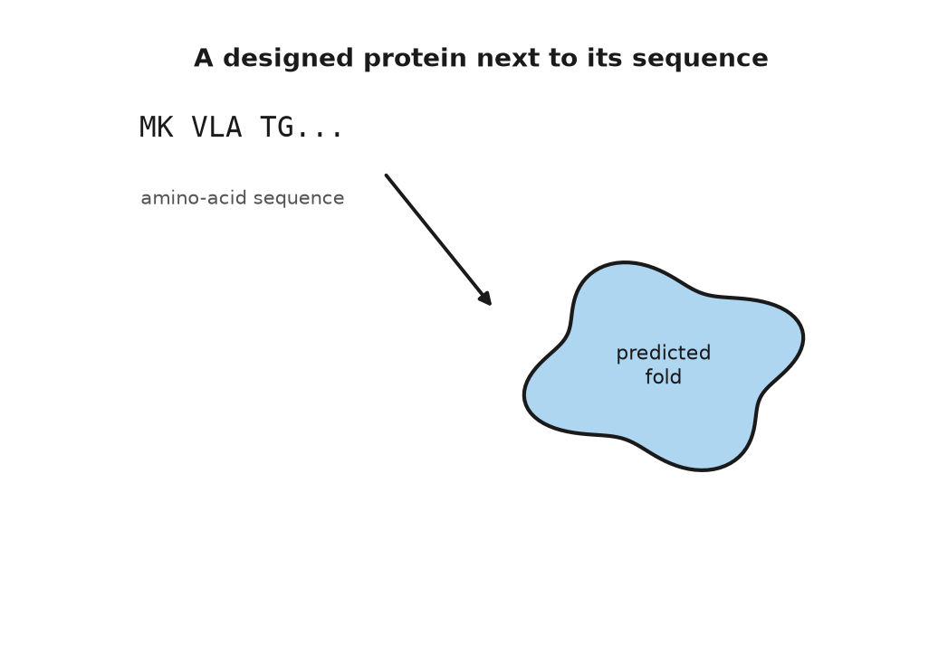
Figure 27. A designed protein next to its sequence.
The gap between prediction and design deserves a plain statement, because press coverage routinely blurs it. Predicting the fold of a natural protein is close to settled for ordinary single-domain proteins, and still unreliable for disordered regions, for large assemblies, for the effect of a single mutation on stability, and for how a protein moves. Designing a new protein that binds a chosen target is now working technology with a real success rate, helped since about 2023 by generative models that produce candidate shapes for the protein's backbone, the folded scaffold the rest of the sequence hangs from. Designing a novel enzyme that catalyses a reaction efficiently remains hard, and the best designed enzymes are generally far slower than natural ones. Designing a metabolic pathway that runs efficiently in a living cell is a matter of building and testing many versions rather than computing the answer, and designing a cell, or an organism, is not on the table at all. The gap between predicting a shape and predicting a behaviour is the whole of biology, and no amount of structural accuracy closes it by itself.
So where is writing still hard? Three places, mainly. Synthesis itself: standard chemistry builds accurate DNA only a few hundred letters at a time, so every lengthy construct is an assembly problem, and cost falls slowly compared with sequencing. Function: we can write any sequence, and we usually cannot predict what a novel sequence will do in a living cell, which is why synthetic-biology projects still run on cycles of build, test and fix. And regulation in the older sense of the word: a genome is not a list of parts but a network of switches whose behaviour depends on context, cell type and history, and no design tool captures that yet.
Against those limits, set what writing has already delivered in industry, which is more than most people notice at the supermarket. Yeast carrying a designed pathway now makes a precursor of the antimalarial drug artemisinin, developed in Jay Keasling's laboratory and handed to a manufacturer, which began production in 2013 as a supplement to the plant harvest. Engineered microbes make enzymes for detergents, vitamins, flavours, fragrances and the rennet in most hard cheese. They make soy leghemoglobin, a heme protein, carrying the same iron-holding ring that colours blood red, that gives one brand of plant-based burger its meaty taste, cleared by the American regulator in 2018. Each of these is a pathway of one or several genes, taken from one organism, tuned, and installed in another that can be grown in a tank. That is real writing, done at industrial scale, and it works because the products are compact molecules whose chemistry is understood, not because anyone has designed a cell.
There is also biosecurity. If a virus is a sequence, and sequences can be ordered, then the barrier to reconstructing a dangerous pathogen is the screening practices of synthesis companies rather than the difficulty of the chemistry. Horsepox, a relative of smallpox, was reconstructed from ordered fragments by a Canadian team in 2017 for about a hundred thousand dollars, and the paper started an argument that has not ended. Most commercial suppliers now screen orders against lists of sequences of concern, voluntarily and unevenly, and in 2023 a framework was agreed to tighten that screening, though it binds no one by law. I think mandatory, audited screening of synthesis orders is the cheapest safety measure available to this field, and the fact that it is still largely voluntary is the least defensible thing about the current arrangement.
Writing, then, is a set of skills at very different stages: copying a genome, settled; minimising one, done once and still not fully understood; writing a therapeutic message, routine; writing a protein, improving fast; writing a life form from first principles, not begun. Meanwhile the most remarkable reading of the last twenty years was done not on living cells at all, but on bones.

28. Reading the Dead
In 2008, Russian excavators working in a cave in the Altai mountains of southern Siberia recovered the tip of a finger bone from a layer that also held stone tools and animal teeth. The fragment was small enough to sit on a fingernail. It went to Leipzig, to the department of Svante Pääbo at the Max Planck Institute for Evolutionary Anthropology, and in 2010 the team reported that the mitochondrial DNA in it, the separate handful of genes passed down only from mothers, belonged to no known human population. It was not modern human and not Neanderthal. Later that year a draft nuclear genome confirmed it. A girl who died in that cave, probably somewhere between 50,000 and 100,000 years ago, belonged to a sister group of the Neanderthals that no one had ever identified from a skull, because no one had a skull. Her people are now called Denisovans, after the cave, and for years they were known almost entirely from a finger, a few teeth and a genome.
Reading a genome from a fossil should not work. DNA begins to break down at death. Water attacks the backbone, cutting long molecules into fragments of a few dozen letters; cytosine loses its amino group and reads as thymine, especially at the frayed ends of fragments; bacteria and fungi move in, so that a typical ancient bone yields a soup in which the human DNA may be one per cent of the total or less. Then there is the modern contamination, which is the hardest problem of all, since the people handling the bone are made of exactly the molecule being sought. Early attempts fell into that trap. A report of DNA from an Egyptian mummy in 1985, by Pääbo himself, later proved to be contamination, and much of the ancient-DNA literature of the 1990s did not survive scrutiny.
The field had begun, as it happens, with a horse. In 1984 Russell Higuchi, working with Allan Wilson at Berkeley, recovered short stretches of DNA from a 140-year-old piece of dried muscle from a quagga, a half-striped southern African zebra hunted to extinction in the nineteenth century, and showed it was a zebra rather than a horse. The following year came the mummy paper. What looked like the start of a rush turned out to be a decade of false positives, because the polymerase chain reaction, the copying trick that unlocked such work, will amplify a single stray modern molecule just as happily as an ancient one.
What rescued the field was a set of unglamorous techniques: clean rooms with filtered air and positive pressure, extractions from the dense petrous part of the temporal bone, which preserves DNA better than the rest of the skeleton, sequencing libraries, the prepared batches of DNA fragments a sequencer actually reads, designed for brief fragments, and, best of all, turning the damage into a signature. Because deamination accumulates in a characteristic pattern at fragment ends, genuine ancient DNA has a chemical fingerprint of age that a modern contaminant does not. The damage that destroys the evidence is also what authenticates it.
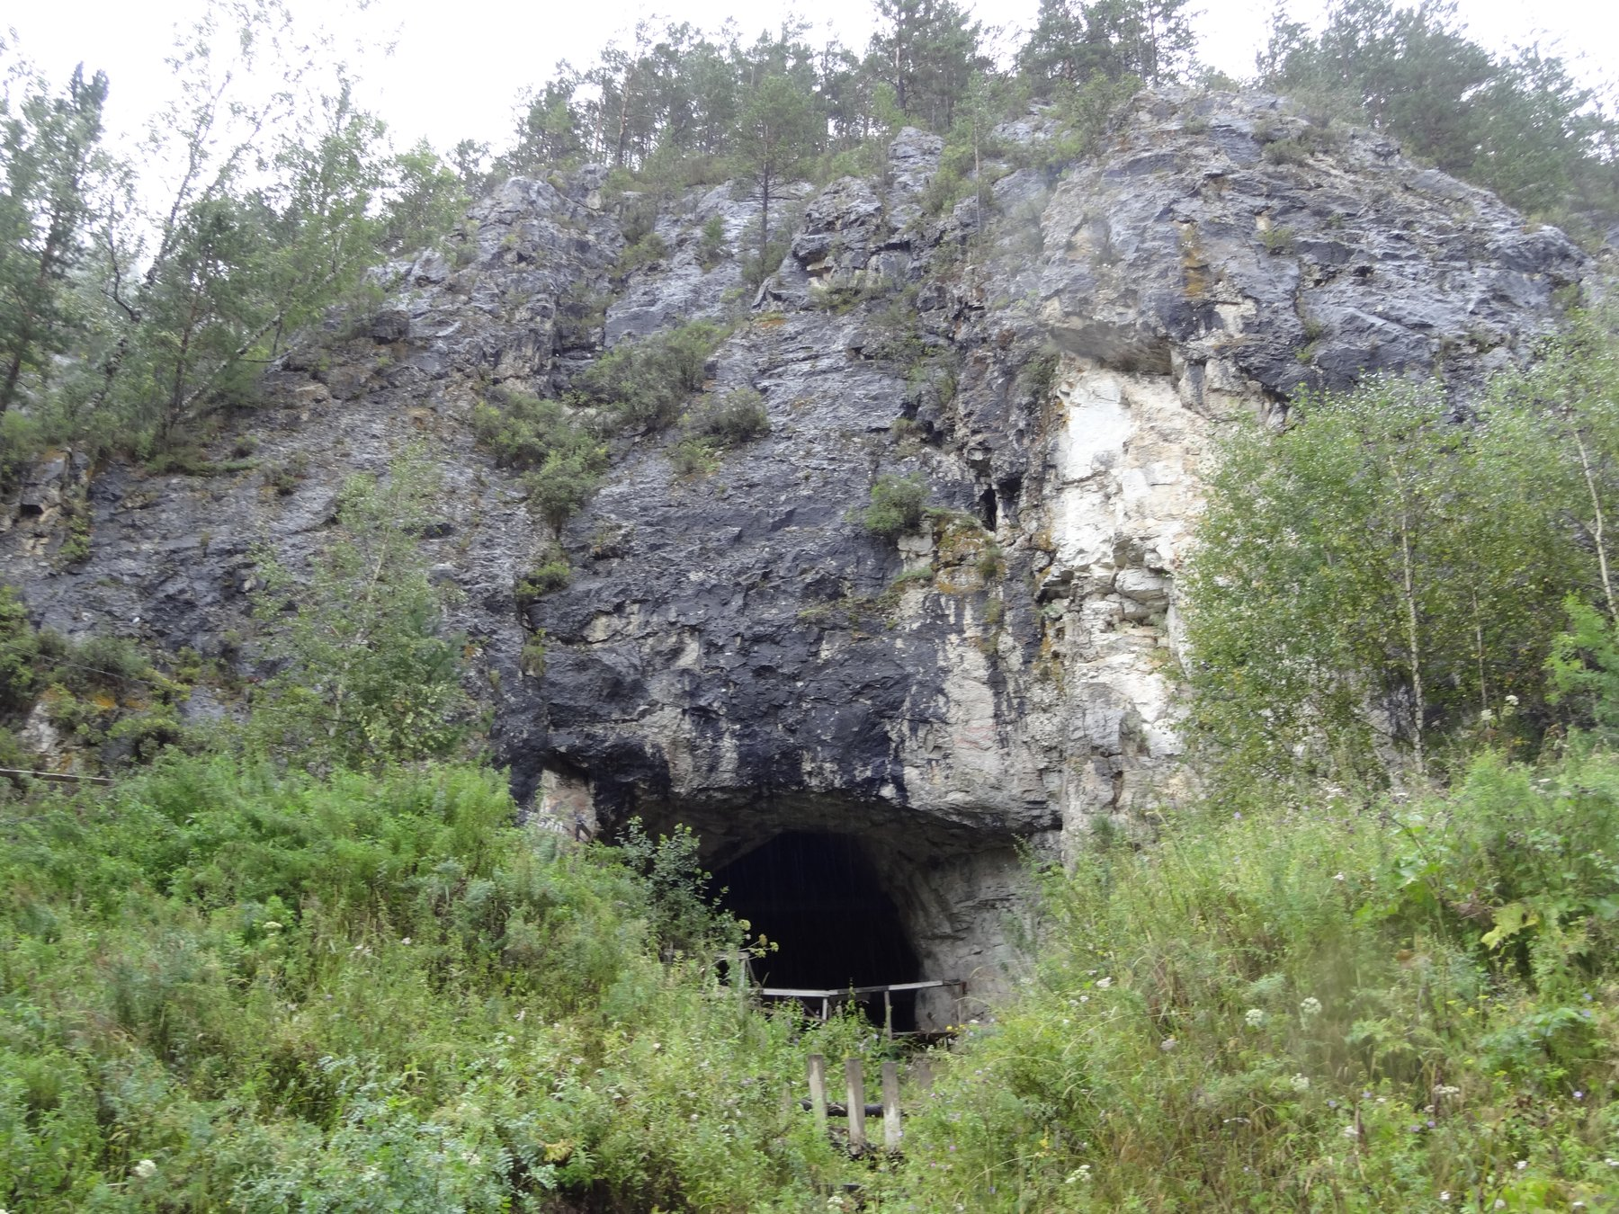
Figure 28. A limestone cave mouth, not confirmed as Denisova Cave.
The Neanderthals had been waiting for this since 1856, when quarrymen blasting a limestone cave in the Neander valley near Düsseldorf threw out a skullcap and some limb bones that a local schoolteacher thought worth keeping. For a century and a half they were argued about entirely from anatomy: brutish or not, ancestor or cousin, capable of speech or not. In 1997, Matthias Krings, Pääbo and colleagues published in Cell a brief stretch of mitochondrial DNA taken from that original 1856 specimen. It fell well outside the range of living humans, which said cousin rather than ancestor, at least in the maternal line. Getting nuclear DNA, the part that would show whether the cousins had children together, took another thirteen years and a change of sequencing technology.
On 7 May 2010, the same year as the Denisovan announcement, Pääbo's group published a draft Neanderthal genome in Science, built mainly from three bones from Vindija cave in Croatia at low coverage. High-quality genomes followed: a Denisovan in 2012, a Neanderthal from the Altai in 2014, each read many times over, in the end more accurately than many genomes of living people. Pääbo received the Nobel Prize in Physiology or Medicine in 2022 for founding the field. There are now several hundred sequenced ancient humans, and the number grows monthly.
The headline result is that Neanderthals did not entirely vanish. People whose ancestry lies outside sub-Saharan Africa carry roughly 1 to 2 percent Neanderthal DNA, a legacy of interbreeding as modern humans moved into Eurasia, probably mostly between about 50,000 and 60,000 years ago. The proportion is a population average and varies between individuals. Each person carries a different set of Neanderthal segments, so that summed across many living people a good fraction of the Neanderthal genome survives, scattered. Denisovan ancestry is concentrated further east: a few percent in Papuans and Aboriginal Australians, less in mainland East Asia. The remains themselves record the mixing directly. One individual from Denisova cave, reported in 2018, had a Neanderthal mother and a Denisovan father.
Some of the inherited segments do work. The clearest case is EPAS1, a gene involved in the response to low oxygen. Tibetans carry a version that dampens the usual response of thickening the blood at altitude, which protects against the complications of chronic mountain sickness. In 2014, Emilia Huerta-Sánchez and colleagues reported in Nature that the Tibetan version closely matches the Denisovan sequence. A population that lived and died in Siberia tens of thousands of years ago supplied an adaptation that people on the Tibetan plateau now depend on. Other archaic segments affect immune signalling, skin and hair, fat metabolism and, in a few studies, the risk of particular diseases, while much of the archaic material appears to have been selected against, since large stretches of the genome carry almost none.
Ancient genomes have also rewritten the prehistory of living populations, which is in some ways the more disruptive result. In 2015 two large studies, one led from Harvard by David Reich and one from Copenhagen by Eske Willerslev, reported that a large movement of people from the steppe north of the Black and Caspian seas, associated with the Yamnaya culture, reached central Europe around 5,000 years ago and contributed a substantial share of the ancestry of most Europeans today. Archaeologists had argued for a century about whether pots move or people move. The genomes said that in this case people moved, in numbers, and that the population of Europe has been replaced or heavily diluted more than once. Similar work has traced the peopling of the Americas, the spread of farming from Anatolia, and the arrival of lactase persistence, which the ancient samples show becoming common surprisingly late.
Individuals can be read too, in detail that feels indecent. The man who came out of a melting glacier on the Italian and Austrian border in 1991, known as Ötzi, died about 5,300 years ago with an arrowhead in his shoulder. His genome, published in 2012 and revised with better data in 2023, says he had brown eyes, was lactose intolerant, carried an elevated genetic risk of heart disease, harboured the bacterium that causes stomach ulcers, and had ancestry mostly from early Anatolian farmers with little of the steppe component that arrived in the region later. A body found in ice has yielded a medical record and a family history five millennia after the funeral that never happened.
Ancient DNA reads more than people. Bronze Age teeth have yielded Yersinia pestis, the plague bacterium, with reported cases going back over 4,000 years and at least one from roughly 5,000 years ago in Scandinavia, and those early genomes lack the genes that later made flea transmission efficient. Medieval burial pits from the Black Death have given whole plague genomes. Tuberculosis, leprosy, hepatitis B, smallpox and the 1918 influenza virus have all been recovered from human remains. Environmental sediments carry DNA too: a study in 2022 reported DNA roughly 2 million years old from northern Greenland, describing a forest ecosystem from the sediment alone, and mammoth teeth from Siberia have given sequences reported as over a million years old. There is a limit somewhere, set by chemistry and temperature, and the field keeps pushing at it.
* * *
Which brings us to the animals in the press releases. Colossal Biosciences, an American company founded in 2021, has declared de-extinction its stated aim, with the woolly mammoth, the thylacine and the dodo named as projects. In March 2025 it announced woolly mice: laboratory mice carrying several edits in genes affecting hair length, texture and fat metabolism, chosen using mammoth sequences. In April 2025 it announced three pups, named Romulus, Remus and Khaleesi, described as dire wolves. The dire wolf, Aenocyon dirus, died out about 13,000 years ago and was a distinct genus, not a large grey wolf. The work as described involved sequencing ancient dire wolf material and then making a reported 20 edits in 14 genes in grey wolf cells, followed by cloning.
It is worth being exact about what such an animal is. Twenty edits is twenty edits. The grey wolf and the dire wolf lineages are separated by millions of years and by a number of genetic differences that credible estimates put in the hundreds of thousands or higher. The pups are grey wolves with a small number of engineered changes, some affecting coat colour and size, presented in the shape of an extinct animal. Many palaeogeneticists said so publicly and bluntly at the time. The company's own framing has at points been that it aims for functional proxies, animals that act and look the part without truly being the extinct species, rather than genetic replicas, which is a defensible goal described in undefensive language elsewhere in its publicity.
I think the honest way to hold this is to separate three claims. That ancient genomes can be read well enough to identify candidate genes: settled. That an edited living species can be given some traits inferred from an extinct one, and that the techniques developed along the way are useful for conservation genetics, for rescuing inbred populations such as the black-footed ferret, and for widening the gene pool of species down to their last hundreds: working, with real results already. That an extinct species can be brought back: speculative, and with the definition of "back" doing most of the work. A mammoth-like elephant would be an elephant with edits, raised without a herd, in a tundra that has changed. Whether it should be attempted at all is an argument about conservation budgets and animal welfare more than about genetics, and the strongest case against is simply that the money and attention would save more species if spent on habitat.
None of this diminishes what the fossils have actually given us, which is a family history no document records. Before 2010, the relationship between modern humans and Neanderthals was a debate about the shape of brow ridges. Now it is a matter of counting segments in living genomes and matching them to a bone from Croatia or a finger from Siberia. The dead did not leave letters. They left their text, damaged, fragmented, deaminated at the ends, mixed with the DNA of the soil and of the archaeologists, and we have learned to reassemble it well enough to say who slept in which cave and who their grandmothers were. Every one of those fragments is a copy of a copy of a copy, degraded in ways we can measure, and it is precisely the imperfections, the broken ends and the misread letters, that tell us how old the message is and how far it travelled to reach us.

PART VII — Copies

29. Dolly, 5 July 1996
The lamb was born in a shed on a research farm seven miles south of Edinburgh, on a Friday evening in early July, and the first thing anyone noticed was her face. It was white. The ewe that had carried her for five months was a Scottish Blackface, a hill breed named for the obvious reason, and a Blackface ewe does not throw a white-faced lamb. The lamb's face said she was a Finn Dorset. There had been no Finn Dorset ram anywhere near the flock. That was the point. She weighed 6.6 kilograms, she stood up, she fed, and the handful of people in the shed slipped away and told nobody. It was 5 July 1996.
The world heard about her seven months later. A Sunday newspaper broke the story on 22 February 1997, five days ahead of the paper it was based on, which appeared in Nature on 27 February under a title that gives nothing away: "Viable offspring derived from fetal and adult mammalian cells." Five authors, Ian Wilmut of the Roslin Institute first among them. Somewhere in the text, in a table, is the number that made the lamb famous. The cell she had grown from was taken from the udder of a six-year-old ewe. A stockman at the farm is usually credited with the name.
What had been done to make her is called nuclear transfer, and the recipe is short even if the practice is not. Take an unfertilised egg from a Blackface ewe. Under a microscope, with a glass pipette finer than a hair, suck out the egg's own chromosomes, so that what remains is a cell with all its machinery and none of its text. Take a cell from a culture that has been grown from a scrap of the Finn Dorset's mammary tissue. Lay the whole cell against the emptied egg and pass a brief pulse of electricity through the pair. The pulse fuses the two membranes, so the udder cell's nucleus finds itself inside the egg, and it also gives the egg the jolt it would normally get from a sperm. The egg starts to divide. Grow it for a few days, then put it into a surrogate ewe and wait 147 days.
The numbers in the table are these. From the adult mammary cells, 277 eggs were fused with a cell. Of those, 29 developed far enough to be worth transferring, and they were placed into 13 ewes. One pregnancy went to term. One lamb. The other 276 are the result as much as the one is. Most reconstructed eggs never became embryos worth moving. Most of those that were moved never implanted. The recipe worked, and it worked rarely, which is the pattern nuclear transfer has kept ever since. A newspaper can print the lamb. The table prints the failures, and the failures are why a clone is not a photocopy you can order. The same paper reports two other cell lines, one from a nine-day-old embryo and one from a 26-day-old fetus, and those gave a few lambs each. But it was the one from the udder that changed the argument, because an udder cell is a fully adult, fully specialised cell, and the question of the century in this corner of biology was whether such a cell still had the whole book in it, and whether the book could be told to start again from page one.
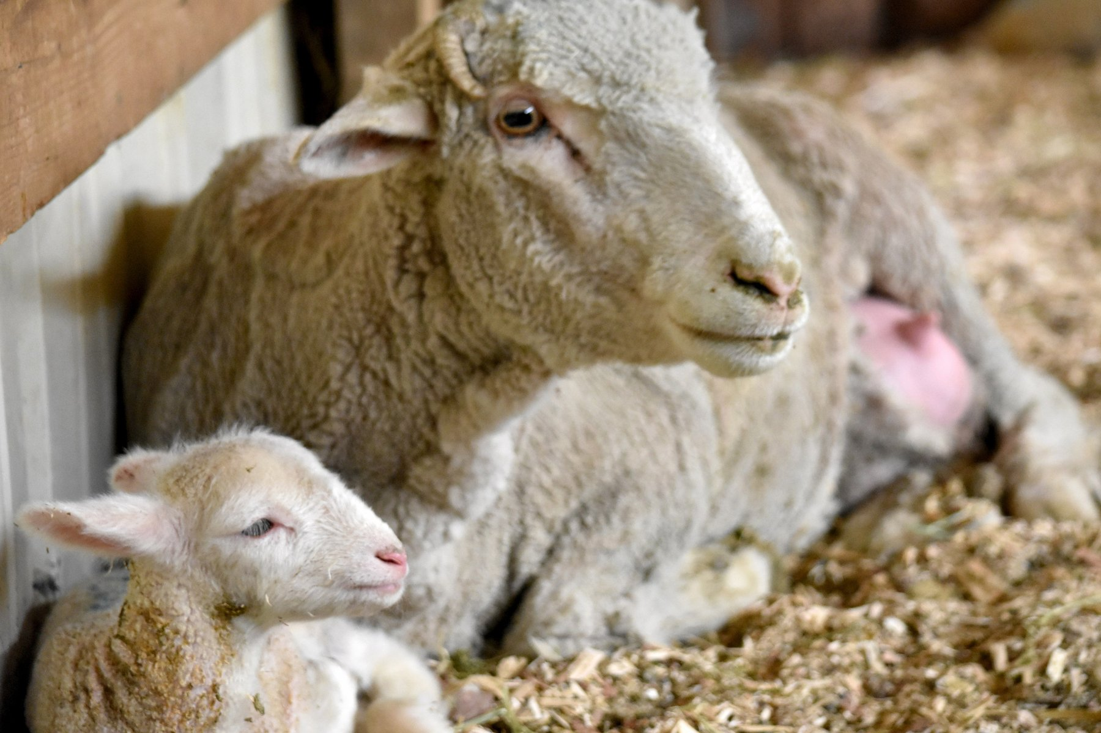
Figure 29. A ewe with her lamb in a barn.
* * *
The puzzle was older than Wilmut. In 1928 the German embryologist Hans Spemann tied a loop of baby hair around a salamander egg, pinching it so that the nucleus was on one side and a bag of cytoplasm on the other. When the nucleated half had divided several times, he loosened the loop and let one nucleus slip across into the empty half. It grew into a normal embryo. In 1938, in a book, he proposed what he called a fantastical experiment: take a nucleus from a cell that had already become something, put it into an egg with no nucleus, and see if the egg could make a whole animal from it. He had no way to do it.
Robert Briggs and Thomas King did it in 1952, in Philadelphia, with the leopard frog. They took nuclei from cells of a blastula, an early hollow ball of a few thousand cells, put them into eggs whose own nucleus had been removed, and got swimming tadpoles. When they tried nuclei from later, more specialised stages, the tadpoles mostly failed. Their conclusion, cautious and reasonable, was that as a cell commits to its fate, its nucleus loses something it cannot get back.
John Gurdon, at Oxford, did not believe it. In 1962 he published an experiment with the African clawed frog Xenopus laevis in which the donor nuclei came from the gut lining of feeding tadpoles, cells that were already doing a job. He used a strain with a visible marker in the nucleus so that nobody could say the frogs had come from a stray egg nucleus. A small fraction of the transfers, of the order of one or two in a hundred, became tadpoles that became fertile adult frogs. It was a slim fraction, but zero would have proved Briggs and King right and it was not zero. Gurdon's school biology master had once written on a report that a scientific career for the boy would be a waste of everyone's time. Gurdon kept the report. In 2012 he shared the Nobel Prize in Physiology or Medicine with Shinya Yamanaka, whose part of the story is two chapters on.
Frogs, however, are not mammals, and for thirty years the mammal refused. A frog's egg is enormous and develops on its own in pond water. A mammal's egg is a tenth of a millimetre across and needs a womb. In 1984 James McGrath and Davor Solter published in Science a careful set of mouse experiments in which transferred nuclei from anything later than the two-cell stage failed, and they ended with a sentence that became notorious: the cloning of mammals by simple nuclear transfer, they wrote, was biologically impossible. Steen Willadsen, working in Cambridge with sheep, showed in 1986 that nuclei from eight-cell embryos would work, and groups in Wisconsin extended it to cattle, but those were embryo cells with almost no history. The adult cell was the wall.
* * *
The person who found the way through was not Wilmut but Keith Campbell, a cell biologist who joined Roslin in 1991 with a background in cell cycles rather than sheep. His idea was that the trouble was one of timing. A nucleus busy copying its own DNA or preparing to divide, dropped into an egg that is at a different point in its own cycle, gets torn chromosomes and a dead embryo. The egg needs a quiet nucleus. Campbell's trick was to starve the donor cells of the serum that feeds them for a few days, so that they stopped growing and dropped into a resting state that biologists call G0. A nucleus in that state, he argued, would be reprogrammed rather than wrecked.
It worked first with cultured embryo cells. Two lambs, Megan and Morag, were born at Roslin in the summer of 1995 from cells that had been grown in a dish for weeks, and the paper appeared in Nature in March 1996. Nobody outside the field noticed. Dolly, from the udder, was the same method pushed one step further, and it is a fair puzzle who deserves the credit for her. Wilmut was the head of the project and the first author. Campbell was the one with the idea. In 2006, giving evidence to an employment tribunal in Edinburgh, Wilmut himself is reported to have put Campbell's share of the credit at 66 percent. Campbell died in 2012 at 58. Wilmut was knighted in 2008 and died on 10 September 2023, at 79.
Dolly herself lived in a barn at Roslin. She could not be put out on the hill, because the institute had received threats, and because a sheep that had been on the front page of every newspaper on Earth was worth stealing. Visitors fed her, and she grew fat. In the spring of 1997, to find out whether a clone could breed, she was put to a Welsh Mountain ram named David. Bonnie was born in April 1998. Twins, Sally and Rosie, followed in 1999, and triplets, Lucy, Darcy and Cotton, in 2000. Six lambs, all by the ordinary method. Whatever the egg had done to the udder nucleus, it had produced a ewe whose own eggs were fine.
Two things then happened that made people wonder whether she had been born old. In May 1999 a paper in Nature reported that Dolly's telomeres, the protective caps on the ends of the chromosomes that shorten a little with every division, were about 20 percent shorter than those of ordinary sheep of her age. The obvious reading was that her cells remembered the six years of the ewe she came from, plus the weeks in culture. Then, in the autumn of 2001, at five and a half, she was found to have arthritis in the hip and knee of her left hind leg, which is early for a sheep. The newspapers had their story. The clone was ageing fast.
The end arrived in February 2003. She developed a cough, a scan showed tumours in both lungs, and on 14 February she was put down, at six years and seven months. A Finn Dorset can live to eleven or twelve. The tumour was ovine pulmonary adenocarcinoma, a cancer caused by a retrovirus, a virus that copies itself straight into a cell's own DNA, called Jaagsiekte sheep retrovirus, that spreads in sheep kept close together indoors. Other sheep in the same barn had it. Her body was preserved and stands today in the National Museum of Scotland in Edinburgh, looking, as she did in life, faintly pleased with herself.
So was she old before her time? The working answer, and I think the right one, is no. Cloned cattle reported in 2000 had telomeres longer than normal, so short telomeres are not a law of cloning. In 2016 a group at the University of Nottingham led by Kevin Sinclair published, in Nature Communications, a full health check of thirteen cloned sheep aged seven to nine, four of them grown from the same frozen mammary cell line as Dolly. They were healthy. Their joints, blood pressure and blood sugar were those of ordinary sheep, and none had unusual arthritis. In 2017 the same group X-rayed Dolly's own skeleton and identified the joint damage of a sheep her age, and no worse. The best account is that she was a fat sheep kept indoors, which is a recipe for bad knees and for catching a lung virus, and that the cloning had little to do with either.
What the cloning had to do with was the argument that the copy in an adult cell is still the whole book. Roughly two hundred distinct cell types, the figure from chapter 9, make a sheep or a person, and each type carries the same text. In a person that text is two parental sets, about 6.2 billion letters. A sheep's cells likewise carry two copies of a text of the same order of length. What differs between an udder cell and a neuron is which pages are open. Dolly showed that an egg can close them all and open them again in the right order, at least once in 277 tries. It was the loudest possible demonstration that the text and the reading of the text are two different things. What she did not show, and what the next chapter is about, is that a clone is a copy of the animal it came from.

30. What a Clone Is and Isn't
In February 2018, in the middle of a long interview about her career, Barbra Streisand mentioned to a reporter from Variety that two of her three dogs had been cloned. Her Coton de Tulear, Samantha, had died in May 2017 at fourteen. Before she died, cells had been taken from her mouth and stomach and sent to a company in Texas, and the result was two puppies, Miss Violet and Miss Scarlett. A month later Streisand wrote a brief piece for the New York Times to explain herself. The puppies, she said, had distinct personalities from each other and from Samantha, and she was waiting to see which one would grow into the dog she missed. She dressed them in contrasting colours so she could tell them apart.
The company was ViaGen Pets, in Cedar Park near Austin, which had begun cloning dogs and cats for the public in 2015. In 2018 the price for a dog was about $50,000. A cat was cheaper, somewhere between $25,000 and $35,000 depending on the year, and by the mid-2020s both were being quoted at $50,000. The first step, the taking and freezing of a skin sample, is listed at $1,600, and a good many owners buy that and stop there.
What they are buying, if they go on, needs saying carefully, because the word clone carries a freight of films. Suppose, purely for the mechanism, that a skin cell of a fifteen-year-old were used to make a clone of him, and a child were born in 2027. What would that child share with the boy born in 2011?
The nucleus, to begin with. The child's nucleus would carry the donor's full diploid genome, both parental sets, about 6.2 billion letters. Two qualifications follow. The skin cell would have picked up its own private mutations since that boy was a single cell, at a rate that in skin runs to dozens a year, and every one of those would be in every cell of the clone. And the child would carry no new mutations from a father's sperm, because there was no sperm. So the clone would be nearer to the donor than the donor is to his own brother, and not identical to him. Identical twins, who are the natural clones, are nearer still, because they start from the same single cell on the same day, and even they diverge: the fingerprints differ, and by middle age each twin carries hundreds of mutations the other does not. About three or four births in every thousand are identical twins, and the rate is oddly constant across the world.
What the clone would not share is everything outside the nucleus. The mitochondria, the small power stations in each cell with their own 16,569-letter text, come with the egg, so they would be the egg donor's, not the boy's. The womb would be another woman's, with her own diet, her own infections and hormones, and her own birthday. And the epigenome, the set of chemical marks on the DNA and its packaging that tells a cell which pages are open, would have been wiped and re-laid by the egg, imperfectly. Freckles written in the nucleus would come along. A memory of the summer he learned to swim would not.
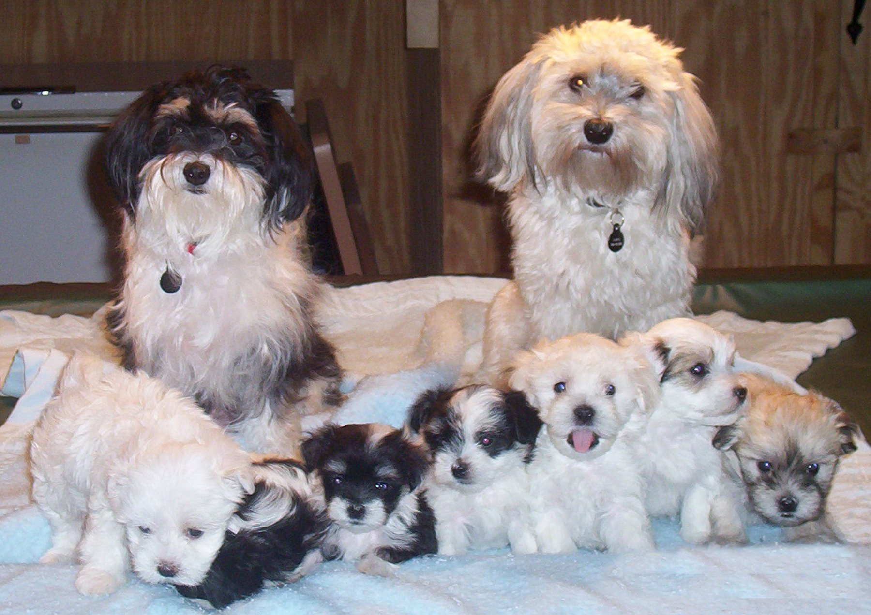
Figure 30. A litter of puppies.
* * *
The most instructive clone ever made is a cat. Her name is CC, and she was born at Texas A&M University on 22 December 2001, announced in Nature in February 2002. The money had come from John Sperling, the founder of the University of Phoenix, who wanted his dog Missy cloned and had funded a project to that end; dogs proved harder than cats, so the cat came first. CC's donor was a calico called Rainbow, a patchwork of orange, black and white. CC turned out grey tabby and white. Not a fleck of orange.
The reason is one that Chapter 12 set up. The gene that makes a cat's fur orange rather than black sits on the X chromosome. A female cat has two X chromosomes, and early in development each of her cells shuts one of them down at random and keeps that choice for life. If one X carries orange and the other black, the result is a patchwork cat, each patch descended from a cell that settled on a different choice. The pattern is not in the text. It is in a set of random decisions taken by a few dozen cells in an embryo a few days old. CC's donor cell had, by chance, shut down the X with the orange copy, and the usual account is that the egg did not fully reverse that decision, so every cell of the clone inherited it. Even if the egg had reset it, the patches would have fallen elsewhere. There is no way, in principle, to clone a calico's coat.
CC was healthy, had three kittens in 2006 by the ordinary method, and died in March 2020 at eighteen. Sperling's company, Genetic Savings & Clone, sold a handful of cloned cats from December 2004 at $50,000 each and closed in 2006 for lack of customers. The first cloned dog, an Afghan hound named Snuppy, was born in Seoul on 24 April 2005, from an ear skin cell; the paper reports 1,095 embryos put into 123 surrogates for that one surviving puppy. Dogs are hard because a bitch's eggs mature late, in the oviduct, the tube that carries an egg toward the womb, and are difficult to collect at the right stage. The laboratory that created Snuppy is a story for the next chapter; the dog, unlike much else to emerge from that laboratory, was real.
* * *
Outside the pet trade, cloning found the uses that pay. Mice were cloned in Honolulu in 1997 and reported in 1998, cattle in Japan in 1998, pigs in 2000, a horse in Italy in 2003, a mule in Idaho the same year, a camel in Dubai in 2009. On 15 January 2008 the United States Food and Drug Administration published its final risk assessment and concluded that meat and milk from cloned cattle, pigs and goats, and from their offspring, were as safe as any other; it made no ruling on sheep for want of data, and it required no label. In practice the clones themselves are rarely eaten. A clone of a prize bull costs something in the region of $15,000 to $20,000, and what is sold is his semen. The offspring of clones are ordinary animals, conceived by ordinary sex, and they have been in the American food chain since the 2000s. The European Parliament voted in 2015 to ban the cloning of farm animals and the sale of products from them, and though the legislation stalled, the practice is not carried on in Europe.
Horses are a special case, because racing's rulebooks forbid clones but polo's do not. In December 2016, in the final of the Argentine Open at Palermo, Adolfo Cambiaso rode six clones of his mare Cuartetera, one after another, and won. The clones had been produced by Crestview Genetics, a company set up by a Texan, Alan Meeker, with Cambiaso as a partner, and Cambiaso's first clone had been of a stallion, Aiken Cura, from cells taken as the horse was dying in 2006. Cloned polo ponies are reported to change hands for more than $100,000. In Dubai the Camel Reproduction Centre produced the first cloned camel, Injaz, on 8 April 2009, from the ovarian cells of a slaughtered adult, and has since cloned racing champions and winners of camel beauty contests by the dozen. What is bought in every case is the same thing: a genetic twin of a proven animal, born later. The buyer of a Cuartetera clone does not get Cuartetera's training. He gets a foal that can be trained.
Conservation has begun to use the same tool. Kurt, a Przewalski's horse, was born in August 2020 from cells frozen in 1980 at the San Diego Zoo's Frozen Zoo, restoring a set of genes that had been lost from the living herd. Elizabeth Ann, a black-footed ferret, was born on 10 December 2020 from cells of an animal frozen in 1988, and clones of the same donor were reported to have produced kits of their own in 2024. That is cloning as a time machine for genetic variation, and it is the use I find easiest to defend.
The primates came last. On 27 November and 5 December 2017, in Shanghai, two crab-eating macaques were born. Their names, Zhong Zhong and Hua Hua, spell the Chinese word for China when set side by side. Qiang Sun and Mu-ming Poo's group published the paper in Cell on 24 January 2018.
The numbers were bleak. The donor cells were fibroblasts, ordinary connective-tissue cells, from an aborted fetus. Seventy-nine embryos went into twenty-one surrogates. Six animals became pregnant. Two gave a live baby. A parallel attempt with adult cells produced two babies that died within hours.
What got monkeys over a line that twenty years of effort had missed was a chemical nudge. The embryos were injected with messenger RNA for an enzyme, Kdm4d, which strips a silencing mark off the packaging of the DNA, and treated with a drug, trichostatin A, that loosens that packaging further. The purpose was not curiosity. Identical monkeys are the ideal control group for a drug trial. In 2019 the same institute reported five cloned macaques with a body-clock gene knocked out.
The Kdm4d trick points at the general problem. Dolly was one in 277. Two decades on, the efficiency of nuclear transfer is still poor: in cattle, a few percent of transferred embryos become live calves, and in pigs and dogs the figure is lower. The losses come at every stage, from embryos that never implant, to placentas that grow wrong, to calves born too large to be delivered, a condition the breeders call large offspring syndrome. That the losses happen is settled. Why they happen is a working account, and its centre is the epigenome: the egg must strip from an adult nucleus every mark that made it an udder cell or a skin cell and then lay down the marks of a one-day-old embryo, and it does the job unevenly. The marks that record which parent contributed each gene copy, the imprints, are especially prone to error, and imprinted genes control the placenta and fetal growth, which is exactly where clones fail.
A growth gene shows the kind of error. IGF2 pushes a fetus to grow. Normally it is read from the father's copy and kept quiet on the mother's. The quiet is a chemical mark, not a changed letter.
In cloned calves the marks at this gene, and at several others like it, often slip. A copy that should be silent speaks, or a copy that should speak goes faint. The fetus overgrows. So does the placenta. The same class of slip, arising on its own rather than from a cloning procedure, is a known human condition, Beckwith-Wiedemann syndrome: babies born large, growth marks wrong.
Cloning did not invent the problem. It stumbles into it when the reset of those marks is incomplete. A live calf shows that the reset was good enough. It does not show that the reset was clean. I would describe the link between the slipped marks and the oversized calves as a working account. The overgrowth is settled. The marks are the best current explanation, and more than one gene is involved.
There is a second mismatch, in the energy supply. Milk yield and muscle work depend partly on mitochondria, and those come with the egg, not with the nucleus that was copied. A clone of a champion cow carries the champion's nuclear text, both parental sets, and the egg donor's mitochondrial circle of 16,569 letters. The face can match. The energy machinery is someone else's, and nothing in the procedure swaps it. That is the same split this chapter has already shown in a calico cat and in two pet dogs. The nuclear text travels. A great deal around it does not.
None of this is what Streisand paid for, and she said as much. She wanted Samantha back, and she got two dogs with Samantha's coat and Samantha's face and their own opinions. The mistake, if it is one, is not in the science but in the word. A clone is a copy of the text, built late, read by another cell, in another body, in another year. Every animal in this chapter is a demonstration that the text is not the animal. The one animal it has never been done to, in any way that anyone has proved, is the one that has argued about it the most.

31. The Human Question
On the morning of 28 November 2018, in a lecture hall at the University of Hong Kong, a thirty-four-year-old biophysicist named He Jiankui walked to a lectern in front of several hundred of the world's genome-editing scientists and a bank of cameras, and the chair of the session asked the audience to let him speak. Three days earlier, videos posted on YouTube and a story in the MIT Technology Review had announced what he was there to describe. Twin girls, given the pseudonyms Lulu and Nana, had been born a few weeks before in China with a gene known as CCR5 altered in their embryos by CRISPR, the gene-editing tool introduced in chapter 25. It was the first time anyone had deliberately altered a human being's heritable text and let the pregnancy go to term. The chair of the summit, David Baltimore, who had shared a Nobel Prize in 1975 and had spent forty years helping to write the rules for exactly this kind of work, branded it irresponsible from the same stage the next day.
The summit was the second of its kind. The first, in Washington in December 2015, had ended with a statement that it would be irresponsible to proceed with editing embryos for pregnancy until the safety questions were answered and society had reached some broad agreement. He Jiankui had been in the room in 2015. The full story of what he did and what was wrong with it comes at the end of this chapter. Before it, there is the older puzzle that Dolly raised in 1997 and that has never been answered by a birth: whether a human being can be cloned, and what people did while trying.
* * *
The reaction to Dolly was immediate and mostly about people. Within a fortnight of the announcement, President Clinton had barred federal funds from any attempt to clone a human and asked his National Bioethics Advisory Commission for a report; it came in June 1997 and recommended a moratorium, a temporary halt. In December 1997 a Chicago physicist named Richard Seed announced that he would set up a clinic to clone people, and got the front pages he wanted. In 2002 a religious group called the Raelians, through a company named Clonaid, announced the birth of a cloned baby girl on 26 December, and never produced her, a DNA test, or anything else. An Italian fertility doctor, Severino Antinori, and an American, Panayiotis Zavos, put forward similar claims across 2002 to 2004 with the same evidence, which is to say none. There is no verified case of a cloned human being born, then or since.
The laws followed anyway. In Britain, a High Court judge ruled in November 2001 that an embryo made by nuclear transfer was not covered by the 1990 fertility law, because that law defined an embryo in terms of fertilisation, and Parliament passed the Human Reproductive Cloning Act within weeks. The Council of Europe had opened a protocol banning human cloning in 1998. On 8 March 2005 the United Nations General Assembly adopted a Declaration on Human Cloning, by 84 votes to 34 with 37 abstentions, calling on states to prohibit all forms of human cloning that were incompatible with human dignity. The declaration is not binding, and the vote split not over babies, which nobody was defending, but over research: Britain, Belgium, South Korea and others voted against because the wording could be read to cover the making of cloned embryos for stem cells, which they allowed. The United States has never passed a federal ban, though some fifteen states have their own. Dozens of countries ban reproductive cloning outright.
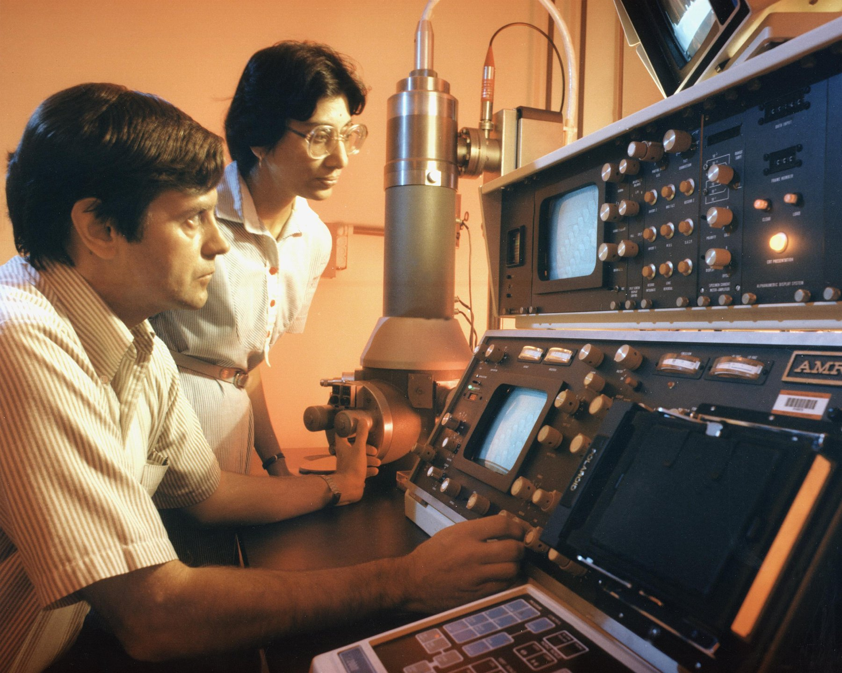
Figure 31. An electron microscope in a laboratory, about 1980.
The research the vote was about is what became known as therapeutic cloning. The idea was Dolly's recipe stopped short. Put a patient's nucleus into an emptied egg, let it grow five or six days to a hollow ball of a hundred or so cells, then take the inner cells and grow them in a dish as embryonic stem cells, which can become any tissue in the body and which carry the patient's own text, so his immune system would accept them. James Thomson in Wisconsin had grown the first human embryonic stem cells from spare embryos left over from IVF, fertility treatment done outside the body, in November 1998. The matched version was the prize, and in 2004 a veterinarian at Seoul National University announced that he had won it.
Hwang Woo-suk's paper in Science, published in March 2004, reported the first human embryonic stem cell line produced by nuclear transfer, from 242 eggs. A second paper in June 2005 reported eleven such lines, each matched to a patient, from 185 eggs, an efficiency that startled everyone in the field. Hwang became the most famous scientist in South Korea, given a title, a postage stamp and his own institute. In the autumn of 2005 the story fell apart. First it emerged that some of the eggs had come from junior women in his own laboratory, and that donors had been paid, which his American collaborator, Gerald Schatten of Pittsburgh, cited when he withdrew in November. Then a television investigative programme, and a group of young Korean scientists posting online, showed that photographs in the 2005 paper were duplicates of each other. A university panel reported on 23 December 2005 that the 2005 data were fabricated, and on 10 January 2006 that the 2004 line was not a clone either. Science retracted both papers on 12 January 2006. Not one matched stem cell line had ever existed. In 2009 Hwang was convicted of embezzling research funds and of violating the bioethics law, and after appeals received a suspended sentence. He went on cloning dogs, at which, as the last chapter said, he was genuinely good.
The thing Hwang faked was eventually done. In May 2013, in Cell, Shoukhrat Mitalipov's group at Oregon Health & Science University reported human embryonic stem cell lines made by nuclear transfer, using skin cells from a fetus and from an eight-month-old infant. The reasons it worked were unglamorous: very fresh eggs from young donors, precise timing of the electrical pulse, and caffeine in the medium, which holds the emptied egg in the right state while the new nucleus settles. In April 2014 two other groups, one in New York and one in California and Korea, extended the method to adult donors, including a man of 75 and a woman with type 1 diabetes. It had taken eleven years from Hwang's claim to the fact. By then it barely mattered.
* * *
It barely mattered because of a paper published in Cell on 25 August 2006 by Kazutoshi Takahashi and Shinya Yamanaka of Kyoto University. Yamanaka had trained as an orthopaedic surgeon, found he was bad at it, and turned to research. His question turned Gurdon's on its head: an egg can reset an adult nucleus, so the egg must contain the factors that do it. What are they, and how few would be enough? He and Takahashi assembled a list of 24 genes active in embryonic stem cells, put all 24 into mouse skin cells with a virus, and got a few cells that behaved like embryonic stem cells. Then they removed the genes one at a time to see which ones were needed. The answer was four: Oct3/4, Sox2, Klf4 and c-Myc. Four genes, delivered to a skin cell, turned it back into something that could become any tissue. He called the cells induced pluripotent stem cells, iPS cells, and in November 2007 his group and James Thomson's, in the same week, did it with human cells.
The consequences for cloning were immediate. To get a patient's own stem cells, you no longer needed a woman's eggs, an emptied egg, a nuclear transfer, or an embryo. You needed a skin biopsy and a virus. Whatever position a country had taken in the 2005 vote, the technology had walked around it. In 2012 Yamanaka shared the Nobel Prize in Physiology or Medicine with John Gurdon, for a frog experiment in 1962 and a mouse experiment in 2006, and it is one of the better-judged prizes: the second experiment answered what the first had only asked. The first patient treated with iPS-derived cells was a Japanese woman in her seventies who received a sheet of retinal cells in Kobe in September 2014, made from her own skin. By 2025 trials for Parkinson's disease, heart failure and several other conditions were under way, and the Parkinson's results reported that year from Kyoto were modest and real. Whether iPS cells become routine medicine is still a working hypothesis. That they killed the argument for cloning humans for spare parts is settled.
That leaves the babies, and the man at the lectern. He Jiankui had a doctorate from Rice University, a postdoctoral year at Stanford, extra research training taken after a doctorate, and a post at the Southern University of Science and Technology in Shenzhen, from which he had taken unpaid leave. Through a support group for people affected by HIV, the virus that causes AIDS, he recruited couples in which the husband was HIV-positive and the wife was not. The consent form the couples signed described the project as the development of an AIDS vaccine. The ethics approval he produced bore the stamp of a Shenzhen hospital, which said it had never given it, and the Chinese investigation that followed found the document forged. He edited CCR5 in the couples' IVF embryos, chose embryos he judged edited, and transferred them. Twin girls were born in late 2018. A third child, from another couple, was born in 2019.
What was wrong scientifically is a list, and it needs no rhetoric. First, there was no medical need. A father's HIV is kept out of an embryo by washing the sperm, a routine procedure since the 1990s, and the mothers were not infected, so the girls were at no risk in the womb. Second, the edit was not the edit. The intended model was Δ32, a 32-letter deletion in CCR5 carried on one chromosome by about 10 percent of northern Europeans and on both by about 1 percent, which removes the doorway that HIV uses to enter a cell. CRISPR cut where it was aimed, but the cell's repair produced different deletions. One girl, from his own slides, had one copy of the gene changed and one untouched, which gives no protection at all. The other had two distinct changes, neither of them Δ32, whose effect on the protein nobody had ever measured. Third, the girls were mosaic: the slides showed that not every cell in the embryos carried the same edit, so the children are patchworks of edited and unedited cells in unknown proportion. Fourth, off-target cuts, CRISPR snipping at an address other than the one it was aimed at, could not be excluded, and cannot be checked in a living child without sampling tissue after tissue. Fifth, the gene itself has other jobs. People with two copies of Δ32 are reported to die more often from West Nile virus infection, and mouse work in 2016 had linked loss of CCR5 to changes in memory, a finding whose meaning for humans is speculative but which no one had considered on the girls' behalf.
What was wrong ethically follows from the list. Children who could not consent were given an unproven change to every cell of their bodies, for no benefit to them, with risks nobody could bound, in secret, under a consent form that misdescribed the work, with paperwork that was forged. It emerged afterwards that a number of scientists in China and the United States had known something of his plans, and that none had raised an alarm loud enough to stop him. The strongest case in his defence, that HIV carries a heavy stigma in China and the parents wanted their children protected, is true and does not reach the list.
On 30 December 2019 a court in Shenzhen sentenced He Jiankui to three years in prison and a fine of three million yuan, about $430,000 at the time, for illegal medical practice; two colleagues received lesser sentences. He was released in April 2022 and has since said publicly that the children are healthy, without publishing any data that would let anyone else judge. Whether editing embryos could ever be justified, for the family in which both parents carry Huntington's and every embryo is at risk, is the argument of Part XI, and I think it is a real argument with real people on both sides. He Jiankui did not have that argument. He had a gene that was easy to cut, couples who trusted him, and a summit to announce it at.
Every cell in those three children carries a change that no parent handed down and no cell miscopied, and if they have children, the change goes with them.

PART VIII — Dinner

32. Ten Thousand Years of Editing
On a table in a botany department there is an ear of supermarket sweetcorn, and next to it there is a spike of teosinte. The sweetcorn is the length of a forearm, with several hundred soft yellow kernels in straight rows, and if you dropped it in a field nothing would happen. The kernels are stuck to the cob and the cob is wrapped in husk, and the seeds would rot in a heap without a hand to strip and scatter them. The teosinte spike is the length of a little finger. It holds about a dozen kernels, each sealed in a stone case hard enough to pass through a bird, and when it ripens it shatters and throws them.
These two plants are the same species. They can be crossed, the offspring are fertile, and the differences between them are the work of people in the Balsas River valley of southwestern Mexico who began, about 9,000 years ago, to keep the seeds of the plants they liked. Starch grains and phytoliths, tiny mineral traces that plants leave behind, from a rock shelter at Xihuatoxtla in that valley, reported by Dolores Piperno and colleagues in 2009, put maize at about 8,700 years old. A genetic study by Yoshihiro Matsuoka and John Doebley in 2002 put the single origin at about 9,000 years, from the teosinte that grows in the Balsas lowlands. The two clocks agree within a few centuries.
George Beadle, who would later share a Nobel for the one-gene-one-enzyme idea, proposed in 1939 that teosinte was the ancestor of maize and was told it was absurd. In 1972 he came back to it with a simple experiment. He crossed the two, grew about 50,000 second-generation plants, and counted how many looked like either parent. About one in five hundred did. That is what you expect if the difference rests on roughly four or five genes, not on hundreds. The conversion of a wild grass into a food plant had been, in genetic terms, a small edit.
Doebley spent the 1990s finding the edits. The first, published in Nature in 1997, was a gene called teosinte branched1, written tb1. Teosinte is a bush, with many branches each carrying a slim spike. Maize is a single stalk with one or two big ears. The difference is not in the protein the gene makes, which is the same in both, but in a control region upstream of it, where maize has a change that makes the plant produce more of the protein and so suppress its branches. A later study found that the change was a jumping piece of DNA, a transposon named Hopscotch, which had landed there about 23,000 years ago, long before any farmer, and sat in the wild population as a rare variant until people started choosing it. The second edit, published by Huai Wang and Doebley in 2005, was tga1, teosinte glume architecture. A single amino-acid change, a swap in one of the compact building blocks a protein is strung together from, turns the stone case into a soft cup, and the kernel is naked. Nobody in the Balsas valley knew any of this. They ate the plants with the fewest branches and the softest kernels and planted what was left.
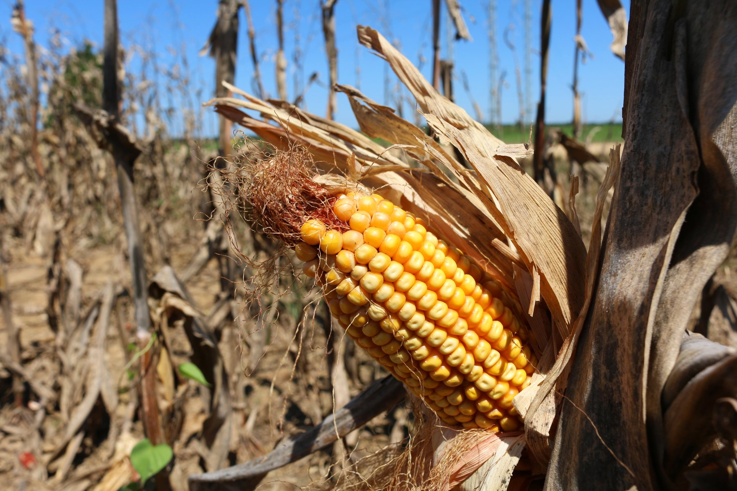
Figure 32. Ears of corn, kernels locked in straight rows.
* * *
Wheat is older. Its wild ancestors, einkorn and emmer, still grow on the hillsides of the Fertile Crescent, and a study by Manfred Heun and colleagues in Science in 1997, which fingerprinted 338 lines of einkorn, pointed at the Karacadağ mountains in southeastern Turkey as the place where the cultivated form began, about 10,000 years ago. The key trait in wheat is not branching but shattering. A wild wheat spike, when it ripens, breaks apart at the joints of its central stalk and the seeds fall. That is what a seed is for. Every so often a plant carries a mutation in one of the brittle-rachis genes, and its spike stays whole. In the wild that plant is a failure, since its seeds never leave it. In a field of people with sickles it is the only plant whose seeds make it home, and whose seeds are sown next spring. The harvest itself did the selecting, and no one had to intend it. Excavations by Ken-ichi Tanno and George Willcox, reported in 2006, suggest the shift from shattering to non-shattering took more than a thousand years, which is what you would expect from a selection nobody was managing.
Bread wheat added a second step. Some 8,000 to 9,000 years ago, near the southern shore of the Caspian, cultivated emmer crossed with a weedy goat grass known as Aegilops tauschii, and the hybrid kept all the chromosomes of both. The result carries three full genomes stacked together, about 16 billion letters, roughly five times the length of the human text, which is one reason the wheat genome was not assembled in full until 2018. The goat grass contributed the proteins that let dough hold gas. Bread is a chromosome accident that people noticed and kept.
The animals came earlier and are harder to date. The dog is the first domesticate, older than any crop, and it descended from the grey wolf somewhere between 15,000 and 30,000 years ago; some claims run older, and the field has argued for two decades about whether it happened once or twice. The oldest undisputed dog is a jaw from Bonn-Oberkassel in Germany, buried with two people about 14,200 years ago. A 2020 study in Science led by Anders Bergström found that by 11,000 years ago there were already at least five distinct dog lineages, which means the split from wolves was well behind them. Cattle descended from the aurochs, a beast that stood taller than a man at the shoulder and whose last known individual died in a Polish forest in 1627. Taurine cattle were domesticated in the Near East about 10,500 years ago, and one 2012 analysis of ancient DNA estimated that the founding herd was as few as about 80 females, a number I would treat as an order of magnitude rather than a count. Zebu cattle were domesticated separately in the Indus valley. The chicken descends from the red junglefowl of Southeast Asia, and here the dates have recently shrunk: a 2022 reassessment of the bones, led by Joris Peters, identified the earliest secure evidence at Ban Non Wat in Thailand about 3,500 years ago, in a rice-growing village, and threw out older claims. The birds probably arrived at the rice, and the people followed the birds.
Darwin understood all of this before anyone knew what a gene was. The first chapter of the Origin of Species in 1859 is about pigeons, not finches, and his 1868 book The Variation of Animals and Plants under Domestication runs to two volumes on the same theme. The farm was his model for nature: variation appears on its own, a chooser keeps some of it, and over generations the chosen line walks away from the original. The chooser on the farm is a person. In the wild it is hunger, cold, and the neighbours. The mechanism is the same, and it runs on the fact this book keeps returning to, that every generation's copy of the text carries a few new letters that were not in the last one. Domestication did not create the variants in tb1 or the brittle-rachis genes. It picked them up, already sitting in a population for thousands of years, and multiplied them.
* * *
For ten thousand years that was the whole toolkit: wait for a variant, notice it, keep it. In 1927 Hermann Muller showed that X-rays raised the mutation rate in fruit flies by a large factor, and the next year Lewis Stadler did the same in barley and maize. Breeders saw at once what that meant. If mutations were the raw material, and radiation made mutations, then a breeder need not wait. Seeds went into X-ray tubes, then, after 1945, into gamma fields, plots of crops exposed to a radioactive source, at places like Brookhaven National Laboratory, where a cobalt-60 source, a radioactive metal giving off penetrating rays, stood at the centre of a circular plot and the plants grew in rings at different doses. Chemicals such as ethyl methanesulfonate, which raise the mutation rate the same way, did the same job in a jar. In Britain in 1959 a woman named Muriel Howorth founded an Atomic Gardening Society and sent irradiated seeds to hobbyists.
The results are on the plate, and most of them carry no label. The database kept by the Food and Agriculture Organization and the International Atomic Energy Agency lists more than 3,400 registered varieties made this way. At Brookhaven the cobalt source stood in the middle of a round field and the crops grew in rings, the inner plants dead or stunted, a ring further out alive and full of new changes a breeder could keep or throw away. Golden Promise barley, from gamma-irradiated seed released in Britain in the 1960s, became a malting barley for Scotch whisky. One fruit shows the two eras in a single colour. Ruby Red grapefruit was a bud sport found on a Texas tree in 1929, decades before anyone aimed a neutron at a seed. Star Ruby, in 1970, and Rio Red, released in 1984, came from budwood irradiated with thermal neutrons at Texas A&M. None of these was regulated as anything other than a plant. A breeder who scrambles a genome at random with radiation and keeps the one seedling in ten thousand that turned out useful is doing conventional breeding, in the law's eyes, and the produce qualifies as organic. That fact will matter in the next chapter.
The largest single edit of the twentieth century was done with neither radiation nor a laboratory, and it fed something like a billion people. Norman Borlaug was born on a farm near Cresco, Iowa, on 25 March 1914, and in 1944 he joined a Rockefeller Foundation programme to improve Mexican wheat. His first invention was a schedule. He grew two generations a year, one in the Yaqui valley of Sonora in the north and one near Toluca in the highlands, shuttling seed between them, which halved the time to a new variety and, by accident, produced wheats that did not care what latitude they grew at. His second problem was stems. A wheat plant given fertiliser grows a heavy head on a tall stalk and falls over in the rain, and a fallen crop rots. What Borlaug needed was a short wheat.
Such a wheat already existed. In Japan a breeder named Gonjiro Inazuka had released a variety called Norin 10 in 1935, descended from a dwarf landrace named Daruma. In 1946 an agronomist with the American occupation, Cecil Salmon, mailed seed of it to the United States. Orville Vogel at Washington State crossed it with a local variety, and in 1953 he sent some of the crosses to Borlaug in Mexico. Borlaug crossed those into his rust-resistant lines and by 1962 had semi-dwarf wheats that stood about half the height of their parents and put the difference into grain. Mexico, which had imported half its wheat when he arrived, was reported self-sufficient by 1956 and exporting soon after. In 1963 the Indian geneticist M. S. Swaminathan invited him to India; in 1966, with famine in prospect, India imported about 18,000 tonnes of Mexican seed, and Pakistan did the same. India's wheat harvest, about 12 million tonnes in 1965, was reported at about 20 million by 1970. Pakistan declared itself self-sufficient in wheat in 1968, India in 1974. On 10 December 1970 Borlaug received the Nobel Peace Prize in Oslo, the only plant breeder who ever has.
The dwarfing genes were named decades later. They are Rht-B1b and Rht-D1b, on two of wheat's three genomes, and a 1999 paper in Nature by Jinrong Peng and colleagues showed what they do: each makes a protein that ignores the growth hormone gibberellin, so the stem stops listening to the signal to elongate. The same year's paper pointed out that rice's Green Revolution variety, IR8, released in the Philippines in 1966, carries a mutation with the same effect in a gene known as sd1. Two crops, two continents, one mechanism: a broken hormone receiver.
The Green Revolution has a bill, and the bill is real. Semi-dwarf wheat only pays if you feed it, so it came bundled with nitrogen fertiliser, irrigation, and a narrowing of the varieties in the ground; those costs get their own chapter at the end of this part. But the method was the oldest one there is. Borlaug did not add a letter to the wheat text. He found a plant that already carried the letters he needed, in a Japanese field, and did what the Balsas farmers had done with their teosinte, faster and on purpose.
The oldest method is still in use. In Salina, Kansas, The Land Institute has spent decades turning a wild perennial grass, intermediate wheatgrass, into a grain sold under the trademark Kernza. A perennial keeps its roots in the ground from one year to the next, so the soil is not opened every spring. By 2025 growers had sown a few thousand acres across about nineteen American states. The harvest is still a niche flour and a beer ingredient, not a substitute for wheat, and the yield remains a fraction of an annual crop. That is breeding at the old speed, choosing which inexact copies to plant, and it is incremental on purpose.
In 1994 a company in California put a tomato on a shelf that carried a letter no tomato had ever had, and the argument about dinner changed shape.

33. The Tomato That Didn't Rot
In the third week of May 1994, in a supermarket in Davis, California, there was a bin of tomatoes with a leaflet beside it. The tomatoes carried the name Flavr Savr, sold under the brand MacGregor's, and the leaflet explained that they had been developed by a company named Calgene, a few miles away, using "genetic engineering." The Food and Drug Administration had said on 17 May that they were as safe as any other tomato. People bought them at a premium, and a reporter counted queues.
The idea was narrow. A tomato softens as it ripens because an enzyme called polygalacturonase digests pectin, the substance that cements a plant's cell walls together. Growers therefore pick tomatoes green and hard, ship them, and gas them with ethylene to turn them red, which is why a winter supermarket tomato tastes of nothing. Calgene's scientists inserted a second copy of the polygalacturonase gene, written backwards. The reversed copy makes an RNA, a chemical cousin of DNA that carries copied instructions, that pairs with the normal message and stops it being read, and the enzyme falls to a small fraction of its usual level. The tomato could ripen on the vine and still survive a truck. The insertion also carried a bacterial gene for resistance to the antibiotic kanamycin, used to pick out the cells that had taken up the new DNA, and much of the FDA's review was about whether that marker mattered. It concluded it did not.
The Flavr Savr was a commercial failure and a historical success. The variety it had been built on was mediocre, the tomatoes bruised in the machinery designed for hard green fruit, and Calgene lost money on every one. Monsanto bought the company in 1997 and the tomato disappeared. In Britain a tomato purée produced from a similar Zeneca tomato, clearly labelled, went on sale in 1996 and sold well until about 1999, when the mood changed. What the tomato proved was that the FDA would review such a food and the public, in 1994, would eat it.
The crops that mattered came two years later, and they were not about flavour. In 1996 Monsanto sold the first soybeans carrying a gene from a soil bacterium, Agrobacterium strain CP4, that made the plant indifferent to the herbicide glyphosate. Glyphosate kills plants by blocking an enzyme in the shikimate pathway, a chain of reactions that makes three amino acids, the compact building blocks proteins are strung together from, that plants need and animals do not; the bacterial version of the enzyme, from a gene written CP4 EPSPS, is not blocked. A farmer could now spray the whole field and kill everything but the crop. The same year brought corn and cotton carrying a gene from Bacillus thuringiensis, a bacterium found in diseased silkworms in Japan in 1901 and named ten years later after the German region of Thuringia. Bt, as it is called, makes crystal proteins that dissolve in the alkaline, meaning non-acidic, gut of a caterpillar or a beetle larva, bind to receptors, docking points on the gut's cells, and punch holes. A mammal's stomach is acid and its gut lacks the receptors, which is why Bt has been sprayed on crops as an insecticide since the 1930s and is allowed on organic farms. Putting the gene in the plant meant the plant produced its own.
The uptake was the fastest of any farm technology on record. The United States Department of Agriculture's annual survey reported that by 2024 about 92 percent of American corn acreage, 96 percent of soybean acreage and 97 percent of cotton acreage carried engineered traits, most of them herbicide tolerance, insect resistance, or both stacked together, two or more engineered traits in one seed. Worldwide, the industry's own count put the area at about 190 million hectares, not far short of the size of Mexico, in 29 countries by 2019, with the United States, Brazil, Argentina, Canada and India taking most of it. If you have eaten anything in the last twenty years containing corn syrup, soy oil or cottonseed oil in North America, you have eaten these.
What changed in those fields was not a secret yield gene. Herbicide-tolerant soy and corn let a farmer spray the whole field and leave the crop standing, which made it much easier not to plough. USDA economists reported that by 2006 about 45 percent of herbicide-tolerant soybean acres were under no-till, compared with about 5 percent of conventional soybean acres. The soil stayed put. Glyphosate use rose, and the weeds, as the last chapter of this part records, learned to live with it. Insect-resistant cotton did a simpler job: it cut the spraying aimed at bollworm. In China, where Bt cotton has been in the ground since 1997 and by about 2018 covered some 95 percent of the national crop, early surveys by Jikun Huang and colleagues recorded pesticide cuts of about half. India adopted the same trait from the early 2000s and saw similar drops, though pink bollworm later caught up where refuges were ignored. The myth is a magic harvest. The reality is two traits that changed how a field is weeded and how a cotton plant is defended.
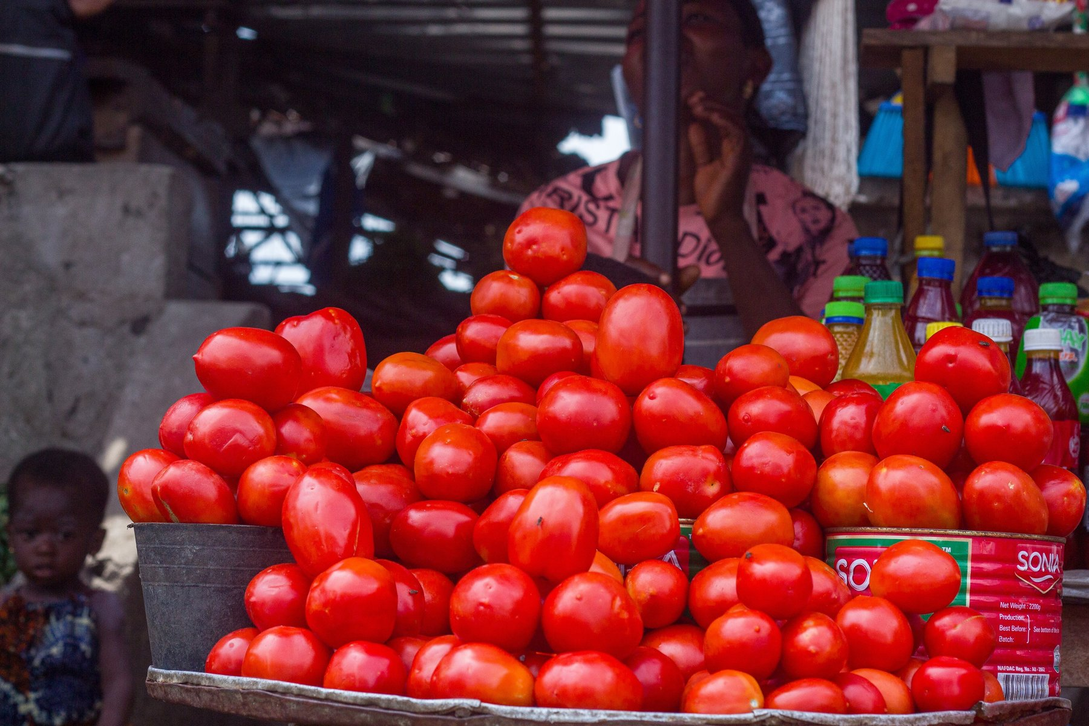
Figure 33. Tomatoes on a market stall, stacked for sale.
* * *
The clearest case that the technique can do something nothing else could is a fruit. Nearly all of Hawaii's papaya grows in the Puna district on the Big Island, and in 1992 papaya ringspot virus arrived there. There is no cure for a plant virus and no resistant papaya existed. By the late 1990s production in Puna had roughly halved. Dennis Gonsalves, a Cornell plant pathologist who had grown up on a Hawaiian sugar plantation, had been working since the 1980s with Richard Manshardt, Maureen Fitch and Jerry Slightom on an idea borrowed from vaccination: put the gene for the virus's own coat protein into the plant. The mechanism, which nobody fully understood at the time, turned out to be that the plant treats the foreign RNA as a target and silences anything matching it, including the real virus when it arrives. The transgenic line, SunUp, a papaya carrying DNA from another species, was crossed with a popular yellow variety to give Rainbow, and seed was handed out to growers in May 1998. Rainbow papaya is now most of what Hawaii grows, and the virus is still there, in the weeds and the unimproved trees, doing nothing to it.
Golden rice is the opposite case, a success in the laboratory that took a quarter of a century to reach a field. Rice endosperm, the white part, contains no beta-carotene, the precursor of vitamin A, and in populations that live on rice the deficiency blinds and kills children. The World Health Organization has estimated that hundreds of thousands of children a year lose their sight to it, and that about half of those die within a year, though the figures are old and hedged. In Science on 14 January 2000, Ingo Potrykus of Zurich and Peter Beyer of Freiburg reported a rice carrying two added genes, a psy from daffodil and a crtI from a bacterium, that made the grain pale yellow with carotene. A 2005 version from Syngenta, with the daffodil gene swapped for the maize one, yielded about 23 times more. Then the arguments began: about patents, about Greenpeace's opposition, about whether a poor child would eat enough rice to matter, and about regulatory tests that took years each. In 2016 more than a hundred Nobel laureates signed a letter asking Greenpeace to stop. On 21 July 2021 the Philippines granted the first permit anywhere to grow it commercially, and farmers planted it in 2022 and 2023. In April 2024 the Philippine Court of Appeals revoked the permit, on the grounds that safety had not been sufficiently shown, and as I write the case is on appeal. Two decades and four months from the paper to the first commercial harvest, and then a court. I think the delay killed children, and it is fair to say so while also saying that the rice was never going to fix a diet on its own.
On the safety of eating such food, the evidence is as close to settled as anything in this book. In 2016 the National Academies of Sciences, Engineering, and Medicine in Washington published a review, Genetically Engineered Crops: Experiences and Prospects, that went through about 900 studies and two decades of health data from countries that ate engineered crops and countries that did not. It found no substantiated evidence of a difference in risk to human health between engineered and conventionally bred crops, and no pattern of environmental harm. It also noted, which the industry quoted less, that the crops had not raised the underlying rate of yield growth, though they had cut insecticide spraying and lowered the cost of weed control. A 2013 review by Alessandro Nicolia and colleagues had gone through 1,783 papers from the previous decade and reached the same place. The studies that grabbed headlines the other way, a 1998 potato experiment in Scotland and a 2012 rat study in France, did not survive scrutiny; the rat paper was retracted in 2013.
Distrust is not about the molecule, mostly. Surveys by the Pew Research Center in 2018 recorded about half of American adults saying engineered foods were worse for health, with the figure higher among people who said they knew least about the science. When people are asked what worries them, the answers cluster around who owns the seed, who profits, whether they were told, and whether anyone would admit it if it failed. Those are questions about institutions, and they are not stupid; the next two chapters take them seriously. The question about the molecule is, on the evidence, answered.
* * *
Labelling is where the two continents parted. In the United States a federal court in Washington, in Alliance for Bio-Integrity v. Shalala in 2000, upheld the FDA's refusal to require labels on foods made with recombinant DNA. Vermont passed a labelling law in 2014, the first in the country. A law signed in July 2016 created a national "bioengineered" disclosure, mandatory from 1 January 2022, a small green seal or a QR code, and overrode the state statutes. The European Union took the opposite path from the start. Directive 2001/18/EC governs the release of engineered organisms, and a 2003 regulation requires any food with more than 0.9 percent engineered content to say so. Approvals for cultivation are so slow and so political that only one engineered crop, an insect-resistant maize called MON810, has ever been grown commercially in the Union at any scale, mostly in Spain. In July 2018 the Court of Justice of the European Union ruled that plants edited with new techniques such as CRISPR, the gene-editing tool from chapter 25, fall under the same directive, while plants mutated at random by radiation, the Golden Promise and Rio Red kind, are exempt because they have "a long safety record." A plant with one deliberate letter changed was regulated; a plant with thousands of random ones was not. The European Commission proposed a fix in July 2023. Parliament voted in February 2024, the member states in March 2025, and a provisional deal was reported in December 2025. On 17 June 2026 the Union adopted Regulation 2026/1388, which from 17 July 2028 will treat some edited plants, those whose changes could have arisen by ordinary breeding, more like conventional varieties, while more extensive edits stay under the old rules for genetically modified organisms. Seed of the easier category will still carry a label. Until mid-2028 the 2018 court ruling still governs a Spanish maize field the way it governed one in 2019. The implementing details were still being written as this book went to press.
While Europe argued, Japan ate the first CRISPR food. A Tokyo company named Sanatech Seed, spun out of the University of Tsukuba, edited a tomato gene written SlGAD3 so that the enzyme it makes lost an inhibitory tail and ran freely, and the fruit accumulated four to five times the usual level of GABA, an amino acid sold in Japan as a calming supplement. The edit changes a native gene and adds no foreign DNA, and Japan's regulators accepted in December 2020 that it needed no special approval. Seedlings were sent to home growers in May 2021 and the fruit, named Sicilian Rouge High GABA, went on sale that September. Nobody had ever bought a CRISPR-edited food before. Two edited fish, a fat sea bream and a fast-growing tiger puffer, followed in Japan the same year. In the United States the first CRISPR organism to be waved through had been a white button mushroom that does not brown, edited by Yinong Yang at Penn State, which the USDA said in April 2016 fell outside its rules because no foreign DNA had been added; it was never sold. The Arctic apple, which also does not brown, is often listed with these but is older technology: Okanagan Specialty Fruits in British Columbia silenced the apple's polyphenol oxidase genes with an RNA-interference construct, the USDA deregulated it in February 2015, and it has been sold in bags of slices since 2017.
The mushroom and the Japanese tomato share a legal fact that is easy to miss. Neither carries a gene from another species. The editors cut a native gene, the cell glued the break, a few letters were lost or a switch was dropped, and that was the crop. Regulators' jargon for that class of change is SDN-1, site-directed nuclease type 1: a targeted cut repaired by the plant itself, with no foreign gene left behind. A transgenic crop, the Flavr Savr and Roundup Ready kind, carries DNA that was never in that species. The two are not the same molecule, and after about 2015 a growing list of countries began treating them as different in law. Argentina was first, in 2015, with a rule that an edited plant is not treated as a genetically modified organism if the finished seed has no new combination of genetic material. Japan followed the same logic for the GABA tomato. The USDA, in the 2016 mushroom letter and in later rules, has generally declined to regulate an edit that adds no plant-pest DNA.
The first gene-edited food actually sold in America was not CRISPR and was not a tomato. In February 2019 a Minnesota company named Calyxt began selling a high-oleic soybean oil, Calyno, from plants whose FAD2 genes, which normally put extra kinks in the oil, had been knocked out with TALENs, the same family of scissors used on the hornless calves of the next chapter. The oil fried longer and made no trans fats. Yields disappointed, the company ran short of money, and on 31 May 2023 it merged into Cibus, a San Diego editor that licenses traits rather than selling a branded bottle. Calyxt's name disappeared. Cibus was still operating in 2026, working on canola, rice, and other crops, without a household product on a supermarket shelf.
Pairwise, founded in North Carolina, did put CRISPR food on a plate. In 2023 it sold a mustard green, Conscious Greens, edited to taste less like mustard, then stopped marketing it the next year and licensed the varieties to Bayer. By early 2026 the company reported selling compact gene-edited blackberries in Colombia, with a code on the punnet that led to an explanation, and was still testing a seedless version. Inari, started in Cambridge, Massachusetts, in 2016, has been editing soy, corn, and wheat for yield without extra fertiliser, and as of late 2026 its soy designs were being trialed as commercial-ready. I have not seen a verified harvest figure that would let me treat that as a crop rather than a claim, so I will not.
China had already been planting a transgenic crop for a generation while the West argued about tomatoes. That crop was the Bt cotton of 1997. Genetically engineered papaya is grown there too. Corn and soy, the calorie crops, moved much more slowly. The Ministry of Agriculture and Rural Affairs, MARA, began registering engineered corn and soy varieties in 2023, and by 2025 industry counts put the planted area at a few million hectares, still a single-digit share of China's corn.
In December 2024 MARA issued the first biosafety certificate for a gene-edited rice event, one particular edit in one particular line, the thing a regulator actually signs off, and certificates for edited wheat as well. Without variety-registration standards those grains could not yet be sold as seed. Laboratories, including Gao Caixia's group at the Chinese Academy of Sciences, have published edited wheat that resists powdery mildew; that is a paper, not yet a field of bread. The political sentence is food security, the rice bowl held in Chinese hands. The field, as of late 2026, was still mostly cotton that makes its own insecticide, plus a cautious expansion of the same two traits, herbicide tolerance and insect resistance, that Monsanto put in American bags in 1996.
The purple tomato is the transgenic one. Cathie Martin at the John Innes Centre in Norwich added two snapdragon genes that switch on anthocyanin, the pigment of blackberries, throughout the fruit rather than just the skin, and in a 2008 paper in Nature Biotechnology her group reported that cancer-prone mice fed the tomatoes lived longer than mice fed red ones. The USDA decided in September 2022 that it posed no plant-pest risk, and in February 2024 the company sold seed packets to American home gardeners, the first time anyone had been able to grow a transgenic plant in a back garden for pleasure.
The labelling argument sits between the edited fruit and the transgenic one, and the honest position is that people are entitled to know and that the knowledge, so far, has told them nothing about their health. The animals we eat are a harder case, because breeding has already changed them more than any gene ever will.

34. Animals on the Menu
There is a photograph in a 2014 paper in Poultry Science that is worth more than most of the arguments about engineered food. It shows three chickens, side by side, all 56 days old, all fed the same ration in the same barn at the University of Alberta. The bird on the left is from a strain frozen genetically in 1957, the middle one from 1978, the one on the right from 2005, the Ross 308 that fills most broiler houses in the world. The 1957 bird weighs 905 grams. The 1978 bird weighs 1,808. The 2005 bird weighs 4,202 grams, more than four and a half times the first, and its breast alone is a larger share of the carcass. Martin Zuidhof and his colleagues did not change the feed, the light or the housing between the three. The whole difference is in the text.
No laboratory did that. It was done by weighing chickens and choosing parents, generation after generation, by a handful of companies whose pedigree lines trace to the 1950s. A modern broiler, a chicken bred and raised for meat, reaches slaughter weight in about six weeks, and the feed it takes to make a kilogram of bird has roughly halved since 1957. Dairy cattle went the same way: the milk from an average American cow has roughly doubled since 1970, to something over 10,000 kilograms a year. A commercial turkey has a breast so large that it cannot mate and has been bred by artificial insemination since the 1960s. Danish sows are bred to wean more than 30 piglets a year. The chicken genome was read in 2004, and since about 2009 breeders have used chips that read tens of thousands of markers to predict a young animal's value before it has produced anything, a method called genomic selection that Theo Meuwissen and colleagues proposed on paper in 2001. But the engine is the old one: variation, choice, repeat.
The bill for the broiler is paid by the broiler. Fast growth outruns the skeleton, and leg disorders, heart failure from fluid in the abdomen, and sudden death are the recognised costs of the 2005 bird; a condition known as woody breast, in which the muscle turns hard and fibrous, was first described about 2012 and now affects a substantial fraction of heavy birds. The parents of broilers, the breeder flocks, would eat themselves infertile if allowed, so they are fed a restricted ration and are hungry for most of their lives. Zuidhof's paper is a fair document because it does not hide this. A gene edit that makes a chicken resist a virus is a small thing next to what selection has already done to the chicken, and any honest discussion of editing animals has to start from that.
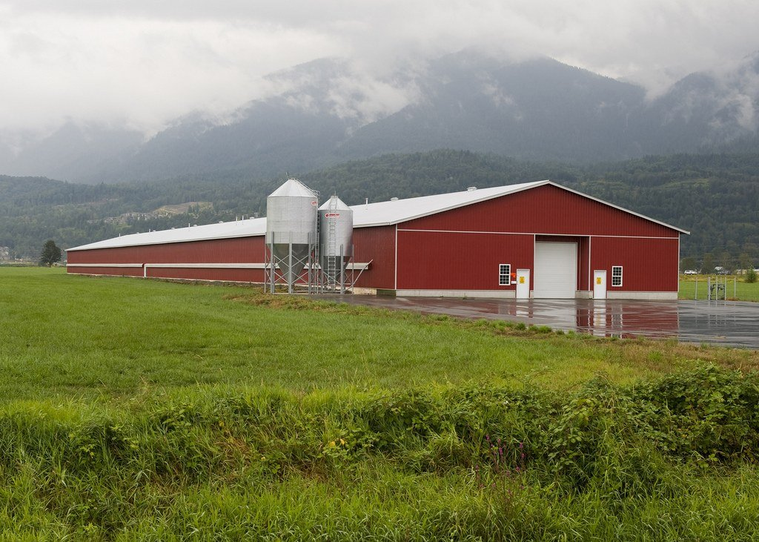
Figure 34. The exterior of a poultry barn, red walls and a metal roof, not the birds inside.
* * *
The first engineered animal approved for anyone's dinner was a fish, and it took twenty-six years. In 1989 Garth Fletcher and Choy Hew at Memorial University in Newfoundland put into an Atlantic salmon a growth-hormone gene from a Chinook salmon, wired to the control switch of an antifreeze-protein gene from the ocean pout, a fish that lives in water near freezing. Salmon normally make growth hormone in summer; the pout switch runs all year, so the fish grew through the winter and reached market weight in about eighteen months instead of about three years. The company that took it on, AquaBounty, filed with the FDA in 1995. The FDA treated the inserted gene as a veterinary drug, which set the template for every animal since, and approved it on 19 November 2015, with the conditions that the fish be sterile females, carrying three sets of chromosomes instead of the usual two, which leaves them unable to breed, and raised in tanks on land. Canada approved it in 2016 and the first fillets, about four and a half tonnes, sold there in 2017 without a label. In the United States an import block written into a spending bill held it up until 2019, and the first American-raised fish, from tanks at Albany, Indiana, sold in mid-2021. Grocery chains, under pressure from campaigners, declined to stock it. In December 2024 the company announced it was ending fish farming altogether and sold the Indiana site. The fish worked; the market did not.
Cattle showed what can go wrong on the other side of the microscope. Most dairy calves are dehorned, with a hot iron or a caustic paste, because horned cows injure each other and the people who handle them. Some beef breeds, Angus among them, are naturally hornless, and the reason is known: a stretch of 212 letters on chromosome 1, duplicated and pasted in place of 10 others, an allele called Celtic POLLED. You could breed it into Holsteins, but you would drag a beef genome along and lose decades of milk selection. In 2015 a Minnesota company, Recombinetics, used an editing tool known as TALENs, a predecessor of CRISPR, to write the Celtic allele into Holstein cells and cloned two calves from them, named Spotigy and Buri. The paper appeared in Nature Biotechnology in 2016. Buri went to the University of California, Davis, where Alison Van Eenennaam's group bred him, and six hornless calves were born in 2017. Brazil planned a herd.
In 2019 scientists at the FDA, reading the company's own published sequence data, found that next to the edit in Buri's genome sat the entire bacterial plasmid, a small ring of DNA that bacteria use to ferry genes around, used to deliver the edit. The passenger was a few thousand letters, including genes for resistance to two antibiotics, a speck against one set of the cow's genome, about 2.7 billion letters. Nobody had looked. Some of Buri's calves inherited the plasmid and some did not. The horns were gone, the edit was clean, and the extra passenger had ridden in with the repair template while everyone was checking the wrong place. Brazil cancelled. The lesson was not that editing is dangerous; the plasmid does nothing in a cow. The lesson was that you read the whole genome afterwards, because the copy made at the edit site is never only the copy you asked for.
The FDA learned too, and by 2022 it had a faster lane. A related company, Acceligen, edited the prolactin receptor gene, PRLR, in beef cattle so that the protein is truncated, which gives the animal the short, slick coat that Senepol cattle from the Caribbean carry naturally and that keeps them cool in heat. In March 2022 the FDA said the two edited calves and their offspring were low risk, on the grounds that the edit reproduced an allele already in the food supply, and let them go to market without a full drug review. That decision took months rather than decades.
The plant side of the same decade has been quieter than the brochures. Drought-tolerant corn exists, both as ordinary breeding and as a Monsanto trait, DroughtGard, that carries a cold-shock gene from a soil bacterium; USDA surveys reported modest, sometimes statistically invisible, gains in dry years, and nothing a farmer could count on in a severe drought. A cereal that makes its own nitrogen fertiliser is still a laboratory hope. The hornless calf and the slick-coated steer, and the PRRS-proof pig that follows, are the cases where an edit does in one generation what a pedigree would take decades to drag across a breed, and they are already adjacent to the plate.
Pigs are the biggest case so far. Porcine reproductive and respiratory syndrome, PRRS, appeared in American herds in 1987 and in Europe in 1990. The virus causes abortions and pneumonia, vaccines work poorly, and the cost to the American industry has been estimated at about $1.2 billion a year in a 2024 analysis, up from about $664 million in an earlier one. The virus gets into a pig's immune cells through a receptor protein encoded by the gene CD163. In 2015 Randall Prather's group at the University of Missouri used CRISPR to knock the gene out, and the pigs, reported in Nature Biotechnology in 2016, simply did not get infected. Genus, the British breeding company that owns PIC, refined the edit to remove only the section of the gene the virus needs, exon 7, one of the gene's coding stretches, so that the rest of the protein keeps its other jobs. At the end of April 2025 the FDA approved the edited pigs for food, the first CRISPR-edited animal it had cleared. Genus said it would wait for approvals in the export markets, Mexico, Canada, Japan and China among them, before selling pork. The same agency had in December 2020 approved a pig from Revivicor with the GGTA1 gene knocked out, which removes a sugar called alpha-gal from its cells; that pig was cleared both for people with a meat allergy triggered by the sugar and as a source of organs, and its kidneys were transplanted into human patients from 2021 onward.
The chicken edit is the one to watch. In 2023 a group led by Mike McGrew at the Roslin Institute in Edinburgh, where Dolly was born, reported in Nature Communications chickens with a small change to ANP32A, a gene the influenza virus needs to copy itself. Nine of ten edited birds shrugged off a low dose of bird flu. At a high dose the virus found a way round, in some birds, by adapting to use related proteins. That is partial resistance, and it is a working result, not a settled one; a fully resistant bird would need edits in three genes, and whether such a bird is healthy is unknown. Given that bird flu has killed or forced the culling of hundreds of millions of poultry since 2020, the incentive to succeed is considerable.
* * *
Cloned animals have been in the food chain longer than edited ones, and quietly. On 15 January 2008 the FDA issued a risk assessment of nearly a thousand pages concluding that meat and milk from cloned cattle, pigs and goats, and from their offspring, were as safe as from any other animal, and that no label was needed. Campaigners had petitioned the agency in 2006 for a moratorium and for labels. They did not get either, and no later lawsuit forced a cloned-food label onto a package. The industry agreed a voluntary hold on selling the clones themselves, which was easy, since a cloned calf costs on the order of $15,000 to $20,000 to make and no one eats a $20,000 animal. What the clones are for is breeding. A prize bull is cloned, the copy stands at stud, and the offspring, which are ordinary calves conceived the ordinary way, go to market. In the European Union the Parliament voted in 2015 to ban cloning for food and the import of clone offspring, and the proposal has sat there since; the offspring almost certainly arrive anyway, in the form of semen and embryos imported from the Americas, and no test can tell them from any other calf. China announced a cattle-cloning plant in Tianjin in 2015 with a stated aim of 100,000 animals a year, a figure I would not take at face value. Argentina and Brazil clone polo horses and breeding cattle as a routine service.
Then the welfare argument, which is the one that will not go away. The philosopher Bernard Rollin put it as a question about which way the fix runs: do you change the cage to suit the animal, or change the animal to suit the cage? The hornless cow is the easy case. Dehorning is painful, the polled allele exists in nature, and a Holstein born without horns has lost nothing. Almost everyone who has looked at it, including the animal-welfare organisations, counts that as a gain. The PRRS pig is harder. Less disease is plainly good for the pig that would have had it. But a herd that cannot catch the disease can be packed tighter, and the edit then becomes a licence for the conditions that made the disease matter. The broiler is the hardest, because there the modification is already done, by the oldest method, and the puzzle is whether an edit that fixed the legs of a 4,200-gram bird would be a kindness or a way of building a heavier one. There is an old thought experiment, associated with the Danish philosopher Peter Sandøe, about breeding hens that are blind, since blind hens in crowded cages peck each other less and seem less stressed. Most people recoil from it. It is worth asking why, given that the same people eat the Ross 308.
I think the test has to be the animal's own experience, not the tool used on it. An edit that removes a source of pain, in a life that is otherwise the same, is good. An edit that lets the life get worse while the numbers get better is not, however it came about. And a change produced by fifty years of weighing chicks deserves the same test as a change produced by CRISPR in an afternoon, which is the point Zuidhof's photograph makes without a word.
Whatever we do to the animals stays in the barn. What we do to the plants goes out into the fields, and there the risks are real, only not the ones on the placards.

35. What Is Actually Risky
In a soybean field in Macon County, Georgia, in the summer of 2005, there were plants standing over the crop that should not have been alive. They were Palmer amaranth, a pigweed from the Sonoran desert that grows five to seven centimetres a day, reaches two or three metres, and drops a few hundred thousand seeds from each female plant. The field had been sprayed with glyphosate, which had killed pigweed reliably for thirty years. These had shrugged it off. Stanley Culpepper of the University of Georgia confirmed the resistance the next year, and by 2010 a paper in the Proceedings of the National Academy of Sciences, PNAS, by Todd Gaines and colleagues had shown how it worked: the plants carried up to 160 extra copies of the EPSPS gene, the very gene the herbicide targets, and simply made more of the enzyme than the spray could block. A later study found the copies riding on a loop of DNA outside the chromosomes, which lets the number climb fast. Within a decade cotton and soybean growers across the American South were paying crews to pull it by hand.
Nobody engineered the weed. The Roundup Ready system had kept glyphosate cheap and simple and the only thing most farmers used, year after year, on tens of millions of hectares. A single herbicide applied that widely is the strongest selection pressure a plant population has ever felt, and the copy of the weed's text that survived it was the one with a mistake in the right place. Ian Heap's international survey of herbicide-resistant weeds, kept since the 1980s, now lists more than 270 species with resistance to at least one herbicide, and more than 50 with resistance to glyphosate. The industry's answer was crops tolerant of older herbicides, dicamba and 2,4-D, sold from 2016. Dicamba evaporates in warm weather and drifts, and in 2017 farmers reported damage on about 3.6 million acres of neighbouring soybeans that had not been engineered to survive it. A federal court threw out the dicamba registrations in June 2020 and again in February 2024. Herbicide-resistant weeds are the largest real cost of engineered crops so far, and they are a cost of how the crop was used, not of the gene.
The insects did the same thing more slowly. When Bt crops were approved in 1996, the Environmental Protection Agency required that a share of every field, originally 20 percent for corn, be planted with non-Bt seed, so that susceptible insects would survive there, mate with any resistant ones from the Bt rows, and dilute the resistance. Where the refuges were kept, the plan worked for a long time. Where they were not, it did not. Fall armyworm in Puerto Rico overcame one Bt protein by 2006. Western corn rootworm in Iowa overcame another by 2009. In India, where Bt cotton reached more than 90 percent of the crop and refuges were widely ignored, the pink bollworm was resistant by about 2010. A 2023 review by Bruce Tabashnik and colleagues counted 26 cases of what they call practical resistance worldwide. The counter-example is Arizona, where the same pink bollworm was eradicated by 2018, using Bt cotton together with the release of billions of sterile moths, and the USDA declared the United States free of the pest that October. Resistance is not a property of the technique. It is a property of selection, which is to say of copying with errors under pressure, and it answers to management.
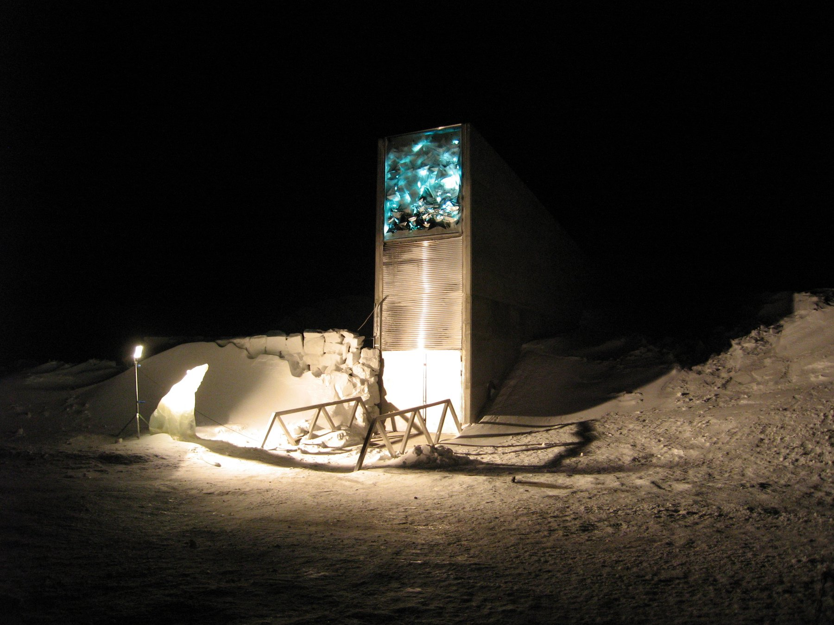
Figure 35. The entrance of the Svalbard Global Seed Vault.
* * *
Gene flow is the third real risk, and the record on it is mixed in a way that rewards reading. In 2003 a glyphosate-tolerant creeping bentgrass, developed by Scotts and Monsanto for golf courses, escaped from test fields in central Oregon, and a study by Lidia Watrud and colleagues showed its pollen had fertilised wild grass up to 21 kilometres away. The USDA fined Scotts $500,000 in 2007; the grass is still growing in irrigation ditches in Oregon and Idaho, where nobody wants a weed that ignores the standard herbicide. In Canada, canola volunteers carrying two and then three different herbicide-tolerance genes, from crosses between neighbouring fields, turned up within a few years of the crops' release. In November 2001 a paper in Nature claimed to have found transgenes in traditional maize landraces in Oaxaca, the crop's homeland; Nature said the next year that the evidence did not justify the paper's publication, a later survey turned up nothing, and a still later one turned up a little. The honest summary is that some flow into landraces has probably happened at low levels, and that maize pollen has been crossing fields since the Balsas valley. In 2000 a Bt corn called StarLink, approved only for animal feed because one of its proteins had not been cleared as a possible allergen, surfaced in taco shells, and about 300 products were recalled at a cost reported in the hundreds of millions of dollars. In 2006 an unapproved herbicide-tolerant rice from Bayer showed up in the American supply, Europe and Japan restricted imports, and Bayer settled with growers for $750 million in 2011. Nobody was harmed by eating any of it. Everyone was harmed by the mess.
Monoculture is older than any of this and remains the deepest risk. The Irish potato famine of 1845 to 1852 happened because most of the island grew a single clone, the Lumper, and a single water mould exploited it; about a million people died and about a million left. In 1970 a fungus destroyed about 15 percent of the American corn crop in one summer because about 85 percent of hybrid seed carried the same male-sterile cytoplasm, adopted to save breeders the cost of detasselling, and the fungus had a toxin that fit it. The banana you buy is a Cavendish, a single sterile clone grown worldwide, which replaced the Gros Michel after a soil fungus known as Panama disease wiped that clone out by the 1960s. A new strain of the fungus, TR4, reached Colombia in 2019 and the Cavendish has no defence. In February 2024 Australia approved a Cavendish carrying a resistance gene, RGA2, copied from a wild banana, the first engineered banana anywhere. Whether the fix for a monoculture is a single engineered clone is a fair question, and the answer, on the evidence of 1845 and 1970, is that it buys time and not safety.
* * *
The corporate story is where public anger has settled, and it deserves a plain account. Monsanto was founded in St Louis in 1901 to make saccharin. It later made PCBs and was one of the manufacturers of Agent Orange, and in 1974 it launched glyphosate under the name Roundup. The glyphosate patent ran out in 2000; the company's future by then lay in seeds carrying the tolerance gene, launched in 1996, and it bought seed companies through the following decade. Every bag came with a contract forbidding the farmer to save seed. Two court cases tested that. In Canada, Percy Schmeiser, a canola grower from Saskatchewan, was ruled in 2004 by the Supreme Court of Canada, by five votes to four, to have infringed Monsanto's patent by knowingly growing canola with the gene, whatever its origin, though he owed nothing because he had not sprayed and had earned no profit from the trait. In the United States, Vernon Bowman, an Indiana farmer, bought ordinary soybeans from a grain elevator, most of which carried the gene, and planted them. The Supreme Court ruled on 13 May 2013, unanimously, that planting a patented seed makes new copies and is infringement, however the seed was obtained. Justice Kagan's opinion noted that the rule was about self-replicating things and might not extend to every case. It was, in the plainest way, a ruling about copying.
Bayer bought Monsanto for $63 billion in a deal completed on 7 June 2018 and retired the name. Two months later a California jury awarded $289 million, later cut to about $20 million, to a groundskeeper named Dewayne Johnson who had used Roundup and had lymphoma. The scientific ground of that and the tens of thousands of suits that followed is a 2015 finding by the International Agency for Research on Cancer that glyphosate is "probably carcinogenic," a category it shares with red meat and hot drinks, while the American, European and other regulators have concluded it is not likely to cause cancer at real exposures. In 2020 Bayer set aside about $10 billion to settle most of the claims, and cases were still being tried in 2025. The company was, by 2024, worth less than it had paid. Whatever one thinks of the herbicide, it is worth being clear that the litigation is about a spray, not a gene.
The seed market did not stay a Monsanto story. Pioneer Hi-Bred, founded in Iowa in 1926 by Henry A. Wallace, had taught America hybrid corn decades before anyone inserted a bacterial gene. DuPont bought Pioneer in 1999. Dow and DuPont merged in 2017 and spun their agriculture business out on 1 June 2019 as Corteva Agriscience, which still sells Pioneer bags. Syngenta was assembled in 2000 from the farm arms of Novartis and AstraZeneca. China National Chemical Corporation, ChemChina, completed its purchase of Syngenta in 2017 for about $43 billion, then grouped Syngenta with other state farm assets as the Syngenta Group in 2020. BASF, which had been strong in chemicals and weak in seeds, bought Bayer's divested soybean, canola, vegetable, and much of its cotton seed businesses, plus the LibertyLink herbicide-tolerance trait, as the price of the Monsanto deal. By the early 2020s the proprietary seed market sat in four laps: Bayer, Corteva, the Syngenta Group, and BASF, with a combined share reported as roughly 60 percent. That is a real concentration of power over food, and it is not a property of DNA; it is a property of patent law, which reaches back to a 1980 Supreme Court decision that a living organism could be patented and a 2001 decision extending full utility patents to plants. Patents also expire. The first Roundup Ready soybean patent lapsed in 2015, and farmers can now buy and save generic tolerant seed.
The revolutionary change was legal and commercial: a patented seed you may not save, two traits that reorganised weeding and insect control, and four companies where there had been more. The biological change was incremental, the same copy-and-choose logic as teosinte, aimed at a spray and a moth. Drought, nitrogen, and a perennial grain that could replace wheat are still, as of late 2026, either modest, unpublished as a farm result, or a few thousand acres. The PRRS pig and the hornless calf are closer to a step-change, because they do in one generation what a pedigree would take decades to drag across a breed.
I would guess, and it is a guess, that by 2035 a farm in Heilongjiang is planting Chinese insect-resistant corn from a domestic bag, Dabeinong's or another, some of it transgenic and some of it edited, and that the farmer is spraying less for borers while still walking the rows for weeds. ChemChina bought a seed and chemical company because the official aim, repeated in MARA documents and in the annual rural-policy papers, is food security on a fifth of the world's people and a much smaller share of its good land. By 2050 a visitor to a public crop gene bank in Beijing may be looking at drawers of rice and wheat whose letters were changed on purpose, after the variety-registration rules that did not yet exist in 2026 have been written. That is not a cartoon super-crop. It is cotton's insect gene, soy's herbicide gene, and whatever drought and nitrogen work has actually survived a northern field, copied into more of the hectares that fill a rice bowl.
Now the risk that is not one. Every meal you have ever eaten contained foreign DNA, in quantity. A person takes in something between a tenth of a gram and a gram of DNA a day, from every cell of every plant, animal, fungus and bacterium on the plate, which comes to tens of thousands of foreign genes per mouthful. Stomach acid and enzymes chop it to fragments, the fragments are absorbed or excreted, and in the whole of medicine there is no case of a gene from a carrot or a cow taking up residence in a human chromosome. An ear of Bt corn contains one bacterial gene among the roughly 32,000 to 40,000 of its own; the salad beside it contains the entire genomes of a lettuce, a tomato and whatever was living on them. The Bt protein has no receptor in a mammal's gut and is digested like any other. The one allergen scare that had substance, a soybean carrying a Brazil-nut protein developed by Pioneer in the mid-1990s, was caught by the company's own testing, published in the New England Journal of Medicine in 1996, and never sold; that is the system working, not failing. The 2016 National Academies review, the 2013 review of 1,783 papers, and the health records of two continents over three decades all say the same thing. On the eating of engineered food, the question is settled. Thirty years of argument have been spent on the wrong risk while the weeds grew. I think that is the right way to hold the ledger.
There is a counter-institution to the patent, and it is a door in a mountain. On 26 February 2008 the Svalbard Global Seed Vault opened on Spitsbergen, about 1,300 kilometres from the North Pole, a tunnel driven 120 metres into the rock and cooled to minus 18 degrees. It has room for about 4.5 million seed samples and holds, by 2025, more than 1.2 million, deposited by national and international gene banks that keep title to what they send; the vault is a backup, not an owner. The first withdrawal came in 2015, when the international centre for dryland agriculture, ICARDA, could no longer reach its own seed bank in Aleppo and asked for its copies back, grew them out in Morocco and Lebanon, and returned fresh seed over the following years. Water from thawing permafrost got into the entrance tunnel in 2016 and 2017, and the entrance was rebuilt. The oldest such bank is in St Petersburg, founded by Nikolai Vavilov, who died in a Soviet prison in 1943 for the crime of doing genetics; during the siege of Leningrad several of his staff starved to death in a building full of seed rather than eat the collection. The vault on Svalbard is their idea, made cold.
Ruby Red grapefruit, the bud sport found on a Texas tree in 1929, began as an accident in an orchard. Rio Red, the deeper fruit irradiated at Texas A&M and released in 1984, came decades later. The vault holds a copy of every crop against the day a field fails, and the fields will fail, now and then, because every seed sown in them is a copy that differs a little from the one in the mountain, and some of those differences belong to the weeds.

PART IX — The Whole Book

36. Three Billion Letters, One Race
The East Room of the White House holds a couple of hundred people if the chairs are set close, and on the morning of Monday 26 June 2000 they were set close. On a screen at the front, Tony Blair sat in Downing Street on a satellite link. At the lectern stood Bill Clinton. On either side of him stood two men who had spent the previous two years trying to beat each other to the same finish line: Francis Collins, director of the public Human Genome Project, and Craig Venter, president of a private company called Celera Genomics. The occasion was the announcement that a "working draft" of the human genome existed. Two working drafts, in fact, one from each side, neither finished, neither yet published, each with the letters in roughly the right order and tens of thousands of gaps.
Clinton's speech reached for Thomas Jefferson and the map of the west that had once been unrolled in the same room, and it reached for God, and the phrase about learning the language in which God created life was in every newspaper the next morning. Collins spoke, then Venter. They shook hands. Reporters who had followed the story knew the handshake had been negotiated over several weeks, mostly in the kitchen of a Department of Energy official named Ari Patrinos, over pizza, because the two men could not be relied upon to be civil in an office. The genome was not done. But the race was declared a draw, which was the only result either government could live with.
To see how that happened it helps to go back to the beginning, which was not 1998 and not the White House but a ski lodge in Utah.
* * *
In December 1984 the Department of Energy convened a meeting at Alta, Utah, on a narrow question: could DNA sequencing ever be good enough to measure the mutation rate in the children of Hiroshima and Nagasaki survivors? The answer was not yet, but the people in the room went home thinking about something larger. In May 1985 Robert Sinsheimer, the chancellor of the University of California at Santa Cruz, held a workshop on whether the whole human genome could be sequenced. In 1986 Renato Dulbecco, a Nobel laureate in cancer research, argued in Science that a cancer biologist would get further with the complete text than with one gene at a time, and Charles DeLisi at the Department of Energy began to push for a program. The DOE had a plausible claim to the job: it had the big computers, the national laboratories, and an abiding institutional interest in what radiation does to chromosomes.
Most biologists hated the idea. The objections were the ones any big project draws. It would cost billions that would otherwise fund small laboratories. It would be dull, industrial work, unfit for graduate students. And most of the text, everyone agreed, was junk, so why read it? A committee of the National Research Council answered these in February 1988 with a plan that was, in hindsight, the important document: map first, sequence later, develop the technology as you go, aim for fifteen years and about $200 million a year, and sequence the genomes of simpler organisms first. Three billion dollars, three billion letters, a dollar a letter. The arithmetic was easy to remember.
James Watson was appointed head of the new NIH (National Institutes of Health) genome office in 1988, and the project formally began on 1 October 1990 as a joint effort of the NIH and the DOE. Watson made one decision that outlasted him: he set aside 3 percent of the budget, later 5 percent, for research on the ethical, legal and social implications of what the project would find. He also alienated the new NIH director, Bernadine Healy, over whether brief fragments of genes could be patented. The disputed fragments came from a young NIH scientist named Craig Venter, who had found a fast way to fish out the expressed parts of genes and wanted to file on thousands of them. Watson thought the idea was foolish and said so in public, and in April 1992 he resigned. Venter left the NIH the same year to run a private institute in Maryland. Francis Collins, who had helped find the cystic fibrosis gene CFTR in 1989 and had helped identify the Huntington's gene in 1993, took over the public project in April 1993.
The public strategy was called hierarchical shotgun. First you built a map: genetic markers spaced along each chromosome, then a physical tiling of large cloned pieces, each about 150,000 letters long, carried in bacteria in units known as BACs, short for bacterial artificial chromosomes. Then you took each BAC, blew it into random fragments, read the fragments by Sanger's dideoxy method, the letter-by-letter reading technique from chapter 21, at 500 to 800 letters a read, and had a computer find the overlaps and stitch them together. Because you knew where each BAC sat on the map, the repeats that make up half the genome could not fool you into joining the wrong pieces. It was slow and it was careful. The genetic maps emerged from Paris and Boston in the early 1990s; the physical maps followed; by 1996 the sequencing had barely started and the project looked, to its critics, like a very expensive way to draw maps.
* * *
Two things changed the pace. The first was a meeting in Hamilton, Bermuda, in February 1996, convened by the Wellcome Trust, at which the heads of the main sequencing centres agreed that any assembled stretch of human sequence longer than a thousand letters would be released to the public within twenty-four hours, unpatented and free. The Bermuda Principles were partly idealism, and the idealism was real, especially in John Sulston, who ran the Sanger Centre near Cambridge and had spent years mapping every cell of a worm. They were also strategy. Sequence in a public database on Tuesday cannot be patented on Wednesday.
The second thing was Venter. In July 1995 his institute had published the complete genome of the bacterium Haemophilus influenzae, 1.83 million letters, the first genome of any free-living organism. He had done it by skipping the map entirely: shred the whole genome, read everything, let the computer assemble it. The NIH had declined to fund the attempt. On 9 May 1998 Venter and the instrument company Perkin-Elmer announced a new firm, Celera, that would apply the same whole-genome shotgun method to the human text with 300 of Perkin-Elmer's new capillary sequencers, machines that read DNA fragments as they crept through hair-thin glass tubes, and one of the largest civilian computers in the world. It would be done, Venter said, by 2001, for about $300 million, a tenth of the public budget. The company would release data, but on its own terms and its own schedule, and it would patent a few hundred genes along the way.
The public project's response, decided at a tense meeting at Cold Spring Harbor a week later, was to speed up. The Wellcome Trust doubled its commitment to the Sanger Centre, which would take a third of the genome. The rest was divided among Eric Lander's centre at the Whitehead Institute in Cambridge, Massachusetts, Robert Waterston's at Washington University in St Louis, Richard Gibbs's at Baylor in Houston, and the DOE's Joint Genome Institute in California. The goal became a rough draft by 2001 instead of a finished genome by 2005. In December 1999 the Sanger-led team published the first complete human chromosome, number 22, in Nature, 33.4 million letters. Chromosome 21 followed in May 2000. Celera, meanwhile, proved its method on a fruit fly, 120 million letters, published in March 2000 with Gerald Rubin's Berkeley group, and then turned the machines on a human sample.
Whose sample was a question nobody answered at the time. The public reference came mostly from one anonymous man in Buffalo, New York, whose DNA had been used to build the main BAC library; about two-thirds of the finished sequence is his. Celera said its sample was pooled from five donors of different ancestries. In 2002 Venter confirmed what many had suspected, that the Celera genome was largely his own.
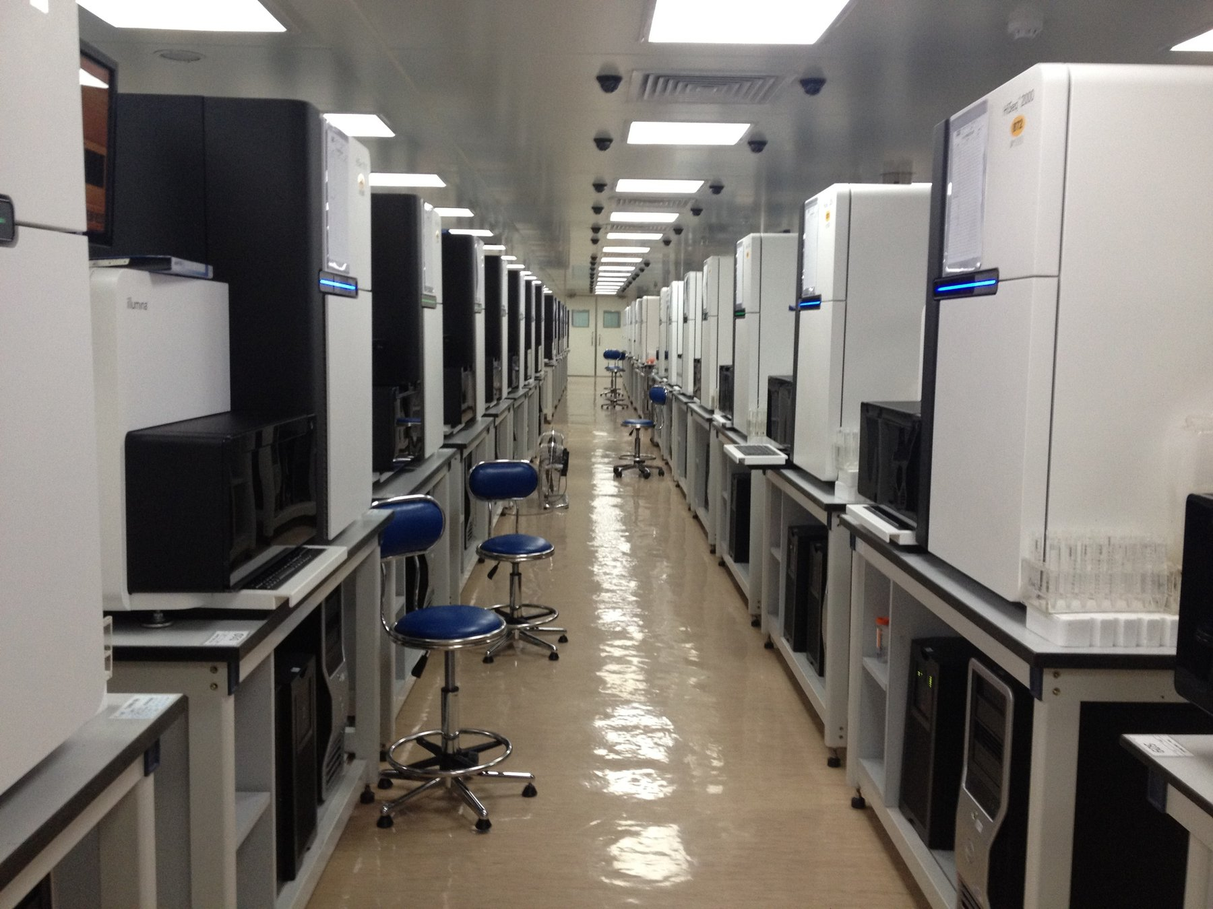
Figure 36. DNA sequencers in a laboratory.
On 14 March 2000 Clinton and Blair issued a joint statement saying that raw genome data should be freely available to scientists everywhere. It was meant as a principle. The stock market read it as a threat to every company with a genome business, and Celera's shares lost about a fifth of their value in a day. That, more than any scientific event, is what put the two sides in Patrinos's kitchen. The White House wanted a joint announcement, and by June it had one.
The two drafts were published side by side in February 2001: the public consortium's in Nature on 15 February, a 62-page paper with Lander as first author, and Celera's in Science the next day, with Venter as first author. Each covered about 90 percent of the gene-containing part of the genome. Each guessed at the gene count and, as the next chapter tells, guessed high. Celera's assembly had drawn on the public data, which was free for the taking; the public project could not use Celera's. Science let Celera keep its sequence on the company's own website, under conditions, rather than deposit it in GenBank, and Sulston and others said in print that this broke a rule that had held since the 1980s. I think they were right. It also stopped mattering within a year, because the public sequence was there for anyone and the private one was not.
The finished text was announced on 14 April 2003, timed to the fiftieth anniversary of the 25 April 1953 paper, with Watson in the room. Finished meant 99 percent of the gene-rich sequence at an accuracy of one error in ten thousand letters, about 2.85 billion letters in all, with 341 gaps that the technology of the day could not close. The project came in two years early. The total spent by the United States was reported as about $2.7 billion, in 1991 dollars, against the $3 billion budget, which works out to a little under a dollar a letter. Celera, having found no way to sell a text that was free next door, moved into drug discovery, and Venter left it in 2002.
The human text was not the first genome, and the ones that came before it are why the human one was possible. The bacterium Haemophilus influenzae, 1.83 million letters, was Venter's proof in 1995 that a whole genome could be shredded and reassembled. Baker's yeast, Saccharomyces cerevisiae, about 12 million letters, was finished by an international consortium in 1996. The nematode Caenorhabditis elegans, about 100 million letters, was finished in 1998 by Sulston's group and Bob Waterston's, the first animal. The fruit fly followed in 2000, as Celera's dress rehearsal. Each of those was a parental set of a simpler creature, read end to end enough times to trust. None of them is 3.1 billion letters. The human number is the human reference, one set, and the cell that carries it still holds two.
What nobody could say at the ceremony, because nobody had had time to look, was what the text actually said.

37. What the Genome Turned Out to Say
In May 2000, at the bar of the annual genome meeting at Cold Spring Harbor Laboratory on Long Island, a young British bioinformatician named Ewan Birney started a sweepstake. The question was how many genes the human genome would turn out to contain. A bet cost one dollar that year, five dollars in 2001, and twenty dollars in 2002, on the reasoning that the answer was getting easier to guess. The guesses, several hundred of them, ran from a little under 26,000 to well over 150,000. The prize was the pot plus a signed copy of The Double Helix.
The high guesses were not foolish. In 1990, when the project was being sold to Congress, Walter Gilbert had done the arithmetic on a napkin: three billion letters, a typical gene perhaps 30,000 letters in length, so about 100,000 genes. Through the 1990s companies that fished out gene fragments announced ever higher counts, 120,000 from one, 140,000 from another, and each number was in someone's business plan. Humans were obviously complicated. Complicated things, it was assumed, needed many parts.
The two draft papers of February 2001 said 30,000 to 40,000 and 26,000 to 38,000. The finished-sequence paper of October 2004 said 20,000 to 25,000. Birney paid out in 2003 to Lee Rowen of the Institute for Systems Biology in Seattle, whose guess of 25,947 had been the lowest in the book. Today the standard catalogue lists a little under 20,000 protein-coding genes, and the count still moves by a few dozen a year as marginal cases are argued in and out. A roundworm the length of an eyelash, sequenced in 1998, has about the same number. A fruit fly has about 14,000. Rice has around 40,000, and a water flea about 31,000. Whatever makes a person more complicated than a worm, it is not the size of the parts list.
* * *
The answer, as far as there is one, is in how the parts are used. About 1.5 percent of the text codes for protein. The rest is introns, regulatory sequence, repeats, and stretches whose function, if any, is still argued over. A single human gene is typically read in several different ways, with exons, the segments of a gene that end up in the finished message, left in or spliced out, so that 20,000 genes make perhaps 100,000 distinct proteins; measurements in 2008 found that about 95 percent of genes with more than one exon are spliced in more than one pattern. The switches that control when and where a gene is read take up more of the text than the genes do. A worm and a person have roughly the same vocabulary. They differ in the grammar.
The drafts also showed how uneven the text is. Genes cluster on some chromosomes and thin out on others; chromosome 19 is dense with them, chromosomes 13 and 18 are sparse, and there are deserts of a million letters or more with no gene at all. More than half the genome is repeated sequence of one kind or another. A single family of short repeats called Alu, about 300 letters in length, is present in over a million copies and accounts for about a tenth of the text. The 2001 Nature paper also claimed that 223 human genes had been acquired directly from bacteria, which would have been a remarkable finding, and within three months a group led by Steven Salzberg showed that most of these were better explained by ordinary descent and loss in other lineages. I mention it because it is the right way to hold any first reading of a big dataset: some of it will be wrong, and the fix comes from the same data read more carefully.
Then there were the numbers that became slogans. Any two people, it was said, are 99.9 percent identical. Humans and chimpanzees are 98.8 percent identical. Both figures are true and both need a footnote in the sentence. The 99.9 counts single letters: at about one position in a thousand, two unrelated people's letters will disagree, which across 3.1 billion letters is roughly three million differences. The 1000 Genomes Project, reporting on 2,504 people in October 2015, reported that a typical genome differs from the reference at four to five million sites. Most of those are single letters. But a few thousand are structural, a chunk deleted here, a chunk duplicated there, and because each chunk can be thousands of letters long, the structural differences involve more total letters than the single-letter ones. Count by letters involved rather than by sites and two people are a bit over 99 percent alike, not 99.9. Neither number is more honest than the other. They are counting distinct things.
The same applies to the chimpanzee. Its genome was published in Nature on 1 September 2005, from a male named Clint at the Yerkes primate centre in Atlanta. Where the two genomes line up letter for letter, they differ at 1.23 percent of positions, which is the source of the 98.8. Add the insertions and deletions and the figure drops to about 96 percent. Add the pieces that do not line up at all, which the complete ape genomes finished in 2025 made visible for the first time, and the gap grows again. About 35 million single-letter differences and five million small insertions and deletions separate a person from a chimpanzee, and a mostly unread set of larger rearrangements sits on top. That 98.8 percent is settled. What it means for the question people actually ask, which is what makes us different, is not.
Two genomes, set side by side, differ at three or four million positions. Set beside a parent they differ at fewer, though not as few as one might think, because half the letters came from the other parent, and they differ at about sixty positions from both parents together, the new mutations a child is born with. This is the whole of inheritance in one arithmetic: nearly all the same, a few million altered, a few dozen new.
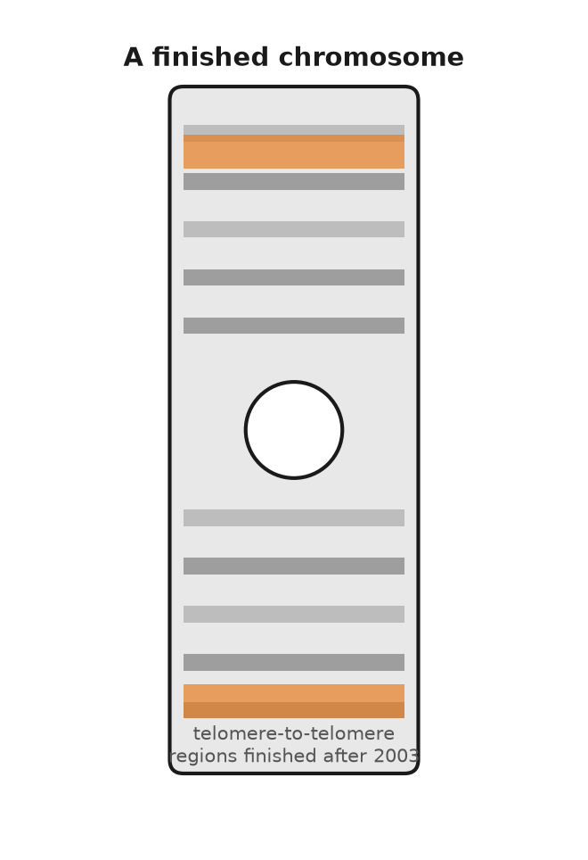
Figure 37. A chromosome ideogram with the regions finished after 2003 marked.
* * *
The word "finished" in April 2003 covered about 92 percent of the genome. The missing 8 percent was not scattered. It was concentrated in the places that Sanger reads of 800 letters, and later Illumina reads of 150, could not cross: the centromeres, where each chromosome carries an array of near-identical 171-letter repeats running to millions of letters; the short arms of chromosomes 13, 14, 15, 21 and 22, which hold hundreds of copies of the genes for ribosomal RNA; and large segmental duplications, blocks of 100,000 letters or more copied almost perfectly to two or three places in the genome. A read of 800 letters that falls entirely inside a repeat tells you nothing about where it belongs. For nineteen years these regions sat in the reference as runs of the letter N.
What closed them was reads long enough to span the repeats. Oxford Nanopore's pores could by 2020 read single molecules of 100,000 letters and more, and Pacific Biosciences' HiFi method produced reads of about 20,000 letters at an accuracy of 99.9 percent. A consortium named Telomere-to-Telomere, led by Karen Miga at Santa Cruz and Adam Phillippy at the NIH, used both on a cell line called CHM13. The line derived from a complete hydatidiform mole, an abnormal pregnancy in which an egg that had lost its own nucleus was fertilised by a sperm whose genome then doubled. Every chromosome in it is therefore present in two identical copies, which removes the assembler's hardest problem, telling two similar parents' chromosomes apart. On 31 March 2022 the consortium published in Science the first truly complete human genome: 3,054,815,472 letters of nuclear DNA, every chromosome read from one end to the other without a gap, about 200 million letters that had never been seen, and predictions of roughly 2,000 new genes, of which perhaps a hundred code for protein. The same paper adds the mitochondrial genome, 16,569 letters, and the sum, 3,054,832,041, is the one-parental-set total used in chapter 5. The mole had no Y chromosome. The Y, half of which had never been read because it is mostly repeats, was completed from a different donor and published in Nature in August 2023: 62,460,029 letters, more than 30 million of them new.
That is a complete genome. It is still one genome, and one is a strange sample size for a species. The reference that hospitals and researchers align their reads against, known as GRCh38 and issued in December 2013, is a mosaic assembled mostly from the Buffalo donor of the 1990s, and it is neither an average person nor a healthy one. At something like two million positions it carries the rarer of the two common letters, and at a few thousand it carries a variant associated with disease. Anyone whose ancestry is far from the donor's will find that some of their sequence has nowhere to align, and the software will call it error.
The answer that began in May 2023 is known as a pangenome. The Human Pangenome Reference Consortium published in Nature on 10 May 2023 the complete or nearly complete genomes of 47 people of diverse ancestry, both chromosomes of each resolved separately, so 94 assemblies in all. Laid over one another they added 119 million letters not present in GRCh38 and about 1,100 extra gene copies. Instead of a single line of text, the reference becomes a graph, a main road with every known alternative route drawn in, and a new genome is aligned to whichever route it matches. The consortium's stated target is 350 people. I think this is the right idea and that the 47 is where it shows most clearly, since the number of people whose complete genome had ever been read before 2023 was, in effect, one.
The 3.1 billion letter reference is still the right length for one set. It is no longer the right shape for every set. Two people can both have about 6.2 billion letters in each nucleus and still not be alignable, letter for letter, to one mosaic from the 1990s.
The slogan people learned was three billion letters. The finished count for one parental set is the T2T total from chapter 5, and a nucleus holds about twice that. A book that puts 3.1 billion letters into forty-six threads two metres long is mixing one set with two. Chapter 5 kept those apart. This chapter is why the printed number moved at all.
There is a reasonable objection to all of this, which is that a reference, however carefully drawn, tells you what the text is and not what it does. To learn what a variant means, you cannot read one genome or fifty. You have to read half a million and ask each one how its owner is doing.

38. Biobanks and the Million
Between 2006 and 2010, in twenty-two temporary assessment centres in shopping precincts and hospital annexes across England, Scotland and Wales, about half a million people did the same thing. They had received a letter, because they were registered with the National Health Service and were between 40 and 69 years old and lived within reach of a centre. About nine million letters were sent. Roughly one in twenty of the people who received one turned up. Each spent about ninety minutes answering a touchscreen questionnaire about diet, smoking, work, and mood, had their height, weight, blood pressure, grip strength, lung function and bone density measured, and gave blood, urine and saliva. Then they signed a consent form allowing the project to follow their medical records for the rest of their lives, and went home. Most were told nothing about themselves that they did not already know.
The project was named UK Biobank. It had been planned since the late 1990s, was funded by the Wellcome Trust and the Medical Research Council, and was run from a building in Stockport, near Manchester, by an Oxford epidemiologist named Rory Collins. Its samples were stored in freezers at minus 80 degrees and tanks of liquid nitrogen, in millions of small tubes handled by robots. The final count was 502,000 participants. They were not a cross-section of Britain; comparison with census data later showed them to be healthier, wealthier, and less likely to smoke than average, which is what happens when you rely on volunteers. The organisers knew this and decided it did not matter for the questions they wanted to ask, which were about what differs between people who develop a disease and people who do not, rather than about how common the disease is.
What made the collection worth more each year was the layers added on top. In 2017 every participant was genotyped, meaning checked at chosen points across the text rather than read letter by letter, on a chip of about 820,000 markers, from which about 90 million positions could be inferred. The inference is imputation: a best guess about letters the chip never read, made from the neighbourhood the reference expected. It fails where that person's copy broke the neighbourhood. A chip can fill in a map. It cannot see a stretch that the map never drew. That is why the later whole genomes were read letter by letter, not because a slogan required it, but because a guessed letter is not a read letter. Between 2019 and 2022 the protein-coding parts of every genome were sequenced. A hundred thousand participants have been through an MRI scanner for brain, heart and body; a hundred thousand wore a wrist accelerometer for a week. And on 30 November 2023 the project released whole genomes for nearly half a million of them, 490,640 in a 2025 Nature count, the largest such dataset in the world, paid for with £200 million from Wellcome, the UK research councils and four drug companies, and read in Reykjavik and at the Sanger Institute near Cambridge. Any bona fide researcher anywhere may apply to use the data, for a fee, and by 2024 more than 30,000 had. The participants get nothing back individually. That was the deal, and I think it was the right one, because a return-of-results promise struck in 2006 would have been a promise about a science that did not yet exist.
* * *
The United States chose the other deal. The NIH's All of Us programme opened enrolment on 6 May 2018 with a target of one million people. By June 2026 more than 880,000 had joined. Other countries built their own collections. What all of them are for is a method that was invented, in its usable form, in 2005.
Before then, the search for the genetics of common disease had been a graveyard. Linkage, which had identified CFTR and the Huntington's gene by tracking a marker through affected families, works when one gene of large effect is responsible. It turned up almost nothing for diabetes, heart disease, or schizophrenia, because those are not diseases of one gene. The alternative, picking a plausible candidate gene and testing whether a variant in it was commoner in patients, produced thousands of papers in the 1990s, most of which failed to replicate. Neil Risch and Kathleen Merikangas had argued in Science in 1996 that the answer was association rather than linkage: compare hundreds of thousands of common variants across the whole genome in thousands of cases and controls, with no prior guess about which genes matter. In 1996 that was not possible. By 2005 the HapMap project had catalogued about a million common variants in 269 people from four populations, and chips could read hundreds of thousands of them at once.
The first genome-wide association study, published in Science in April 2005 by Josephine Hoh, Robert Klein and colleagues at Rockefeller and Yale, was small by later standards: 96 patients with age-related macular degeneration, 50 controls, about 100,000 markers. One variant stood out, a single-letter change in the gene CFH, which encodes complement factor H, a brake on part of the immune system. People with two copies of the risk letter had several times the usual chance of the disease. Nobody had guessed CFH. That was the point.
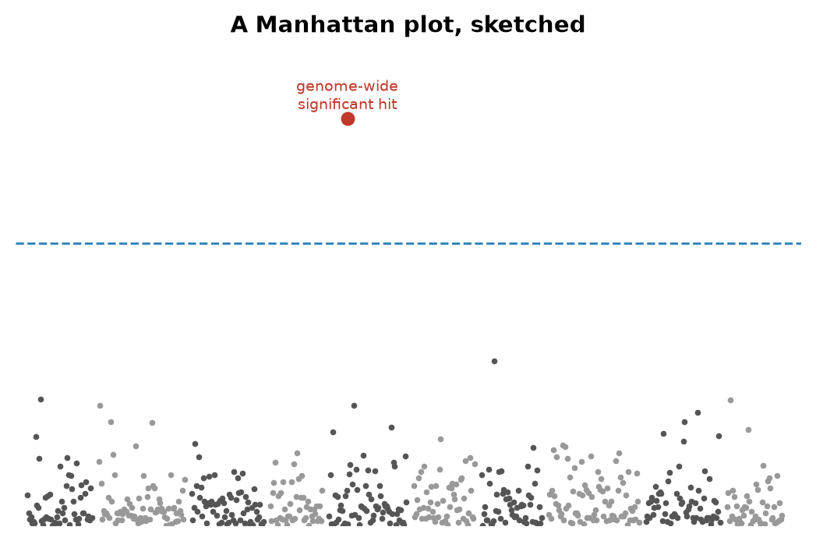
Figure 38. A Manhattan plot, sketched.
The picture that emerged from these studies has a name. Lay the chromosomes end to end along a horizontal axis, and for each marker plot how unlikely its association with the disease would be if there were no real link, on a logarithmic scale, where each step up means the chance is ten times smaller, so that the more improbable the chance, the higher the point. Most of the hundreds of thousands of points lie in a low band near the floor. A real association stands up as a tower of points, because neighbouring markers travel together through the generations. The result looks like a skyline, and it has been called a Manhattan plot since the 2007 papers. The first tower worth naming is the CFH peak from 2005. The threshold for calling a tower real, a probability of five in a hundred million, comes from asking a million questions at once and refusing to be fooled by the one in twenty that would pass at ordinary standards by luck. Two years later, in June 2007, the Wellcome Trust Case Control Consortium published in Nature a study of 14,000 patients with seven common diseases against 3,000 shared controls, at 500,000 markers each, and turned up 24 solid associations in one go, most of them in genes nobody had suspected.
* * *
By 2024 the public catalogue of such studies listed more than 6,000 papers and several hundred thousand associations. Two lessons emerged from them that are now settled. The first is that common diseases involve hundreds or thousands of variants, each of modest effect; a typical one raises the odds by 5 or 10 percent, not by half. The second is that most of these variants lie not in genes but in the switches between them, which is why the 98.5 percent of the text that does not code for protein turned out to matter.
The natural next step was to add the small effects up. A polygenic risk score takes every variant with a measured effect, weights it, and sums across a person's genome to give one number. In August 2018 a team led by Sekar Kathiresan and Amit Khera published in Nature Genetics a score for coronary artery disease built from 6.6 million variants and tested in UK Biobank; the 8 percent of people with the highest scores had about three times the average risk, which is roughly the risk conferred by the single-gene condition familial hypercholesterolaemia, an inherited condition that leaves LDL cholesterol, the form that clogs arteries, dangerously high from birth, a condition doctors already screen for. Scores for breast cancer, type 2 diabetes, atrial fibrillation and others followed. A score at the 90th percentile, meaning higher than 90 out of every 100 people tested, tells a person that people with scores like theirs develop the disease perhaps one and a half times as often as the average. It does not tell them that they will, and a change in weight would move the real risk more than any letter in the score. Polygenic scores are a working tool, useful at the extremes and nearly useless in the middle, where most people are.
They have a harder problem than that. In 2019 Alicia Martin and colleagues counted who had been in the studies the scores were built from: about 79 percent of participants were of European ancestry, though Europeans are about 16 percent of the world, and people of African ancestry were about 2 percent. A score built in one population loses accuracy in another, because the markers on the chip are only proxies for the causal variants, and the proxies travel with different partners depending on the population. Martin's group found that scores performed about four and a half times worse in people of African ancestry than in Europeans. The height score from the 2022 study of 5.4 million people explains about 40 percent of the variation in height among Europeans and only 10 to 20 percent elsewhere. Every clinic that adopts a score built on UK Biobank inherits UK Biobank's sample. If the family the score is applied to came from Lagos rather than Leeds, the same number on the same web page would mean less, and the page would not say so.
Set against that, what a million genomes finds is real. It finds rare people whose genomes contain a natural experiment: in 2005 and 2006 Helen Hobbs and Jonathan Cohen in Dallas identified African Americans carrying a broken copy of PCSK9 who had 28 percent lower LDL cholesterol and, over fifteen years, 88 percent less coronary disease, and by 2015 two drugs that block the PCSK9 protein were on the market. It finds which correlations are causal: variants that raise HDL cholesterol, the so-called protective form, do not lower heart disease, as a 2012 study in The Lancet showed, which is why the drugs that raised HDL failed. And it tells drug companies where to bet. Drug targets with genetic support have been shown, in several analyses since 2015, to be about twice as likely to reach approval as targets without it.
What it cannot do is also plain. It cannot see the environment except through the crude proxies of a questionnaire. It cannot correct for the fact that the people in it chose to be in it. And it cannot turn a probability into a prediction; a score that doubles a 5 percent risk has still left the person with a 90 percent chance of being fine. Biobanks are the least glamorous and the most useful thing genetics has done since 1953. Half a million genomes are half a million slightly varied copies of one text, each produced by the same machinery, none of them exact, and when a tube posted in the prologue comes back as a web page, everything it says will have been learned by reading the differences.

PART X — Reading Your Own

39. The Spit Kit
Six weeks after the mailbox, on a weekday evening, the three of them are at Anna's kitchen table. Ruth has come the twenty minutes from her house. Theo is fifteen and wants to know whether he is descended from anyone interesting. Anna has the laptop open between the plates. All three are invented. The page on the screen is not.
The page has tabs. One is called Ancestry, and shows a map with coloured regions and percentages to one decimal place. Another is named Health, and lists reports with careful names. A third is labelled DNA Relatives, and contains a list of strangers sorted by how much of Anna's text they share, and at the top of the list is a woman in Ohio whom the page calls a second cousin. The tube has come back as a set of probabilities. The first thing to understand is what was measured to produce them, and the second is who did the measuring, because the company's own history is a fair summary of what this kind of reading is worth.
The company was founded in April 2006 in Mountain View, California, by Anne Wojcicki, Linda Avey and Paul Cusenza. Its name is a joke about the 23 pairs of chromosomes in each of your cells. It launched its service in November 2007 at $999, and Time magazine named the retail DNA test its invention of the year for 2008. The price fell to $399 in 2008 and to $99 in December 2012. By then the company had several hundred thousand customers and an ambition that went beyond ancestry maps. Wojcicki said openly that the point was a research database, and the customers who ticked a consent box, about 80 percent of them, became research subjects who had paid for the privilege.
On 22 November 2013 the US Food and Drug Administration sent the company a warning letter. The Personal Genome Service, it said, was a medical device being sold without clearance, the company had stopped answering the agency's questions, and it should stop marketing health reports. The company complied. For about two years it sold ancestry and raw data only. Then it returned one test at a time. A carrier report for Bloom syndrome was authorised in February 2015. In April 2017 the FDA allowed the first direct-to-consumer genetic health risk reports it had ever permitted, for ten conditions, including late-onset Alzheimer's disease and Parkinson's disease. In March 2018 the company was allowed to report three variants in BRCA1 and BRCA2, the ones common in Ashkenazi Jewish families, with a warning that a negative result said almost nothing about the thousands of other harmful variants in those two genes.
In July 2018 GlaxoSmithKline invested $300 million and signed a four-year drug-discovery collaboration in which the database was the asset. In June 2021 the company listed publicly by merging with a blank-cheque company backed by Richard Branson, at a valuation of about $3.5 billion. Within two years the shares had lost most of their value, for a reason no test kit could fix: a customer buys one once.
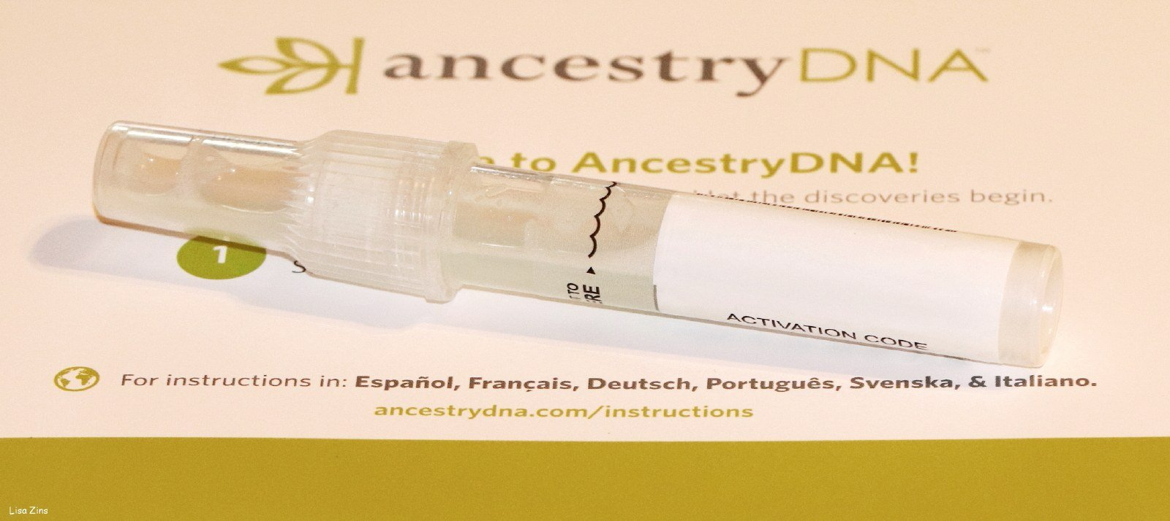
Figure 39. A consumer saliva collection tube on a kit instruction card, a different company from the one this chapter names.
* * *
In October 2023 the company disclosed a breach. Attackers had used passwords leaked from other websites to log into about 14,000 accounts, and from those, through the DNA Relatives feature, had scraped profile data for about 6.9 million users: names, birth years, ancestry estimates, and lists of matches. Lists of users with Ashkenazi Jewish or Chinese ancestry were offered for sale. The company agreed in 2024 to a class-action settlement reported as $30 million.
On 23 March 2025 it filed for Chapter 11 bankruptcy protection in a court in Missouri, and Wojcicki resigned as chief executive the same day. Attorneys general in several states advised customers to delete their data while they could. The drug company Regeneron won the first auction in May 2025 with a bid of $256 million. Then Wojcicki's nonprofit, the TTAM Research Institute, returned with a bid of $305 million, the court approved the sale at the end of June, and the deal closed in July 2025. By then roughly 15 million people had sent in a tube. The samples went from a private company, through a bankruptcy court, to a nonprofit run by the same woman who had founded the company, and the customers were spectators throughout.
So that is the company. Now the measurement. The laboratory did not read Anna's genome. It ran her DNA over a genotyping chip, a glass slide carrying hundreds of thousands of short probes, each designed to catch one position in the text where people are already known to differ. The chip the company has used since 2017 checks somewhere around 640,000 positions. That is about 0.02 percent of the 3.1 billion letters of one parental set. At each of those positions it reports which of two known letters Anna has, and because she has two copies it can report that she has one of each, or two the same. It cannot find a spelling mistake that nobody has catalogued, because no probe was built to look for it. It also does not read the second copy as a separate 3.1 billion letter book. It samples both copies at the positions it was built to see.
The chemistry is hybridisation, which is base pairing done on a glass slide. Each probe is a short stretch of single-stranded DNA glued to a spot. Anna's DNA, broken into fragments and tagged with a dye, is washed over the slide. Where her letters match a probe, they stick, by the same A-with-T and G-with-C rule as in the helix, and the spot lights up. Where they do not match, they wash off. The machine is not reading a sentence. It is asking, at hundreds of thousands of addresses, which of two prewritten words is in her text. That is why the price could fall to $99, and why a variant the catalogues have never seen is invisible to it. A nucleus still holds about 6.2 billion letters. The slide looks at a few hundred thousand of the addresses in one set.
The nearest analogy is checking a book by looking only at the places where different printings are known to disagree. If a new misprint has crept into your copy on page 412, the check will not find it. Whole-genome sequencing, the reading that costs a few hundred dollars in 2025 and was the subject of Part IX, reads every page. As of late 2026 some of those full reads are done on a slide of short fragments, and some are done by nanopore sequencing: threading a single long molecule through a protein pore and watching each letter disturb an electrical current, the method of Chapter 24. Either way, a clinical genome is a different object from the chip on this table. A chip is cheaper and faster and was, in 2007, the only thing that could be sold for $999. A great deal of what is in the 640,000 can be stretched further by statistics, because letters that sit close together on a chromosome travel together through the generations, a fact Sturtevant used to draw the first map in 1913. From the measured positions, software can guess millions of unmeasured ones with fair confidence. Guess is the right word.
The Ancestry tab is built on the chip result in a way that the decimals do not advertise. The software chops Anna's chromosomes into windows and compares each window to reference panels: sets of present-day people whose four grandparents all came from the same place. Each window is assigned to the population it most resembles, and the windows are added up. The percentages are therefore a statement of resemblance to living people in a reference set, not a record of where Anna's ancestors stood in the year 1700. When the company updates its reference panels, which it does every few years, the percentages move. Customers who had 4 percent Scandinavian ancestry in one version and none in the next had not lost any ancestors. The panel had changed.
Two more things follow that surprise people. Full siblings receive unequal percentages, because each inherited a separate half of each parent, as Chapter 11 described. And Theo, when he eventually mails a tube of his own, will show numbers that are not the average of his parents' numbers. The shuffle in meiosis does not deal fair halves of every region.
* * *
The DNA Relatives tab is the most reliable part of the page, because it does not depend on any reference panel. It depends on segments. Two people who share an ancestor share stretches of text inherited whole from that ancestor, and the software finds those stretches by looking for long runs where the two chips agree. The length is measured in centimorgans, the unit for shared genetic material that Sturtevant defined in chapter 18. A parent and child share about 3,400 centimorgans, which is half the text. Full siblings share about 2,600 on average. First cousins share about 850, which is 12.5 percent. Second cousins share about 3 percent, a bit over 200 centimorgans. The woman in Ohio shares 213 centimorgans with Anna in nine segments, and the label is right: she is a second cousin, or something equivalent, such as a first cousin's grandchild.
The method thins out fast. Third cousins share under one percent, and some third cousins share no detectable segment at all, because segments are passed on whole or not at all, and after enough generations a given ancestor's contribution can drop out of a line entirely. Beyond the fourth cousin the list is mostly noise, and the site says so.
Close relatives are not noise. A match of 50 percent is a parent or a child, and a match of 25 percent is a grandparent, a half-sibling, or an aunt. These numbers do not care what a family has said about itself, and every year they contradict some families. The industry term is "not parent expected." Historical studies of misattributed paternity in Western Europe, using surnames and Y chromosomes, put the rate at about one percent per generation. Over the millions of people who have tested, that is a great many surprised adults. Donor-conceived children have found donors who were promised anonymity in the 1980s, and half-siblings by the dozen. In Indiana a fertility doctor named Donald Cline was discovered, from 2016 onward, to have used his own sperm for patients decades earlier; consumer tests identified more than 90 of his children, and the state passed a law against fertility fraud in 2019. The chip reads what is there.
The page also offers a download, a text file of the roughly 640,000 calls, and a great many customers take it and upload it somewhere else: a genealogy site, a health interpreter, a research project. The file is not a genome. It is a list of addresses and the letter found at each, and anyone who holds the list can ask new questions of it without mailing another tube. That is why the 2023 breach mattered beyond the names. A stolen relatives list is a family tree. A stolen genotype file is a permanent sample.
A clinical genome, the kind Part IX described, would have shown Anna things this page cannot. It would have read both parental sets, about 6.2 billion letters, including spellings no catalogue has named, and it would have cost a few hundred dollars in 2025 rather than $99. The spit kit's advantage was never completeness. It was that a person could buy it without a doctor, and that millions did. The health reports on the page are a curated subset of the chip, written to a regulatory standard, and they leave out most of what the raw file contains. Ancestry percentages will move when the reference panels are updated. The Ohio cousin will not. She is in the segments, and the segments do not depend on a company's map of the world.
Which brings the table back to the Health tab. Anna has two results the prologue promised her. One is Anna's switch, from her father: she drinks milk. Ruth cannot. Theo can.
The other result says she has one copy of a variant that raises her chance of a certain disease, by a factor the page states carefully and with a footnote. Theo treats the factor as a fortune. Ruth's objection is the one the page itself supports. The slide looked at about 0.02 percent of one parental set and is offering the rest as a story. Anna reads the footnote again. The chip cannot tell them whether the variant will act, or how tall Theo will end up, or what chance will do after birth. They do not agree, and they are all looking at the same page. That argument is the next two chapters.

40. What a Genome Can Tell You
On 14 May 2013 the New York Times printed an opinion piece by Angelina Jolie under the title "My Medical Choice." Her mother had died of ovarian cancer at 56. Jolie had been tested and carried a harmful variant in BRCA1; her doctors, she wrote, had put her lifetime risk of breast cancer at 87 percent and of ovarian cancer at 50 percent. She had just completed a preventive double mastectomy. Two years later she wrote again, about having her ovaries and fallopian tubes removed. In the months after the first piece, referrals to family-history clinics in Britain roughly doubled, an effect reported in 2014 and still known, in the literature, as the Angelina effect.
Behind the op-ed is one of the cleanest stories in human genetics, and it starts with a woman who spent seventeen years being told she was wasting her time. Mary-Claire King, then at Berkeley, collected families in which breast cancer struck early and often, and looked for a stretch of chromosome that travelled with the disease. In December 1990 her group reported in Science that such a stretch existed, on the long arm of chromosome 17. This was the demonstration that a common cancer could have a single-gene hereditary form. The race to find the gene itself was won in October 1994 by Myriad Genetics, a company founded in Salt Lake City in 1991 by Mark Skolnick and colleagues from the University of Utah. BRCA2, on chromosome 13, was identified in December 1995 by Michael Stratton's group in London.
Myriad patented both genes and the test for them. By 2013 its BRACAnalysis cost about $3,000 to $4,000, and no other American laboratory was allowed to offer a full test. In Association for Molecular Pathology v. Myriad Genetics, decided 13 June 2013, one month after Jolie's op-ed, the US Supreme Court ruled unanimously that a naturally occurring segment of DNA is a product of nature and cannot be patented merely because it has been isolated. Laboratory-made complementary DNA, it said, can be. Within days other laboratories were offering BRCA tests at a fraction of the price. The genes, in the words the court used, were not invented by anyone.
What the genes do is repair. The BRCA1 and BRCA2 proteins are part of the machinery that mends double-strand breaks in DNA by homologous recombination, the accurate route described in Chapter 25. A woman born with one broken copy has a working copy in every cell, and she is fine until, in some cell in the breast or ovary, the working copy is lost by a mutation of the kind Chapter 10 catalogued. That cell then repairs badly, mutates faster, and is on the road to cancer. This is Alfred Knudson's two-hit idea of 1971, and it explains why a dominant cancer syndrome works through a recessive mechanism inside the cell.
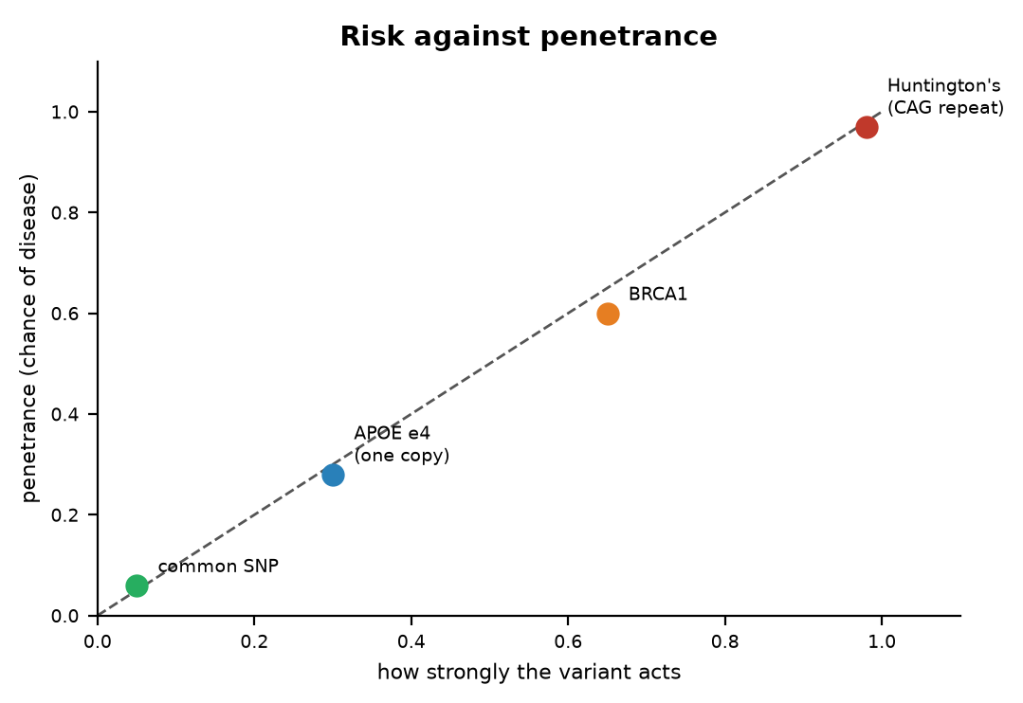
Figure 40. Risk against penetrance.
The numbers are settled. A 2017 study in JAMA that followed nearly 10,000 carriers reported that women with a harmful BRCA1 variant had a 72 percent chance of breast cancer by age 80, and a 44 percent chance of ovarian cancer; for BRCA2 the figures were 69 percent and 17 percent. The general population figure for breast cancer is about 12 to 13 percent. Around one woman in 300 to 400 carries such a variant; in Ashkenazi Jewish populations it is about one in 40, because three particular variants became common in a small founding population, and these three are the ones the spit kit is allowed to report. Men who carry BRCA2 variants have raised risks of prostate and male breast cancer, and pass the variant to half their children.
The word for a 72 percent chance is penetrance: the fraction of people carrying a variant who go on to have the condition. It is the single most useful number on any genetic report and the one most often missing.
* * *
Here is how the question travels through a family, using the invented one. Suppose Ruth's sister had breast cancer at 48. That is early, and it is the kind of history that gets a clinic's attention. The right first test is the sister's, because if she does not carry a BRCA variant the family's concern mostly dissolves. If she does, Ruth has a 50 percent chance of carrying it, since sisters share one copy of each chromosome from each parent on average. If Ruth carries it, Anna has a 50 percent chance, and if Anna does, Theo has a 50 percent chance. Ruth is 78 and has lived through most of the years in which the risk falls, so a result would say more about Anna than about her. Anna's spit kit reported that she does not carry the three Ashkenazi variants, which in a family with no Ashkenazi ancestry is true and useless. A clinical test sequences both genes in full. This chain, with the affected relative tested first and the rest tested in cascade, is how the clinics actually work.
Huntington's disease is the other end of the chart, where penetrance is nearly complete. James Gusella's group had placed the gene on chromosome 4 in 1983, using blood from very large families around Lake Maracaibo in Venezuela that Nancy Wexler had spent years collecting. The gene itself took a further ten years and six laboratories, and was published in Cell on 26 March 1993. It is called HTT, and the mutation is a stutter: the three letters CAG, repeated. Fewer than 27 repeats is normal. Forty or more, and the disease will come if you live long enough, usually beginning in the thirties or forties, sooner for longer repeats. Between 36 and 39 it may or may not. The repeat tends to lengthen when passed through fathers, so the disease can arrive earlier in each generation, a pattern known as anticipation.
A predictive test has existed since 1993, and one based on linked markers since 1986. Most people at 50 percent risk choose not to take it; studies of uptake in the countries that offer it put the figure at roughly 10 to 20 percent. There is no treatment that changes the course. Wexler, whose mother died of the disease and who led the hunt for the gene, said publicly in 2020 that she has it herself. The text, in this one case, reads like a sentence, and most people who could read it decline.
APOE sits between the two. In 1993 Allen Roses's group at Duke reported that one common form of the gene, known as ε4, was over-represented in people with late-onset Alzheimer's disease. The gene comes in three common forms, ε2, ε3 and ε4, and about a quarter of people of European ancestry carry at least one ε4; two or three percent carry two. One copy raises the risk of Alzheimer's roughly threefold. Two copies raise it roughly eight to twelvefold, though the effect is smaller in people of African ancestry and larger in East Asians. And still it is not a sentence. Many people with two copies die old and clear-headed, and most people with Alzheimer's have no ε4 at all. A 2024 paper in Nature Medicine argued that carriers of two copies almost all show the disease's biomarkers by their sixties and should be regarded as having a genetic form of it; that reading is contested, and I would call it working. What changed in 2023 is that the result became actionable: the antibody drugs lecanemab and donanemab cause brain swelling more often in ε4 carriers, so the label now advises testing before treatment.
* * *
The most immediately practical reports on any genome concern drugs, and this is a settled corner of the subject. Clopidogrel, sold as Plavix and given to millions after a stent, is a prodrug: it does nothing until an enzyme, CYP2C19, converts it. People with two loss-of-function copies of CYP2C19 make little active drug and get little protection, which is why the FDA put a boxed warning on the label in March 2010. About two percent of Europeans are poor metabolisers by this measure, and about 13 to 15 percent of East Asians. The HIV drug abacavir causes a dangerous hypersensitivity reaction in people who carry the HLA-B\57:01 allele, one inherited variant of that gene, present in about five to eight percent of Europeans; a trial published in the New England Journal of Medicine in 2008 showed that screening before prescribing eliminated the confirmed reactions, and testing is now standard everywhere the drug is used. Warfarin is the old blood thinner with the narrow safe dose, and variants in CYP2C9 and VKORC1* account for about a third of the difference in dose between one patient and another; the label has carried a dosing table since 2010, though trials of genotype-guided dosing have given mixed results.
The list goes on. TPMT and the thiopurine drugs used for leukaemia and Crohn's disease; DPYD and the chemotherapy fluorouracil, where a poor metaboliser can die of a standard dose, and where European regulators recommended testing in 2020; HLA-B\15:02* and the epilepsy drug carbamazepine in people of Han Chinese and Southeast Asian ancestry, on the label since 2007. A consortium of clinicians has published dosing guidelines for these pairs since 2009. The useful thing would be for the genotype to already be in the chart when any of these drugs is prescribed. The science is done; the implementation, in most hospitals, is not.
Two more reports belong on the list, both about the beginning of life. Carrier screening asks whether a healthy adult carries one copy of a recessive variant that would matter if their partner carried one too. It began with Tay-Sachs disease in 1971, in Ashkenazi communities in Baltimore and Washington, and the disease has since almost vanished in those communities, partly through an anonymous matching scheme called Dor Yeshorim founded in 1983. By 2021 the American College of Medical Genetics and Genomics recommended offering everyone who is pregnant or planning to be a panel of 113 genes. This is the one form of genetic testing where a result has an obvious use and no waiting.
Newborn screening began in 1963 with Robert Guthrie in Buffalo, a drop of heel-prick blood on filter paper, and a bacterial test for phenylketonuria, the disease Chapter 14 described as genetic and managed by diet. Most rich countries now screen every baby for thirty to fifty conditions from the same blood spot. The next step is under way: in October 2024 Genomics England began the Generation Study, which will sequence the whole genomes of 100,000 newborns in England and look for more than 200 rare conditions that appear in early childhood and can be treated. The heel-prick and the genome are not the same test. Guthrie's spot looks for a handful of diseases that a diet or a drug can change this month. A whole genome looks at both parental sets, about 6.2 billion letters, and can return findings the parents did not ask about and cannot act on for decades. That difference is why the Generation Study publishes a list of conditions it will report, and why everything else on the file stays off the letter home.
What such a programme should do with the rest of the genome, the adult-onset findings and the risks that are only odds, is the unsettled part, and it is where the next chapter begins.

41. What It Cannot Tell You
A school nurse's wall has a chart of heights, and a boy of fifteen is standing against it. There is an old formula for guessing how tall he will end up: average the parents' heights and add six and a half centimetres for a boy. It is right to within about eight centimetres most of the time, which is to say it is not very right. In 2022 a consortium led by Loïc Yengo published, in Nature, the largest genetic study of anything ever done: 5.4 million people, 12,111 places in the text that each nudge height a little. Put together into a single polygenic score, those variants explain about 40 percent of the variation in adult height among people of European ancestry. Among people of East Asian ancestry the same score explains about 10 to 20 percent, and among people of African ancestry less again.
Hold onto that result, because it is the best case. Height is easy to measure, almost everyone's has been recorded, twin studies put its heritability, the share of variation across a population that traces to genes as chapter 13 defined it, at about 80 percent, and there is no shame in it, so millions of people gave their data. Even so, after 5.4 million people, the best score in the world reads about half of the heritable part, and only for the population it was built in. The parents' heights, on the wall chart, do about as well. Everything that follows in this chapter is a harder problem than height.
The first thing a genome cannot tell you is whether a variant will act. Chapter 40 gave the BRCA1 figure of 72 percent, and it is a good figure, but it was measured in families that were studied because they were full of cancer. Those families share other things besides the one variant: modifier genes, habits, exposures. When biobanks began sequencing hundreds of thousands of people who were not selected for anything, and simply counted how many carriers of a given variant had the disease, the penetrance came out lower, often much lower, for one gene after another. The same letter, spotted by accident in a healthy person, means less than it did when it turned up in a family with the disease. This is called ascertainment bias, and it is the reason a variant on a spit-kit report and the same variant in a clinic's file are not the same fact.
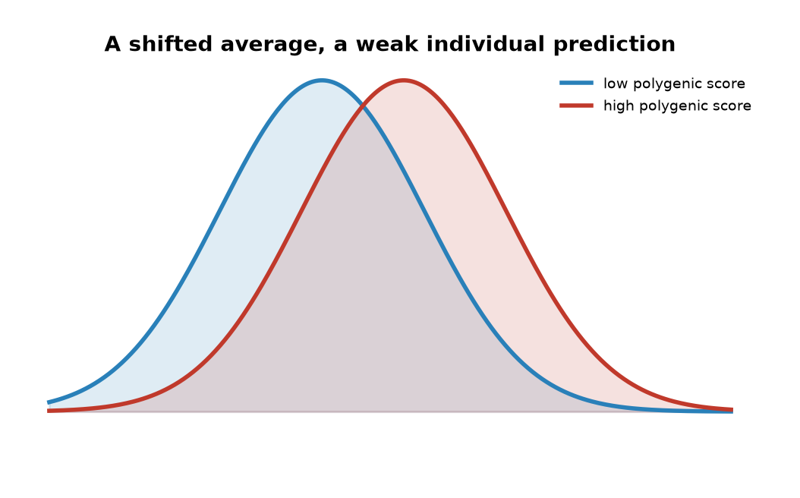
Figure 41. Two overlapping bell curves.
* * *
The second thing is the size of the pieces. Twin studies had said height was 80 percent heritable, and the first genome-wide association studies, in 2008, found about 40 variants that explained 5 percent of the variance, the spread in height from person to person that those variants could account for. A news feature in Nature that year dubbed it the case of the missing heritability, and the phrase stuck. Most of it has since been recovered, but only by admitting what it was: thousands of variants of tiny effect, each too small to see until the sample reached the millions. In 2010 Peter Visscher's group showed that all the common variants taken together, even the ones no study had flagged, accounted for about 45 percent of the variance in height. The rest is a working account: rare variants that chips do not catch, structural changes, and a suspicion that the twin estimates were too high, because twins share environments and because tall people marry tall people, which inflates what looks like genetics.
The third thing is the phrase "the gene for." In 2007 Timothy Frayling's group reported that a variant in a gene named FTO was associated with body weight, and the headlines nicknamed it the fat gene. Each copy of the risk variant is worth about one to one and a half kilograms on average. Against the range of human weight that is a rounding error, though across a whole population it is real. Then in 2014 it turned out that the variant, although it sits inside FTO, does its work by altering two neighbouring genes, IRX3 and IRX5. The gene for obesity was not even the gene. Most of what a genome says about a common trait is like this: a long list of minor nudges, many of them acting on genes other than the one they sit in.
This is why the prediction gap for common disease is what it is. In 2018 Sekar Kathiresan's group built a score from 6.6 million variants for coronary artery disease and showed that about 8 percent of people carried a score giving them threefold the average risk, the same order as a single-gene disorder like familial hypercholesterolaemia, the inherited high-cholesterol condition from chapter 38. That is a real finding and it will be used. But most heart attacks happen to people with average scores, because there are so many more of them, and adding the score to the things a doctor already knows, cholesterol, pressure, smoking, age, moves only a few percent of patients into a different risk band. A 313-variant score for breast cancer, published in 2019, puts the top one percent of women at about three times the average risk. These are odds, and modest ones, for most people.
The gap is wider outside Europe. A 2019 analysis in Nature Genetics by Alicia Martin and colleagues counted that about four-fifths of participants in association studies to that date were of European ancestry, and that scores built on them performed about four and a half times worse in people of African ancestry. The reason is technical and stubborn: the markers on a chip are mostly proxies, standing in for causal variants that sit near them, and which proxy stands for what differs between populations. Until the studies are as large elsewhere as they are in Europe, a polygenic score is a European instrument. I would call this settled, and the fix a matter of money and time.
* * *
Then there is the argument that will not go away, which is intelligence. The largest studies here measure years of schooling, because it is recorded for everyone. A 2018 study of 1.1 million people, and a 2022 study of three million, produced scores that explain about 12 to 16 percent of the variance in educational attainment in independent samples of European ancestry. For scores on intelligence tests themselves, the figure is a few percent. When the same scores are checked within families, by comparing siblings who drew distinct cards from the same parents, the direct effect shrinks by about half. A 2018 paper in Science from Iceland showed why: the variants a parent carries but does not pass on still predict the child's schooling, because they shape the home. Genetic nurture, the authors called it. The score is partly reading the parents' genes, partly the neighbourhood, and partly the fact that people with similar education marry each other.
The controversy is loud and I will state the positions rather than pretend it away. Robert Plomin's 2018 book Blueprint argued that DNA is, in his phrase, a fortune-teller, and that the scores will only get better. Kathryn Paige Harden's 2021 book The Genetic Lottery accepted the heritability and argued that it is a reason for more equal treatment, not less, since nobody chose their draw. A fringe uses the scores to make claims about groups, which the data cannot support even in principle, because the scores do not transfer across ancestries, as the previous paragraphs described. My own view, marked as mine: a score that explains a few percent of test performance in one population, halves within families, and cannot be ported, is a research instrument. It is not a fortune, and I think using it on a child would tell you less than ten minutes with the child.
The fourth thing a genome cannot tell you is what chance will do. Identical twins share every letter, and when one has schizophrenia the other has it about half the time. For type 1 diabetes the figure is somewhere between 30 and 50 percent, for multiple sclerosis about a quarter. Half or more of the outcome, for these conditions, is not in the text at all: it is in the somatic mutations that Chapter 10 described, in infections, in the noise of development that gives twins different fingerprints. In 2015 Cristian Tomasetti and Bert Vogelstein argued in Science that most of the variation in cancer risk between tissues tracks the number of cell divisions in that tissue, that is, the number of chances for a copying error. Their framing was contested, but the point under it was not: a great deal of what happens to a body is the copy going wrong after birth, which no genome read at birth can foresee.
Now suppose Anna, instead of a spit kit, had her whole genome sequenced for some unrelated reason. The laboratory would see all of it, including things she had not asked about. In 2013 the American College of Medical Genetics and Genomics published a list of genes in which a harmful variant should be reported whether or not the patient asked: 56 genes at first, 73 by 2021, and 81 in the 2023 version. They are the ones where knowing changes what you do: BRCA1 and BRCA2, the Lynch syndrome genes for bowel cancer, the genes for inherited cardiomyopathies, diseases that weaken the heart muscle, and long QT, a rhythm disorder of the heartbeat, LDLR for familial hypercholesterolaemia, RYR1 for a fatal reaction to anaesthetics. Somewhere between one and three percent of people sequenced for another reason turn out to carry one. Since 2014 a patient has been allowed to say no in advance.
Many will say no, and the reason has a name. In 2007 James Watson had his own genome read by 454 Life Sciences at a cost of about $1 million, as Chapter 24 recorded, and published it in Nature in April 2008 with one deletion. He asked that his APOE status be masked, because a grandmother had died of Alzheimer's disease and he did not want to know. In 2009 a group in Australia pointed out, in the European Journal of Human Genetics, that his ε4 status could be read anyway from the variants on either side of the gene, because letters travel in blocks. A further two million letters around APOE were then removed from the public file. You cannot hide one word in a text where words travel in sentences. The Council of Europe wrote the right not to know into its 1997 convention on biomedicine, and the Huntington's families had been exercising it since 1986. A person of seventy-eight might rather not hear the odds. That is a right, and it is the same right Watson asked for.
A polygenic score is a sum. Each variant contributes a fraction of a centimetre, or a fraction of a percent of risk, and the sum shifts a bell curve by a little. Two people with the same score can differ by a hand's breadth in height, or by a lifetime in health, because the score is an average over millions and a person is one draw. The curves in Figure 41 overlap for that reason. A shift you can measure in a population is still a guess about the person standing in the room.
That is Anna's own text and what it can and cannot say to her. There is another question, and it is about who, besides Anna, can read it.

42. Who Else Is Reading
On 24 April 2018 the police in Sacramento County, California, arrested a 72-year-old former police officer named Joseph James DeAngelo at his home in the suburb of Citrus Heights. Between 1974 and 1986, under names the newspapers had given him, the East Area Rapist, the Original Night Stalker, and finally the Golden State Killer, one man had committed at least 13 murders and about 50 rapes across California. His DNA from several scenes had been matched to each other years earlier. It had never matched anyone in the national offender database, because he had never been convicted of anything.
What changed was not the evidence. It was where investigators looked. Paul Holes, an investigator in Contra Costa County, and Barbara Rae-Venter, a retired patent lawyer who had taught herself genetic genealogy, had a laboratory convert semen from a 1980 double murder in Ventura into the kind of profile a consumer chip makes, several hundred thousand markers rather than the twenty short repeats the police use. They uploaded it to GEDmatch, a free website founded in 2010 by two hobbyists, Curtis Rogers and John Olson, where about a million people had posted their raw spit-kit files to find relatives. The upload found matches at about the level of third cousins. From those the team built family trees back into the nineteenth century, looked for a man of the right age who had lived in the right places, and identified one. Officers collected DNA from a car door handle while he shopped, and then from a tissue in his rubbish, and matched it to the crime scenes. He pleaded guilty in June 2020 to 13 murders and 13 kidnappings and was sentenced to life without parole.
None of the cousins had agreed to help the police. None had been asked. They had uploaded their files to find a great-aunt, and the site's terms of service had not contemplated the alternative.

Figure 42. Server racks in a data centre.
The arithmetic of why this works was published in Science in October 2018 by Yaniv Erlich and colleagues. Using a database of 1.28 million profiles, they calculated that a search for a person of European descent in the United States turned up a match at third-cousin level or closer about 60 percent of the time. A database holding just two percent of a population, they calculated, would give nearly everyone in that population such a match. A third cousin shares a pair of great-great-grandparents with you, and a typical person has, on one estimate, close to 200 of them. You cannot opt your cousins out, and the two percent has been passed in the United States for people of European ancestry. The rest of the population is being drawn in as the databases grow.
The rules were written afterwards. In 2019 GEDmatch let police use the site to find a suspect in an assault in Utah, a crime outside its stated limit of murder and rape, and in May of that year it switched every user to opt-out of police matching unless they chose otherwise; the pool available to investigators dropped from about a million to a few tens of thousands overnight, and has since recovered to a few hundred thousand. In December 2019 the site was bought by Verogen, a forensic company, which was in turn bought by Qiagen in 2023. FamilyTreeDNA admitted in early 2019 that it had been letting the FBI upload profiles. The two largest companies, 23andMe and Ancestry, say they refuse police access without a court order and have fought the orders they received. The US Department of Justice issued an interim policy in November 2019 limiting the method to violent crimes and unidentified remains, and only after the offender database had failed. Maryland passed the first state law in 2021, requiring a judge's authorisation. By 2023 the method had been credited with several hundred identifications, of suspects and of bodies.
Here are the two positions at their strongest. For: the crimes solved were real, some of the people identified had gone free for forty years, and the method has also cleared the wrongly convicted and named the unidentified dead, whose families had waited just as many years. Against: it puts every person with a cousin into a permanent lineup, without consent and without a warrant, on the strength of a hobby website's terms of service; and the American doctrine that what you share with a third party is no longer private, from a 1979 case about telephone records, was written before anyone shared a genome. In 2018 the Supreme Court held in Carpenter v. United States that mobile-phone location records need a warrant. Whether genetic matches do has not been decided. I think the use is good and the process is bad, and that the answer is a warrant and a judge, which is what Maryland did.
* * *
The law that most Americans believe protects them was signed on 21 May 2008. The Genetic Information Nondiscrimination Act, GINA, had taken thirteen years to pass after Louise Slaughter first introduced it in 1995, and it went through the House by 414 votes to one. Its first title bars health insurers from using genetic information to set premiums or eligibility. Its second bars employers with 15 or more workers from using it in hiring, firing or promotion, or from asking for it. Both are real protections and both have gaps that fit a genome through.
GINA says nothing about life insurance, disability insurance, or long-term-care insurance. An insurer in most American states may ask on the application whether you have had a genetic test, and may use the answer; declining to disclose a result you know is fraud. GINA does not cover the military, or companies with fewer than 15 employees. And it protects only information about a disease you do not yet have. Once a condition has appeared, GINA stops, and the protection against being refused health cover for it comes from the 2010 Affordable Care Act instead. In 2020 Florida became the first state to bar life, disability and long-term-care insurers from using genetic test results; most states have not followed. Britain took a different route: since 2001 a voluntary agreement between the government and the insurers' association has barred the use of predictive test results, with a single exception, a Huntington's disease result on a life policy above £500,000. Canada passed a criminal statute in 2017 and its Supreme Court upheld it in 2020. So Anna's report carries unequal legal weight depending on which side of which border she is standing on, and in her own country the gap is exactly where she might one day need cover.
Ownership is a stranger question, and the case that defines it began before the double helix. Henrietta Lacks was born on 1 August 1920 in Roanoke, Virginia, and in January 1951, with cervical cancer, she travelled to the Johns Hopkins Hospital in Baltimore, the only major hospital in reach that would treat Black patients. A piece of her tumour was sent, without her knowledge, to the laboratory of George Gey, who had been trying for decades to keep human cells alive in glass. Hers kept dividing. They doubled about every day and they have never stopped. She died on 4 October 1951, aged 31. Her cells, named HeLa from the first letters of her names, were used to test Jonas Salk's polio vaccine in 1952 and 1953, were the first human cells cloned, went into orbit, showed Harald zur Hausen the papillomavirus that causes cervical cancer, and appear in more than 100,000 published papers. By one estimate the total mass of HeLa cells grown since 1951 runs to tens of millions of tonnes. Her family found out in 1973, when researchers asked them for blood to help sort out which cultures around the world had been contaminated by HeLa.
Rebecca Skloot's 2010 book made the story public. In March 2013 a laboratory in Germany published the full HeLa genome without asking the family, and withdrew it after protest; in August 2013 the National Institutes of Health agreed that requests to use the genome would pass through a committee including two family members. In October 2021 the estate sued Thermo Fisher Scientific, one of many companies selling HeLa products, for unjust enrichment, the legal claim that a company had profited unfairly at her family's expense. The case settled on 31 July 2023, on the eve of what would have been her 103rd birthday, on confidential terms, and further suits against other companies followed. The settlement is a settlement, not a ruling. The ruling that stands in American law is Moore v. Regents of the University of California, decided in 1990: a man whose spleen cells were turned into a patented cell line had no property right in them once they left his body, though his doctors should have told him what they were doing. Under that rule you own the tube until you post it.
* * *
Consumer companies sit under the same rule with a contract on top. When a customer accepts the terms, the company gets a licence to the data, and about four in five customers have ticked the box that allows research use, which is what the GlaxoSmithKline deal in 2018 was buying. The federal medical-privacy law, HIPAA, does not apply to a company that is not a health-care provider. When 23andMe entered bankruptcy in March 2025 the question became whether fifteen million people's genotypes were an asset like the office chairs, and the court's answer was yes, with a privacy ombudsman appointed to watch the sale. In the weeks after the filing about 1.9 million customers asked for their data to be deleted, a figure reported in the proceedings. The buyer promised to keep the old privacy policy. A promise is what it was.
The deletion button has a limit that a password does not. In 2013 Yaniv Erlich's group showed in Science that anonymous men whose genomes sat in a public research database could be named by taking the repeats on their Y chromosome, searching genealogy websites where hobbyists had posted the same repeats next to surnames, and combining the result with the age and state that the database also listed. No password was involved. Your genome is a fixed identifier that you share, in halves and quarters, with everyone related to you, and it cannot be reissued.
States hold the biggest collections of all. Britain founded the first national police DNA database in April 1995, and after laws of 2001 and 2003 allowed profiles to be kept from anyone arrested, it held about 4.5 million by 2008, including hundreds of thousands of people never charged. In December 2008 the European Court of Human Rights ruled unanimously, in S and Marper v. the United Kingdom, that indefinite blanket retention of innocent people's profiles breached the right to private life. Britain deleted about 1.7 million profiles under a 2012 statute and the database now holds roughly six million. The American system, CODIS, an acronym for the Combined DNA Index System, went national in 1998 and by 2024 held more than 17 million offender profiles and several million more from people merely arrested; the Supreme Court held in June 2013, five to four, that a cheek swab on arrest for a serious offence is no different in kind from a fingerprint. One point in the databases' favour deserves saying: a police profile is twenty short repeats in non-coding regions, chosen because they say nothing about health, and it is a much thinner reading than a spit kit. The genealogy method, by contrast, uses the full chip.
Elsewhere the numbers are larger and the consent thinner. Human rights groups and newspapers have reported that China has collected DNA from tens of millions of men for a national Y-chromosome database, and from most of the adult population of Xinjiang in 2016 and 2017. Kuwait passed a law in 2015 requiring DNA from every citizen and visitor, and its constitutional court struck it down in 2017. Even the newborn heel-prick cards of Chapter 40 have been read by people the parents did not have in mind: Texas destroyed about five million stored blood spots after a 2009 lawsuit revealed they had been kept and shared without consent, and in 2022 a New Jersey public defender reported that police had obtained a suspect's newborn spot to make a DNA match.
So the answer to who else can see this is: the company, its buyer, the researchers who licensed it, the cousins' website if the file is uploaded there, the police through the cousins whether it is uploaded or not, an insurer if it asks and she answers, and anyone who breaks in. The cells copy the text with an error or two per division and forget nothing. The server copies it without error and forgets nothing either, and the second kind of copy, it turns out, is the one she has less control over. What remains, for the last part of the book, is the question that all the reading has been leading to: whether the text, once read, should be corrected.

PART XI — Correcting the Text

43. Fixing What Is Broken
A vial of cloudy fluid, thawed a few minutes earlier in a bath of warm water, is being pushed through a line into a vein. The patient is in a hospital bed in an isolation room and has been there for about three weeks. On the vial's label are the patient's name, a batch number, and a warning that it must not be irradiated. The wholesale acquisition cost of what is in it, the published United States list in December 2023, was $2.2 million.
The fluid is the patient's own blood-forming stem cells. They were drawn from the bloodstream some months earlier, shipped to a factory, edited, tested, frozen, and shipped back.
The name on the label is Casgevy. The longer name, exagamglogene autotemcel, shortens to exa-cel. It is the first medicine built with CRISPR, the bacterial scissors from Chapter 25. The United Kingdom approved it on 15 November 2023. The American Food and Drug Administration followed on 8 December 2023, for sickle cell disease. Transfusion-dependent beta-thalassaemia, a related failure of the same blood protein, was added in the United States on 16 January 2024.
What the edit does is worth stating exactly, because it is not what most people assume. It does not repair the sickle mutation in HBB. The Glu6Val change described in Chapter 6 is still there in every edited cell. Instead the scissors cut an enhancer, a DNA switch that can turn a gene's activity up or down, sitting beside a different gene, BCL11A, whose protein normally switches off the fetal form of hemoglobin in the months after birth. Break the switch and the cells revert to making fetal hemoglobin, which does not sickle. The cure is a detour, not a correction. It works because a fetus does not have sickle cell disease, and the edit keeps one part of the patient a fetus, in one narrow biochemical sense, for life.
Before the vial can go in, the patient's own bone marrow has to be cleared to make room. That is done with busulfan, a chemotherapy drug, at doses that cause hair loss, mouth sores, weeks in isolation, and usually infertility. Then the vial. Then a wait of several weeks while the edited cells find their way to the marrow and start producing blood. In the trial that supported approval, 29 of the 31 sickle cell patients who could be evaluated went at least twelve consecutive months without a severe pain crisis. Some of them had been having several a year since childhood.
* * *
The first distinction in this Part is the one that everything else rests on, and it is settled in law, in ethics statements, and in practice. Edit a person's blood cells, liver cells, eye cells, or muscle cells, and the change lives and dies with that person. That is somatic editing, from the Greek word for body. Edit an egg, a sperm, or an early embryo, and the change is in every cell of the resulting person, including the cells that will make the next generation's eggs and sperm. That is germline editing. The first is medicine, of an expensive and slightly heroic kind. The second is the subject of the next chapter, and of about seventy national laws that forbid it.
Everything approved so far is somatic. The prices, in US dollars and with their years, say what kind of medicine this is.
Medicine | Year | What it does | Launch list
Luxturna | 2017 | Working RPE65 under the retina, both eyes | about $850,000
Zolgensma | 2019 | Working SMN1 for spinal muscular atrophy | $2.125 million
Zynteglo | 2022 | Edited stem cells for beta-thalassaemia | $2.8 million
Hemgenix | 2022 | Working F9 for haemophilia B | $3.5 million
Roctavian | 2023 | Working F8 for haemophilia A | $2.9 million
Casgevy | 2023 | CRISPR-edited stem cells for sickle cell | $2.2 million WAC
Lyfgenia | 2023 | Gene-addition for sickle cell | $3.1 million

Those figures are published lists, not hospital bills. England's published list for Casgevy is £1,651,000, bought at a confidential discount. Then, in 2025, one baby, one edit, one patient, no product name, and no price list at all.
That baby is KJ Muldoon, and he turns the list from a set of products into a method. He was born in August 2024 in Pennsylvania with a severe deficiency of the liver enzyme CPS1, which clears ammonia from the blood. Untreated, about half of babies with the severe form die in infancy, and the survivors are often brain-damaged by the ammonia. His two mutations in CPS1 were, in effect, his own; nobody had built a therapy for them, and nobody ever would have on commercial terms. A team at the Children's Hospital of Philadelphia and the University of Pennsylvania, led by Rebecca Ahrens-Nicklas and Kiran Musunuru, designed a base editor for one of the two mutations, tested it in cells and in mice carrying his variant, made a clinical-grade batch, and had the FDA's permission to dose him within about six months of diagnosis. The first infusion went in on 25 February 2025, when he was about seven months old, and the New England Journal of Medicine paper of 15 May 2025 reports a second infusion at about eight months. Later public accounts of the case have spoken of a third dose. I will follow the paper's own summary, which is two infusions, and not pretend the summaries agree on a third. By then he could eat more protein and needed less of the drug that mops up ammonia. Nobody used the word cure. The word the team used was personalised.
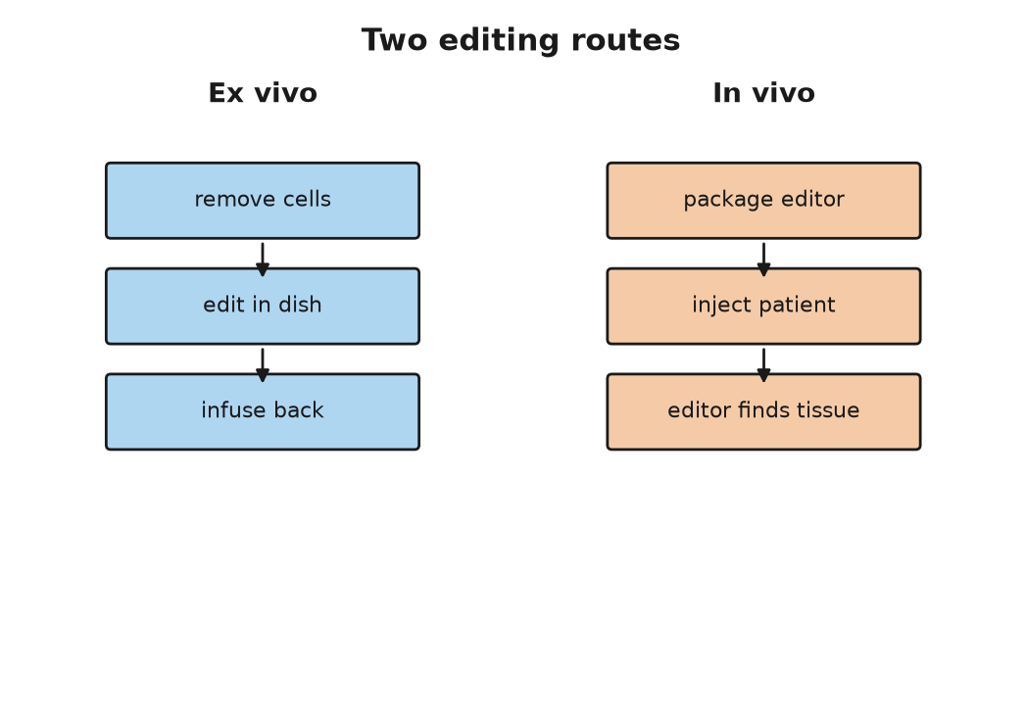
Figure 43. Ex vivo and in vivo editing routes.
* * *
The hard part of somatic editing is not the editing. The scissors, the base editors, and the prime editors of Chapter 25 are, by now, well understood. The hard part is the post. You have to get a few thousand letters of instructions, or a protein and a guide, into the right cells of a living person, and nowhere else, without the immune system noticing, and in a quantity that does something.
There are two routes, and the diagram for this chapter shows them side by side. Ex vivo, "outside the body," is the Casgevy route: take the cells out, edit them in a dish where you can check your work, put them back. It works for blood, because blood-forming stem cells can be harvested from a vein and re-seeded into marrow, and it is the reason blood diseases came first. It does not work for a liver, a heart, or a brain, which cannot be taken out. In vivo, "inside the body," means putting the editing machinery into a person and trusting it to find the address.
For in vivo delivery there are, at present, two kinds of envelope. The first is a virus, usually an adeno-associated virus, AAV, a small harmless passenger virus that most people have met without knowing. Its own DNA is replaced with the gene you want to deliver, and the virus does the rest. Luxturna, Zolgensma, Hemgenix, and Roctavian all use AAV. Its limits are real. The capsule holds only about 4,700 letters, roughly enough for two or three ordinary genes end to end, which excludes many large genes. A third or more of adults already carry antibodies against the common AAV types and cannot be dosed, or cannot be dosed twice, because the first dose immunises them against the second. And at the very high doses needed to reach muscle throughout the body, AAV has killed. In a trial of a gene therapy for X-linked myotubular myopathy, a rare muscle disease, several boys who received the highest dose died of liver failure between 2020 and 2021, and the programme was later halted.
The second envelope is a fat droplet, a lipid nanoparticle, of the kind that carried the mRNA vaccines of 2020. Those vaccines were a DNA-adjacent tool, not an edit. They sent a temporary RNA instruction for a viral protein, and they did not rewrite anyone's genome. The same class of envelope can now carry an editor instead. The difference is permanence: a vaccine's instruction fades in days, and an editor's change, if it lands, stays for the life of that cell and its daughters. The particle carries messenger RNA that tells the cell to make the editor for a day or two and then disappears. It can be dosed again. And it has one enormous convenience: injected into a vein, most of it ends up in the liver, because the liver's job is to pull fat particles out of the blood. For a disease of the liver, the parcel delivers itself. That is why the first in vivo CRISPR trial, in 2021, was for a liver disease. Six patients with transthyretin amyloidosis, in which the liver makes a misfolded protein that clogs the heart and nerves, received a single infusion of lipid particles carrying instructions for Cas9 and a guide aimed at TTR. At the higher dose the amount of the protein in their blood fell by an average of 87 percent, and the results appeared in the New England Journal of Medicine in June 2021. KJ Muldoon's editor arrived in the same kind of particle for the same reason: CPS1 is a liver enzyme.
Beyond the liver, delivery is a working problem, not a solved one. Getting an editor into the brain, past the blood-brain barrier, at scale, is not done. Getting it into every muscle fibre of a body with muscular dystrophy is not done safely. Getting it into the lining of the lung, for cystic fibrosis, has been tried since 1993 with inhaled vectors and has never produced a durable benefit. The list of approved products is a map of the organs that are easy to reach: the eye, which is small and closed and largely ignored by the immune system; the blood, which can be taken out; and the liver, which the parcel finds by itself.
About 7,000 diseases are counted as rare, most of them caused by a fault in a single gene, and most of them affecting a few hundred or a few thousand people worldwide. Added together, the best current estimate, from a 2020 analysis of the Orphanet database, is that between 3.5 and 5.9 percent of people carry one of them, which is roughly 260 to 450 million people, and the round number of 300 million is the one usually quoted. In a class of forty, the odds are that one or two classmates have a rare disease. Almost none of them will ever have a product built for them, because there are not enough of any one of them to pay for the trial.
That is what KJ Muldoon's case changes, or might. The argument, made openly by the Philadelphia team and taken up by the FDA, runs like this. The lipid particle was one already used in other trials. The base editor was a published enzyme. The only new thing was the twenty-letter guide that told it where to go. If the envelope and the enzyme can be qualified once, as a platform, then a new patient with a new mutation needs a new guide and a few months of testing, not a new decade. In 2025 the FDA's leadership described in print a possible "plausible mechanism" pathway for exactly this kind of case, in which a treatment for a very limited number of patients could be authorised on the strength of a well-understood mechanism, a demonstrated effect in the patient's own cells or in an animal model, and close monitoring, rather than a randomised trial that could never be run. Whether that becomes a regulation, and how safety is policed when every patient is a trial of one, was still being argued as this book went to press.
The money is the other half. A million-dollar price for a one-time treatment can be cheaper than the alternative. A person with severe sickle cell disease in the United States runs up lifetime medical costs estimated at about $1.7 million, and dies on average in their forties. But the arithmetic only works if someone pays up front, and in the American system the payer is often a state Medicaid programme with an annual budget. In 2025 the federal Medicare and Medicaid agency began an arrangement under which the makers of the sickle cell therapies are paid partly on results, and by which states could pool the risk. In England the published list is £1,651,000. The National Health Service agreed a confidential discount and began treating patients in 2024 for thalassaemia and in 2025 for sickle cell. In the countries where most sickle cell disease actually is, in sub-Saharan Africa and India, where perhaps 300,000 babies are born with it every year, none of this is available, and at any price with six zeros in it none of it will be. A cure that exists and cannot be delivered is a new kind of inequality, and it is settled that it is a real one.
As of late 2026 the first CRISPR medicine is spreading slowly, not flooding. The company that sells Casgevy reported that in 2025 a few dozen people received the infusion, with a few hundred more somewhere on the path from referral to cell collection. Prime editing that same year was still two patients reported in a journal. That is a start, and it is still a start in the countries that can staff a transplant unit. The countries where most sickle cell disease is born have not been reached.
I think the fair way to describe the state of somatic editing in 2026 is this. For a short list of diseases of the blood, the eye, and the liver, we can fix what is broken, at great cost and with real risk, and the fix holds. For a much longer list, the fix is designable in principle and the parcel is the problem. And for one baby, the fix was designed for him alone, which is the thing nobody expected to see this soon. All of it dies with the patient. The question of whether to make a fix that does not is the one this book has been putting off since the Prologue, and it is time to stop.

44. The Line We Said We Would Not Cross
The Francis Crick Institute sits behind St Pancras station in London, a building of glass and pale stone that its critics compared to a beached submarine. On the morning of 6 March 2023 its auditorium was filling for the Third International Summit on Human Genome Editing, three days of talks that had been waiting, in a sense, since the Second, in Hong Kong in November 2018, when a man from Shenzhen stood up and told the room that two edited girls had already been born.
One of the first speakers was not a scientist. Victoria Gray, the Mississippi woman who in July 2019 had been the first sickle cell patient treated with CRISPR-edited cells, told the room what her life had been before and after. The choice of opening was not an accident. The organisers wanted the world to see the somatic side of the ledger, the side with a cured patient on it, before anyone talked about embryos. When the organising committee issued its closing statement on 8 March, it said that somatic editing was working and needed to be made affordable, and that heritable human genome editing "remains unacceptable at this time." The phrase "at this time" was doing a lot of work, and everyone in the room knew it.
The line between somatic and germline, drawn in the last chapter, is the line the summit was defending. What follows is the case for crossing it, put as strongly as I can, then the case against, put the same way, then the two things that are already on the far side of the line and have been for years, and then what I think.
* * *
The case for begins with a couple. Invent two people for a paragraph: a man and a woman who both have sickle cell disease, each carrying two copies of the HBB variant, who want a child of their own. Every child they conceive will have the disease. There is no embryo to select, because all of them carry two copies. The same is true for a parent who carries two copies of the Huntington's expansion in HTT, the fatal brain disease from Chapter 40, which is rare but not unknown, and for any couple in which one partner has two copies of a dominant condition. For these families, embryo selection, the workhorse of the last thirty-five years, has nothing to offer. Germline editing is the only route to a child who is genetically theirs and free of the disease. The number of such couples is small, and I have not found a reliable estimate, but it is not zero.
The case for goes on. We already accept risk to future people for the sake of their parents' wishes. IVF, short for in vitro fertilisation, was itself done first, in 1978, without anyone knowing what it would do to Louise Brown. Mitochondrial replacement, described below, is a heritable change and has been legal in Britain since 2015. Selection against a disease and correction of a disease have the same aim. If somatic editing of a child's blood is a cure, and everyone agrees it is, then editing the same letter one generation earlier, so that the child never has the disease and never needs the cure, is at worst the same act done sooner. And the 2020 report of the International Commission on the Clinical Use of Human Germline Genome Editing, convened by the US National Academies and Britain's Royal Society, laid out a narrow pathway: serious single-gene diseases, no other option, an edit to a common variant known to be harmless, with proof that the edit is exactly what was intended and nothing else, before any pregnancy. That is not "never." It is "not yet, and only like this."
The case against begins with consent. The person most affected by a germline edit does not exist when the decision is made and cannot be asked. The standard reply, that nobody consents to being born with any genome, is true and does not settle it, because a natural genome is nobody's choice and an edited one is somebody's. Then irreversibility: a somatic edit that goes wrong harms one patient, and a germline edit that goes wrong is inherited. Then mosaicism, which is the technical objection with teeth. Cas9, the cutting enzyme from Chapter 25, injected into a fertilised egg does not always act before the first cell division. If it acts at the two-cell or four-cell stage, some cells are edited and some are not, and the resulting person is a patchwork whose cells cannot all be tested before birth. He Jiankui's twins were, on the evidence he himself presented, mosaic. Then off-target cuts and unintended damage at the target itself: in 2020 several groups reported that Cas9 in human embryos sometimes removed large pieces of the chromosome around the cut, at rates that were not small. And then the argument that is not technical at all: that the same technique which removes a disease can, in the next laboratory, add a preference, and that a society which allows the first will not find the place to stop before the second. The next chapter is about how little of the second is actually possible, but the slope argument is not about what is possible now.
There is also the practical objection that the summit's statement leaned on. For almost every family that fears passing on a single-gene disease, embryo selection already works, is legal almost everywhere, and does not involve touching the text at all.
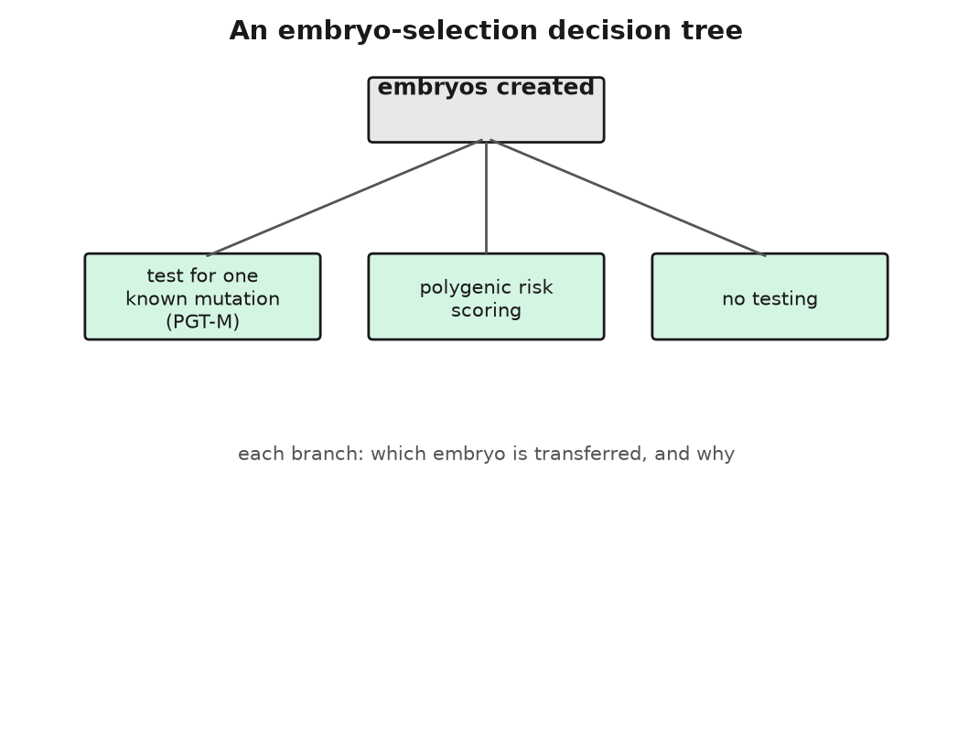
Figure 44. An embryo-selection decision tree.
* * *
Selection is the first thing already on the far side of the line, and it has been there since 1990. In April of that year Alan Handyside and colleagues at the Hammersmith Hospital in London reported in Nature that they had taken a single cell from each of several three-day-old IVF embryos, amplified a piece of the Y chromosome by PCR, the DNA-copying method from Chapter 22, and transferred only female embryos to two women who carried X-linked diseases, disorders carried on the X chromosome. Both women became pregnant with twin girls. It went by the name preimplantation genetic diagnosis then and is called preimplantation genetic testing for monogenic disease, PGT-M, now. It has been used for cystic fibrosis since 1992, for Huntington's, for BRCA1 and BRCA2, and for several hundred other conditions. The embryo is not edited. It is read, and the ones that carry the variant are not used. The moral weight of that is real, and people disagree about it, but it involves no new text and no new risk to the child who is born.
The embryos that are not transferred do not vanish. A typical IVF cycle produces several, one or two go in, and the rest are frozen in tanks of liquid nitrogen, in straws labelled with a name and a date. Estimates of how many sit in American tanks run from about a million to several million; there is no census. Some will be thawed for a later pregnancy. Some will be donated. Some will be discarded. Some stay because nobody answers the storage invoice. As of late 2026 that leftover stock is the quiet background to everything sold as embryo selection. The single-gene tests, and the polygenic scores below, are offered on the embryos a couple already has, including the ones that would otherwise never leave the tank.
What has changed since about 2019 is that companies began selling selection on the basis of the polygenic scores described in Chapter 41, for conditions that are not single-gene at all. Genomic Prediction, founded in 2017 in New Jersey, reported in 2021 the first baby chosen with such a score. Orchid, founded in 2019 in California, sequences the whole genome of each embryo from a few cells and reports risk scores for diabetes, heart disease, schizophrenia, several cancers, and more, at a price reported as a few thousand dollars per embryo. There are others.
What the scores can actually do is measurable, and it is not nothing, but it is small. A 2019 paper in Cell by Ehud Karavani, Shai Carmi, and colleagues worked out the expected gain from choosing the top-scoring embryo among ten for height: about 2.5 centimetres. For IQ, using the scores then available: about 2.5 points, with a wide spread. A 2021 paper in the New England Journal of Medicine by Patrick Turley and colleagues listed the reasons the numbers are worse in practice. A couple rarely has ten viable embryos to choose from. The scores were built on people of European ancestry and predict less well in everyone else. A score for one thing drags others with it, in directions nobody has measured. And the score ranks the embryos against each other, not against anyone's hopes. The European Society of Human Genetics said in 2021 that offering polygenic embryo selection was unproven and premature. The companies say their customers are adults making informed choices. Both are true. The gap between what is sold and what is shown is, I think, the widest in this book, and the marketing has a way of not mentioning the centimetres.
The second thing already on the far side of the line is mitochondrial replacement. About one in 5,000 people is born with a serious disease caused by a fault in the 16,569 letters of mitochondrial DNA, which passes only from mother to child, as Chapter 12 explained. The fix is to move the nucleus of the mother's egg, or of the fertilised egg, into a donor egg whose own nucleus has been removed and whose mitochondria are healthy. The child carries the nuclear DNA of both parents and the mitochondrial DNA of the donor, which is why the newspapers called them "three-parent" babies, a phrase the embryologists dislike because the donor contributes about 0.1 percent of the child's genes and none of the ones that make a face.
It is heritable, if the child is a girl, and it was made legal on purpose. The House of Commons voted 382 to 128 on 3 February 2015 to allow it, the Lords agreed on 24 February, and the regulations came into force in October 2015. The Newcastle Fertility Centre received the first licence in March 2017. On 16 July 2025 the Newcastle team reported in the New England Journal of Medicine that eight babies had been born in Britain by pronuclear transfer, the nucleus-swap technique just described, all healthy at the time of writing, with the mother's faulty mitochondria undetectable in most of them and present at low but measurable levels in a few, which is the thing to watch. Australia passed a similar law in 2022. The United States has not; a rider attached to the federal budget every year since December 2015 forbids the FDA from even considering an application for a heritable modification, and mitochondrial replacement is caught by it. A boy born in 2016 to a Jordanian couple treated by a New York doctor working in Mexico is, as far as the record shows, the first child born by the method, and the rider is the reason it was done in Mexico.
The international rules are a patchwork with a clear centre. A 2020 survey in the CRISPR Journal found that of 96 countries with relevant policy, 70 prohibited heritable human editing outright and none permitted it; the rest were silent or ambiguous. The Council of Europe's Oviedo Convention has banned heritable modification since 1997. China, after 2018, wrote a criminal offence for it into its penal code in 2021. The World Health Organization published a governance framework in 2021 and set up a registry of trials. The summit statement of 2023 was the scientific community's own line: not now, and not until the technical bar of the 2020 report has been met and there is a public consensus that it should be done at all.
He Jiankui was released in April 2022 after his three years. He set up a laboratory, announced plans for gene therapy research, and has posted regularly about his intentions since, including statements in 2024 and 2025 that he wanted to work on embryo editing to reduce Alzheimer's risk. I stick to the record and note only that nobody has reported him doing any such thing, and that the children he did edit are, as far as anyone outside a narrow circle in China knows, alive and unstudied.
So here is what I think, marked as mine. Somatic editing is medicine and should be paid for like medicine. Embryo selection for serious single-gene disease is a reasonable thing for a family to choose and a reasonable thing for a family to refuse. Polygenic embryo selection is a product ahead of its evidence; I would not buy it, but I would not forbid adults from buying it either, provided the centimetres are in the brochure. Mitochondrial replacement has been done carefully, for a small number of families with no alternative, and the results so far justify it. Germline editing of the nuclear text I would keep where the summit left it, for the reason the summit gave: almost everyone it could help can be helped by selection instead, and the few who cannot are not yet enough to justify the first mistake. But I do not think "never" is a serious position, and I notice that the people who use the word tend to have no one in their family with two copies of anything. The line will move when the risk is shown to be smaller than the harm it prevents, and not before, and the arguing about where that point is will be done by people who are not yet born. The harder argument is not about disease at all, and it starts with a very strong little boy in Berlin.

45. Enhancement
The boy was born in Berlin in 1999, and the first thing anyone noticed was his legs. Newborns are soft; this one had the defined thigh and calf muscles of a compact athlete, and within days his twitches were strong enough to be worth a neurologist. The neurologist was Markus Schuelke at the Charité hospital, and over the next four years he and colleagues in Berlin and at Johns Hopkins worked out why. In June 2004 they published the answer in the New England Journal of Medicine. The boy carried two broken copies of MSTN, the gene for myostatin, a protein whose job is to tell muscle to stop growing. He made none of it. By the age of four and a half he could hold a three-kilogram weight in each hand with his arms stretched out sideways, and the cross-section of his thigh muscles was about twice that of other children his age. His mother, reported as a former professional athlete, carried one broken copy. She was, the paper noted, unusually strong.
Myostatin was not new. Se-Jin Lee and Alexandra McPherron at Johns Hopkins had knocked it out in mice in 1997 and produced animals with two to three times the normal muscle mass, which the newspapers called Schwarzenegger mice. Belgian Blue and Piedmontese cattle, the double-muscled breeds that look as though they have been inflated, turned out to carry natural MSTN mutations, an 11-letter deletion in the Belgian Blue's case. Whippets carry a 2-letter deletion; dogs with one copy are over-represented among racing winners, and dogs with two, known as bully whippets, are heavily muscled and prone to cramp. All of this is settled, and it produces the first entry on a list that this chapter is really about: the list of things that some people already are, by accident of birth, that the rest of us are not, and that an editor could in principle write in.
* * *
The list is shorter than the films suggest, and each entry has a footnote.
Eero Mäntyranta was a Finnish cross-country skier who won seven Olympic medals between 1960 and 1968, three of them gold. His blood carried, by report, about 50 percent more hemoglobin than a normal man's, and in 1993 Albert de la Chapelle's group in Helsinki found out why: a single-letter change in EPOR, the gene for the receptor that responds to erythropoietin, the hormone that tells the marrow to make red cells. The mutation truncated the receptor and removed its off switch. About thirty members of his extended family carried it. It is the nearest thing in humans to a natural blood-doping allele, and Mäntyranta spent the rest of his life, until his death in 2013 at 76, explaining that he had not cheated. The footnote is that thick blood clots. What the allele cost his family over their lifetimes is not on record in any detail, and that absence is itself a warning about how little we know of the price of these things.
CCR5-Δ32 is a 32-letter deletion that removes a protein from the surface of immune cells. About 10 percent of people of northern European descent carry one copy, and about 1 percent carry two. HIV uses the CCR5 protein as a door; people with two deleted copies have no door, and are almost immune to the common strains of the virus. That is why, in February 2007 in Berlin, a doctor named Gero Hütter gave an HIV-positive leukaemia patient named Timothy Ray Brown a marrow transplant from a donor with two copies of Δ32. Brown's leukaemia was cured, and so, as far as anyone could tell for the rest of his life, was his HIV. He stopped his antiviral drugs and the virus never came back. He died in September 2020 of a return of the leukaemia, still free of HIV, and a handful of people have since been cured the same way. It is also the allele He Jiankui tried to write into two embryos in 2018, which is why it belongs in this chapter and not only in the last. The footnote is West Nile virus: people with two Δ32 copies are several times more likely to fall seriously ill if they catch it, and there are hints, less certain, of worse outcomes with influenza and some other infections. A 2019 paper claiming that Δ32 homozygotes, people with two deleted copies, die younger was retracted the same year when its genotyping proved faulty, so that particular cost is not shown. But the door HIV uses is a door the immune system built for a reason.
ACTN3 encodes a protein in fast-twitch muscle fibres. About 18 percent of people worldwide carry two copies with a stop codon, a signal that halts the gene's instructions early, and make none of it, and they are fine. But among elite sprinters and power athletes the two-copy version is almost absent, which Kathryn North's group in Sydney reported in 2003, and among endurance athletes it may be slightly enriched. The footnote is the size of the effect: it shifts the odds of being a champion by a modest amount, and it makes nobody fast on its own.
BHLHE41, also known as DEC2, carries in a few families a variant, P385R, a change at position 385 in the protein, that Ying-Hui Fu's group at the University of California, San Francisco, reported in Science in 2009. The people who carry it sleep about six hours a night, feel rested, and have done so all their lives; mice engineered with the same variant sleep less too. Fu's group has since identified several other short-sleep variants in other genes. The footnote is that nobody knows what, if anything, the two saved hours cost over a lifetime, because the families are small and the question is hard.
LRP5 is a gene in a signalling pathway that controls bone growth, and two families reported in 2002, one of them in the New England Journal of Medicine, carry variants that give them bones several times denser than normal. Their members have walked away from car accidents that break other people's hips, and it has been reported that some of them have trouble swimming, because they sink. The footnote, so far, is modest: an enlarged jaw in some, a bony ridge on the palate in others. Osteoporosis drugs acting on the same pathway followed.
And then PCSK9, which is the free lunch, or the nearest thing to one. In 2006 Jonathan Cohen and Helen Hobbs at the University of Texas Southwestern reported in the New England Journal of Medicine that about 2.6 percent of Black participants in a large heart study carried a nonsense mutation, a change that stops the gene's instructions partway through, in PCSK9, a gene whose protein removes LDL receptors from the surface of liver cells. Carriers had LDL cholesterol, the "bad" cholesterol that clogs arteries, 28 percent lower than everyone else and, over fifteen years, 88 percent fewer coronary events, meaning heart attacks and related heart trouble. A woman was later found with both copies broken, an LDL cholesterol of about 14 milligrams per decilitre, roughly a tenth of the usual figure, and no apparent ill effect at all. Two antibody drugs that block the protein were approved in 2015, a gene-silencing RNA treatment that mutes the gene for six months at a time followed in 2020, and in 2022 a company named Verve dosed the first patients with a base editor that writes a stop into PCSK9 in the liver, permanently, in a single infusion, with results reported in 2023. The trial had its troubles and was paused and redesigned; the point is that the natural allele told the drug designers exactly what to build.
The oldest and best-documented entry on the list is not usually put on it, because it is so common. Anna's switch, from her father, is an enhancement by any definition: a new ability, useful, heritable, no evident cost. It was written by copying errors and dairy farming, not by anyone.
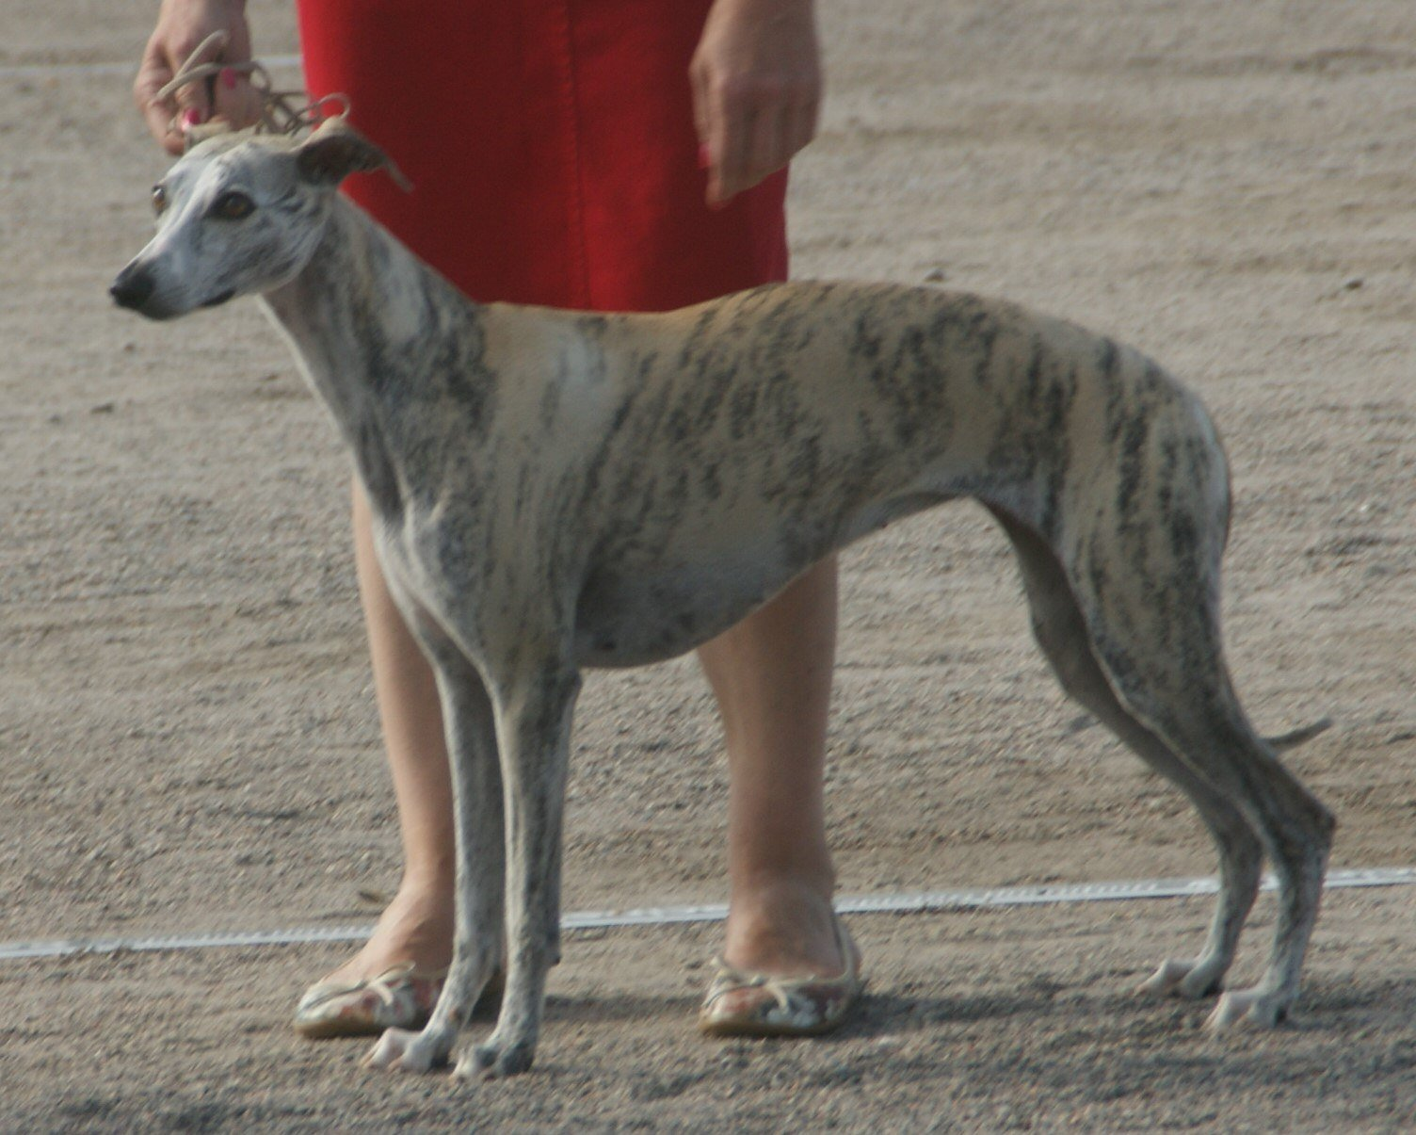
Figure 45. A whippet, the deep chest and narrow waist the breed was selected for.
* * *
Now the accounting. Every entry above except the last two comes with a trade, and the trades are the same shape as the one this book has met before. Sickle cell is the pattern: one copy of the HBB variant protects against severe malaria, two copies cause the disease, and the variant is common in exactly the places where malaria has been. CCR5-Δ32 blocks one virus and opens the door to another. EPOR wins medals and thickens blood. Myostatin loss builds muscle, and in cattle causes calving problems severe enough that most Belgian Blue calves are delivered by Caesarean, and in humans nobody knows what it does to tendons and hearts over sixty years, because the boy from Berlin is only in his twenties.
What we call superhuman, in other words, is mostly a menu of trade-offs that evolution has already priced, with a small number of items that look, on present evidence, like pure gain: PCSK9 loss, dense bones, Anna's switch. That is the right way to hold the whole subject. The alleles exist, they are in people walking around today, and an editor that can write one letter into a liver cell can write these. What it cannot do is remove the footnote.
Gene doping is where the argument stops being theoretical. The World Anti-Doping Agency put gene doping on its prohibited list in 2003, before anyone had done it, defined broadly as the non-therapeutic use of genes or cells to improve performance. A product called Repoxygen, a virus carrying an erythropoietin gene that had been developed for anaemia, turned up in 2006 in the German trial of an athletics coach, in emails in which he tried to obtain it. No case of a gene-doped athlete has ever been confirmed, and detecting one is hard, because the added gene makes the athlete's own protein. Somatic editing of an athlete's EPOR or MSTN is, as of 2026, technically closer than most sports bodies would like to admit, and if it happens it will come to light the way East German doping did, by paperwork and defections, not by a test.
Then intelligence, which is the item on every list and the one with the least behind it. Chapter 41 gave the numbers. The largest study of educational attainment, with 3 million people in 2022, produced a polygenic score that predicts about 12 to 16 percent of the variance, the person-to-person differences, in years of schooling, and within a family, comparing siblings, about half of that, because the rest is the family's money and the schools. The score is built from thousands of variants of tiny effect, scattered across the text, most of them in regulatory regions whose function nobody has worked out, and none of them a lever. There is no MSTN for thinking. There is no single letter that makes a mind, and there is no evidence, working or speculative, that one is waiting to be found. Anyone who sells the possibility of an edited genius is selling something they have not seen.
Which leaves the honest position, and I will mark it as mine. The natural superhuman alleles are real, few, and mostly bought at a price. Somatic editing to copy one of them into an adult who wants it, with eyes open, is a question of medical ethics and sporting rules, not of the future of the species. Germline editing to write one of them into a child is the line of the last chapter, with less excuse. And the enhancement that would matter most, if anyone could offer it, is the one nobody can find in the text. The last chapter of this book is about what a hundred years of all this might look like, and the first thing to say is that the text will not be waiting for us to decide.

46. The Next Hundred Years
It is 2126, as of the guesses one can make in late 2026, and a child has been born in a hospital that is, in most respects, recognisable. The lights are the same. The mother is tired. What is different is that on the wall a display is already showing the child's genome, both copies of the 3.1 billion letter text, read from a few of the child's cells in the last hour of labour and compared, before the cord is cut, with the text of both parents and with a reference built from several hundred million other people. Nothing about the cutting of the cord has changed. The reading is simply done, the way a birth weight is done, and it will say, within the hour, which of the sixty or seventy new letters this child carries were in neither parent, and whether any of them matter.
What that wall would mean is narrower than a parent standing in front of it will want. It would name the new letters that neither parent carried, the copying errors of one conception, and whether any of them sit in a gene a paediatrician can already treat. It would, if anyone asked, show the drug-response letters of Chapter 40. It would not say how tall the child will be, or how long the child will live, or what kind of person the child will become. A polygenic score on that screen would shift a curve. It would not place the infant. The display is a reading of a text that will keep being copied, and miscopied, in every tissue, for the rest of that life.
I do not know that this is what 2126 will look like. Nobody does, and I have spent forty-five chapters being careful about numbers, so I am not going to stop now. What I can do is sort the guesses by how much stands behind them today, using the three words this book has used since Part VI, and then say, marked as mine, what I would bet on. The reader in 2126, if there is one, may score it.
Some of this is already being done at a scale where the only uncertainty is how far it spreads.
Newborn genomes are already being read. Genomics England began its Generation Study in October 2024 with the aim of sequencing 100,000 newborns and reporting on more than 200 treatable childhood conditions. A baby in intensive care can have a diagnostic genome within a day or two, and the record, set in 2022, was under eight hours. The blood-spot screening that Robert Guthrie started in 1963 tested for one disease. A genome tests for all of them at once, and the price is within sight of what a routine hospital test costs. I would put universal newborn sequencing in the rich world within twenty years, not a hundred, and the argument about what to report from it, which Chapter 41 described, will go on for the whole century.
Once a child's text is on the wall, the cures that can follow it will keep spreading. As of late 2026 that spreading is still a trickle: a few dozen Casgevy infusions in a year, a handful of bespoke editors, two prime-edited patients in a journal. Somatic cures for single-gene diseases will extend from the blood, eye, and liver of Chapter 43 into whatever organs the delivery problem yields, and the KJ Muldoon model, one patient, one guide, will become a service line in a few dozen hospitals. The cost will fall, because it has fallen for everything else in this book: the $2.7 billion genome became the $200 genome in about twenty years, and the manufacturing that makes Casgevy cost $2.2 million is young. I would expect a child born in 2126 with sickle cell disease to be treated in infancy, in Lagos as well as London, and I would expect the disease to be, like polio, something grandparents remember. The present census is not that future. It is the start of it.
The same reading will sit in front of a prescription. Prescribing by genome is settled in principle and merely slow in practice. A 2023 trial in the Lancet, across seven European countries, gave nearly 7,000 patients a twelve-gene panel before prescribing and found about 30 percent fewer serious drug reactions than in patients treated the usual way. The panel costs less than a night in hospital. By 2126 the idea of prescribing a drug without knowing the patient's CYP2C19 status, the drug-response gene from Chapter 40, will look the way prescribing without knowing their weight looks now.
Farms will have made the same shift earlier. Engineered crops and livestock are already the default in the countries that grow most of the world's calories, as Chapter 33 counted. The edited tomato and the PRRS-resistant pig are the front of a queue. I would expect the distinction between genetically modified and conventional to have dissolved by mid-century, not because the arguments were won but because the edited varieties will be the ones that survive the climate they are grown in.
The reading will not stop at people. Sewage was the proving ground: cities began reading their wastewater for the COVID virus in 2020, and in June 2022 the poliovirus turned up in London's sewage before a single case had been diagnosed, which set off a vaccination campaign. Some of that public reading was done on nanopore sequencers, devices the size of a USB stick, of the kind Chapter 24 described. In January 2022 two groups, one working at Copenhagen Zoo and one at a zoo in England, showed that the DNA drifting in the air could identify the animals nearby. Water, air, soil, the surfaces of hospitals, the breath of the person next to you on the train: the cost of reading is heading toward the cost of the tube, and by 2126 the ambient genome of a city will be a public utility, monitored the way air quality is now. What that does to privacy, Chapter 42 has already said.
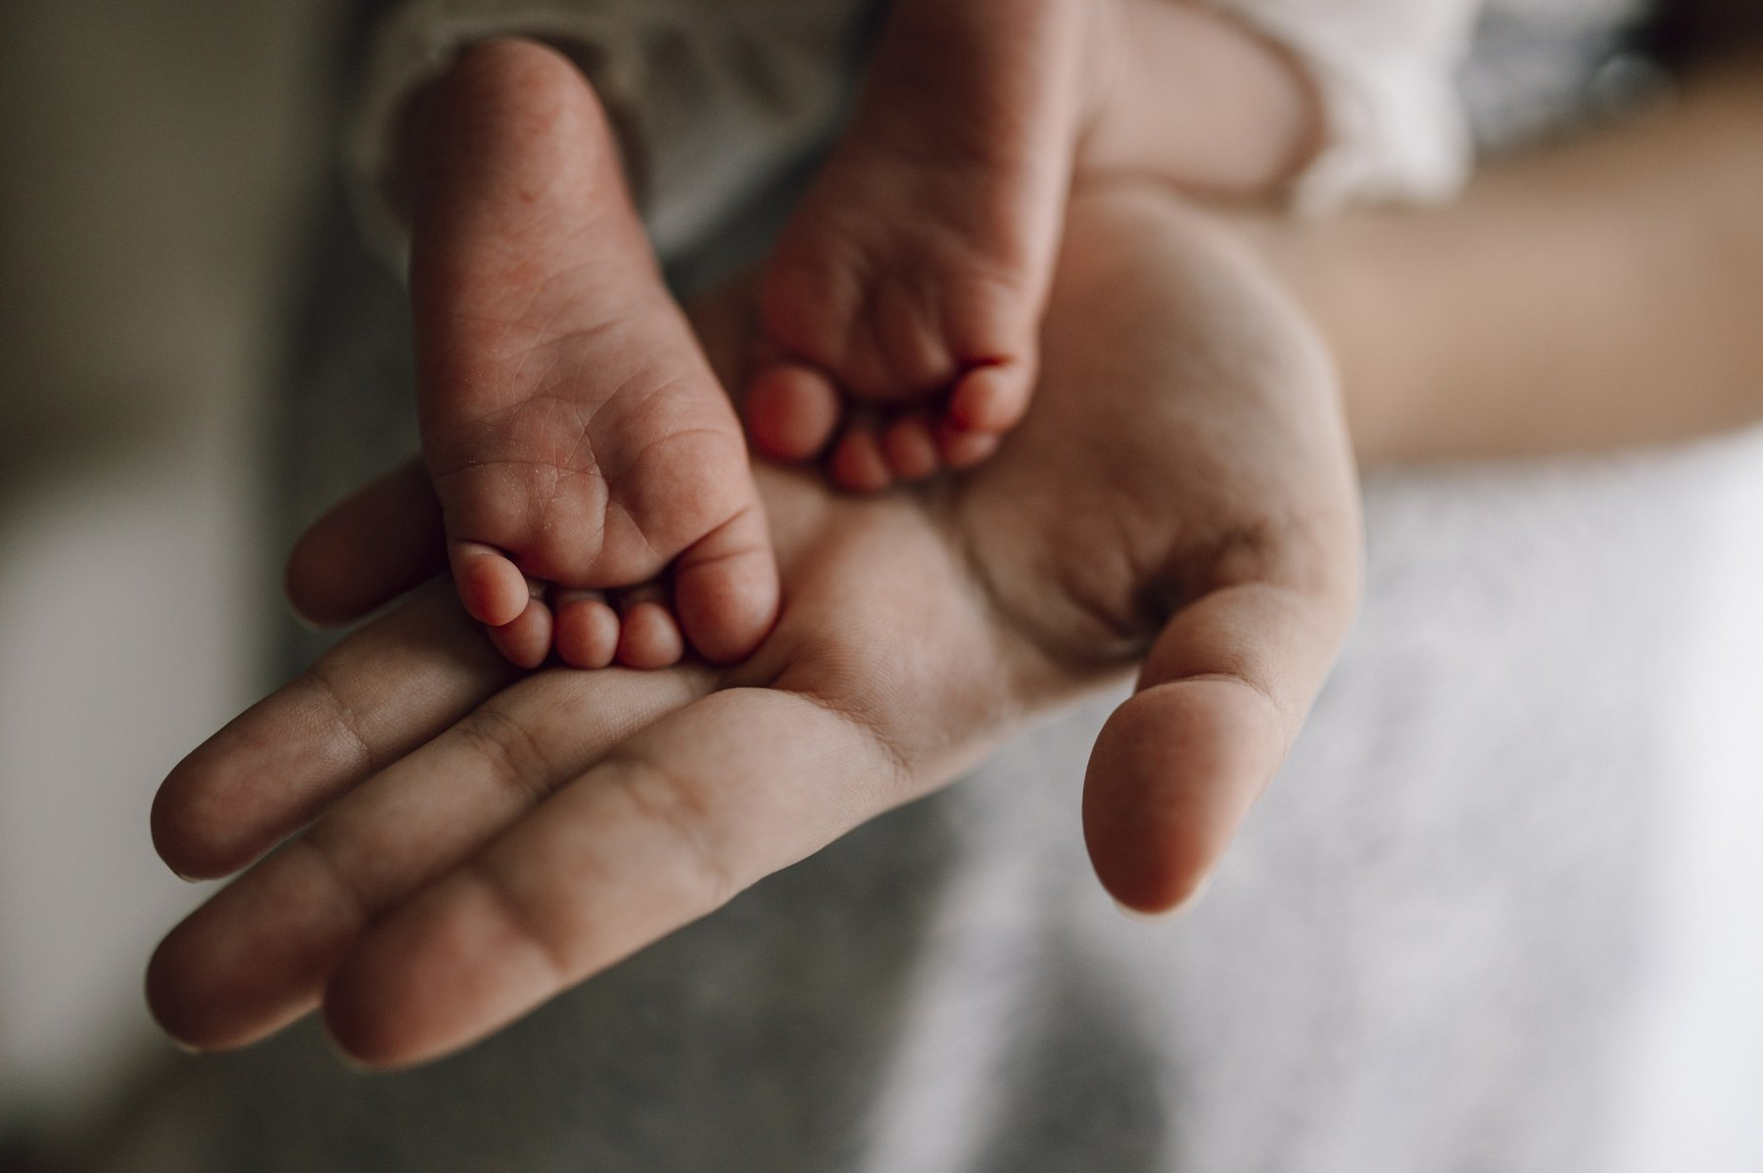
Figure 46. A newborn's feet in an adult hand, one person at the scale the last chapter is guessing about.
* * *
Other guesses have a best current account and a real gap, and they should stay in that order.
Polygenic embryo selection, sold since 2019, will be normal in some countries and illegal in others, and I would guess the line will fall roughly where the line on commercial surrogacy falls now, with the same tourism across it. The pressure will not wait for the centimetres to grow. As of late 2026 a couple who already has leftover embryos in a tank can be sold a ranking of them. Once a child's genome is on a wall, the same scores will look, to some parents, like a report card. They will not be one. The scores will get better as the biobanks of Chapter 38 pass ten million people and stop being mostly European, and the gain from picking the best of ten embryos will rise from two and a half centimetres to something a brochure can print without shame. It will never be large, because the gap between the embryos a couple actually has is the gap between siblings, and siblings differ, as Chapter 11 showed, in ways that no score can see.
Partial reprogramming is the working scenario I would watch most closely, because it is the one that could change what a century means. In 2006 Shinya Yamanaka showed that four proteins could turn an adult cell back into something like an embryonic one, as Chapter 31 described. In December 2016 Juan Carlos Izpisua Belmonte's group at the Salk Institute reported in Cell that switching those four factors on briefly and repeatedly, without letting the cells complete the reversal, made mice with a premature-ageing disease live about 30 percent longer and left their tissues looking younger by several measures. In December 2020 David Sinclair's group at Harvard reported in Nature that three of the four factors, delivered by virus into the eyes of old mice, let damaged optic nerves regrow and returned some lost vision. In January 2022 a company called Altos Labs launched with about $3 billion of private money and several of the people who had done the work, to try to make it a medicine. The first human trials, for eye conditions, were being planned as this book went to press.
What is working here is real: the epigenetic marks of Chapter 9 drift with age, the drift can be measured as a clock, and in mice the clock can be partly rewound without turning the cell into a tumour. What is not shown is that it can be done safely in a whole human body, that the gain is more than modest, or that it does anything for the cell's DNA, which has been accumulating the copying errors of Chapter 10 the whole time and is not rewound by any of this. My guess is that partial reprogramming becomes a treatment for particular tissues, the eye first, joints and skin perhaps, within thirty years, and that it adds years of health to old age rather than decades to life. The text still sets the ceiling.
De-extinction as a conservation tool is working in the sense that the animals exist. Colossal's grey wolves with twenty edits, born in late 2024 and shown in April 2025, are not dire wolves, as Chapter 28 said, but the same company's cloning of red wolves, of which fewer than twenty remained in the wild, is conservation by any name. The black-footed ferret Elizabeth Ann, cloned in December 2020 from cells frozen in 1988, and her successors, who have since produced kits, put genetic diversity back into a species that had been reduced to seven founders. By 2126, I would guess, every endangered mammal has a cell line in a freezer and a cloning protocol, and the word extinct will need a footnote.
Synthetic organisms in industry are already there in modest form. Yeast engineered by Jay Keasling's group to make the malaria drug artemisinin entered production in 2013, and precision fermentation now makes insulin, rennet, vanilla flavouring, and the heme in a plant-based burger. The 473-gene cell of 2016 and the rewritten yeast chromosomes of 2023 are the far end of the same road. What is not shown is that a wholly designed organism can do anything better than an edited natural one, and the working answer may be that it cannot, and that synthetic biology in 2126 will mostly mean very heavily edited yeast.
The copy is never exact, and mixing two copies is a different kind of inexactness. As of late 2026 a chimera, in the laboratory sense, is an animal whose body holds cells from two genomes that did not start in the same fertilised egg. That is not a pig kidney sewn into a person, which surgeons in New York, Maryland, and Xi'an have already tried, and it is not a gene-edited pig that is still wholly a pig, of the kind Chapter 34 already put on the farm. Human cells in early pig embryos have been reported, in 2017 and again in 2023 from a group in Guangzhou, as sparse contributions stopped weeks before birth. Mice given a human immune system after they are born have been ordinary laboratory animals for years. Mini-organs grown in a dish, organoids, are real enough to test drugs and, in a few early trials, to put islet-like clusters back into a person; they are not a spare heart on a shelf. I would guess that by mid-century a few people receive pig organs, that a mostly-human kidney grown inside a pig remains a working hope with a real gap, and that the line the 2021 international stem-cell guidelines drew, a substantial human contribution to an animal brain, is still the line worth keeping.
Space does not wait for a spare organ. A year on a station, as the 2019 NASA twins paper in Science showed, thins bone and muscle, shifts fluid into the head, and can swell the back of the eye. China flew four mice to its station in late 2025; one female later had litters on the ground. That is not a child conceived in orbit, and it is not a redesigned human. I would bet on better exercise, drugs, and shielding by 2035. The radiation of deep space will add copying errors. It will not, on any schedule I would sign, grow extra limbs or a new species.
* * *
Past those, the guesses are allowed and not shown.
As of late 2026 the germline remains where the 2023 summit left it: not now, and gated by the 2020 pathway, the heritable-genome-editing report's own requirement of a long medical reason and broad oversight before an edited embryo is brought to term. Germline editing for a few diseases, in a few countries, for the small number of couples for whom embryo selection cannot work: I would guess it happens before 2050, that the first cases are for sickle cell or thalassaemia where both are common, and that the arguments of Chapter 44 are re-run in full each time. I would also guess that by 2126 the practice is rare, legal in some places, and has changed nobody's view of what a person is, which is what happened with IVF.
Inequality by genome is the guess people fear most: the rich selecting and editing while the poor do not, until the gap becomes heritable. A 1997 film put that picture on a screen. The guess is allowed, and it is unlikely to arrive in that costume, for a dull reason: the traits that money most wants, intelligence and temperament, are the ones with no lever, as the last chapter said, and the ones with a lever, disease, are the ones public health systems have the strongest reason to pay for. The inequality that is actually coming, and is already here, is the one Chapter 43 described: a cure that exists in one country and not in another.
Human variants for space or climate are the far end. The genes that let a bacterium survive radiation, the Tibetan EPAS1 variant for thin air, the enlarged spleen of the Bajau sea nomads for diving, heat tolerance borrowed from the slick-coat cattle of Chapter 34: all of these have been proposed, in print, as edits for a species that means to live off Earth or on a hotter one. None has been tried, none is close, and the delivery problem alone puts them beyond this century for adults. For embryos, they are the enhancement slope of Chapter 44 with a rocket attached. I would put nothing on it before 2100, and I notice that the people most enthusiastic about it are not, on the whole, the people who would be edited.
And the designer argument, in the end, may resolve itself, because the strongest evidence in this book is that we do not know what we want. Every allele on the list in Chapter 45 was a trade. The one clear enhancement in human history, the lactase switch, was not designed and could not have been, because nobody eight thousand years ago knew what a gene was or that cheese was coming. Evolution has not stopped. It wrote EPAS1 into the Tibetans within the last few tens of thousands of years, the lactase switch within ten thousand, and it is working now on whatever gets people through cities, sugar, and antibiotics, at a pace no one can see within a lifetime. Whatever we design will sit on top of that, and will be judged by it. The judgement will mostly be that we were cautious about the wrong things.
So, marked as mine, my guess for 2126. Every child's text is read at birth, and most single-gene diseases are fixed in infancy or before. Prescribing, farming, and public health are done by sequence. Old age is longer and better by a decade or two, not by a century. Embryo selection is ordinary, edited embryos are rare, and the species is recognisably the one that mailed the tube. The thing that will have changed most is not the text but our relation to it: from something that happened to us to something we read, argue about, and occasionally, with great care, correct.
And the text will not have noticed. In the hour after the child of 2126 is born, in the lining of the child's gut, cells are dividing, and each division copies about 6.2 billion letters, both parental sets, and the copying enzyme checks its work, and a second set of enzymes checks it again, and about one letter in a billion still comes out wrong. It has been doing that for something like 3.8 billion years, through every editor, every summit, every price list, and every book. Everything that lives, including the reader, is what those errors added up to.
We may learn to correct a few of them. We will not make the copying perfect, and I think, if it ever came to it, we would be wrong to try.

APPENDIX

Five Books
A general reader who wants a book, rather than a journal, can start with a few that exist and can be checked.
Horace Freeland Judson, The Eighth Day of Creation (1979), is the long history of how the molecule was worked out, from the phage group through the code. It is not light, and it is the one to open if the middle of this book felt too short.
Matthew Cobb, Life's Greatest Secret (2015), tells the race to crack the genetic code, which is Part II here, at the length that story deserves.
Brenda Maddox, Rosalind Franklin: The Dark Lady of DNA (2002), is the biography. The Photo 51 chapter in this book is a sketch beside it.
Daniel J. Kevles, In the Name of Eugenics (1985), is the history behind Chapter 19. It is a scholarly book, and it is the right next one if that chapter is the one that stays.
Siddhartha Mukherjee, The Gene: An Intimate History (2016), covers much of the same ground as this book in a different voice. Read it as another account, not as a correction of the dates and counts given here.
The glossary below is a reminder of words, not a second book. The papers after that are the sources named in the text.

A Spit-Kit Glossary
AAV — adeno-associated virus, a small virus used as an envelope to carry a gene into a patient's cells. Allele — one of the alternative versions of a gene at a given position. Amino acid — a small building-block molecule; twenty kinds are strung together to make proteins. Base — one of the four chemical units, adenine, thymine, guanine, or cytosine, that form the "letters" of DNA. Base editing — a form of gene editing that changes one letter without cutting both strands of the DNA. Base pair — two bases joined across the double helix, A with T or G with C. Cas9 — the protein in the CRISPR system that cuts DNA where a guide RNA tells it to. Centromere — the pinched region of a chromosome where the two copies are held together before a cell divides. Clone — an organism grown from the nucleus of one donor cell, so that its nuclear DNA matches that donor. Identical twins are natural clones. CRISPR — a bacterial immune system, repurposed as a programmable gene-editing tool guided by RNA. Chromatin — DNA wound around histones, compact spool-like proteins that help pack it tightly. Chromosome — a single long DNA molecule, together with its packaging proteins; humans have forty-six. Codon — a group of three DNA or RNA letters that specifies one amino acid or a stop signal. Diploid — having two parental sets of chromosomes, the usual state of a body cell. In a person that is about 6.2 billion letters. Dominant — a version of a gene that shows its effect when only one copy is present. It does not mean common, and it does not mean healthy. Enhancer — a stretch of DNA that boosts a gene's activity, sometimes from far away along the chromosome. Enzyme — a protein (occasionally an RNA) that speeds up a chemical reaction. Epigenetics — chemical marks on DNA or its packaging proteins that change gene activity without changing the underlying letters. Eugenics — the programme, named by Francis Galton in 1883, of trying to improve a population by encouraging some people to have children and discouraging or preventing others. Event — in plant biotechnology, one particular insertion or edit of a trait in one line; regulators approve events, not abstract genes. Exon — a coding segment of a gene, the part kept once the non-coding pieces are cut out. Franklin, Rosalind — the scientist at King's College London (1920–1958) who used X-rays to work out the shape of DNA. Photo 51 and her measurements underpinned the 1953 model. Her paper with Raymond Gosling appeared in the same issue of Nature as Watson and Crick's. Gene — a stretch of DNA that specifies a protein or a functional RNA molecule. Gene-edited — of a crop, a plant whose own DNA has been cut and repaired, usually with CRISPR or TALENs, without leaving a gene from another species. Contrast transgenic. Genome — the complete set of DNA in an organism. Genome-wide association study (GWAS) — a search that compares hundreds of thousands of common variants across many people with and without a trait, looking for positions that differ more often than chance. Genotyping — reading a chosen set of positions where people already differ, rather than the whole genome. A spit-kit chip does this. Germline — the cells that give rise to eggs or sperm; changes here pass to offspring. Guide RNA — a short RNA strand that leads Cas9, or a base editor, to one address in the DNA. Haploid — having one parental set of chromosomes, as in an egg or a sperm, or in the reference genome of about 3.1 billion letters. Haplogroup — a branch on the maternal or paternal tree, defined by a shared set of mitochondrial or Y-chromosome variants, used to group people by deep ancestry along one line. Heritability — the fraction of variation in a trait, within a specific population, attributable to genetic differences. Heterozygous — carrying two different alleles of a gene, one from each parent. Histone — a spool-like protein that DNA winds around for compact packaging. Homozygous — carrying two identical alleles of a gene. Intron — a non-coding segment of a gene, cut out before the gene's message is used. Manhattan plot — a graph of a genome-wide association study, chromosomes along the floor, each variant a point whose height is how unlikely the association would be by chance; a real signal stands up as a tower. Meiosis — the cell division that produces eggs or sperm, each with half the usual number of chromosomes. Messenger RNA (mRNA) — the RNA copy of a gene that carries instructions to the ribosome, the cell's protein-making machine. Mitochondrial DNA — the small circular genome inside the mitochondria, 16,569 letters in people, inherited from the mother. Mitosis — ordinary cell division, producing two genetically identical daughter cells. Mutation — a permanent change to the sequence of DNA letters. Nanopore sequencing — reading a DNA strand by threading it through a protein pore and watching each letter disturb an electrical current. Nucleotide — the basic unit of DNA or RNA: a sugar, a phosphate, and a base. Nucleus — the compartment of a cell that holds its DNA. Pangenome — a reference genome built from many individuals rather than one, to capture human variation more fully. Penetrance — the probability that a person carrying a particular genetic variant actually develops the associated trait or disease. Phenotype — an observable trait, as distinct from the genetic makeup that produces it. Photo 51 — the May 1952 X-ray fibre photograph of wet (B-form) DNA, taken by Raymond Gosling under Rosalind Franklin at King's College London. The white X on the film is the signature of a helix. Point mutation — a change to a single DNA letter. Plasmid — a small ring of DNA, used by bacteria and by genetic engineers to carry a gene from one cell to another. Polygenic — influenced by many genes acting together, each with a small effect. Polygenic score — a single number that adds up many small genetic effects on a trait. It shifts an average. It does not place one person. Polymerase chain reaction (PCR) — a way to copy a chosen stretch of DNA over and over in a tube, with no cell required. Polymerase — an enzyme that builds a new strand of DNA or RNA using an existing strand as a template. Preimplantation genetic testing (PGT) — the reading of an embryo's DNA during IVF so that one embryo can be chosen for transfer. Prime editing — a form of gene editing that nicks one strand and writes a short new sequence from a template carried on the guide RNA. Promoter — the DNA address where the copying of a gene into RNA begins. Recombination — the exchange of DNA segments between paired chromosomes during meiosis. Recessive — a version of a gene whose effect is hidden when a dominant version is also present. Two copies are needed for the trait to show. Restriction enzyme — a bacterial enzyme that cuts DNA at a specific sequence. Ribosome — the cellular machine, built of RNA and protein, that translates mRNA into protein. Semiconservative replication — the copying scheme in which each new DNA molecule contains one old strand and one newly made strand. Somatic cell — any cell of the body other than the germline; changes here do not pass to offspring. Splicing — the removal of introns from a freshly built RNA transcript. Stacked trait — two or more engineered traits, such as herbicide tolerance and insect resistance, combined in one seed. Tautomer — an alternative chemical form of a molecule, differing in the position of a hydrogen atom. Telomere — a repetitive, protective stretch of DNA at the end of a chromosome. Transcription — the copying of a DNA gene into RNA. Transcription factor — a protein that binds DNA to help control transcription. Transfer RNA (tRNA) — an adaptor molecule that matches a codon to its amino acid during translation. Translation — the process by which a ribosome builds a protein from an mRNA sequence. Transgenic — carrying DNA from another species, as Roundup Ready soy carries a bacterial gene. Contrast gene-edited. Transposon — a DNA sequence capable of copying and inserting itself elsewhere in the genome.

A Short Timeline
1865 — Gregor Mendel presents his results on pea crosses to the Brünn Natural History Society; published 1866. 1869 — Friedrich Miescher isolates "nuclein" from white blood cells in Tübingen. 1900 — Hugo de Vries, Carl Correns, and Erich von Tschermak independently rediscover Mendel's paper. 1902–03 — Walter Sutton and Theodor Boveri propose that chromosomes carry Mendel's hereditary factors. 1910 — Thomas Hunt Morgan finds a white-eyed mutant fly and begins the Drosophila work that founds classical genetics. 1913 — Alfred Sturtevant draws the first genetic map. 1928 — Frederick Griffith discovers the bacterial "transforming principle." 1933 — Nazi Germany passes a compulsory-sterilisation law modelled partly on American statutes. 1937–40s — Fisher, Haldane, Wright, Dobzhansky, Mayr, and Simpson build the Modern Synthesis, joining Darwin and Mendel. 1944 — Oswald Avery, Colin MacLeod, and Maclyn McCarty identify DNA as the transforming substance. 1950 — Erwin Chargaff publishes the base-ratio rule. 1952 — Alfred Hershey and Martha Chase's phage experiment; Rosalind Franklin and Raymond Gosling take Photo 51. 1953 — Watson and Crick publish the double-helix structure (25 April); Franklin and Gosling, and Wilkins and colleagues, publish the X-ray evidence in the same issue; Watson and Crick publish the copying mechanism (30 May). 1956 — Arthur Kornberg isolates a DNA polymerase; Vernon Ingram finds the single amino-acid change behind sickle cell disease. 1958 — Meselson and Stahl demonstrate semiconservative replication. 1961 — Marshall Nirenberg and Heinrich Matthaei crack the first codon; Christian Anfinsen shows sequence determines protein folding. 1962 — Nobel Prize in Physiology or Medicine to Watson, Crick, and Wilkins. Franklin had died in 1958; the prize is not awarded posthumously. 1964 — Genetics research resumes in the Soviet Union after Lysenko's fall from official favour. 1966 — The genetic code is fully worked out. 1970 — Restriction enzymes characterised (Arber, Smith, Nathans); Howard Temin and David Baltimore find reverse transcriptase. 1972–73 — Paul Berg makes the first recombinant DNA molecule; Stanley Cohen and Herbert Boyer clone a gene in bacteria. 1975 — The Asilomar Conference sets voluntary safety guidelines for recombinant DNA. 1977 — Frederick Sanger sequences the first DNA genome (phage phi X174); Sharp and Roberts discover introns. 1978 — Recombinant human insulin produced in bacteria. 1983 — Kary Mullis conceives PCR; Barbara McClintock receives the Nobel Prize for transposons. 1984 — Alec Jeffreys develops DNA fingerprinting. 1990 — The Human Genome Project formally begins; the first gene-therapy trial (Ashanti DeSilva). 1994 — The Flavr Savr tomato reaches supermarket shelves. 1996 — Dolly the sheep is born on 5 July at the Roslin Institute. Monsanto commercialises glyphosate-tolerant soy and Bt corn and cotton in the United States. 1997 — China plants Bt cotton. 2000 — The draft human genome is announced at the White House on 26 June. 2003 — The Human Genome Project is declared complete in April, the fiftieth anniversary of the double helix. 2003–05 — Hwang Woo-suk's human cloning claims are exposed as fraudulent. 2007 — Shinya Yamanaka reprograms adult cells into induced pluripotent stem cells. 2010 — J. Craig Venter's team boots up a cell with a fully synthetic genome; Svante Pääbo's group publishes the draft Neanderthal genome. 2012 — Jennifer Doudna and Emmanuelle Charpentier publish CRISPR-Cas9 as a programmable editing tool; ENCODE publishes its functional-genome estimate. 2013 — CRISPR editing demonstrated in human cells; Angelina Jolie's op-ed on BRCA1; the U.S. Supreme Court rules on gene patents in Association for Molecular Pathology v. Myriad Genetics. 2018 — He Jiankui announces germline-edited twins in Hong Kong in November. Bayer completes its purchase of Monsanto on 7 June. 2019 — Victoria Gray becomes the first sickle cell patient dosed with CRISPR-edited cells. 2020 — Nobel Prize in Chemistry to Doudna and Charpentier; AlphaFold2 solves protein folding at the CASP14 competition. 2022 — The telomere-to-telomere human genome (T2T-CHM13) is completed; Nobel Prize in Physiology or Medicine to Svante Pääbo. 2023 — Casgevy (exa-cel), the first CRISPR-based therapy, approved in the UK and the United States. 2024 — Nobel Prize in Chemistry to Demis Hassabis, John Jumper, and David Baker for protein structure prediction and design. 2025 — KJ Muldoon receives a personalised base-editing treatment for CPS1 deficiency, published in the New England Journal of Medicine in May. Two patients receive a prime-edited stem-cell therapy for chronic granulomatous disease (New England Journal of Medicine, December). 2026 — The European Union adopts Regulation 2026/1388 on plants obtained by certain new genomic techniques, 17 June, to apply from 17 July 2028.

Papers Named in the Text
The primary sources named throughout this book are, deliberately, the ones worth going to first. The three papers of 25 April 1953 ran in one issue of Nature: Watson and Crick, then Wilkins, then Franklin and Gosling.
Watson, J. D., and Crick, F. H. C. "Molecular Structure of Nucleic Acids." Nature, 25 April 1953. Wilkins, M. H. F., Stokes, A. R., and Wilson, H. R. "Molecular Structure of Deoxypentose Nucleic Acids." Nature, 25 April 1953. Franklin, R. E., and Gosling, R. G. "Molecular Configuration in Sodium Thymonucleate." Nature, 25 April 1953. Watson, J. D., and Crick, F. H. C. "Genetical Implications of the Structure of Deoxyribonucleic Acid." Nature, 30 May 1953. Avery, O. T., MacLeod, C. M., and McCarty, M. "Studies on the Chemical Nature of the Substance Inducing Transformation of Pneumococcal Types." Journal of Experimental Medicine, February 1944. Meselson, M., and Stahl, F. W. "The Replication of DNA in Escherichia coli." Proceedings of the National Academy of Sciences, July 1958. Mendel, G. "Versuche über Pflanzen-Hybriden." Verhandlungen des naturforschenden Vereines in Brünn, 1866. Jeffreys, A. J., Wilson, V., and Thein, S. L. "Hypervariable 'Minisatellite' Regions in Human DNA." Nature, 1985. Jinek, M., Chylinski, K., Fonfara, I., Hauer, M., Doudna, J. A., and Charpentier, E. "A Programmable Dual-RNA-Guided DNA Endonuclease in Adaptive Bacterial Immunity." Science, June 2012. International Human Genome Sequencing Consortium. "Initial Sequencing and Analysis of the Human Genome." Nature, February 2001. Green, R. E., et al. (Pääbo lab). "A Draft Sequence of the Neanderthal Genome." Science, May 2010. Slocombe, L., Sacchi, M., and Al-Khalili, J. "An Open Quantum Systems Approach to Proton Tunnelling in DNA." Communications Physics, 2022. Slocombe, L., Winokan, M., et al. "Quantum Tunnelling Effects in the Guanine-Thymine Wobble Misincorporation via Tautomerism." Journal of Physical Chemistry Letters, 23 December 2022. A later calculation, still not an experiment in a living cell. Löwdin, P.-O. "Proton Tunneling in DNA and its Biological Implications." Reviews of Modern Physics, July 1963. Wilmut, I., Schnieke, A. E., McWhir, J., Kind, A. J., and Campbell, K. H. S. "Viable Offspring Derived from Fetal and Adult Mammalian Cells." Nature, February 1997. Nurk, S., et al. "The Complete Sequence of a Human Genome." Science, 31 March 2022. The nuclear assembly is 3,054,815,472 base pairs; with the mitochondrial genome of 16,569 the one-parental-set total is 3,054,832,041. Musunuru, K., et al. "Patient-Specific In Vivo Gene Editing to Treat a Rare Genetic Disease." New England Journal of Medicine, online 15 May 2025. The paper on KJ Muldoon. It reports two infusions. Later hospital and university accounts of the same case have spoken of a third dose. Gori, J. L., et al. "Prime Editing for p47phox-Deficient Chronic Granulomatous Disease." New England Journal of Medicine, 7 December 2025. Two participants. Follow-up in the paper is months, not years. Bycroft, C., et al. "The UK Biobank Resource with Deep Phenotyping and Genomic Data." Nature, 2018. UK Biobank Whole-Genome Sequencing Consortium. "Whole-Genome Sequencing of 490,640 UK Biobank Participants." Nature, 6 August 2025. The All of Us Research Program Genomics Investigators. "Genomic Data in the All of Us Research Program." Nature, 2024. The release described in the paper contains 245,388 whole genomes. National Institutes of Health. "NIH's All of Us Research Program is now the largest integrated genomics and health database in the world." 30 June 2026. Enrolment over 883,000; more than 535,000 whole genomes in that release. Sclater, A. "The Extent of Charles Darwin's Knowledge of Mendel." Journal of Biosciences, June 2006. Darwin's copy of Focke, pages 108 to 110 uncut. Gitschier, J. "It Was Heaven: An Interview with Evelyn Witkin." PLOS Genetics, 2012. Witkin's recollection that Max Delbrück called DNA a stupid molecule. Vertex Pharmaceuticals. Form 8-K, 8 December 2023. Wholesale acquisition cost of Casgevy in the United States set at $2.2 million, the day the Food and Drug Administration approved it for sickle cell disease. Medicines and Healthcare products Regulatory Agency. Casgevy marketing authorisation, 15 November 2023. National Institute for Health and Care Excellence. TA1003 and TA1044. Published list price of exagamglogene autotemcel £1,651,000 per course, with a confidential NHS discount. Food and Drug Administration. Letter to Calgene, Inc., 17 May 1994, concluding that FLAVR SAVR tomatoes had not been significantly altered compared with tomatoes with a history of safe use. Alliance for Bio-Integrity v. Shalala, 116 F. Supp. 2d 166 (D.D.C. 2000). Bowman v. Monsanto Co., 569 U.S. 278 (2013). Monsanto Canada Inc. v. Schmeiser, 2004 SCC 34. National Academies of Sciences, Engineering, and Medicine. Genetically Engineered Crops: Experiences and Prospects. 2016. Regulation (EU) 2026/1388 of the European Parliament and of the Council of 17 June 2026 on plants obtained by certain new genomic techniques and their products. Huang, J., Rozelle, S., Pray, C., and Wang, Q. "Plant Biotechnology in China." Science, 25 January 2002. Early account of Bt cotton reducing pesticide use in China.

Photo Credits
The diagrams are original. The photographs are from Wikimedia Commons, under the licence named with each one.
Figure 0. An opened spit-kit box, the collection tube still sealed in its bag. "Home DNA Testing Kit Tube (47400098641).jpg," by Tony Webster, CC BY 2.0. https://commons.wikimedia.org/wiki/File:Home_{DNATestingKitTube}_(47400098641).jpg
Figure 1. The Eagle, Bene't Street, Cambridge. "Cmglee Cambridge Friar House from The Eagle.jpg," by Cmglee, CC BY-SA 4.0. https://commons.wikimedia.org/wiki/File:CmgleeCambridgeFriarHousefromTheEagle.jpg
Figure 4. Colonies of bacteria on a plate. "Agarplate redbloodcells edit.jpg," by Bill Branson, National Cancer Institute, public domain. https://commons.wikimedia.org/wiki/File:Agarplate_{redbloodcellsedit}.jpg
Figure 14. A bare field in winter. "Dülmen, Umland, Sonnenaufgang im Winter -- 2013 -- 9899.jpg," by Dietmar Rabich, CC BY-SA 4.0. https://commons.wikimedia.org/wiki/File:D%C3%BClmen,_Umland,_Sonnenaufgang_{imWinter}_--_2013_--_9899.jpg
Figure 15. A drawing of Mendel's pea flowers and pods. "Fairbanks - Mendel Axial and Terminal Flowers and Pods.jpg," by Daniel J. Fairbanks, CC BY 4.0. A botanical drawing, not a photograph. https://commons.wikimedia.org/wiki/File:Fairbanks_-_Mendel_{AxialandTerminalFlowersandPods}.jpg
Figure 17. The abbatial church of the Augustinian abbey of St Thomas in Old Brno. "Basilica of the Assumption of Our Lady, Abbatial church, Brno.jpg," by Jan Sapák, CC BY-SA 4.0. https://commons.wikimedia.org/wiki/File:Basilica_{oftheAssumptionofOurLady},_Abbatial_{church},_Brno.jpg
Figure 18. A fruit fly, Drosophila melanogaster. "D-Melanogaster 2.jpg," by Francisco Romero Ferrero, CC BY-SA 4.0. https://commons.wikimedia.org/wiki/File:D-Melanogaster₂.jpg
Figure 19. Field workers of the Eugenics Record Office at Cold Spring Harbor, June 1912. "First Annual Field Workers' Conference, Eugenics Record Office, Cold Spring Harbor, Long Island, New York, June 20 and 21,1912.jpg," public domain. https://commons.wikimedia.org/wiki/File:First_{AnnualFieldWorkers}%27_Conference,_Eugenics_{RecordOffice},_Cold_{SpringHarbor},_Long_{Island},_New_{York},_June₂₀_and₂₁,1912.jpg
Figure 26. A blood collection tube and needle. "Vacutainer with blood collection tube.jpg," by Whispyhistory, CC BY 3.0 US. https://commons.wikimedia.org/wiki/File:Vacutainer_{withbloodcollectiontube}.jpg
Figure 28. A limestone cave mouth, not confirmed as Denisova Cave. "Таинственная пещера.jpg," by Xenochka, CC BY-SA 4.0. https://commons.wikimedia.org/wiki/File:%D0%A2%D0%B0%D0%B8%D0%BD%D1%81%D1%82%D0%B2%D0%B5%D0%BD%D0%BD%D0%B0%D1%8F_%D0%BF%D0%B5%D1%89%D0%B5%D1%80%D0%B0.jpg
Figure 29. A ewe with her lamb in a barn. "A ewe and her lamb at Reed Ranch (40871239920).jpg," U.S. Fish and Wildlife Service, public domain. https://commons.wikimedia.org/wiki/File:A_{eweandherlambatReedRanch}_(40871239920).jpg
Figure 30. A litter of puppies. "Havanese Litter.png," by Cartman0052007, CC BY 3.0. https://commons.wikimedia.org/wiki/File:Havanese_{Litter}.png
Figure 31. An electron microscope in a laboratory, about 1980. "U.S. Department of Energy - Science - 276 003 003 (16625682631).jpg," U.S. Department of Energy, public domain. https://commons.wikimedia.org/wiki/File:U.S._Department_{ofEnergy}_-_Science_-_276_003_003_(16625682631).jpg
Figure 32. Ears of corn. "CORN HARVEST close up of ear (48980552538).jpg," Alabama Extension, CC0. https://commons.wikimedia.org/wiki/File:CORN_{HARVESTcloseupofear}_(48980552538).jpg
Figure 33. Tomatoes on a market stall. "Fresh tomatoes stacked at market stall.jpg," by TopmanJnr1, CC BY-SA 4.0. https://commons.wikimedia.org/wiki/File:Fresh_{tomatoesstackedatmarketstall}.jpg
Figure 34. The exterior of a poultry barn, red walls and a metal roof, not the birds inside. "Red chicken barn Canada.jpg," Chicken Farmers of Canada, CC BY 2.0. https://commons.wikimedia.org/wiki/File:Red_{chickenbarnCanada}.jpg
Figure 35. The entrance of the Svalbard Global Seed Vault. "Entrance to Svalbard Global Seed Vault in 2008.jpg," by Dag Endresen, CC BY. https://commons.wikimedia.org/wiki/File:EntrancetoSvalbardGlobalSeedVaultin2008.jpg
Figure 36. DNA sequencers in a laboratory. "Illumina Hiseq 2000 sequencers, BGI Hong Kong sequencing room.JPG," by Scotted400, CC BY 3.0. https://commons.wikimedia.org/wiki/File:Illumina_{Hiseq2000}_sequencers,_BGI_{HongKongsequencingroom}.JPG
Figure 39. A consumer saliva collection tube on a kit instruction card, a different company from the one chapter 39 names. "Wonder Who I Am - Flickr - Lisa Zins.jpg," by Lisa Zins, CC BY 2.0. https://commons.wikimedia.org/wiki/File:Wonder_{WhoIAm}_-_Flickr_-_Lisa_{Zins}.jpg
Figure 42. Server racks in a data centre. "NOIRLab HQ Server Racks (6V6A0395-CC).jpg," NOIRLab/NSF/AURA/T. Slovinský, CC BY 4.0. https://commons.wikimedia.org/wiki/File:NOIRLab_{HQServerRacks}_(6V6A0395-CC).jpg
Figure 45. A whippet. "Whippet 2018 6.jpg," by Canarian, CC BY-SA 4.0. https://commons.wikimedia.org/wiki/File:Whippet₂₀₁₈_6.jpg
Figure 46. A newborn's feet in an adult hand. "Newborn feet nestled gently in a parent's hand highlighting the bond of love and care at home.jpg," by Shixart1985, CC BY 2.0. https://commons.wikimedia.org/wiki/File:Newborn_{feetnestledgentlyinaparent}%27shandhighlightingthebondofloveandcareathome.jpg

